**SBA1**

1. **Create an array of 10 elements and print them using the for each loop.**

**Code:**

import java.util.*;

class ForEachLoop

 {

  public static void main(String[] args)

   {

     int[] arr=new int[10];

     Scanner sc =new Scanner(System.in);

    for(int i=0;i<10;i++)

    {

     arr[i]=sc.nextInt();

    }

   System.out.println("  ");

    for (int number: arr)

     {

      System.out.println(number);

    }

  }

}

**Output:**

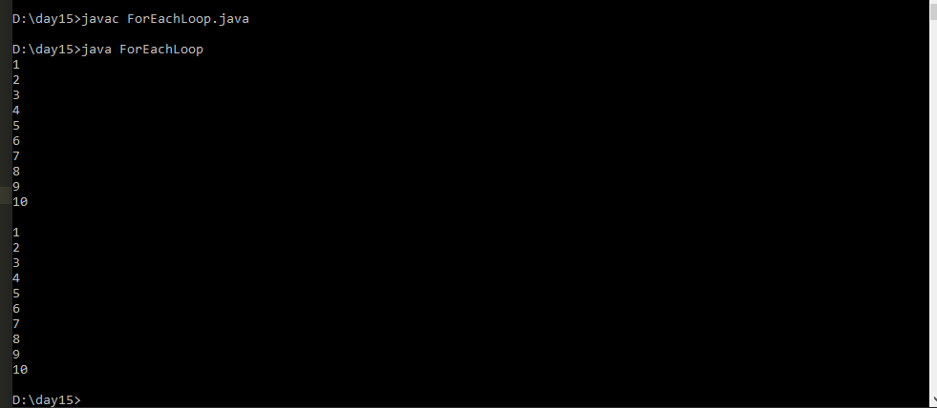

2. **Take the number input from the console and add all the positive numbers. (Not to consider the negative number if entered)**

**Code:**

import java.util.*;

public class Sample

{

    public static void main(String[] args)

    {

       int n;

Scanner sc =new Scanner(System.in);

System.out.println("Enter the Number of elements you want to enter  :");

n=sc.nextInt();

int[] a= new int[n];

System.out.println("Enter the  elements :");

        for (int i = 0; i < n; i++)

        {

            String s = System.console().readLine();

            a[i] = Integer.parseInt(s);

        }

       int sum=0;

      for (int i = 0; i < n; i++)

        {

            if(a[i] >=0)

               sum=sum+a[i];

        }

    System.out.println(" sum of positive no " +sum);

    }

    }

Output:

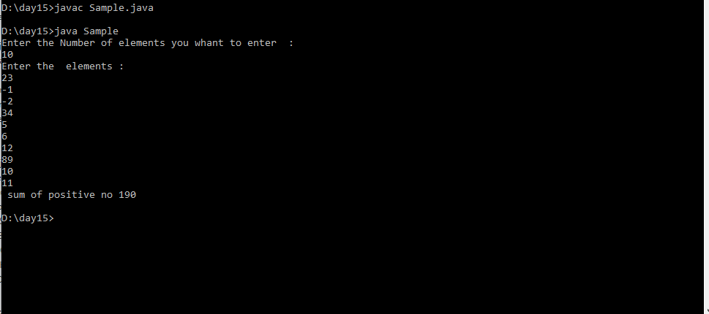

3. **Create a labelled break and write a simple logic and execute the program.**

**Code:**

public class LabelledBreak

{

public static void main(String[] args)

{

int i=7;

loop1:

while(i<20)

{

if(i==10)

break loop1;

System.out.println("i ="+i);

i++;

}

System.out.println("Out of the loop");

}

}

**Output:**

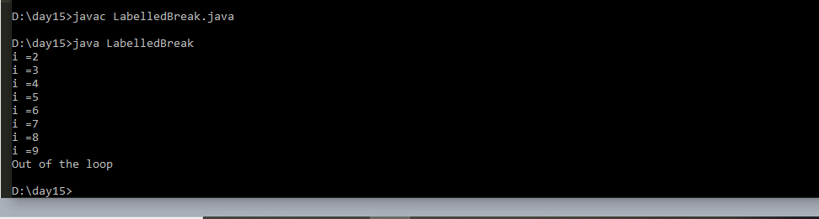

4. **Do the addition of around 10 even numbers, but use the continue statement in the logic.**

**Code:**

import java.util.*;

 class SumofEven1

{

public static void main(String[] args)

{

int count=0;

int sum = 0;

outer:

for(int i=1;i<50;i++)

{

if(i%2!=0)

{

continue;

}

else if(i%2==0)

{

sum+=i;

count++;

if(count==10)

{

break outer;

}

}

}

System.out.println(" The Sum of Even Numbers upto 10 "+ "  =  " + sum);

}

**}**

**Output:**

