**SBA2**

**1.Write a Java Program to reverse a string with or without using String inbuilt function reverse ().**

Code:

import java.util.*;

class StringRev1

{

 public static void main(String[] args)

 {

  String str;

Scanner sc=new Scanner(System.in);

    System.out.println("Enter a Sting :");

    str=sc.next();

    String str1=str.toLowerCase();

    int l=str1.length();

    for(int i =l-1; i>=0; i--)

    {

     System.out.print(str.charAt(i));

  }

 }

}

**Output:**

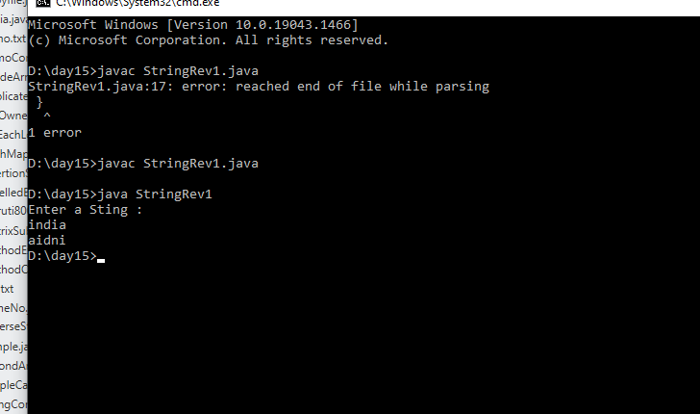

2. **Write programs to depict the usage of contains (), length (), replace (), concat (), equals ()**

**Code:**

import java.lang.String;

public class StringMethods {

    public static void main(String[] args) {

        String str = "softwareTesting";

        String str1 = "testing";

        String str2 = "blog";

        System.out.println(str.length());

        String replace = str.replace('o', 'u');

        System.out.println(str);

        System.out.println("testing is a part of Softwaretestinghelp: " + str.contains(str1));

        System.out.println("blog is a part of Softwaretestinghelp: " + str.contains(str2));

        System.out.println(str1.concat(str2));

        System.out.println(str1.equals(str2));

    }

}

**Output:**

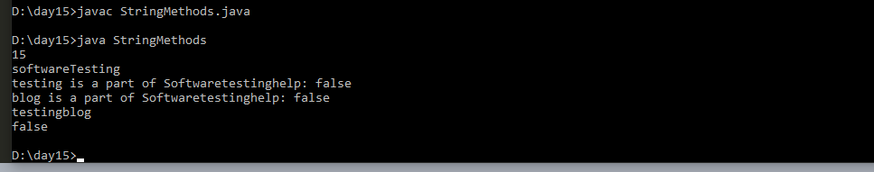

**3. Customized exception class for a Banking project.**

**Code:**

**package** com.ust;

**public** **class** InSufficientFundException **extends** RuntimeException {

**private** String message;

**public** InSufficientFundException(String message) {

**this**.message = message;

}

**public** InSufficientFundException(Throwable cause, String message) {

**super**(cause);

**this**.message = message;

}

**public** String getMessage() {

**return** message;

}

}

**package** com.ust;

**public** **class** Account {

**private** **int** balance = 3000;

**public** **int** balance() {

**return** balance;

}

**public** **void** withdraw(**int** amount) **throws** InSufficientFundException {

**if** (amount > balance) {

**throw** **new** InSufficientFundException(String.*format*(

"Current balance %d is less than requested amount %d",

balance, amount));

}

balance = balance - amount;

}

**public** **void** deposit(**int** amount) {

**if** (amount <= 0) {

**throw** **new** IllegalArgumentException(String.*format*(

"Invalid deposit amount %s", amount));

}

}

}

**package** com.ust;

**public** **class** Test {

**public** **static** **void** main(String args[]) {

Account acct = **new** Account();

System.***out***.println("Current balance : " + acct.balance());

System.***out***.println("Withdrawing $200");

acct.withdraw(200);

System.***out***.println("Current balance : " + acct.balance());

acct.withdraw(3500);

}

}

**Output:**

