**Hydra:THM**

1)The password of mooly we account



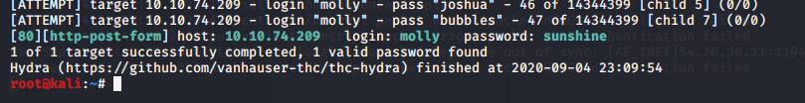



2)The password of ssh using hydra

