Telecom Customer Churn Intelligence Dashboard
Project Report: Data Analytics with AI
Business Intelligence | Python | scikit-learn | Streamlit
Prepared by: Sneha Tanty

1. Introduction
Customer churn is one of the costliest problems for subscription businesses. This project builds a business-intelligence dashboard that converts raw telecom customer data into actionable decisions, following the flow Data → Insight → Decision → Action.

2. Problem Statement
A telecom provider loses roughly one in four customers. Management needs to know (a) which customers churn, (b) what drives churn, (c) which active customers are most likely to leave next, and (d) which retention actions should be prioritised.

3. Dataset
- Telco Customer Churn (IBM sample data): 7,043 customers, 21 columns.
- Source: https://www.kaggle.com/datasets/blastchar/telco-customer-churn
- Features: demographics, services subscribed, contract, billing, payment method, tenure, monthly and total charges.
- Target: Churn (Yes/No). 26.5% of customers churned.

4. Methodology

4.1 Data cleaning
- Converted TotalCharges from text to numeric; 11 blank values (new customers with tenure 0) were filled with MonthlyCharges × tenure.
- Created ChurnFlag (0/1), tenure groups and readable SeniorCitizen labels.

4.2 Model
A scikit-learn pipeline scales numeric features, one-hot encodes categorical features and trains a Gradient Boosting classifier on 80% of the data (stratified split, random_state=42). Performance is measured on the remaining 20%.
Metric | Value
Accuracy | 80.3%
ROC-AUC | 0.843
F1 score (churn class) | 0.581

4.3 Dashboard
- Backend: pandas, NumPy, scikit-learn. Frontend: Streamlit and Plotly, in a single Python file.
- Page 1 Executive Overview: KPIs and churn trends.
- Page 2 Churn Drivers & Segments: feature importance, segment explorer, heatmap, model performance.
- Page 3 Risk, Opportunity & Action: at-risk customers, top-15 priority list, recommended actions and a what-if scorer.
4.4 Dashboard output (screenshots)
The screenshots below show the three pages of the running Streamlit dashboard.
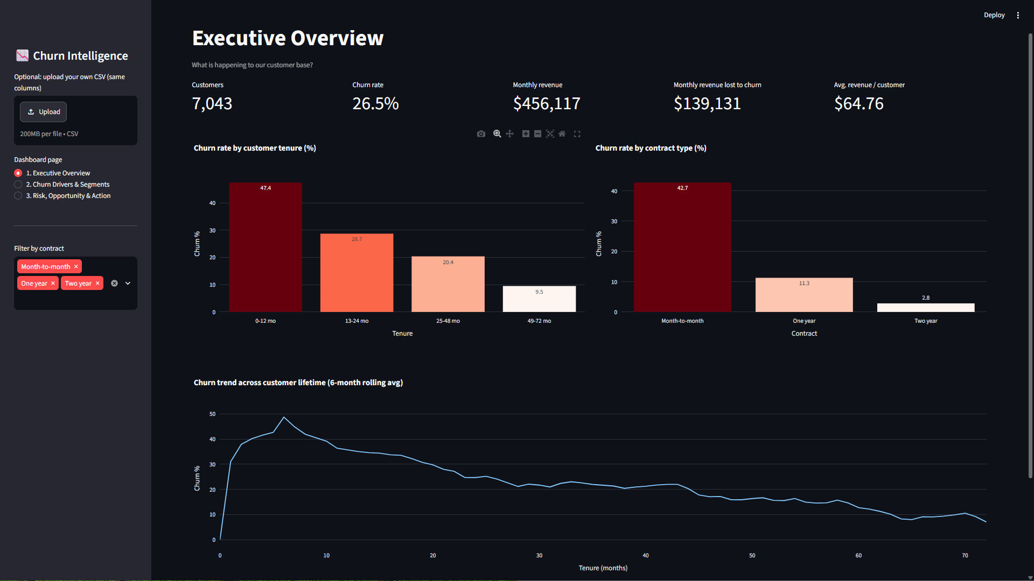
Figure 5: Page 1 - Executive Overview
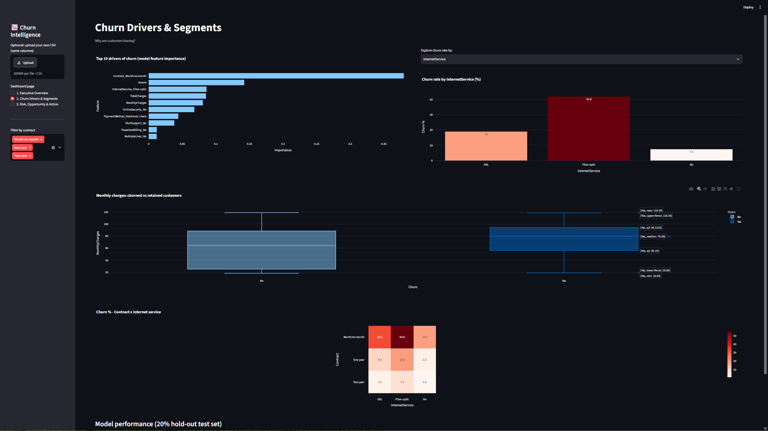
Figure 6: Page 2 - Churn Drivers & Segments
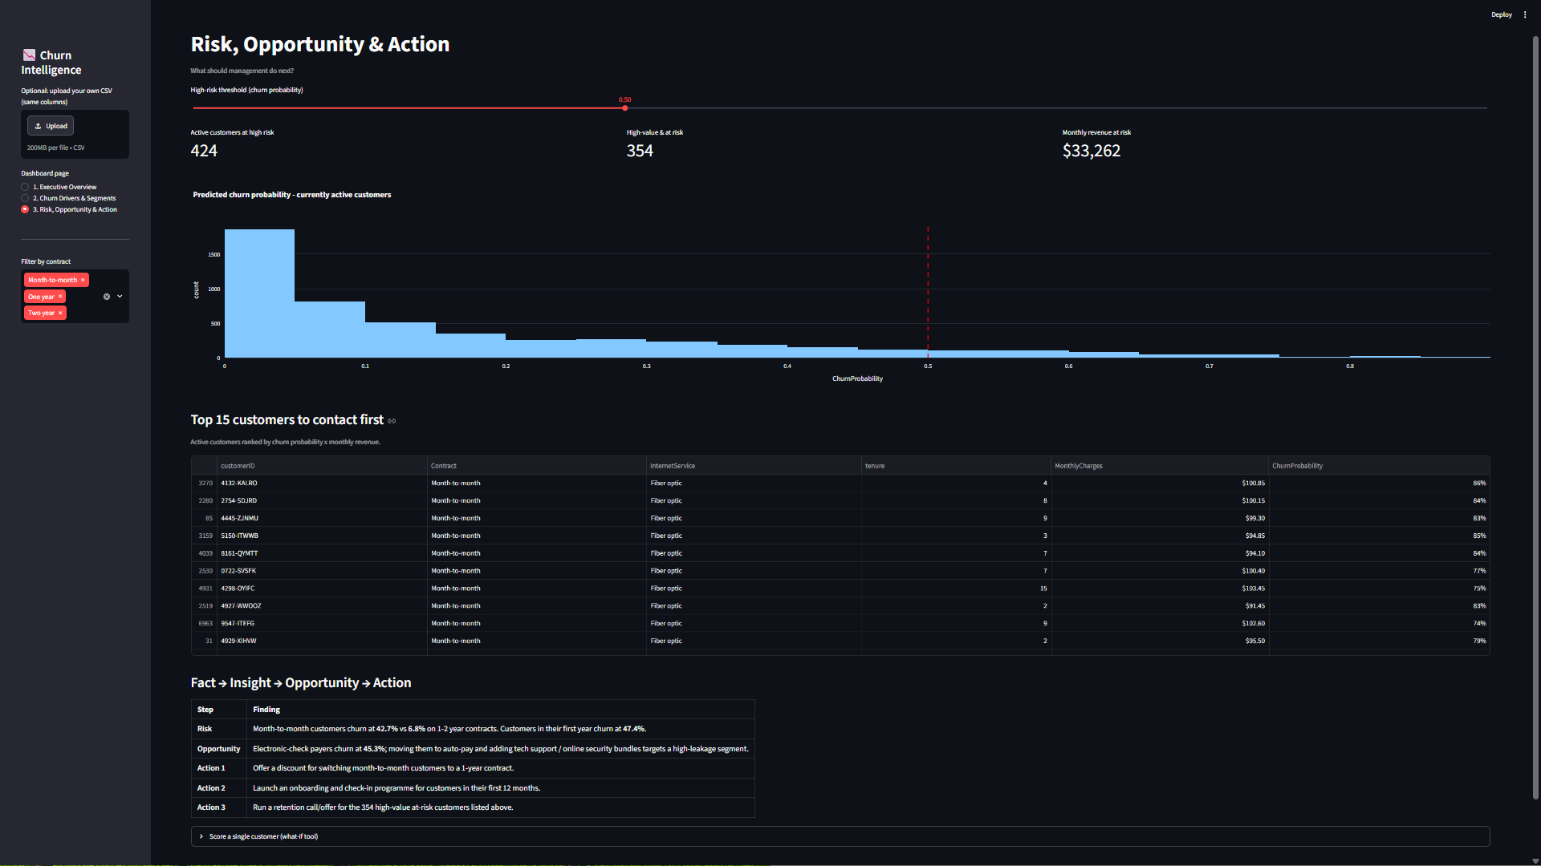
Figure 7: Page 3 - Risk, Opportunity & Action

5. Key KPIs
KPI | Value
Total customers | 7,043
Churn rate | 26.5%
Monthly recurring revenue | $456,117
Monthly revenue lost to churn | $139,131
Average revenue per customer | $64.76

6. Insights

6.1 Contract type is the strongest driver
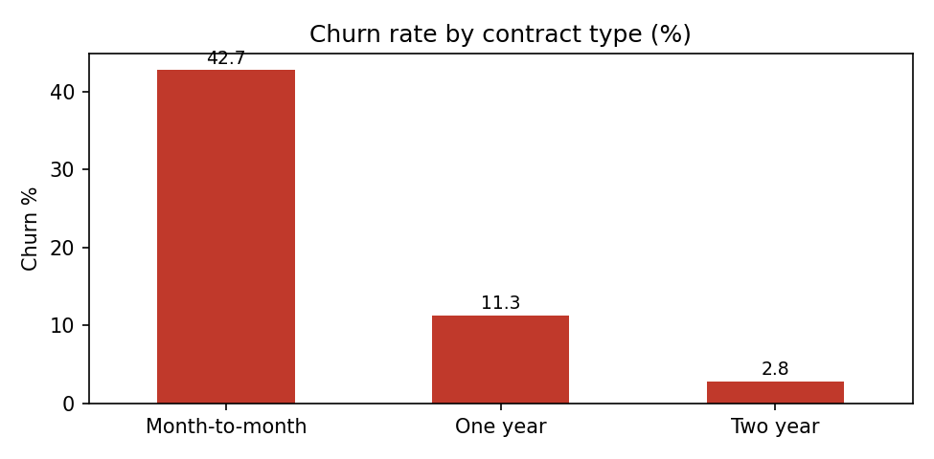
Figure 1: Churn rate by contract type
Month-to-month customers churn at 42.7%, compared with 11.3% for one-year and 2.8% for two-year contracts.

6.2 Early-tenure customers are most at risk
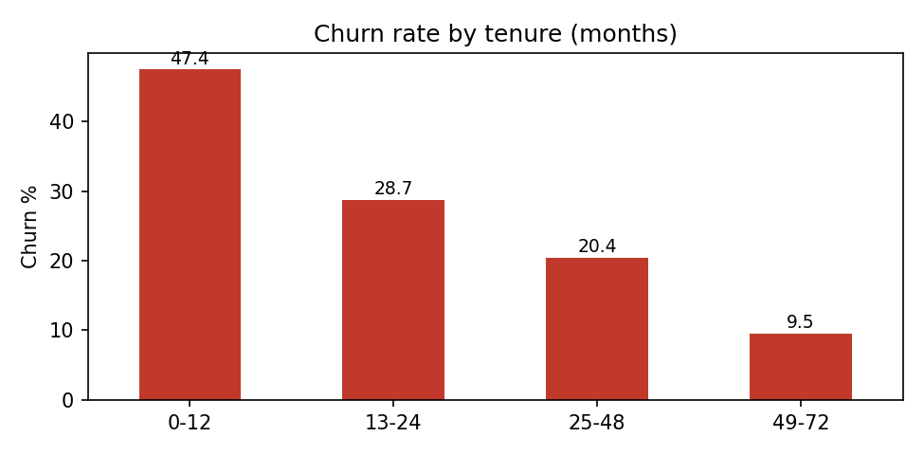
Figure 2: Churn rate by tenure
Customers in their first 12 months churn at 47.4%; churn falls steadily as tenure grows.

6.3 Payment method and service type
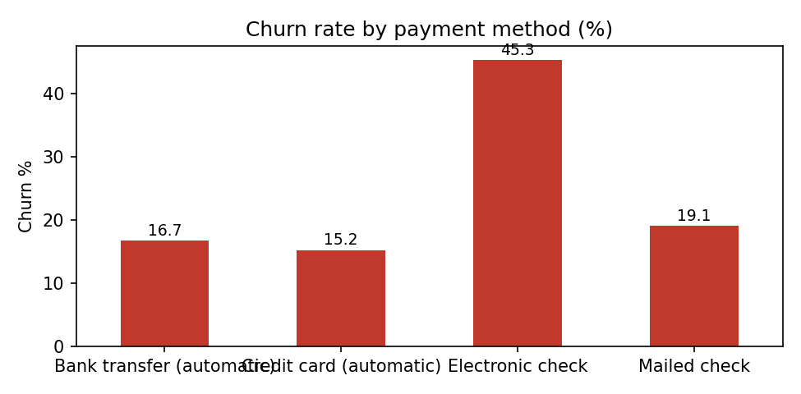
Figure 3: Churn rate by payment method
Electronic-check payers churn at 45.3% versus 15-19% for other methods. Fiber-optic customers churn at 41.9% (DSL 19.0%). Customers without tech support churn at 41.6% versus 15.2% with it.

6.4 Model feature importance
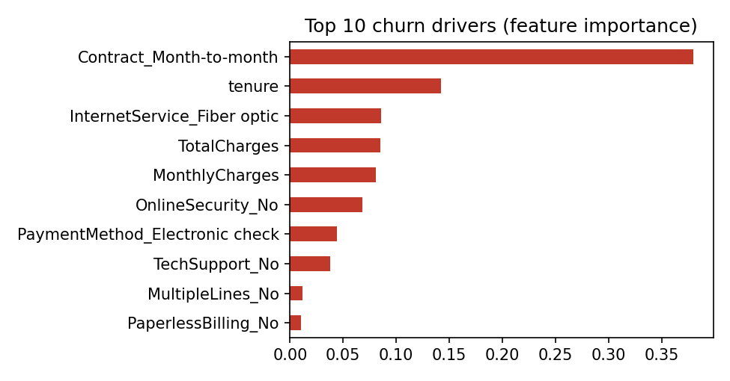
Figure 4: Top 10 churn drivers
Month-to-month contract (0.38) and tenure (0.14) dominate, followed by fiber-optic service, charges, missing online security and electronic-check payment.

7. Risk, Opportunity and Action
Category | Finding
Risk | 424 active customers have a predicted churn probability of 50% or more, putting $33,262 of monthly revenue at risk. 354 of them are high-value (monthly charge above the median).
Opportunity | Electronic-check, fiber-optic and no-tech-support segments show very high churn and can be targeted with auto-pay, bundles and support offers.
Action 1 | Offer a discount for moving month-to-month customers to a 1-year contract.
Action 2 | Run an onboarding and check-in programme for customers in their first 12 months.
Action 3 | Contact the 354 high-value at-risk customers with a retention offer, starting with the top-15 priority list in the dashboard.

8. How to Run
- Install dependencies: pip install -r requirements.txt
- Start the dashboard: streamlit run SnehaTanty_ChurnDashboard.py
- The app loads the dataset automatically (local CSV, or the public mirror of the same data), or accepts an uploaded CSV.

9. Conclusion
The dashboard shows that churn is concentrated among new, month-to-month, electronic-check and fiber-optic customers. A model with 0.84 ROC-AUC identifies active customers likely to leave, letting the business focus retention spend on the highest-value, highest-risk accounts.

10. Future Work
- Add customer lifetime value and expected savings per retention offer.
- Compare additional models and tune the decision threshold for cost-sensitive retention.
- Connect the dashboard to live billing data for automatic weekly scoring.

