**Phase 5: Project Documentation & Submission**

**Earthquake Prediction Using For Python**

**Documentation:**

* **Clearly outline the problem statement, design thinking process, and the phases of development.**

Certainly, here is an outline that incorporates the problem statement, design thinking process, and the phases of development:

**I. Problem Statement**

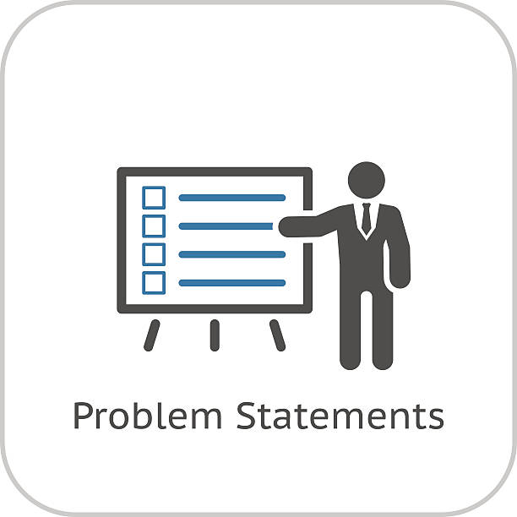

* Introduction:

Contextualize the problem, its relevance, and the stakeholders involved.

* Problem Definition:

Clearly articulate the issue, its impact, and its specific challenges.

* Scope and Boundaries:

The parameters within which the problem statement operates.

* Current State Analysis:

Analyze the existing situation, outlining its shortcomings and implications.

* Desired Outcome:

Define the ideal solution and the expected benefits.

**II. Design Thinking Process**

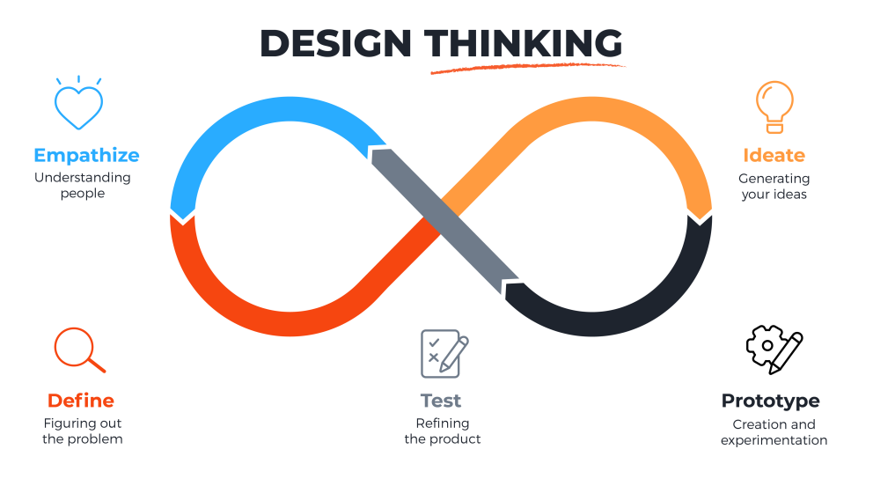

* Empathize:

Understand the problem from the perspective of stakeholders, considering their needs and pain points.

* Define:

Refine the problem statement based on insights gained, focusing on the core issues that need to be addressed.

* Ideate:

Brainstorm potential solutions, encouraging creativity and a diverse range of ideas.

* Prototype:

Develop a tangible representation of the solution to test and gather feedback.

* Test:

Evaluate the prototype to determine its effectiveness, iterating as necessary.

**III. Phases of Development**

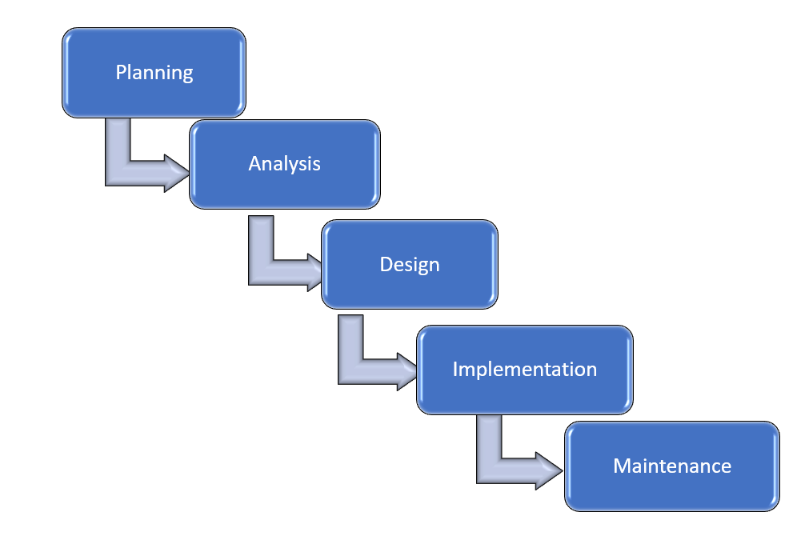

Planning:

Outline the project plan, defining tasks, timelines, and resource requirements.

Analysis:

Conduct a detailed analysis of the problem, the proposed solution, and its potential impact.

Design:

Create a comprehensive blueprint of the solution, incorporating feedback from stakeholders.

Implementation:



Execute the designed solution, adhering to the project plan and addressing any challenges that arise.

Testing and Quality Assurance:

Conduct rigorous testing to ensure the solution functions as intended and meets the desired outcomes.

Deployment:

Roll out the solution to stakeholders, providing necessary support and training.

Evaluation and Iteration:

Assess the effectiveness of the solution, gather feedback, and make necessary adjustments for continuous improvement.

**Documentation**

* **Describe the dataset used, data preprocessing steps, and sentiment analysis techniques.**

To document the dataset, data preprocessing steps, and feature exploration techniques, you will need to follow a systematic approach. Here is a structured outline to help you get started:

**Dataset Description:**

* Describe the source of the dataset, including any data collection methods, if applicable.
* Specify the type of data (e.g., structured, unstructured, time-series, etc.).
* Outline the features or variables present in the dataset.

**Data Preprocessing Steps:**

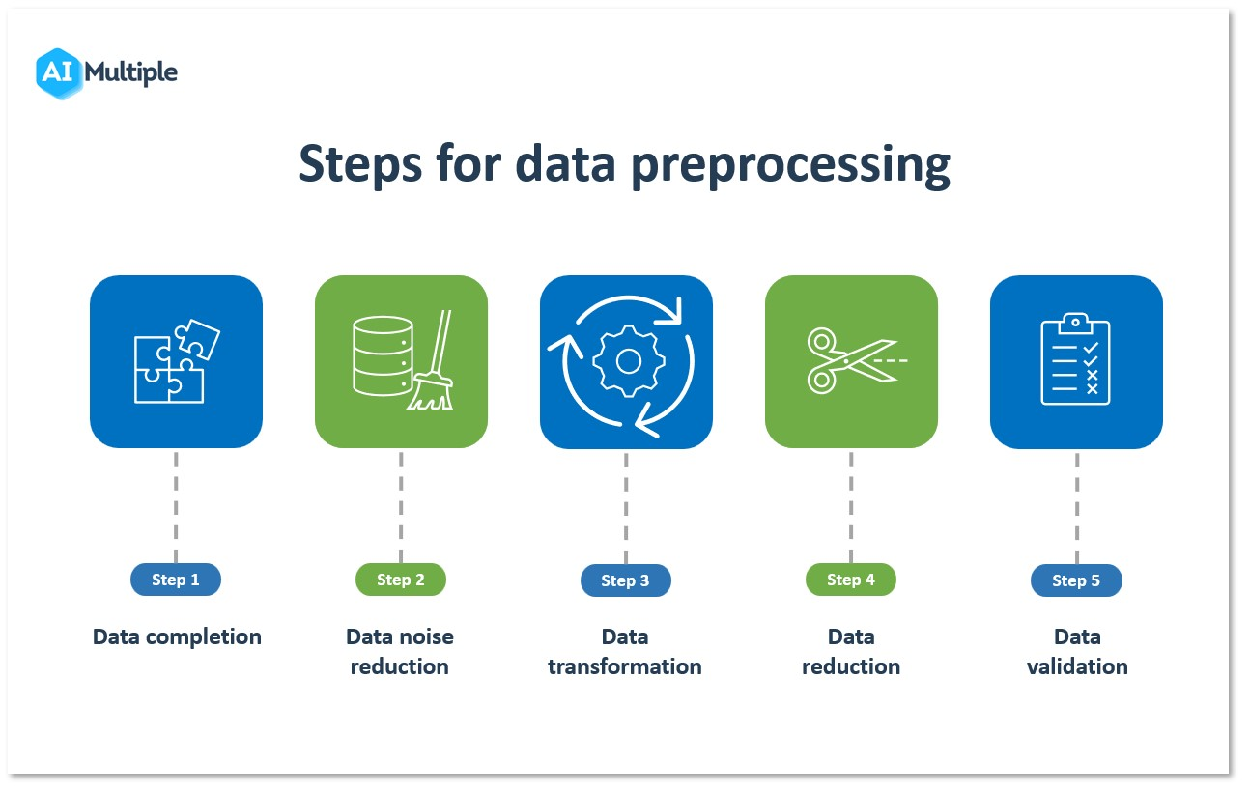

* Explain the steps taken to clean the data, including handling missing values, outliers, or duplicates.
* Detail any data transformations performed, such as scaling, normalization, or encoding categorical variables.

Mention any feature engineering techniques used, like creating new features or aggregating existing ones.

**Feature Exploration Techniques:**

* Discuss the statistical summary of the features, including measures like mean, median, and standard deviation.
* Utilize visualizations like histograms, scatter plots, and box plots to understand the distribution and relationships between different features.
* Conduct correlation analysis to determine the relationships between different variables and their impact on the target variable, if applicable.
* Ensure that each section is well-documented with clear explanations and any relevant code snippets, where applicable. This documentation will serve as a comprehensive guide for others to understand the dataset and the steps taken during the preprocessing and exploration phases.

**Documentation**

* **Document any innovative techniques or approaches used during the development.**

Innovation techniques and approaches can vary depending on the context and industry, but here are some common methods used during the development process:

**Design Thinking:**

Design thinking is a human-centered approach to problem-solving that involves empathizing with end-users, defining the problem, ideating potential solutions, prototyping, and testing to continuously refine and improve products or services.

**Agile Methodology**:

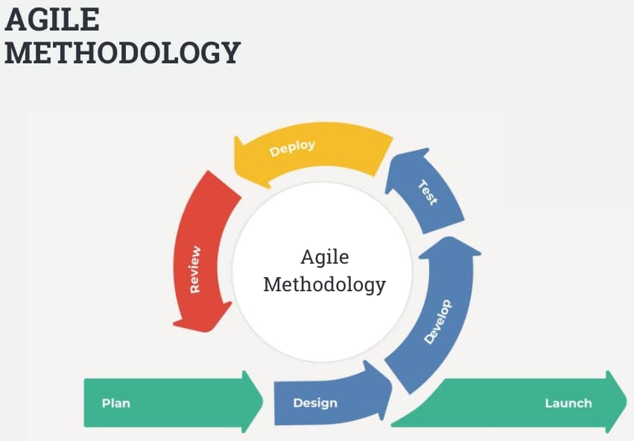

Agile is a project management and product development approach that emphasizes flexibility, collaboration, and incremental development. It involves breaking down the project into small, manageable iterations and adjusting based on feedback.

**Lean Startup:**

The lean startup methodology encourages building a minimum viable product (MVP) to quickly test assumptions, gather customer feedback, and make data-driven decisions to pivot or persevere with a product or service.

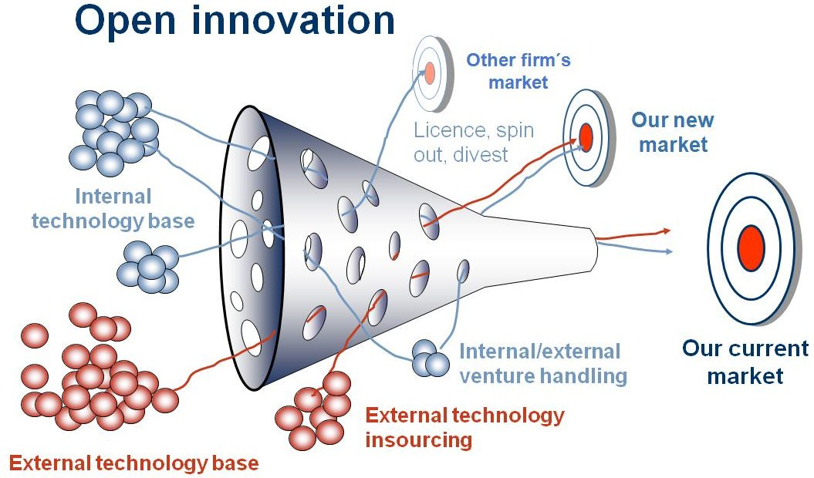

Open innovation involves collaborating with external partners, such as customers, suppliers, or other organizations, to share ideas and resources for the development of new products or solutions.

**TRIZ (Theory of Inventive Problem Solving):**

TRIZ is a problem-solving and innovation technique that uses a systematic approach to identify inventive solutions by leveraging inventive principles and patterns.

**Brainstorming:**

sessions involve gathering a diverse group of individuals to generate creative ideas and solutions for a particular challenge. It encourages free thinking and the exploration of unconventional ideas.

**Rapid Prototyping**:

Rapid prototyping involves creating quick, low-cost prototypes to visualize and test ideas, allowing for rapid iteration and refinement of the product or concept.

**Scrum:**

Scrum is an agile framework for managing complex knowledge work, with a focus on delivering value incrementally through short, time-boxed iterations.

**Six Sigma:**

Six Sigma is a data-driven approach to process improvement and problem-solving that aims to reduce defects and variations in products or services.

**Blue Ocean Strategy**:

Blue Ocean Strategy is a strategic approach that encourages businesses to explore untapped markets by creating new value propositions rather than competing in existing, crowded markets.

**Technology Scouting**:

Technology scouting involves actively seeking out emerging technologies, trends, and innovations in the market to incorporate into product development or improve existing processes.

**Cross-functional Teams**:

Forming cross-functional teams with members from various disciplines and backgrounds can stimulate creative thinking and diverse perspectives during the development process.

**Crowdsourcing**:

Crowdsourcing allows organizations to tap into a global network of contributors or the wisdom of the crowd to gather innovative ideas and solutions.

**Failure Mode and Effects Analysis (FMEA):**

FMEA is a systematic approach to identifying and mitigating potential failure points in a product or process, reducing risks and improving overall quality.

**Customer Feedback and User-Centered Design**:

Gathering and analyzing customer feedback and applying user-centered design principles help ensure that the final product meets the needs and expectations of the end-users.

The choice of technique or approach depends on the specific project, goals, and industry, and often a combination of these **methods is used to foster innovation during development.**

**Submission**

**Compile all the code files, including the data preprocessing, model training, and evaluation steps**.

**Source:**

* Jupyter

import numpy as np

import pandas as pd

import matplotlib.pyplot as plt

import os

print(os.listdir("../input"))

['database.csv']

data.columns

output:

Index(['Date', 'Time', 'Latitude', 'Longitude', 'Type', 'Depth', 'Depth Error',

'Depth Seismic Stations', 'Magnitude', 'Magnitude Type',

'Magnitude Error', 'Magnitude Seismic Stations', 'Azimuthal Gap',

'Horizontal Distance', 'Horizontal Error', 'Root Mean Square', 'ID',

'Source', 'Location Source', 'Magnitude Source', 'Status'],

dtype='object')

import datetime

import time

timestamp = []

for d, t **in** zip(data['Date'], data['Time']):

try:

ts = datetime.datetime.strptime(d+' '+t, '%m/**%d**/%Y %H:%M:%S')

timestamp.append(time.mktime(ts.timetuple()))

except **ValueError**:

*# print('ValueError')*

timestamp.append('ValueError')

timeStamp = pd.Series(timestamp)

data['Timestamp'] = timeStamp.value

**Visualization:**

from mpl_toolkits.basemap import Basemap

m = Basemap(projection='mill',llcrnrlat=-80,urcrnrlat=80, llcrnrlon=-180,urcrnrlon=180,lat_ts=20,resolution='c')

longitudes = data["Longitude"].tolist()

latitudes = data["Latitude"].tolist()

*#m = Basemap(width=12000000,height=9000000,projection='lcc',*

*#resolution=None,lat_1=80.,lat_2=55,lat_0=80,lon_0=-107.)*

x,y = m(longitudes,latitudes)

fig = plt.figure(figsize=(12,10))

plt.title("All affected areas")

m.plot(x, y, "o", markersize = 2, color = 'blue')

m.drawcoastlines()

m.fillcontinents(color='coral',lake_color='aqua')

m.drawmapboundary()

m.drawcountries()

plt.show()

**Splitting:**

X = final_data[['Timestamp', 'Latitude', 'Longitude']]

y = final_data[['Magnitude', 'Depth']]

from sklearn.cross_validation import train_test_split

X_train, X_test, y_train, y_test = train_test_split(X, y, test_size=0.2, random_state=42)

print(X_train.shape, X_test.shape, y_train.shape, X_test.shape)

from sklearn.ensemble import RandomForestRegressor

reg = RandomForestRegressor(random_state=42)

reg.fit(X_train, y_train)

reg.predict(X_test)

output:

array([[ 5.96, 50.97],

[ 5.88, 37.8 ],

[ 5.97, 37.6 ],

...,

[ 6.42, 19.9 ],

[ 5.73, 591.55],

[ 5.68, 33.61]])

reg.score(X_test, y_test)

output:

0.8614799631765803

from sklearn.model_selection import GridSearchCV

parameters = {'n_estimators':[10, 20, 50, 100, 200, 500]}

grid_obj = GridSearchCV(reg, parameters)

grid_fit = grid_obj.fit(X_train, y_train)

best_fit = grid_fit.best_estimator_

best_fit.predict(X_test)

output:

array([[ 5.8888 , 43.532 ],

[ 5.8232 , 31.71656],

[ 6.0034 , 39.3312 ],

...,

[ 6.3066 , 23.9292 ],

[ 5.9138 , 592.151 ],

[ 5.7866 , 38.9384 ]])

best_fit.score(X_test, y_test)

Output:

0.8749008584467053

from keras.models import Sequential

from keras.layers import Dense

def create_model(neurons, activation, optimizer, loss):

model = Sequential()

model.add(Dense(neurons, activation=activation, input_shape=(3,)))

model.add(Dense(neurons, activation=activation))

model.add(Dense(2, activation='softmax'))

model.compile(optimizer=optimizer, loss=loss, metrics=['accuracy'])

return model

from keras.wrappers.scikit_learn import KerasClassifier

model = KerasClassifier(build_fn=create_model, verbose=0)

*# neurons = [16, 64, 128, 256]*

neurons = [16]

*# batch_size = [10, 20, 50, 100]*

batch_size = [10]

epochs = [10]

*# activation = ['relu', 'tanh', 'sigmoid', 'hard_sigmoid', 'linear', 'exponential']*

activation = ['sigmoid', 'relu']

*# optimizer = ['SGD', 'RMSprop', 'Adagrad', 'Adadelta', 'Adam', 'Adamax', 'Nadam']*

optimizer = ['SGD', 'Adadelta']

loss = ['squared_hinge']

param_grid = dict(neurons=neurons, batch_size=batch_size, epochs=epochs, activation=activation, optimizer=optimizer, loss=loss)

grid = GridSearchCV(estimator=model, param_grid=param_grid, n_jobs=-1)

grid_result = grid.fit(X_train, y_train)

print("Best: **%f** using **%s**" % (grid_result.best_score_, grid_result.best_params_))

means = grid_result.cv_results_['mean_test_score']

stds = grid_result.cv_results_['std_test_score']

params = grid_result.cv_results_['params']

for mean, stdev, param **in** zip(means, stds, params):

print("**%f** (**%f**) with: **%r**" % (mean, stdev, param))

model = Sequential()

model.add(Dense(16, activation='relu', input_shape=(3,)))

model.add(Dense(16, activation='relu'))

model.add(Dense(2, activation='softmax'))

model.compile(optimizer='SGD', loss='squared_hinge', metrics=['accuracy'])

model.fit(X_train, y_train, batch_size=10, epochs=20, verbose=1, validation_data=(X_test, y_test))

output:

<keras.callbacks.History at 0x78dfa2107ef0>

[test_loss, test_acc] = model.evaluate(X_test, y_test)

print("Evaluation result on Test Data : Loss = **{}**, accuracy = **{}**".format(test_loss, test_acc))

model.save('earthquake.h5')

Definition:

Certainly, I can provide a high-level overview of the typical steps involved in a machine learning project, including data processing, model training, and evaluation. However, I cannot provide specific code files as the code for such a project can be extensive and highly dependent on the programming language, libraries, and the nature of the data and problem. I can, however, provide a simplified outline of these steps.

**Data Processing:**

Import necessary libraries (e.g., numpy, pandas, scikit-learn).

Load and preprocess the dataset.

Handle missing data (e.g., by imputing or removing rows/columns).

Perform data cleaning (e.g., removing outliers).

Encode categorical variables (e.g., one-hot encoding).

Split the data into training and testing sets.

**Model Training:**

Choose an appropriate machine learning algorithm (e.g., RandomForest, SVM, Neural Networks).

Create and train the model on the training data.

Tune hyperparameters for optimal performance.

from sklearn.ensemble import RandomForestClassifier

Evaluate the model on the test data to assess its performance.

Visualize and analyze the results.

**Further Steps:**

Depending on the results, you might need to iterate through these steps, adjust the model, or collect more data.

Save the trained model for future predictions.

Remember that real-world machine learning projects can be more complex, and code can span multiple files and directories. Additionally, specific data preprocessing, model selection, and hyperparameter tuning will depend on the problem you're addressing. It's also common to use machine learning frameworks and tools like TensorFlow, PyTorch, and scikit-learn to streamline these processes.