1) IP address of Raspberry pi is 10.60.62.29

2) Credentials:
Log in : pi
password : raspberry

3) Location of server.py file : /home/pi/sneha/

4) Running :
python server.py

5) Feautures of server.py :
Whenever request(http post) comes from backened of the Ateye, gpio related function will call and blink the leds connected to pin 23 for Entry and pin 24 for Exit. Right now we are using only one led i.e., connected to 23 pin.

6) Wire connections :
GPIO 23 for Entry (pin 16 on board)
GPIO 24 for Exit ( pin 18 on board)

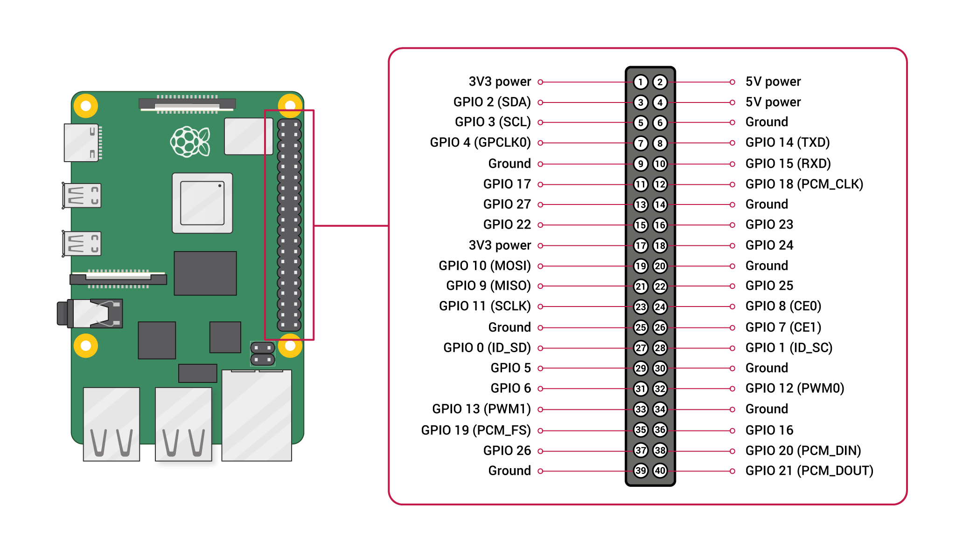
Resistor value : 330 Ω (If there are four colour bands, they will be Orange, Orange, Brown, and then Gold ,If there are five bands, then the colours will be Orange, Orange, Black, Black, Brown.)

We have used pin 14 on board as Ground and connected the led to pins of pi as following:

Ground (pin 14 ) – Resistor(330Ω ) – short leg (cathode) of led
GPIO 23(pin 16) – long leg (anode) of led

