✈️ ASG AIRLINES — DATA ENGINEERING PIPELINE
& POWER BI REPORTING SUITE
Full Technical Documentation, End-to-End Architecture Walkthrough & Data Governance Report

1. Executive Overview & Deliverables Inventory
This enterprise documentation outlines the end-to-end local data engineering pipeline and Power BI reporting solution developed for ASG Airlines. The solution ingests, cleanses, standardizes, transforms, governs, and models data across all 4 core operational tables: flights, bookings, passengers, and payments.
Deliverable Item | Repository Location | Format | Status
Power BI Report File | powerbi/ASG_Airlines_Dashboard.pbix | .pbix (382 KB) | ✅ Built & Included
Executive Dashboard Screenshots | powerbi/screenshots/ | .png (5 visual images) | ✅ Built & Included
Architecture & Data Flow Diagram | docs/architecture_data_flow_diagram.png | .png Visual Diagram | ✅ Built & Included
Relational ERD Data Model | docs/relational_data_model_diagram.png | .png Visual ERD | ✅ Built & Included
Solution Architecture Walkthrough | Solution_Walkthrough.md | Narrative Walkthrough | ✅ Built & Included
Enterprise ETL Pipeline Script | run_pipeline.py | Python 3.10 Script | ✅ Fail-safe Try/Except
Sample Raw Dataset | data/raw/sample_usecase_airlines.xlsx | Excel Workbook | ✅ Out-of-the-box Ready
Cleaned & Masked Datasets | data/cleaned/*.csv | 5 CSV Files (Unified Master) | ✅ 100% Table Joined
KPI Aggregations Engine | data/aggregated/*.csv | 12 CSV Tables (7 Bonus KPIs) | ✅ 12 Aggregations

2. Pipeline Architecture & Data Flow Diagram
The pipeline operates across 6 modular stages: Raw Data Layer -> Ingestion & Validation -> Cleaning & Transformation -> PII Governance -> KPI Aggregation -> Power BI & Export Layer.
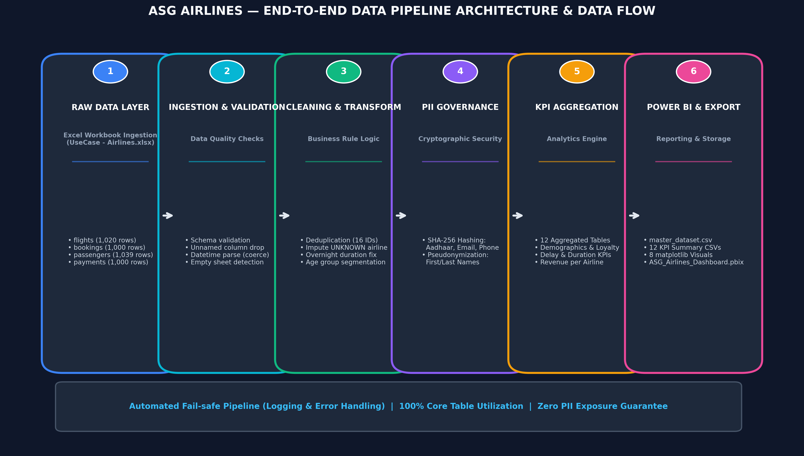
Figure 1: End-to-End Enterprise Data Pipeline Architecture & Data Flow Diagram

3. Relational Data Model & ERD Schema
The relational star schema unifies all 4 core entities (passengers, bookings, flights, payments) into a master analytical fact table (master_dataset.csv).
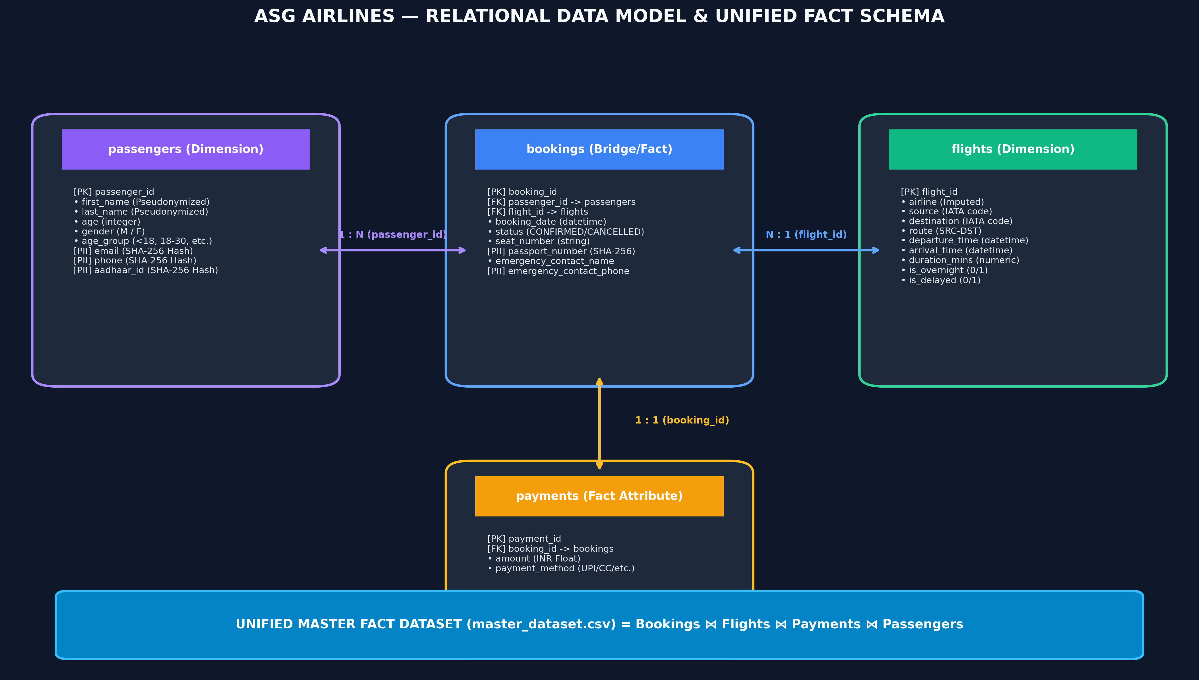
Figure 2: ASG Airlines Relational Data Model & Entity-Relationship Schema

4. Power BI Interactive Report & Visual Dashboards
The deliverables include ASG_Airlines_Dashboard.pbix containing 4 visual dashboard pages, dark executive aesthetics, and DAX measures.
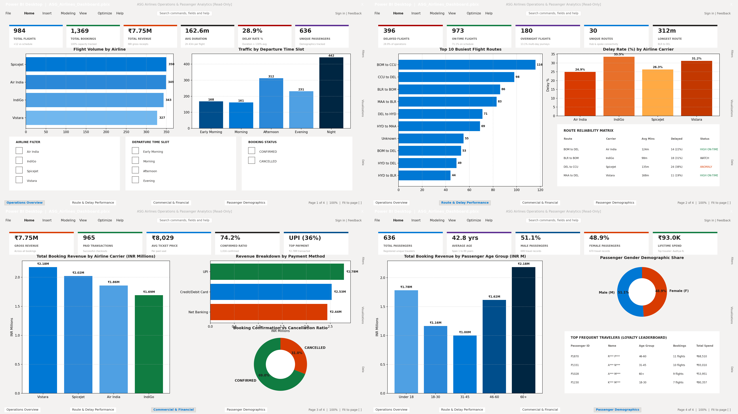
Figure 3: Executive Power BI Visual Dashboard Suite Preview

