SRGG MARKETPLACE PLATFORM
“Building a Quantified, Insured, Hedged, and Tokenized Sustainable Society.”
SRGG Marketplace Platform – The New Digital Infrastructure for Emerging Economies
The SRGG Marketplace Platform is a next-generation, multi-sectoral exchange ecosystem designed to monitor, quantify, insure, tokenize, hedge, and monetize the core value chains that drive Africa and LATAM.
It bridges traditional commodities, cultural capital, and human equity into a unified, auditable, blockchain-based marketplace backed by global financial standards.
SRGG functions as the “Market Maker”—not only facilitating trade but shaping, smoothing, and securing the marketplace itself.
This is done through proprietary methodologies that quantify every layer of the ecosystem—from land productivity to cultural capital—making value visible, transferable, bankable, and globally tradable.

The “Market Maker Methodology” – SRGG’s Core Engine
SRGG’s Market Maker approach integrates three core principles:

A. MONITOR
Real-time tracking of commodities and human-centered datasets across:
- Agriculture (crop yield, soil health, supply volumes)
- Livestock (traceability, health, production rates)
- Natural Resources & Minerals
- Carbon Credits & Environments
- Culture & Human Equity Metrics
- Logistics & Port Movement
- SME productivity
- Village-to-city trade flow
All data is collected through IoT sensors, digital registries, farmer mobile inputs, satellite imagery, and blockchain oracles.

B. QUANTIFY
SRGG converts monitored data into measurable economic value:
- Crop productivity = commodity token
- Livestock health = yield futures
- Culture & human equity = social capital index
- Carbon sequestration = carbon tokens
- Mineral extraction = verified, risk-rated assets
- Logistics movement = supply chain health score
SRGG creates a digital footprint of society—a measurable, monetizable layer that gives structure to historically informal economic sectors.

C. MONETIZE
Once quantified, SRGG enables:
- Marketplace trading
- DeFi-style credit systems
- Futures / hedging
- Insurance underwriting (via Lloyd’s matrix)
- Tokenized reserves
- Impact investment deployment
- SRGG Hedge Fund leveraged positions
- Global export brokerage through SRGG exchanges
SRGG becomes the infrastructure where villages become markets, markets become exchanges, and exchanges become global gateways.

Agri-Blockchain Integration

SRGG’s backbone is the AgriBlockchain Framework—a transparent ledger that records every activity from seed to export container.

Core Capabilities
- Farm-to-port traceability
- Seed to Harvest traceability
- Land/parcel registration
- Crop & livestock digital passports
- Verified yield reporting
- Mineral origin verification
- Cultural IP rights tokenization
- Royalty systems for producers
- Smart contracts for supply chains
- Non-tamperable audit trails

Why This Matters
Africa & LATAM lose billions annually due to:
- middlemen opacity
- price manipulation
- undocumented production
- certification fraud
- data-free export processes
SRGG’s blockchain eliminates this by creating:
- Verified producers
- Verified commodities
- Verified movement
- Verified sustainability metrics
This opens the door to global buyers, premium pricing, insurance protection, and investment capital.
Lloyd’s of London Integration (Matrix, Risk, and Insurance Security)
SRGG integrates a Lloyd’s-aligned Risk & Insurance Matrix that creates unprecedented protection for emerging-market producers.

The Insurance Framework Includes:
- Parametric crop insurance
- Livestock mortality insurance
- Shipping & maritime insurance
- Mineral extraction & movement insurance
- Supply chain delay coverage
- Cultural heritage & IP insurance
- Carbon credit authenticity insurance
- Infrastructure resilience insurance
- Seeds Banks Id Insurance
This ensures that every SRGG-validated commodity is certified, insured, and bankable.
Lloyd's integration turns SRGG into the trust layer for global buyers and investment funds.

Chicago Commodities Exchange (CME) Integration

Africa & LATAM’s Pathway to Become Commodity Export Hubs
SRGG acts as the intermediary bridge between:
- Local producers
- National governments
- International commodities markets

SRGG Exchange & Brokerage Role
SRGG positions itself as:
- The African–LATAM Commodity Broker
- The pre-CME aggregator & certifier
- The origin validation platform
- The risk-rated exporter
Once SRGG assets are tracked, insured, and quantified, they can be structured for:
- CME Futures contracts
- Options & hedging
- International spot trading
SRGG becomes the gateway where local commodities enter global financial markets.

SRGG Hedge Fund Integration (Hedging + Platform Proforma)
The SRGG Hedge Fund becomes the strategic financial arm of the ecosystem.

Hedge Fund Functions:
- Provide liquidity for SRGG Marketplace
- Hedge producer risk using CME futures
- Tokenize baskets of commodities
- Buy distressed assets and rehabilitate value chains
- Leverage carbon credits as collateral
- Create structured products backed by SRGG data
- Reduce volatility for producers
- Stabilize Africa–LATAM export earnings

Platform Proforma:
Revenue streams include:
- Trading fees
- Brokerage fees
- Insurance premiums
- Hedging spreads
- Data licensing
- Carbon credit tokenization
- Export certification markup
- Private-label investment vehicles
SRGG becomes a financial stabilizer, not just a marketplace.

Futures Integration (Hedging Theory + Emerging Market Application)
SRGG brings Futures trading to regions where producers historically take all the risk.

Purpose of SRGG Futures Market:
- Lock prices for farmers
- Reduce shocks from global volatility
- Secure export quotas
- Align supply chain forecasting
- Back loans with guaranteed forward sales

Hedging Theory—Simplified:
A future = a promise to sell or buy later at a fixed price.
This stabilizes:
- farmers
- exporters
- governments
- buyers
- financial institutions
SRGG becomes the regional futures clearinghouse, enabling predictable income and coordinated supply.

Quantum AI Intelligence Integration

“Balancing the Marketplace – Quantifying a Sustainable Society”
SRGG integrates Quantum AI as the decision-making brain of the ecosystem.

Quantum AI Capabilities:
- Predictive modeling of crop yields
- Real-time risk scoring (weather, geopolitics, disease, logistics)
- Dynamic pricing engine
- AI-based carbon credit verification
- Social impact measurement
- Commodity movement forecasting
- Supply chain “stress testing”
- Insurance premium optimization
- Futures position balancing
- Hedging recommendation engine
Quantum AI allows SRGG to self-balance the entire Marketplace:
matching supply, demand, timing, insurance, transportation, volatility, and pricing.
This transforms SRGG into a quantum-optimized sustainable economic matrix.
Africa–LATAM Gateways

MVP Pilots: Dominican Republic & Ghana
SRGG begins with two strategic entry points:

A. Dominican Republic (Caribbean Gateway to South America)
- Agro-export hub
- Strong logistics routes
- Access to Panama Canal corridor
- Bridge to Colombia, Venezuela, and Brazil
- Cultural IP block (music, arts, heritage)
- Carbon credit expansion via coastal & forest regeneration
DR becomes SRGG’s Caribbean–LATAM Data & Exchange Node.

B. Ghana (West African Gateway)
- Entry to ECOWAS (400+ million population)
- Strong agriculture footprint (cocoa, maize, cassava, horticulture)
- Gold & mineral anchored commodities
- Culture & anthropology capital (Kente, Adinkra, festivals)
- High carbon credit potential (forestry, mangroves)
- Port of Tema = major export gateway
Ghana becomes SRGG’s Africa Ground-Truthing & Export Certification Node.

Quantifying Trades Through Gateway Ports & Supply Chains
SRGG integrates ports directly into the blockchain matrix.

Port Quantification Includes:
- Container-level traceability
- Ship movement tracking
- Customs verification
- Insurance scoring
- Export–import timing
- Gate-to-gate transparency
- Demurrage risk tracking
- Routing optimization
- Carbon impact scoring
This allows SRGG to manage and quantify:
- trade volumes
- supply chain health
- country-level export performance
- risk & insurance pools
- futures contract reliability
SRGG becomes the digital nervous system of ports, connecting small farmers and producers to global supply chains.

SRGG Marketplace Platform — One Sentence Summary
SRGG is a quantified, insured, hedged, AI-optimized, blockchain marketplace that turns Africa & LATAM’s informal economies into global, tradable, data-backed assets.

SRGG Marketplace Whitepaper
Overview
SRGG Marketplace is a revolutionary platform that integrates blockchain technology, artificial intelligence, and commodities trading to create a robust ecosystem for stakeholders in agriculture, finance, and resource management. Our platform aims to digitize and tokenize agricultural commodities, mines, and minerals, providing real-time data analysis and quantification of value.

Key Features:
- Agri-Blockchain Leveraging blockchain technology to increase transparency, efficiency, and trust in agricultural trade and commodity markets

- Marketplace Platform,
A comprehensive platform for buying, selling, and trading digital assets, including tokenized commodities and resources
- Hedge Funds Providing investment opportunities in agriculture, commodities, and resources through hedge funds and tokenized assets

- Quantum AI Utilizing artificial intelligence and machine learning to analyze market trends, predict prices, and optimize trading strategies

- Real-World Assets (RWA):Tokenizing real-world assets, such as gold reserves, farmland, and commodity contracts, to create tradable digital instruments

- Currency Hedging
Offering currency hedging solutions to mitigate risks associated with market volatility

- Governance Implementing a governance model that ensures transparency, accountability, and community engagement through our Governance Syndicate Token

- Tokenization
Tokenizing assets and commodities to enable fractional ownership, increase liquidity, and facilitate global trading

- Global Market Integration
Integrating with global markets, including the Chicago Commodities Exchange and Lloyds of London insurance, to provide a comprehensive trading experience

- Smart Agri-City Digital Footprint Creating a digital footprint for smart agriculture and cities, enabling real-time data analysis and monitoring

Benefits:

- Increased Efficiency
Streamlining trading processes and reducing counterparty risk through blockchain technology

- Improved Transparency Providing real-time data analysis and quantification of value for commodities and resources

- Increased Liquidity
Enabling fractional ownership and global trading of tokenized assets

- Risk Management Offering currency hedging solutions and insurance integration to mitigate risks associated with market volatility

Tokenomics

- Governance Syndicate Token A token designed for community engagement, governance, and decision-making

- Trading Token: A token used for trading and transactions on the platform

- Stable Token: A stablecoin pegged to a fiat currency, providing stability and predictability in transactions

Target Markets

Developing Countries Focusing on Africa, Caribbean, and South America to digitalize agriculture, mines, and minerals, and provide access to global markets

Agricultural Commodities: Providing solutions for agricultural trade, commodity markets, and resource management

Financial Institutions: Partnering with financial institutions to provide investment opportunities and trading solutions

Roadmap

Q1: Develop and launch the SRGG Marketplace platform

Q2: Integrate with global markets, including the Chicago Commodities Exchange and Lloyds of London insurance

Q3: Expand tokenization offerings to include more assets and commodities

Q4: Launch Governance Syndicate Token and implement community governance model

SRGG Marketplace Platform is poised to revolutionize the way commodities and resources are traded, providing a robust ecosystem for stakeholders in agriculture, finance, and resource management. With its innovative approach to tokenization, artificial intelligence, and blockchain technology, SRGG Marketplace is set to become a leader in the digital asset trading space.

SRGG Marketplace Whitepaper

1. Executive Summary
- Brief one-page overview of the platform, its purpose, and its unique value proposition.
- Highlight the problem and the solution.

2. Introduction & Problem Statement
- Current challenges in agriculture, commodities, and resource trading.
- Issues with transparency, inefficiency, and liquidity.
- Why blockchain + AI + tokenization is needed.

3. SRGG Marketplace Overview
- Platform Vision: revolutionizing commodities & resources.
- Mission: digitizing and tokenizing agriculture, mines, and minerals.
- Ecosystem Snapshot: (visual diagram recommended).

4. Key Features
Organize into thematic clusters for clarity:
- Blockchain & Tokenization (Agri-Blockchain, RWA, fractional ownership).
- AI & Analytics (Quantum AI, market prediction, data analysis).
- Marketplace Infrastructure (trading, hedging, liquidity).
- Governance & Community (Governance Syndicate Token, governance model).
- Global Integration (Chicago Commodities Exchange, Lloyd’s insurance).
- Smart Agri-City Footprint (digital twin of agriculture & cities).

5. Benefits & Value Proposition
- Efficiency, transparency, liquidity, and risk management.
- Case examples or potential scenarios (e.g., African agriculture, gold reserves).

6. Tokenomics
- Governance Syndicate Token: role, voting, community.
- Trading Token: utility, exchange medium.
- Stable Token: peg mechanism, stability assurance.
Token distribution (supply, allocation, vesting).
(Consider adding visuals like pie charts for token allocation.)

7. Target Markets
- Developing countries (Africa, Caribbean, South America).
- Agricultural commodities & global trade.
- Financial institutions and hedge funds.

8. Roadmap
- Quarterly goals (expand beyond Q1–Q4 with future vision: Year 2–3 milestones).
- Include timeline graphics for clarity.

9. Governance & Compliance
- Governance Syndicate structure.
- Legal, regulatory, and insurance integrations.
- Transparency and accountability measures.

10. Conclusion
- Re-emphasize mission, innovation, and transformative impact.
- Call to action for investors, partners, and stakeholders.

Appendices (Optional)
- Technical Architecture.
- Operational Flow (ecosystem diagrams).
- Risk management framework.
- Glossary of terms.

1) Technical Architecture
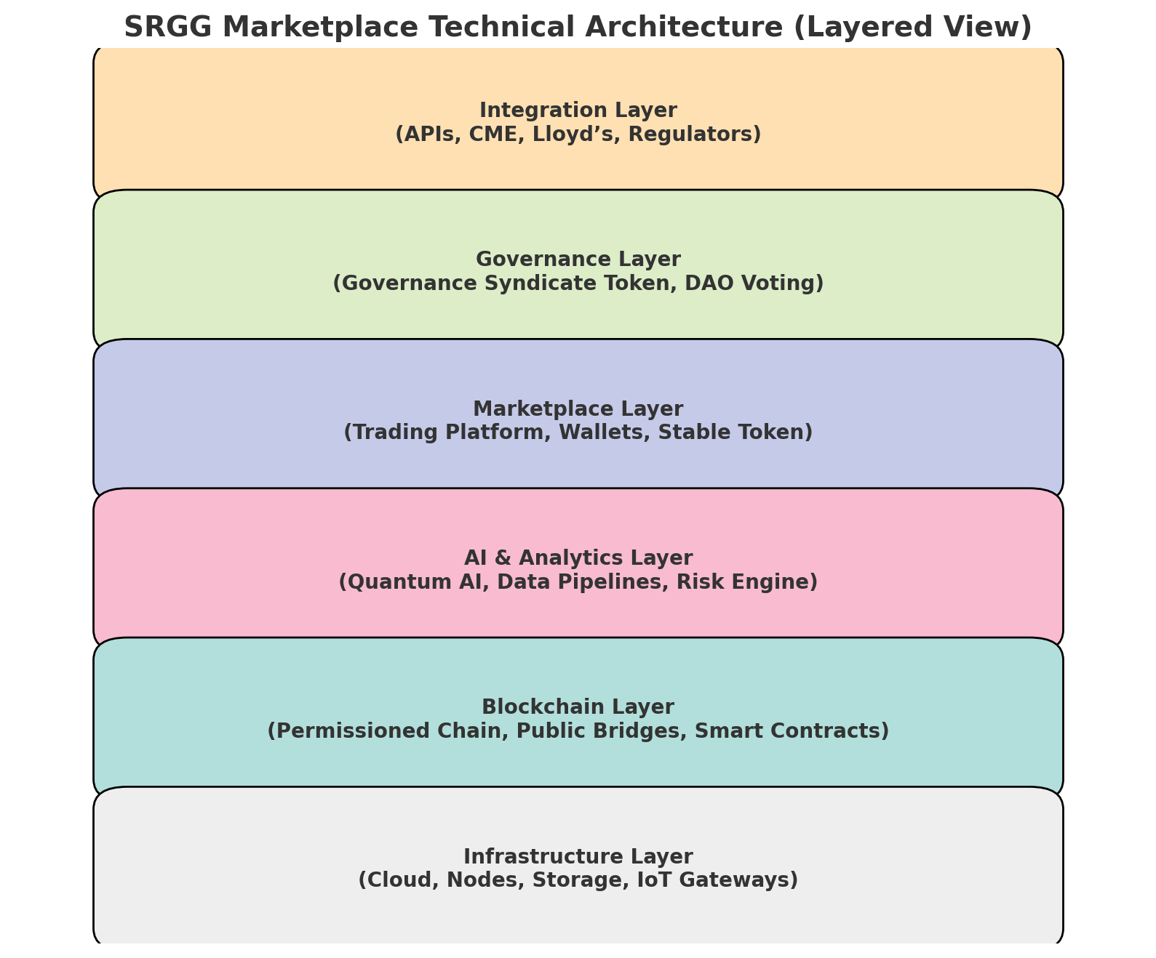
At the core, SRGG Marketplace runs on a multi-layered architecture:
a. Blockchain Layer
- Permissioned blockchain for agricultural/commodity trade records (ensuring scalability and privacy).
- Public chain bridges for token issuance, cross-chain swaps, and global interoperability.
- Smart contracts governing tokenization, fractional ownership, hedge fund structures, and governance voting.
b. AI/Analytics Layer
- Quantum AI Engine: Runs predictive models (machine learning + time-series forecasting).
- Data ingestion pipelines: Real-time feeds from IoT (sensors in farms/mines), global commodities exchanges, weather APIs, and financial data streams.
- Risk engine: Identifies volatility triggers and suggests hedging strategies.
c. Marketplace Layer
- Trading platform (DEX + CEX hybrid): Peer-to-peer exchange powered by smart contracts, but with institutional-level custodianship integration.
- Token custody/wallets: Multi-sig wallets, hardware wallet support, and custodial services for institutions.
- Stable Token integration for predictable settlement.
d. Governance Layer
- Governance Syndicate Token: Token-holders vote on proposals, roadmap milestones, and treasury allocations.
- DAO-like system with tiered voting power (weighted by staking/holding).
e. Integration Layer
- APIs for financial institutions, insurers (Lloyd’s of London), and exchanges (Chicago Mercantile Exchange).
- IoT gateways to digitize crops, soil data, and mineral reserves into blockchain entries.

2) Operational Flow (Ecosystem Diagrams – textual description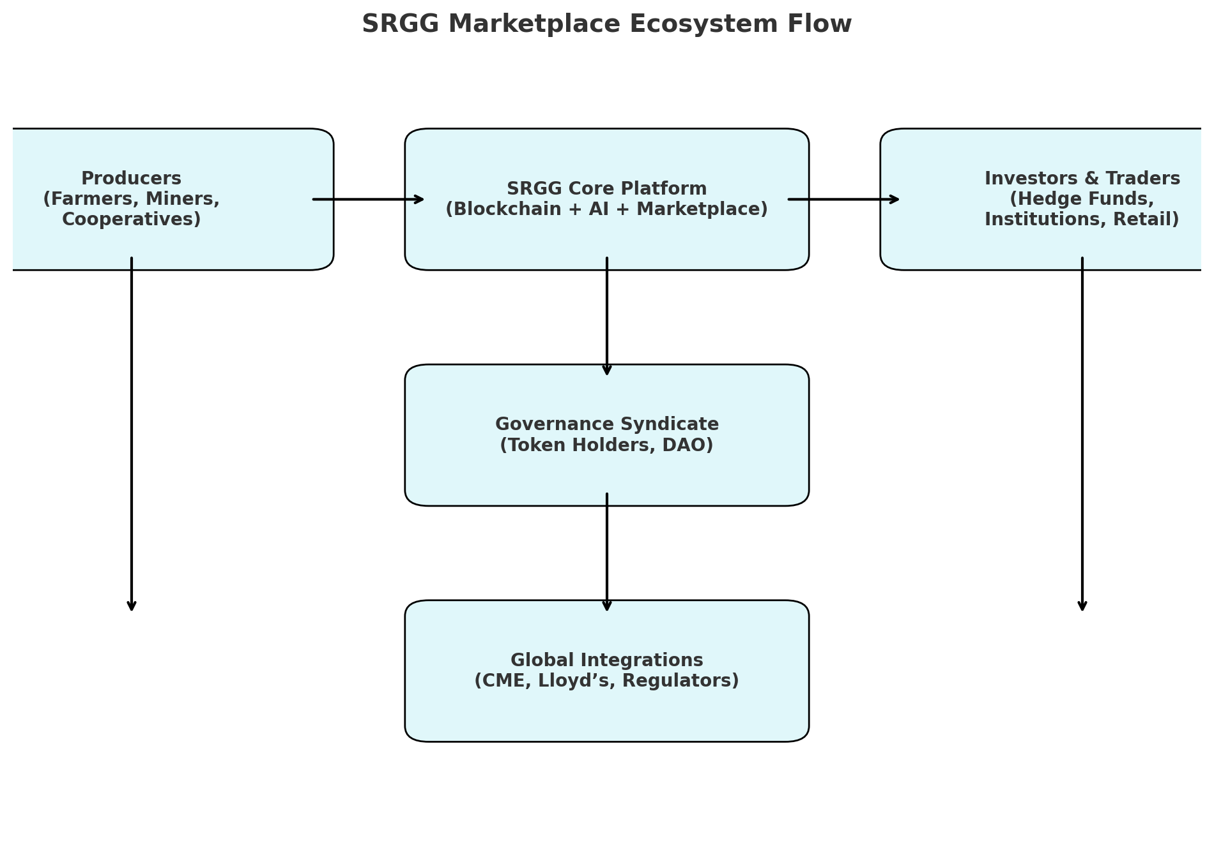
Imagine the ecosystem like a hub-and-spoke model:
- Producers (farmers, miners, cooperatives)
→ upload production data via IoT devices / mobile apps
→ assets tokenized (Agri-Token, Mineral-Token, RWA Token).
- SRGG Marketplace Core
  - Token issuance smart contracts.
  - Quantum AI forecasts prices.
  - Hedge funds & institutional investors plug into data feeds.
- Investors & Traders
  - Buy/sell tokenized assets.
  - Use Trading Token as medium of exchange.
  - Use Stable Token for settlement.
  - Hedge risk with derivatives and currency-hedging contracts.
- Governance Syndicate
  - Token-holders propose changes.
  - Votes executed via smart contracts.
  - Treasury disbursements tracked transparently.
- Global Integrations
  - CME (price benchmarking).
  - Lloyd’s (insurance wrappers for contracts).
  - Local governments/regulators (compliance layer).

3) Risk Management Framework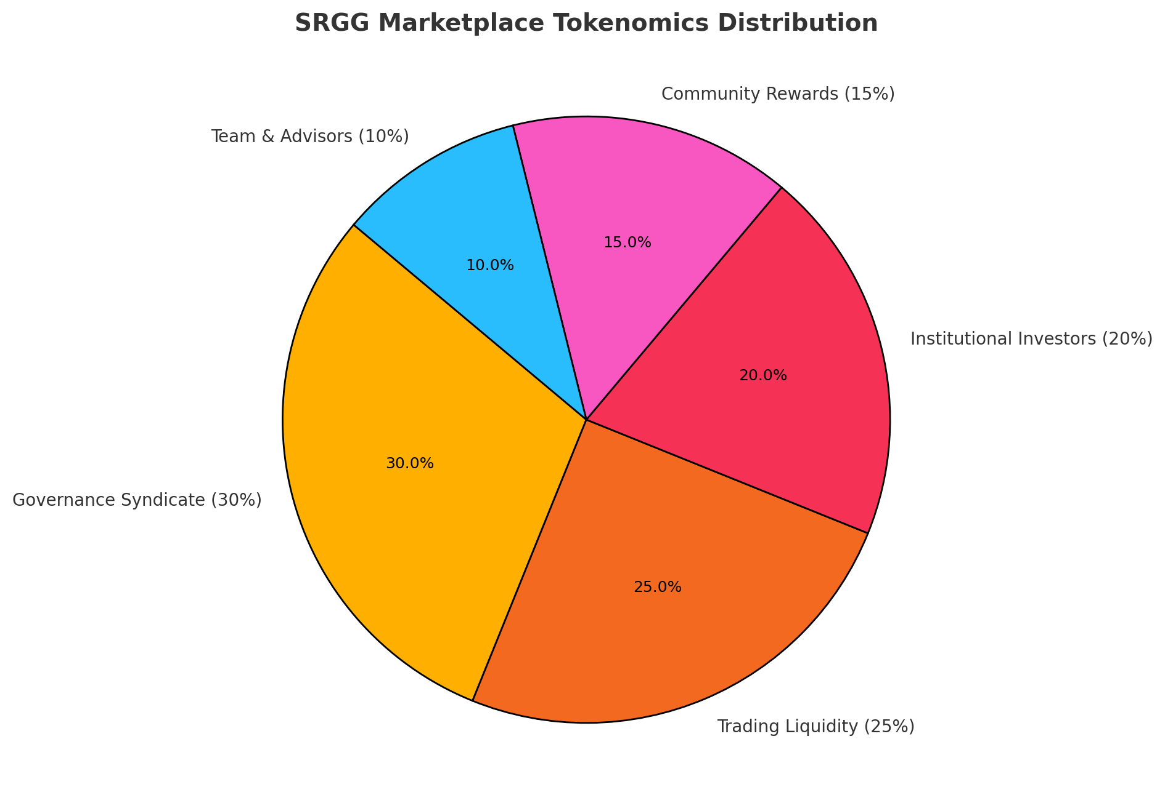
Market Risks
- Volatility controls: AI-driven alerts on commodity shocks (e.g., drought, political unrest).
- Stable Token ensures predictable settlements.
- Automated hedging: Smart contracts initiate currency or commodity hedges.
Operational Risks
- Multi-sig wallets and institutional custodianship to reduce fraud.
- Regular audits of smart contracts.
- Redundant nodes across regions to prevent downtime.
Regulatory/Compliance Risks
- Governance Syndicate to vote on compliance updates.
- Partnerships with legal firms to monitor changing global regulations.
- Built-in KYC/AML protocols for institutional users.
Cybersecurity Risks
- Layered security: TLS encryption, AI-driven anomaly detection, penetration testing.
- Insurance (via Lloyd’s partners) against theft or smart contract exploits.
Environmental & Data Integrity Risks
- IoT devices subject to tampering → solution: blockchain-signed sensor data.
- Cross-verification of satellite imagery with on-ground IoT data.

SRGG MARKETPLACE PLATFORM — FULL SYSTEM ARCHITECTURE

(Structured for developers, identical to your format, but mapped to SRGG’s ecosystem)

A. Core Platform & Admin

Multi-Branch / Multi-Entity Support
- Multi-country / multi-region SRGG hubs (Africa, LATAM, Caribbean)
- Multiple marketplace nodes:
  - Agriculture hubs
  - Livestock hubs
  - Mineral/resource validation centers
  - Cultural-IP registries
  - Carbon-credit verification zones
  - Port / logistics gateways
- Centralized vs. market-node–specific configurations
- Cross-node commodity lookup (farmer → exporter → port → global buyer)

Master Data Management
Core entities include:
- Producer profiles (farmer, miner, artisan, SME)
- Land parcels, geolocation identifiers
- Commodity categories:
  - Crops, livestock, minerals, forestry, fishery
  - Carbon sequestration assets
  - Cultural heritage & human equity assets
- Tariffs, commodity rates, export duties
- Item masters:
  - Seeds, inputs, feed, tools, assets, containers
- Global Commodity Code Sets
  - HS Codes, ISO Commodity Codes
  - Blockchain Asset IDs
  - Carbon credit classification
  - Cultural IP classification

User Management & Roles
- Role-based access control (RBAC)
- Permissions by module, market pathway, region
- Access by department:
  - Agriculture
  - Livestock
  - Export
  - Blockchain validation
  - Port authority
  - Insurance underwriting
  - Hedging desk
  - SRGG Hedge Fund
- Maker-checker workflows (approvals for commodity listings, tokenization, insurance, etc.)

Audit & Security
- Blockchain-backed audit logs
- Who validated what, where, timestamp
- IP-based restrictions for sensitive modules
- Session management and forced logout
- Encryption at rest (commodity data) & in transit (API, blockchain, insurer data)

Localization & Config
- Local currencies (KES, GHS, USD, DOP, COP, CNY, BTC/crypto)
- Tax rules, duty rules
- Timezones, languages (EN, FR, ES, PT, SW)
- Custom fields for cultural, ecological, indigenous metrics

B. Producer / Trader Front Office

1. Registration & Economic Identity
- Unique SRGG Economic ID (blockchain-backed)
- Multi-ID support:
  - Government ID
  - Farm ID
  - Land registry ID
  - Cooperatives
  - Corporate exporters
- Biometrics (optional):
  - Face / fingerprint for high-value commodities
- Family / village association
- Document upload:
  - Land docs
  - Mining certificates
  - Cultural ownership proofs

2. Commodity Listing & Scheduling
- Marketplace slot booking
- Farm inspection scheduling
- Livestock vaccination/health verification scheduling
- Mineral sampling appointments
- Virtual/AI inspection flags
- Auto-reminders for export deadlines, compliance, insurance renewals

3. Trade Desk & Queue Management
- Token generation for:
  - Marketplace queues
  - Validation queues
  - Insurance underwriting queues
- Priority tagging:
  - Perishables
  - VIP exporters
  - High-carbon-value contributors

4. Producer Portal
- View commodity tokenization status
- Download certificates (origin, sustainability, culture/IP)
- View bids/offers
- Request logistics / transport
- Request insurance
- Apply for SRGG Hedge Fund financing
- View carbon credit rewards

C. Commodity Validation & Digital Registry Modules

1. Agriculture EMR → Agriculture Production EMR Equivalent
(Same structure but for agricultural validation)
- Production data capture (soil, yield, crop stage)
- History (last seasons, seeds used, inputs used)
- Risk flags (weather, pests, drought)
- Standardized templates (crop-by-crop)
- Smart contract–based orders for:
  - Testing
  - Soil analysis
  - Certification
- Follow-up field visits

2. Livestock Management
- Registration / tag linking
- Movement tracking
- Health & vaccination logs
- Husbandry records
- Breeding cycle
- Feed routines
- Livestock-to-token valuation

3. Cultural & Human Equity Registry
- Cultural artifact documentation
- Indigenous knowledge mapping
- Artist/creator registries
- Community equity rules
- Royalty percentages
- Smart-contract ownership

4. Mineral & Natural Resource Validation
- Mining site registration
- Mineral sampling workflows
- Certificate of origin issuance
- Blockchain-based authenticity tests
- Environmental impact score

5. Carbon Credit Registry
- Carbon project mapping
- MRV (measurement, reporting, verification) logs
- Drone/satellite integration-ready data
- Carbon tokenization steps
- Offsetting workflows

D. Diagnostics & Supply Chain Logistics

1. Quality Testing & Lab System (Equivalent of LIS)
- Commodity testing catalog
- Barcode generation for samples
- Sample tracking (farm → lab → export)
- Machine integration for spectroscopy, soil testing
- Critical deviation alerts
- Lab reports linked to blockchain asset ID

2. Port & Logistics (Equivalent of Radiology/RIS+PACS)
- Port scheduling (vessel → container → commodity)
- Container assignment
- RFID / QR / GPS linking
- Digital images (container inspection, seal integrity)
- Second-check workflows
- Smart routing decisions

3. Supply Inputs Marketplace (Equivalent of Pharmacy)
- Seeds, fertilizers, feed, tools, storage bags
- Order from EMR-equivalents
- Stock checks
- Substitution suggestions
- Expiry/batch tracking

4. Warehouse / Cold Storage Registry
- Inventory tracking
- Batch/lot monitoring
- Temperature monitoring logs
- Chain-of-custody reports

E. Operations & Support Services

1. Inventory & Procurement
- Tools, equipment, and commodity storage
- Purchase requisitions
- Vendor management
- Batch/lot-level tracking
- Reorder levels
- Inter-hub transfers

2. Asset & Equipment Management
- Farm equipment registry
- Maintenance schedules
- Engineering logs
- SRGG equipment downtime tracking

3. Field Operations
- Agent assignments
- Soil testing routing
- Livestock inspection dispatch
- Community hub task management

4. Food / Harvest Processing & Packing
- Processing plant workflows
- Packaging plans
- Label generation
- Yield-to-output conversion tracking

5. Transport / Freight / Maritime
- Truck booking
- Route optimization
- Maritime schedules
- Customs logs
- Freight charging

F. Finance & Trade Monetization Engine

1. Billing & Tariffs
- Commodity pricing (spot, fair value, AI-based)
- Quality-based premiums
- Fees:
  - SRGG validation
  - Insurance
  - Export certification
  - Logistics
  - Tokenization

2. Insurance / Lloyd’s Integration
- Underwriting matrix
- Parametric payouts
- Premium calculation
- Risk categories per commodity

3. Payments
- Multi-currency
- Stablecoin/crypto support
- Escrow
- Advance receipts
- Refund workflows

4. Accounting Interface
- Full chart-of-accounts mapping
- ERP export
- Branch-level revenue recognition
- Carbon credit revenue integration

G. HR & Biometric Layer

1. HR Basics
- SRGG staff profiles
- Inspectors, validators, auditors
- Shift management
- Leave management

2. Biometrics
- Staff attendance
- Access control for:
  - Mining vaults
  - Export warehouses
  - Insurance-critical modules
- Producer biometric verification

H. Quality, Compliance & Risk
- Commodity incident reporting
- Risk flags: weather, disease, spoilage
- Commodity recall workflows
- Inspection checklists
- Consent & community agreements
- Compliance logs (export, fair trade, environmental)

I. Analytics, Dashboards & Reports

Operational Dashboards
- Commodity flow
- Export readiness
- Port congestion
- Inventory health

Financial Dashboards
- Revenue by commodity
- Hedging performance
- SRGG Hedge Fund returns
- Insurance premium performance

Sustainability / Social Dashboards
- Carbon capture
- Cultural royalties paid
- Community uplift metrics

Custom Report Builder
- Drag-and-drop
- Export to Excel, CSV, PDF
- Scheduled reports

J. Integration Layer & APIs

Standard Interfaces
- Blockchain nodes
- Insurance APIs
- Government export systems
- Port management systems
- Payment gateways
- IoT device inputs
- Digital land registry

Developer-Friendly APIs
- Commodity APIs
- Producer APIs
- Validation APIs
- Tokenization APIs
- Hedging/futures APIs
- Carbon APIs
- Port logistics APIs

Webhooks
- Token minted
- Insurance approved
- Commodity validated
- Truck dispatched
- Container sealed
- Carbon credits issued

Modular Packaging for Pricing (SRGG Version)

CORE STARTER
- Core Platform
- Producer Registration
- Commodity Listing
- Basic Pricing
- Basic Inventory
- Simple exports

VALIDATION SUITE
- Agriculture EMR
- Livestock EMR
- Minerals validation
- Cultural registry
- Carbon registry

MARKETPLACE SUITE
- Bidding/offers
- Tokenization
- Logistics routing
- Port integration

FINANCE & HEDGING SUITE
- Insurance underwriting
- Hedging tools
- SRGG Hedge Fund APIs
- Carbon credit monetization

OPERATIONS SUITE
- Inventory
- Assets
- Field management
- Cold storage

ENTERPRISE ANALYTICS
- Multi-hub views
- Predictive AI
- Quantum AI marketplace balancing

SRGG Marketplace — Technical Framework & Delivery Package
Contents (what's in this document)
- Architecture diagram (logical + component-level)
- Developer backlog (Jira-ready epics, features, user stories, acceptance criteria, estimates)
- Data model (ERD: key entities, fields, relationships) + Mermaid ER diagram
- Full API schema (REST endpoints, payloads, auth, webhooks)
- Platform roadmap (MVP → V1 → V2) with milestones and deliverables

1. Architecture — Logical & Component Diagram

High-level architecture (summary)
SRGG Platform is a modular, multi-tenant, hybrid cloud-edge system with the following layers:
- Edge / Field Agents: mobile apps, kiosk UIs, IoT sensors (soil, fridge temp, RFID), local sync agents
- API / Integration Layer: REST API Gateway, GraphQL (optional), Webhooks, MQTT for IoT
- Core Services:
  - Identity & Access (RBAC)
  - Producer Registry & Master Data
  - Marketplace Engine (Order book, Matching, Auctions)
  - AgriBlockchain Node & Tokenization Service
  - Validation & Certification Service (lab, port, insurer validators)
  - Finance Engine (Payments, Escrow, Invoicing, Accounting export)
  - Insurance & Underwriting Engine (Lloyd's matrix connectors)
  - Hedging & Futures Engine (SRGG Hedge Fund APIs, CME connector)
  - Quantum AI Engine (prediction, dynamic pricing, risk scoring)
  - Analytics & Reporting
- Data Layer: Relational DB (Core operational), Document DB (audit, logs), Time-series DB (IoT), Object Storage (documents/images), Blockchain ledger(s)
- External Integrations: Payment gateways, Port management systems, Government registries, CME/Exchange, Lloyd's underwriters, Shipping APIs
- Admin & UX: Admin console (multi-tenant), Producer portal, Buyer portal, Broker dashboard, Mobile apps (Android/iOS), Field-agent kiosk
flowchart TB
subgraph Edge
Mobile[Mobile Apps / Field Agents]
IoT[IoT Sensors & Gateways]
end
subgraph API
APIGW[API Gateway (REST, GraphQL)]
Webhooks[Webhooks & Event Bus]
end
subgraph Core
Auth[Identity & RBAC]
Registry[Producer Registry]
Marketplace[Marketplace Engine]
Blockchain[AgriBlockchain Node]
Validation[Validation & Lab Service]
Finance[Finance & Escrow]
Insurance[Insurance Engine]
Hedging[Hedging / Futures Engine]
Quantum[Quantum AI Engine]
Analytics[Analytics]
end
subgraph Data
RDB[(Relational DB)]
DocDB[(Document DB / Audit Logs)]
TSDB[(Time-series DB)]
Blob[(Object Storage)]
Ledger[(Blockchain Ledger)]
end
Mobile --> APIGW
IoT --> APIGW
APIGW --> Auth
APIGW --> Registry
APIGW --> Marketplace
Marketplace --> Blockchain
Marketplace --> Finance
Marketplace --> Hedging
Validation --> Marketplace
Validation --> Blockchain
Finance --> Insurance
Finance --> Ledger
Hedging --> CME[(CME Connector)]
Insurance --> Lloyds[(Lloyd's Connector)]
APIGW --> Analytics
Auth --> RDB
Registry --> RDB
Marketplace --> RDB
Validation --> DocDB
IoT --> TSDB
Mobile --> Blob
Blockchain --> Ledger
Analytics --> RDB
Analytics --> Ledger
Diagram notes:
- Use API Gateway to centralize auth, throttling, and observability.
- Blockchain node(s) run in a permissioned configuration (consortium with SRGG, insurers, ports).
- Quantum AI Engine runs in secure environment with batched and streaming inputs (TSDB + historical DB).

2. Developer Backlog — Jira-ready
How to use: copy the epic/issue list into Jira (or your backlog tool). Each Epic contains Features / Stories with Acceptance Criteria (AC) and suggested Story Points.

EPIC 1 — Core Platform & Identity (20 SP)
- US-101: Implement multi-tenant platform skeleton (AC: tenants can be created, tenant contexts isolated). (5 SP)
- US-102: Build Identity & RBAC service (AC: user, role, permissions, tenant-scoped). (5 SP)
- US-103: Implement Master Data models (Producer, Parcel, Commodity types). (5 SP)
- US-104: Admin console: tenant & user management. (5 SP)

EPIC 2 — Producer Registration & Registry (25 SP)
- US-201: Producer registration flow (multi-ID, documents). (5 SP)
  - AC: New producer can register with gov ID, land doc; MRN created.
- US-202: Biometric optional integration (adapter + fallback). (8 SP)
- US-203: Land parcel registration with geolocation + verification request workflow. (6 SP)
- US-204: Producer portal MVP (view registrations, certificates). (6 SP)

EPIC 3 — Marketplace Engine & Tokenization (40 SP)
- US-301: Marketplace order book & listing model (AC: create listing, bid, offer). (8 SP)
- US-302: Matching engine (fixed-price, auction). (8 SP)
- US-303: Tokenization service (mint asset token after verification). (8 SP)
- US-304: Escrow & Payment hold/release integration. (8 SP)
- US-305: Audit trail & blockchain anchoring (write proofs to ledger). (8 SP)

EPIC 4 — Validation, Labs & Port Integration (30 SP)
- US-401: Lab sample lifecycle & barcode tracking. (6 SP)
- US-402: Port booking & container assignment module. (6 SP)
- US-403: Validator UI & workflows (inspector accept/reject, notes). (6 SP)
- US-404: Integration adapters (PACS-style URL for container images, lab machines). (6 SP)
- US-405: Certificate issuance (origin, quality, sustainability). (6 SP)

EPIC 5 — Insurance & Lloyd’s Connect (20 SP)
- US-501: Underwriting matrix & parametric product builder. (6 SP)
- US-502: Premium calculator & payment flows. (6 SP)
- US-503: Lloyd’s API connector (mock + integration). (8 SP)

EPIC 6 — Finance, Hedging & Hedge Fund APIs (30 SP)
- US-601: Payment gateway, multi-currency & stablecoin support. (6 SP)
- US-602: Futures & hedging module (position book) — internal clearing. (8 SP)
- US-603: SRGG Hedge Fund integration APIs (order, allocation, P&L). (8 SP)
- US-604: Accounting exports & reports. (8 SP)

EPIC 7 — Quantum AI & Predictions (30 SP)
- US-701: Data pipeline (historical + streaming) into AI engine. (6 SP)
- US-702: Predictive yield model (first commodity: maize). (8 SP)
- US-703: Dynamic pricing engine (real-time price suggestion). (8 SP)
- US-704: Risk scoring API for insurance & hedging. (8 SP)

EPIC 8 — Logistics & Port Sync (20 SP)
- US-801: Container tracking with GPS & RFID inputs. (6 SP)
- US-802: Customs & documentation workflow. (6 SP)
- US-803: Demurrage & SLA monitors. (8 SP)

EPIC 9 — Analytics, Dashboards & Reports (15 SP)
- US-901: Operational dashboards (occupancy, flow). (5 SP)
- US-902: Financial dashboards & fund performance. (5 SP)
- US-903: Sustainability & social impact dashboards. (5 SP)

EPIC 10 — DevOps, Observability, Security (20 SP)
- US-1001: CI/CD pipelines & deployment scripts. (5 SP)
- US-1002: Centralized logging & metrics (ELK/Prometheus). (5 SP)
- US-1003: Pen-test & vulnerability scanning. (5 SP)
- US-1004: Secrets management & key rotation. (5 SP)

3. Data Model (ERD)

Key Entities (short list)
- Tenant: tenant_id, name, country, currency, timezone
- User: user_id, name, email, phone, roles, tenant_id
- Producer: producer_id, srgg_eid, name, type (farmer/miner/artist), location
- Parcel: parcel_id, producer_id, geojson, land_docs
- Commodity: commodity_id, name, category, hs_code
- Listing: listing_id, commodity_id, producer_id, qty, quality_score, price, status
- Token: token_id, listing_id, blockchain_tx, token_metadata
- Order: order_id, buyer_id, listing_id, qty, price, status
- Payment: payment_id, order_id, amount, currency, status
- Validation: validation_id, listing_id, validator_id, type (lab/port/inspector), result, cert_id
- InsurancePolicy: policy_id, linked_token, premium, insured_amount, provider
- HedgePosition: position_id, token_id, hedge_type, qty, strike_price, expiry
- IoTReading: reading_id, device_id, timestamp, metrics (json)
- Certificate: cert_id, type, issued_to, issued_by, issued_at, ipfs_hash
erDiagram
TENANT ||--o{ USER : has
TENANT ||--o{ PRODUCER : owns
PRODUCER ||--o{ PARCEL : owns
PRODUCER ||--o{ LISTING : creates
COMMODITY ||--o{ LISTING : referenced_by
LISTING ||--o{ TOKEN : mints
LISTING ||--o{ VALIDATION : validated_by
TOKEN ||--o{ ORDER : backed_by
ORDER ||--o{ PAYMENT : paid_by
TOKEN ||--o{ INSURANCEPOLICY : insured_by
TOKEN ||--o{ HEDGEPOSITION : hedged_by
IOTREADING }o--|| PARCEL : monitors
CERTIFICATE ||--o{ LISTING : attests
Note: ERD is intentionally simplified — implement sub-entities for quality metrics, lab details, and multi-currency ledgers.

4. Full API Schema (Summary)
Auth
- POST /api/v1/auth/login → returns JWT (tenant scoped)
- POST /api/v1/auth/refresh
- POST /api/v1/auth/register-producer → start KYC flow
Tenant & Admin
- GET /api/v1/tenants (admin)
- POST /api/v1/tenants
- GET /api/v1/users (tenant scoped)
Producer Registry
- POST /api/v1/producers — body: {name, type, ids[], documents[]}
- GET /api/v1/producers/{id}
- PUT /api/v1/producers/{id}
- POST /api/v1/producers/{id}/biometrics — upload biometric hash
Parcel / Land
- POST /api/v1/parcels — body: {producer_id, geojson, docs}
- GET /api/v1/parcels/{id}
Commodity Listing & Marketplace
- POST /api/v1/listings — create listing (commodity, qty, quality attrs)
- GET /api/v1/listings — filters: commodity, region, status
- POST /api/v1/listings/{id}/tokenize — request tokenization (trigger validation workflow)
- POST /api/v1/orders — place order
- GET /api/v1/orders/{id}
Token / Blockchain
- GET /api/v1/tokens/{id}
- POST /api/v1/tokens/{id}/anchor — anchor proof to ledger
Validation & Labs
- POST /api/v1/validations — create validation task (lab, inspector)
- GET /api/v1/validations/{id}
- POST /api/v1/validations/{id}/result — upload lab result (pdf, metrics)
Insurance
- POST /api/v1/insurance/quote — calculate premium (body: token_id, risk_profile)
- POST /api/v1/insurance/policy — buy policy
- POST /api/v1/insurance/claim — submit claim
Hedging & Futures
- POST /api/v1/hedge/positions — open hedge position (token_id, qty, type)
- GET /api/v1/hedge/positions — listing
- POST /api/v1/hedge/settle — settle position
Payments
- POST /api/v1/payments/create — returns payment_url / tx_ref
- Webhook POST /api/v1/webhooks/payment — payment result
IoT & Telemetry
- POST /api/v1/iot/readings — device -> push readings
- `GET /

