After downloading or cloning the repository, open your VS code. Assuming you have Python installed in your device, if required make sure to install them, go to the ‘app.py’ file and run the code. Once the Setup is complete you can run the project. After starting the server click the ▷symbol on the marked top right corner. Then a terminal will open, if it’s a local server, there you will see a link like this,

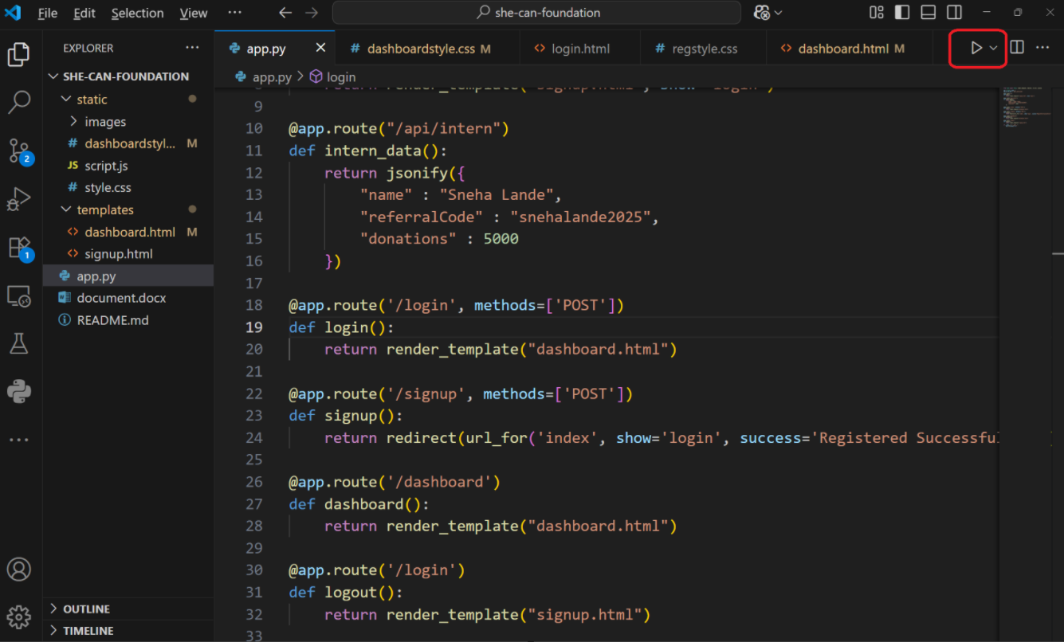

Then a terminal will open, if it’s a local server, there you will see a link like this,

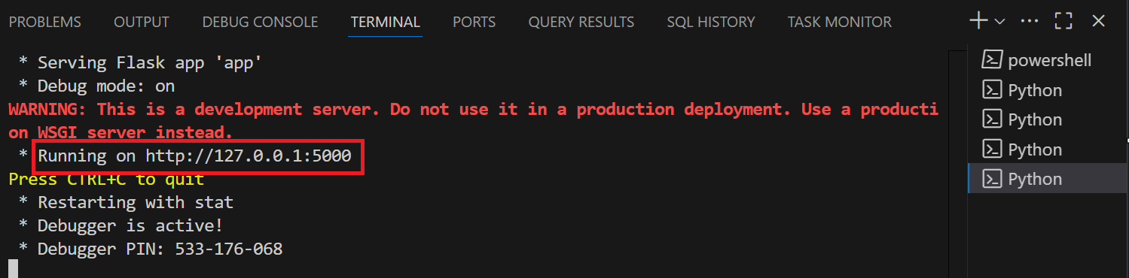

Then simply follow the link. Once the project loads, explore its features. Use the login form to enter the a username and you’ll directed to the Intern Dashboard.

