Software Requirements Specification
for
Pivi
Version 1.0 approved
Prepared by
Nithya Kogaleru
Pujitha Kara
Sri Kiran Panchavati Ganesh
Giridhar Peddabuttaiahgari
Snehal Shendware

Arizona State University
11/15/2016
Table of Contents
Table of Contents ii
Revision History ii
1. Introduction 1
1.1 Purpose 1
1.2 Document Conventions 1
1.3 Intended Audience and Reading Suggestions 1
1.4 Product Scope 1
1.5 References 1
2. Overall Description 2
2.1 Product Perspective 2
2.2 Product Functions 2
2.3 User Classes and Characteristics 2
2.4 Operating Environment 2
2.5 Design and Implementation Constraints 2
2.6 User Documentation 2
2.7 Assumptions and Dependencies 3
3. External Interface Requirements 3
3.1 User Interfaces 3
3.2 Hardware Interfaces 3
3.3 Software Interfaces 3
3.4 Communications Interfaces 3
4. System Features 4
4.1 System Feature 1 4
4.2 System Feature 2 (and so on) 4
5. Other Nonfunctional Requirements 4
5.1 Performance Requirements 4
5.2 Safety Requirements 5
5.3 Security Requirements 5
5.4 Software Quality Attributes 5
5.5 Business Rules 5
6. Other Requirements 5
Appendix A: Glossary 5
Appendix B: Analysis Models 5
Appendix C: To Be Determined List 6

Revision History

Date | Version | Description | Author
November 18, 2016 | 1.0 | Initial Draft | Snehal Shendware, Sri Kiran Panchavati Ganesh  , Giridhar Peddabuttaiahgari
November 26, 2016 | 2.0 | Updated to reflect changes by Sponsor | Snehal Shendware

Introduction

Purpose
This document describes the software requirements and specifications for the capstone project “An eclipse Plug-In for Visual Parallel Programming “sponsored by Prof. Javier Gonzalez. The scope of the project is to develop eclipse plug-in in various versions depending on the time constraint. The first version of the project is to develop the eclipse plug-in focusing on facilitating teaching techniques and implications of parallel, concurrent and multicore computing. Depending on the time constraints, the project can be expanded further to include in the Eclipse Marketplace for the enterprise level.

Intended Audience and Reading Suggestions
This project is mainly intended to facilitate teaching techniques and implications of parallel, concurrent and multicore computing. This tool primarily aims at students that allows them to create a visual model of a problem (by the interconnection of representative icons of atomic structures) building a graph that represent a complete programmable system. This document is primarily targeted at students that enables them in learning concurrent programming. This tool, however, can be further enhanced to include additional features to be used at the enterprise level based on the time constraints.
This document is succeeded by the following sections: Product Scope, Overall Description, Product Perspective, Product Functions, User Classes and Characteristics, Operating Environment, Design and Implementation Constraints, User Documentation, Assumptions and Dependencies etc.

Product Scope
The aim of the project is to develop an eclipse plug in titled PiVi: “An eclipse Plug-In for visual parallel programming”. This project focuses on facilitating teaching students concurrent programming. Using this tool, the user can program a multi-threaded application in java. This is built inside the eclipse environment where visual programming based on icons can be achieved. The tool allows the students to create a program visually that represents a complete programmable system. This should in turn automatically generate code of the problem in Java or C/C++, inlaying the necessary elements for concurrent or parallel systems, to compile, execute and run.

Overall Description

Product Perspective
The project was originated from the Sponsor’s thesis study. This project aims at students allowing them to get a better understanding of how concurrent programming works. The project proposed is a self-contained project that intends to use a visual language, in which program is built by icons, pipelines and textual elements to create multidimensional expressions.

Product Functions
The major functionalities of the project as listed out as follows:
- Use visual language in which a program is built by icons, pipelines and textual elements to create multidimensional expressions.
- Each node in the graph, an actor represents a different entry, flow control structures, data attributes.
- Two type of pipelines define two types of flows: execution and control flow.
- Provide a sub set of visual elements executing in parallel (Ex. Multi Threading in Java)
- Show generated code and execution results of visual parallel programming.

This Eclipse Plug-In is focused on facilitating teaching/learning techniques and implications of parallel, concurrent and multicore programming.

User Classes and Characteristics
The version 2 of the project is mainly targeted to students for learning purposes. It is used to facilitate learning of parallel programming. Version 3 of the project will be aimed at enterprise level to be included in the Eclipse Marketplace. This version will have more optimizations and will have enhanced security features to be used at the enterprise level.

Operating Environment
The plug in will be deployed in eclipse. Back end code will be generated in java. It can be run on any machine where we can install Eclipse IDE and JDK.

Design and Implementation Constraints
Due to the quasi-academic nature of the project, there is a time constraint for the project to be completed by 6 months. The system being developed should be compatible with java as multithreading visualization is only supported by java. This project targets to develop a plug-in for eclipse, using which a user can program a multi-threaded application in java. This is based on the assumption that the existing system is compatible with eclipse IDE.

The scope of the project is to develop the plugin for students to learn concurrent programming. Here we intend to use visual language, in which a program is built by icons, pipelines and textual elements to create multidimensional expressions. Completing the scope of the project contributes to the successful completion of the project. The project would be further enhanced to include additional functionality to be used at the enterprise level depending on the time.

User Documentation
User guide document and a few examples are additional documents required in order for the developed system to be operationally useful. As this project is mainly targeted for students to learn concurrent programming, the team will have additional task of including further more documentation including installation document, user guides, and basic examples of how the system works. These documents help the students to use the system more efficiently.

Assumptions and Dependencies
The scope of the project is to develop the plugin for students to learn concurrent programming. Here we intend to use visual language, in which a program is built by icons, pipelines and textual elements to create multidimensional expressions. Completing the scope of the project contributes to the successful completion of the project. The project would be further enhanced to include additional functionality to be used at the enterprise level depending on the time.

Due to the quasi-academic nature of the project, there is a time constraint for the project to be completed by 6 months. The system being developed should be compatible with java as multithreading visualization is only supported by java. This project targets to develop a plug-in for eclipse, using which a user can program a multi-threaded application in java. This is based on the assumption that the existing system is compatible with eclipse IDE.

External Interface Requirements

User Interfaces
The interface should include the Eclipse graphical editors (plugin GUI) using Graphical Modeling Framework (GMF). The development of graphical editors is based on Eclipse Modeling Framework (EMF) and Graphical Editing Framework (GEF). The GUI will be constrained to standards of Eclipse user interface and will follow guidelines provided by Eclipse open source community.

Communications Interfaces
The product is inclusive of the components dependent on Eclipse community framework and standards. There seems to be no communication functions required by this product. The product will be part of Eclipse Plug-In community and liable to community edition standards and protocols.

System Features

Accessing Plug In

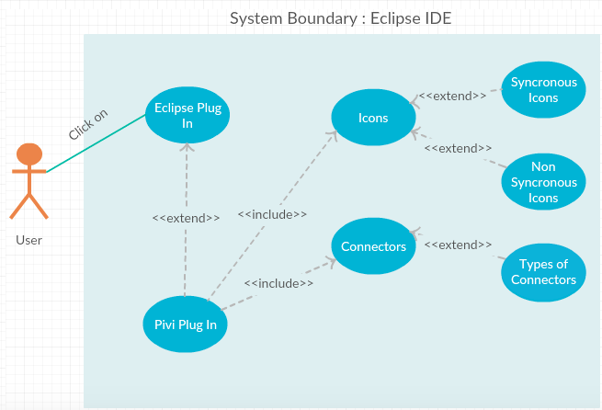

4.1.1 Description and Priority
The delivered should work as a plugin for eclipse and should run inside Eclipse IDE. The user shall access the plug-In either by launching it from menu bar or window perspective in eclipse IDE.

Priority Rank: 1
4.1.2 Stimulus/Response Sequences
User installs the plugin in eclipse. This should enable an additional option either in menu bar or add an additional perspective in eclipse IDE. The user then selects the provided option and creates a new project in it.
4.1.3 Functional Requirements
REQ-1: Installation of the plugin should enable the option to open the plugin perspective in eclipse IDE.
REQ-2: Selection of the option should open GUI for visual programming.
REQ-3: Close the GUI perspective on close option

Editing UI Blocks

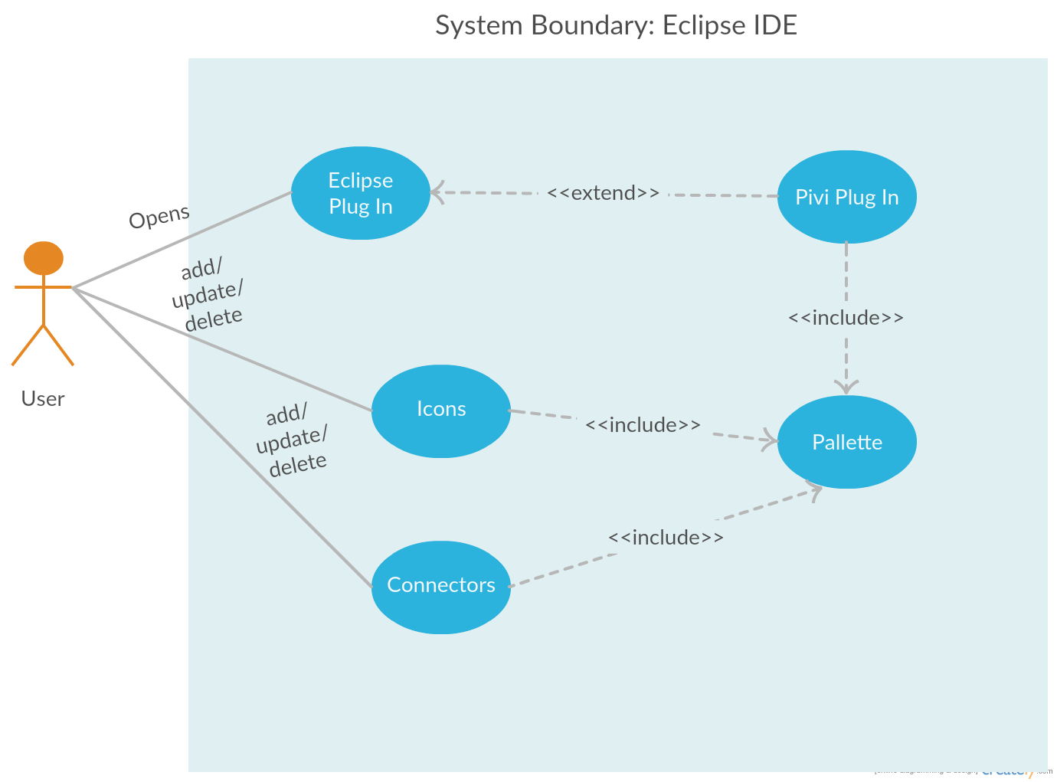
4.2.1 Description and Priority
The plugin perspective should provide a palette with icons that can be selected by the user. The user should be able to add/edit/delete these icons to/from the canvas provided beside the palette.

Priority Rank: 2
4.2.2 Stimulus/Response Sequences
The plugin provides a user interface which has a palette of icons and a canvas. The user selects an icon and places it on the canvas. User can also delete an existing icon from the canvas. User edits the properties of the icon and saves them. The state of the canvas is stored upon saving the program.
4.2.3 Functional Requirements
REQ-1: User interface provides an icon palette and a canvas
REQ-2: User should be able to add icon from palette to canvas
REQ-3: User should be able to edit properties of existing icons in canvas
REQ-4: User should be able to delete existing icons from canvas
REQ-5: User should be able to edit properties for each icon

Linking Icons

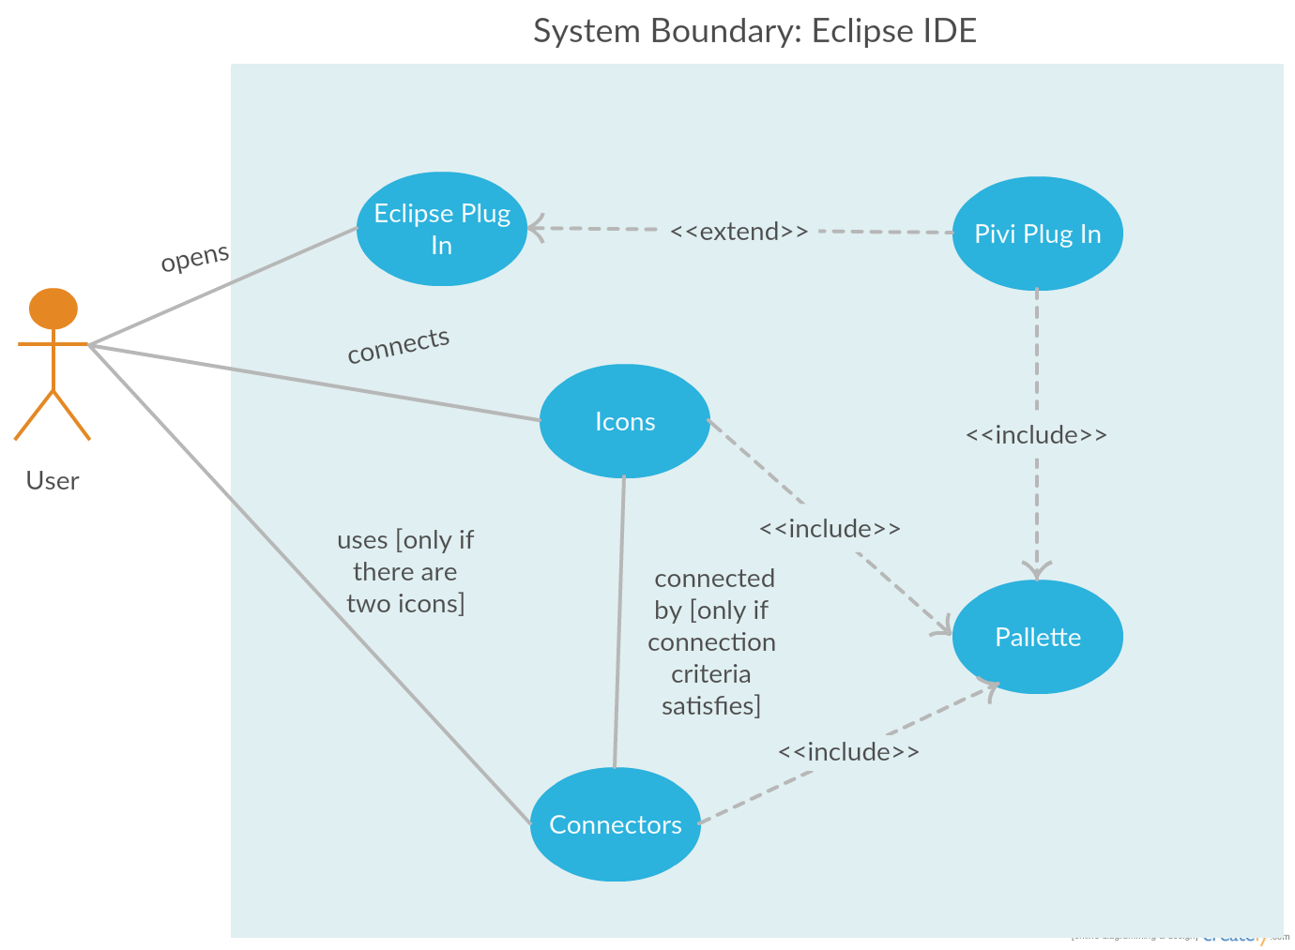
4.3.1 Description and Priority
User should be able to connect the icons present in the canvas. These connections should have a direction indicating the flow of the control. The system should also validate if the connection is valid or not and accordingly perform the action.

Priority Rank: 4

4.3.2 Stimulus/Response Sequences
User draws an arrow from the source icon to the destination icon on canvas. System checks if it is a valid connection. If it is valid the arrow will be linked with the second icon. If the connection is not valid then the arrow will not get linked to the second icon.
4.3.3 Functional Requirements
REQ-1: User should be able to connect two icons by drawing an arrow from one icon to another.
REQ-2: System should validate the connection when two icons are linked
REQ-3: User should be able to delete an existing link between icons

Generating code

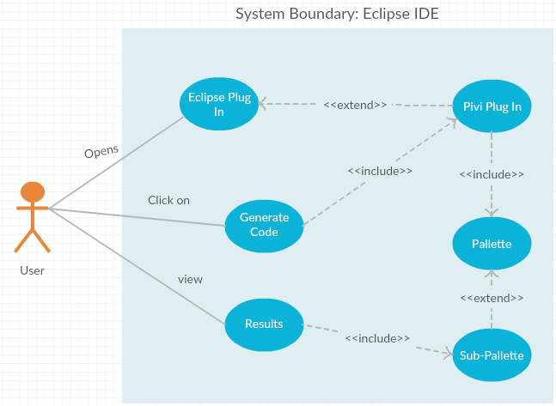
4.4.1 Description and Priority
Once the user arranges icons on the canvas and connects them, he/she should be able to generate code for the flow diagram. The system should check if it is a valid flow diagram. For a valid flow diagram, the system should generate the required code for it. If it is not a valid diagram, then errors are prompted to the user.

Priority Rank: 5

4.4.2 Stimulus/Response Sequences
User places the icons and connects them as per the need. Then he selects the option to generate code. System validates the flow diagram. If valid, system generates the required code to execute the flow. If it is not a valid diagram, then errors are prompted to the user.
4.4.3 Functional Requirements
REQ-1: User should be able to generate code on completion of structural flow
REQ-2: Structural flow diagram needs to be validated before code generation

Icon Functionality

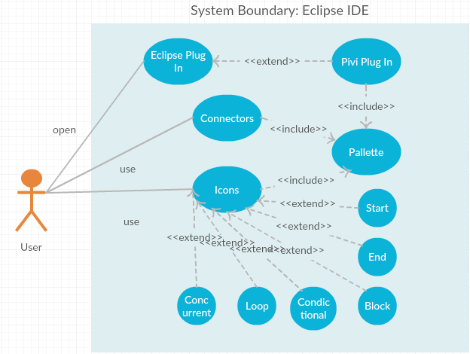
4.5.1 Description and Priority
List of icons provided in the palette should contain necessary control structures.

Priority Rank: 3

4.5.2 Stimulus/Response Sequences
User should be able to select different icons from the palette and create meaningful programs from them.
4.5.3 Functional Requirements
List of icons present in the palette should support below requirements.
REQ-1: Palette should contain an Icon to start the program
REQ-2: Palette should contain an Icon to end the program
REQ-3: Palette should contain an Icon to input instructions
REQ-4: Palette should contain Icons to support conditional operation
REQ-5: Palette should contain Icons to support Loop operation
REQ-6: Palette should contain Icons to support Concurrent programming

Other Nonfunctional Requirements

Software Quality Attributes
Functional (F), Non-Functional (NF), User (U), System (S), Domain Specific (DS), Domain Independent (DI), Unambiguous (UA), Complete(COM), Consistent (CON), Ranked for importance or stability (R), verifiable (V), modifiable (M), traceable (T)

# | Requirement | F | NF | U | S | DS | DI | UA | V
1 | Installation of the plugin should enable the option to open the plugin perspective in eclipse IDE. | ✓ | ✗ | ✗ | ✓ | ✗ | ✓ | ✓ | ✓
2 | Selection of the option should open GUI for visual programming. | ✓ | ✗ | ✗ | ✓ | ✗ | ✓ | ✓ | ✓
3 | Close the GUI perspective on close option | ✓ | ✗ | ✗ | ✓ | ✗ | ✓ | ✓ | ✓
4 | User interface provides an icon palette and a canvas | ✓ | ✗ | ✗ | ✓ | ✗ | ✓ | ✓ | ✓
5 | User should be able to add icon from palette to canvas | ✓ | ✗ | ✓ | ✗ | ✗ | ✓ | ✓ | ✓
6 | User should be able to edit properties of existing icons in canvas | ✓ | ✗ | ✓ | ✗ | ✗ | ✓ | ✓ | ✓
7 | User should be able to delete existing icons from canvas | ✓ | ✗ | ✗ | ✓ | ✗ | ✓ | ✓ | ✓
8 | User should be able to edit properties for each icon | ✓ | ✗ | ✓ | ✗ | ✗ | ✓ | ✓ | ✓
9 | User should be able to connect two icons by drawing an arrow from one icon to another. | ✓ | ✗ | ✓ | ✗ | ✗ | ✓ | ✓ | ✓
10 | System should validate the connection when two icons are linked | ✓ | ✗ | ✗ | ✓ | ✗ | ✓ | ✓ | ✓
11 | User should be able to delete an existing link between icons | ✓ | ✗ | ✓ | ✗ | ✗ | ✓ | ✓ | ✓
12 | User should be able to generate code on completion of structural flow | ✓ | ✗ | ✓ | ✗ | ✗ | ✓ | ✓ | ✓
13 | Structural flow diagram needs to be validated before code generation | ✓ | ✗ | ✗ | ✓ | ✗ | ✓ | ✓ | ✓
14 | Structure icons with different names and functionalities: (e.g. start, instruction, condition, loop, end) | ✓ | ✗ | ✓ | ✗ | ✗ | ✓ | ✓ | ✓
15 | Generate different type of icons with id and meta properties | ✓ | ✗ | ✗ | ✓ | ✗ | ✓ | ✓ | ✓

Quality Attribute as whole:

Requirements list | COM | CON | R | M | T
All | ✓ | ✓ | ✓ | ✓ | ✓

