🎮 GAME-A-THON | GAME DESIGN DOCUMENT

UNDER INVESTIGATION
Chase the suspect. Follow the evidence. Crack the case.
A five-stage arcade investigation where every new clue changes the case.
This document follows the Game-A-Thon template and turns the concept board into a clear, playable design: fast action first, then interrogation, evidence gathering, deduction, and a final reveal.

1. GAME TITLE & TAGLINE 🎮
Game Title: UNDER INVESTIGATION
Tagline: Chase the suspect. Follow the evidence. Crack the case.
Core identity: A compact detective game that begins with immediate arcade action and gradually teaches the player to question what they have already seen.

2. YOUR GAME IDEA 💡
What is the game about? A valuable research prototype disappears from a college laboratory during a precisely timed camera blackout. The cameras go offline from 2:00 AM to 2:20 AM. At 2:20 AM, security spots Leo escaping the laboratory perimeter, and Investigator Jaga is sent with Detective Julian Vance to stop him. What looks like a straightforward capture becomes a deeper investigation when Leo claims he was only paid to help and that someone else was behind the robbery.
Genre: Arcade + Investigation / Deduction
Player's Goal: Recover the truth behind the stolen prototype, follow the evidence from Leo to Apartment 69, expose the contradiction in Maya's story, and uncover the person who planned the robbery.
Design Promise: The player should always understand the immediate objective while slowly realizing that the larger case is more complicated than the opening chase suggests.

3. HOW WILL THE GAME BE PLAYED? 🕹️
What does the player do? The player completes five short stages, each built around one easy-to-learn interaction.
Core Gameplay: HIT → INTERROGATE → FIND CLUES → FIND LIAR → SOLVE CASE
• Hit five facial targets, three times each, before the countdown ends.
• Stop a fictional interrogation meter to unlock three secrets.
• Search Apartment 69, Gokuldham and uncover the locker, phone, and security evidence.
• Compare four statements and spot the contradiction.
• Make the final deduction and close the case.

4. WHAT MAKES YOUR GAME SPECIAL? ⭐
Unique Idea: The game changes genre without changing its story. The first stage feels like a quick target-hitting arcade game, but that exact suspect becomes the starting point for the investigation. The player is not simply moving from one unrelated minigame to another; each mechanic produces information that becomes useful later.
The Hook: The player is told exactly what to do — stop the suspect — before they have enough information to question that order. Once the suspect is captured, the investigation opens up. Every new discovery makes the player reconsider earlier assumptions.
Why it works for a Game-A-Thon: The concept creates a strong narrative payoff without requiring open-world systems, advanced AI, or a large inventory. Five focused scenes can deliver a complete beginning-to-ending experience.
Design Pillars:
• Immediate — the player can begin playing in seconds.
• Readable — each stage has one central mechanic and one obvious goal.
• Connected — clues from one stage matter in the next.
• Twist-driven — the meaning of the opening capture changes by the finale.

5. GAME WORLD & STORY 🌍
Where does the game take place? The story moves through four compact connected spaces: the college research laboratory and security perimeter, a tense interrogation room, Apartment 69 in Gokuldham, and the final evidence-board confrontation. Each location exists to support one focused gameplay interaction rather than open-world exploration.
Story / Premise: Last night, a highly valuable research prototype was stolen from the college laboratory. The security cameras were disabled for exactly twenty minutes — from 2:00 AM to 2:20 AM. At 2:20 AM, security spotted Leo escaping the laboratory perimeter. Investigator Jaga and Detective Julian Vance were assigned to the case. Jaga assumes Leo is the thief, but the investigation soon reveals that Leo was only an accomplice and that the evidence pointing toward Maya has been manipulated.
BACKSTORY / OPENING CINEMATIC: 02:00 AM — the laboratory cameras go dark. 02:20 AM — they return and Leo is spotted escaping the perimeter. Jaga and Vance are sent after him. The player is encouraged to assume Leo is the thief; the investigation is designed to challenge that assumption.
Narrative Progression:
STAGE 1 — HIT THE SUSPECT
Purpose: Introduce the player to the case through immediate action.
Mechanic: Five facial target points appear on Leo: head, left eye, right ear, nose, and mouth/chin. Each point must be hit three times before the timer expires. The face moves slightly and the targets shift, creating a fast reaction challenge.
Result: Leo is captured. His first warning is brief: "You have the wrong man." He admits he was paid to help, but says he never saw the planner's face.
Key dialogue beat: Vance challenges Leo's claim while Jaga begins to question whether the obvious suspect is the real culprit.
STAGE 2 — BREAK THE SILENCE
Purpose: Turn the captured suspect into a source of information.
Mechanic: Jaga questions Leo while a fictional pressure meter swings back and forth. The player must stop it in the red zone three times. A wrong stop resets the streak.
Result: Three clues are revealed:
1. Apartment 69, Gokuldham is the meeting point.
2. A handwritten note says: "When the power supply cuts, go inside from the secret entrance."
3. Leo was instructed to contact the planner through a phone hidden inside a locker.
Key dialogue beat: Vance pushes for answers, while Leo insists he was only following instructions.
STAGE 3 — FIND THE CLUE
Purpose: Convert Leo's information into physical evidence.
Mechanic: The player searches Apartment 69, Gokuldham using five to six clickable objects. The investigation follows a fixed clue chain rather than a complex inventory system.
Puzzle chain: Search desk → find locker PIN 4712 → open locker → discover burner phone and security printout → notice Maya Lin entered at 2:08 AM → inspect photograph → solve the phone PIN 0200 → unlock the burner phone → recover three contacts.
Result: The player obtains the Maya entry record, the three contacts (Maya, Dr. Jhatka, Elena), and the security evidence needed for the next stage.
Key dialogue beat: Jaga realizes Maya's recorded entry falls inside the 2:00–2:20 AM blackout window.
STAGE 4 — FIND THE LIAR
Purpose: Use reasoning rather than reflexes to test witness statements against collected evidence.
Mechanic: Four suspect portraits are presented. The player keeps the evidence visible and compares the statements.
Statements:
• Maya Lin: "I left the laboratory before 2:00 AM."
• Dr. Jhatka: "I was sleeping at my house. I wanted the prototype recovered. I would never destroy my own research."
• Elena Rostova: "I was not inside the lab during the blackout. Earlier that night, I was sent home early by the police due to security reasons."
Result: Maya's statement contradicts the security printout showing her entry at 2:08 AM. The player identifies Maya as the liar.
Key dialogue beat: Maya insists, "I really wasn't there!" The scene points toward a larger conspiracy rather than immediately proving Maya is the mastermind.
STAGE 5 — SOLVE THE CASE
Purpose: Deliver the final deduction and reveal why the earlier evidence was misleading.
Mechanic: The player answers three questions, then clicks CLOSE CASE. The intended first solution is wrong, triggering a contradiction glitch and three short evidence puzzles.
Initial questions:
1. Who was the accomplice? → Leo
2. Who was the mastermind? → Maya (intentionally wrong)
3. How do you know? → Security log
After CLOSE CASE, the screen freezes and displays: "ERROR: CONTRADICTION DETECTED — THE EVIDENCE DOES NOT MATCH THE TRUTH."
Final puzzles:
• Handwritten Note → handwriting matches Leo, confirming he was the accomplice.
• Police Log → hidden override record reveals CAMERA SYSTEM OVERRIDE at 02:03 AM, AUTHORIZATION: POLICE SECURITY, DEVICE: POLICE-07.
• Elena's Face → her statement and the police response raise the final access question.
Result: The evidence board reveals that Vance knew the blackout window, had police security access, instructed Leo, manipulated evidence toward Maya, and stayed close to Jaga to control the investigation.
Characters:
• Investigator Jaga — the player character and lead detective responsible for connecting the evidence.
• Detective Julian Vance — Jaga's police partner and the hidden mastermind who controls the investigation from inside it.
• Leo — the man caught escaping the laboratory; an accomplice/pawn who follows instructions from the planner.
• Maya Lin — lab assistant who is framed as the obvious culprit after manipulated evidence points toward her.
Core Cast: Dr. Jhatka — lead scientist and connected suspect. Elena Rostova — researcher and connected suspect. Modi and Kim — wrong-option names used only in the first final question.
Core Twist: The investigation begins with certainty — Leo appears to be the thief. Later, Maya appears to be the mastermind. Both conclusions are incomplete. The final evidence reveals that Vance was behind the operation and deliberately controlled what the player believed.

6. LOOK & FEEL 🎨
What will the game look like? The visual direction is a unified retro detective case-file aesthetic inspired by a corkboard investigation wall. Worn paper, pinned photographs, strings, red markings, dark wood, warm lamp light, and evidence notes make the game feel like an active case being assembled in front of the player.
Choose or describe your style:
• 🎨 Stylized
• 🖍️ Cartoon
• 🌑 Dark / Atmospheric
• ✨ Other — Retro / Case-file / Detective-board
Describe the visual style: Stage 1 should have strong readability and exaggerated facial targets so the gameplay is instantly understandable. Interrogation should use dramatic shadows and focused lighting. Apartment 69 should feel dusty, abandoned, and clue-rich, with a believable mix of ordinary objects and suspicious evidence. The final deduction should return to the investigation-board language, using photographs, records, handwriting, and red markings to assemble the truth.
Concept Board / Visual Reference: The following generated concept image defines the intended five-stage composition, environments, suspect presentation, evidence-board tone, and overall visual identity for the project.
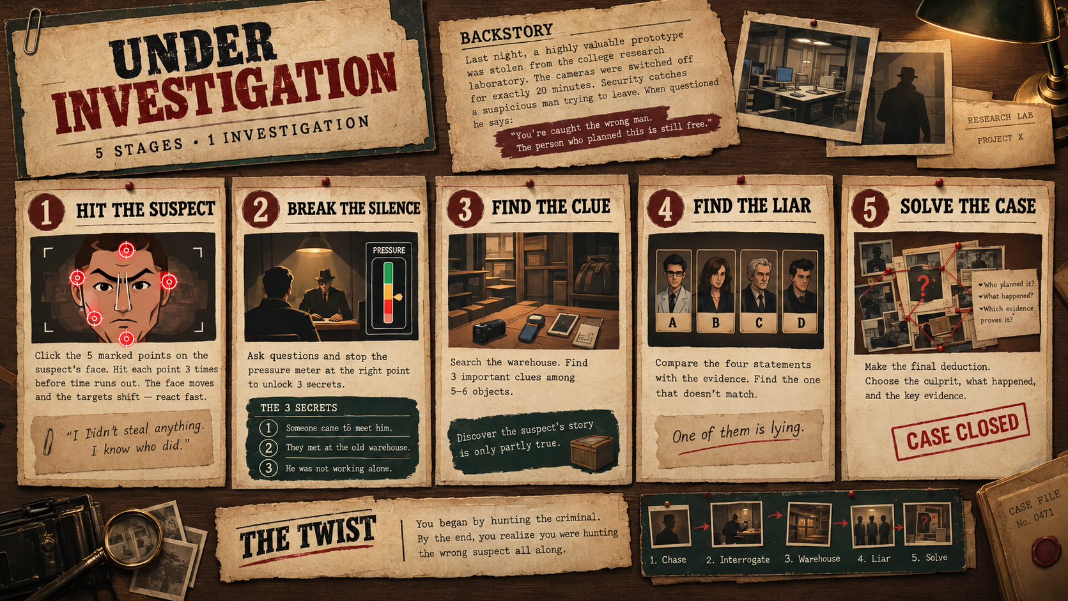
Figure 1. UNDER INVESTIGATION — five-stage concept board and visual direction.
Reference Images / Games: Primary reference is the supplied UNDER INVESTIGATION concept board. Its major visual anchors are the detective corkboard, numbered stage panels, evidence photographs, handwritten notes, warm cinematic lighting, and consistent brown/sepia palette. The updated storyline should keep these elements consistent across the laboratory, interrogation, Apartment 69, and final evidence-board sequences.
UI Language: Every screen should reuse numbered stage cards, cream-paper panels, dark borders, red accent marks, and compact evidence labels. Interactive controls should feel like parts of a physical case file rather than modern glossy UI.
Character Direction: Characters use expressive illustrated portraits for quick recognition. The Stage 1 suspect face is the primary gameplay target and should keep all five facial target zones clearly readable at gameplay scale.
Environment Direction: The laboratory should feel controlled and high-tech; the interrogation room should be sparse and dramatic; Apartment 69 should feel dusty, abandoned, and packed with believable evidence objects. The final evidence board should feel like the investigator is assembling the truth in real time.
Asset Priority: Prioritize one strong Leo face, four suspect portraits, one interrogation scene, one Apartment 69 investigation scene, clue icons, evidence cards, the security printout, the handwritten note, the burner phone, and reusable UI panels. Decorative background detail is secondary to readability and interaction.

7. SOUND & ATMOSPHERE 🎵
What should the game sound like? Sound should make each stage feel distinct while keeping the same detective identity across the whole game.
• Stage 1 — quick target-hit sounds, short impact feedback, countdown urgency, and a sharper cue when the final target is completed.
• Stage 2 — low interrogation ambience, restrained UI clicks, meter movement, and a reveal sting when each secret is unlocked.
• Stage 3 — quiet warehouse room tone, subtle object-click sounds, and a satisfying discovery cue for important clues.
• Stage 4 — tense selection sounds, soft suspense underneath the statements, and a clear contradiction/reveal cue.
• Stage 5 — restrained build-up followed by a strong case-closed sting.
Atmosphere should progress from urgency → tension → curiosity → suspicion → resolution, so the audio supports the same narrative arc as the gameplay.

8. GAME EXPERIENCE 🗺️
What should the player feel while playing?
• ☑ Excited
• ☑ Curious
• ☑ Challenged
• ☑ Mysterious
• ☑ Playful
Describe the overall experience: The opening should be immediate and energetic — the player sees a target and understands that they must react quickly. After the capture, the pace changes rather than simply becoming harder. The player begins reading, comparing, searching, and forming a theory. The strongest feeling should be discovery: earlier information becomes more meaningful when combined with later evidence. The ending should reward the player with a clear explanation rather than leaving the twist unexplained.
Player Learning Curve:
• First minute — learn movement, target clicking, and the countdown.
• Early investigation — learn that actions produce information, not just points.
• Mid-game — learn to inspect details and connect evidence.
• Final stage — apply the information independently and make a reasoned deduction.

9. YOUR GAME IN THE 12-HOUR ROUND 📦
What part of your game would you most want to see playable by the end of the 12 hours? An end-to-end playable build of all five stages, with each stage demonstrating its one signature mechanic and feeding into the same mystery.
Minimum Playable Version:
• Stage 1: Working facial target-hit mechanic, five target points, three hits per point, timer, score/progress feedback, and success/failure state.
• Stage 2: One interrogation scene with a functional fictional pressure meter and exactly three secret reveals.
• Stage 3: One compact Apartment 69 investigation scene with five to six clickable objects and the locker → phone → evidence clue chain.
• Stage 4: Four suspect portraits, four statements, an evidence panel, and one contradiction that identifies the liar.
• Stage 5: Three final selections followed by a contradiction glitch, three short evidence puzzles, the Vance reveal, and a concise case ending.
• Shared presentation: consistent UI, character art, transitions, basic audio feedback, and a final “CASE CLOSED” screen.
Implementation Priorities:
• Prioritize the gameplay loop and transitions before optional polish.
• Use simple state-based scenes instead of advanced AI or large environments.
• Keep all interactions mouse/click friendly and visually obvious.
• Reuse characters, UI components, evidence cards, and visual assets across stages.
• Keep the mystery solvable from information already shown to the player; do not require outside knowledge.
What to Avoid in the Jam Build: Large open-world exploration, complex inventory systems, procedural dialogue, advanced enemy AI, or mechanics that do not contribute to the investigation. The strength of the project is its focused five-stage progression.
Suggested 12-Hour Build Order:
• Hour 1–2: Set up shared UI, scene flow, timer system, and Stage 1 target interaction.
• Hour 3–4: Finish Stage 1 polish and build the interrogation meter with the three secret states.
• Hour 5–7: Build the Apartment 69 investigation scene, clickable objects, PIN chain, clue collection, and evidence panel.
• Hour 8–9: Build the four-suspect statement screen and contradiction logic.
• Hour 10–11: Build the final deduction screen, ending reveal, audio cues, and transitions.
• Hour 12: Test the complete flow, fix progression bugs, improve readability, and prepare the presentation build.
Demo / Presentation Moment: The live demonstration should show the complete transformation in a few minutes. Start with Stage 1 so judges immediately interact with Leo's face, briefly show one interrogation clue, reveal the Maya entry record in Apartment 69, demonstrate the liar selection, trigger the contradiction, and finish with the Vance reveal and CASE CLOSED screen.
Success Criteria for the Build:
• A new player understands Stage 1 without verbal instructions after seeing the first target.
• Every stage can be completed in a short sitting without dead ends or confusing navigation.
• Clues shown earlier are necessary and sufficient for the final deduction.
• The final reveal clearly connects Leo, Maya, the police security access, Vance, and the stolen prototype.
Final Polish Checklist:
• Check target hitboxes, timer reset, stage transitions, and restart behavior.
• Check that clue interactions give immediate feedback and never trap the player.
• Check statement text for readability and ensure the contradiction is discoverable from the evidence.
• Test the complete five-stage route from a fresh launch before submission.

Why should we choose your game? UNDER INVESTIGATION combines the instant readability of an arcade game with the satisfaction of a detective story. Its five stages are small enough for a Game-A-Thon yet connected enough to feel like one complete case. The key payoff is that the player first catches Leo, then exposes Maya, and finally discovers that the investigation itself was being controlled by Vance.
ONE-LINE PITCH: “A fast five-stage investigation that starts with a suspect in your sights and ends with the truth in your hands.”

