PRACTICAL – 7 – “Join” Queries

1. **Find the salary of Adam.**

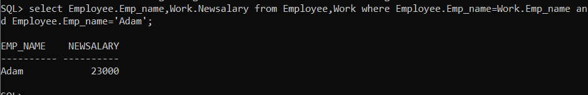

1. **Find the city where Brooks work.**

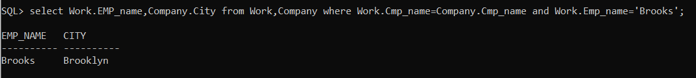

1. **Display the sailor’s details whose boat is booked for 9th May, 98.**

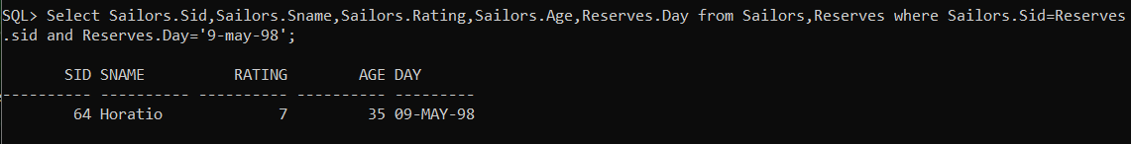

1. **Display the day of ride and sailor name for boat 103.**

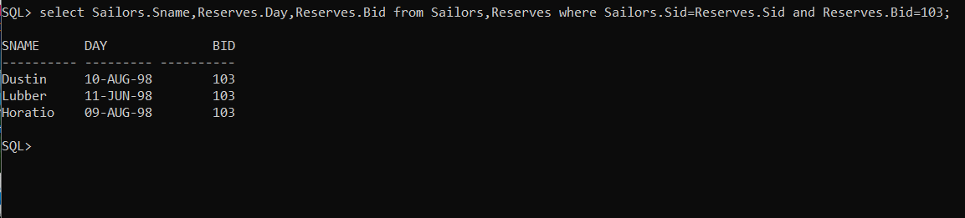

1. **Display the sailor name and its age for Red color and 101 boat**

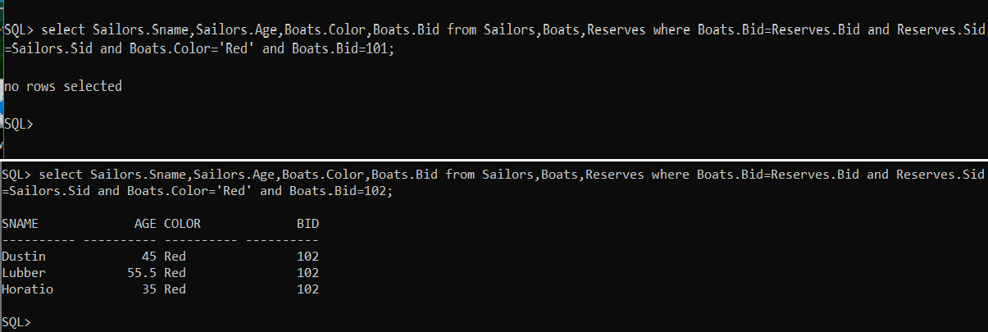

1. **Display the sailor details whose boat is never booked.**

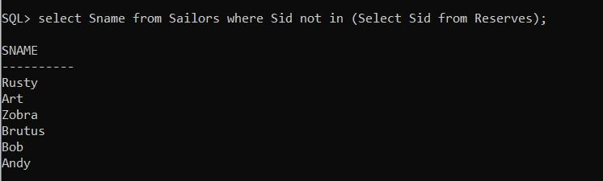

1. **Display the sailor name that has Red or Green Boat.**

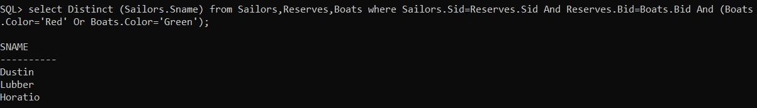

1. **Display all sailor details and boat details and who has Interlake boat**

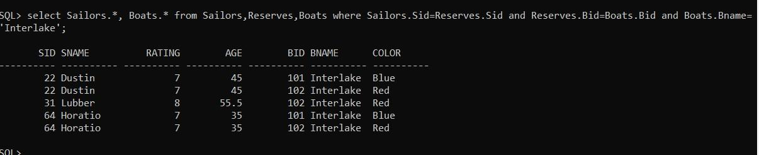

1. **Display sailor’s rating with boat details or the trip on 10th October, 98.**

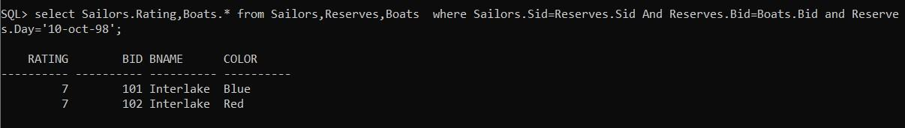

1. **Display the sailor id and name whose age is more than 42 or who has Blue colored boat.**

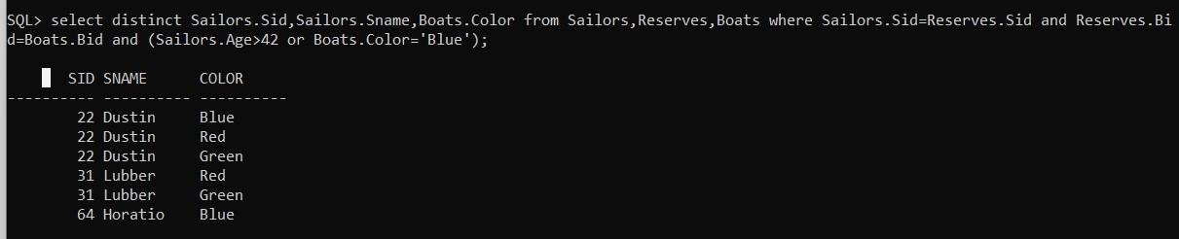

1. **Display name and rating of sailor whose boat name is Clipper**

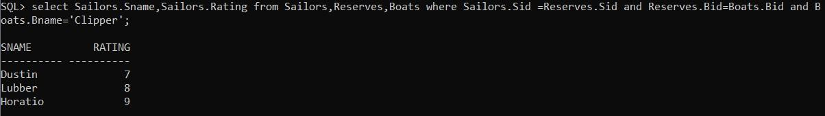

1. **List products whose selling price is more than 500 and less than equal to 750.**



1. **Describe the second highest salary of an employee**.

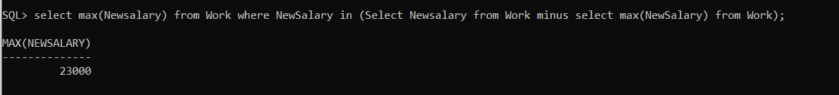

1. **Display the date of travel and sailor’s name whose age is between 35 and 65.**

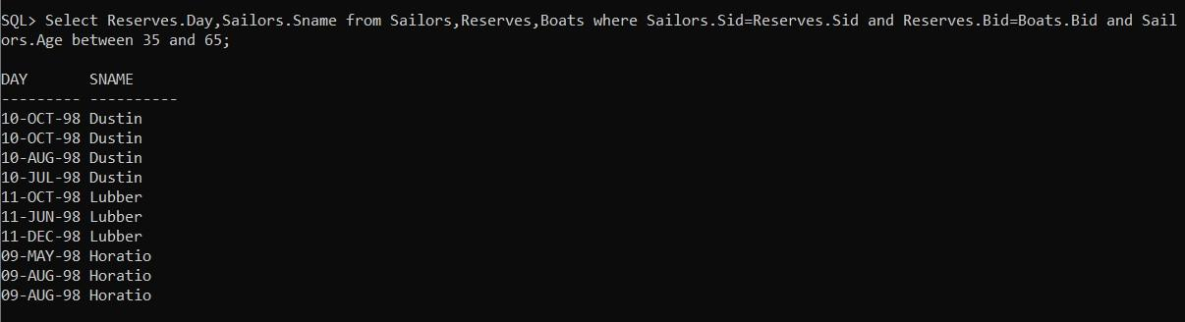

1. **List all the employees working for “FBC”**

