PRACTICAL – 8 – “Join” Queries

1. **Display all the employee name and the city where they work.**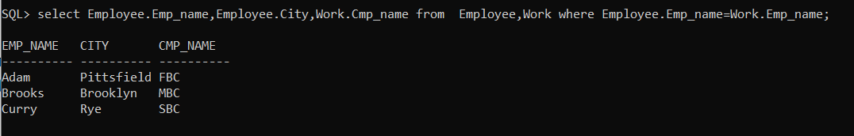
2. **Display the employee name and company’s name having salary more than 15000.**

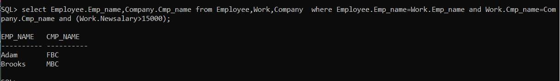

1. **Find the average rating and age of all sailors.**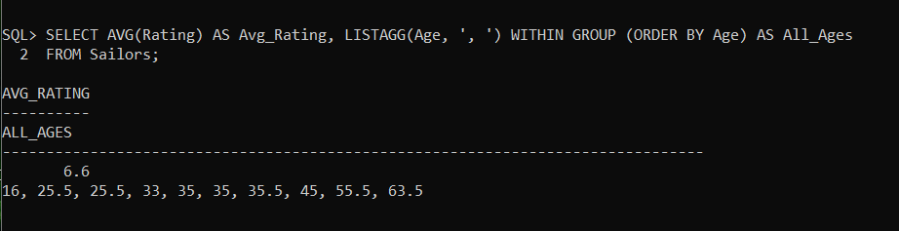
2. **List various products available.**

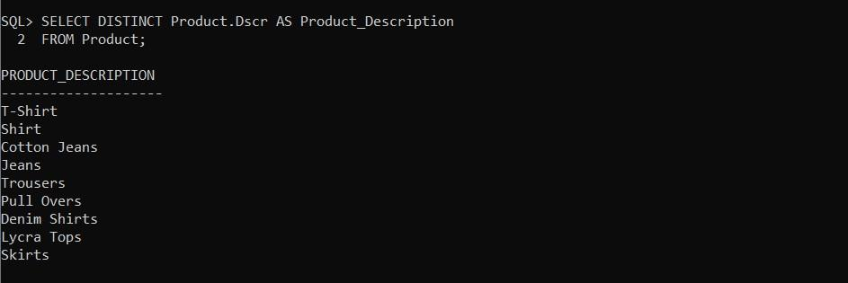

1. **Display the names of salesman who have salary more than 2850.**
2. **Change the cost price of Trousers to 950**
3. **List all the clients having “a” as a second character in their names.**



1. **List all the products whose QtyonHand is less than Reorderlvl**
2. **Print the description and total qty sold for each product.**

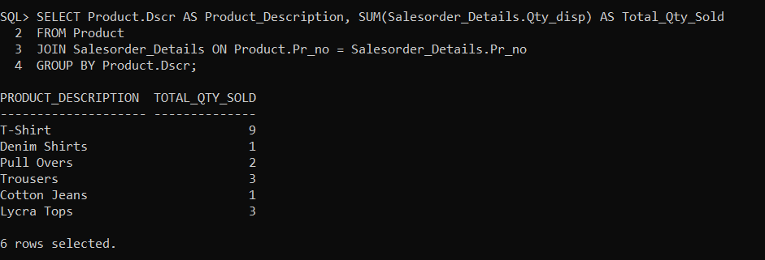

**10) Find out all the products which have been sold to “Ivan Bayross”.**

1. **Find the names of all clients who have purchased Trousers.**

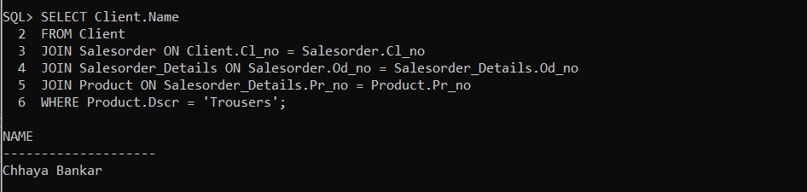

1. **Find the products and their quantities for the orders placed by client C00001 and C00002.**

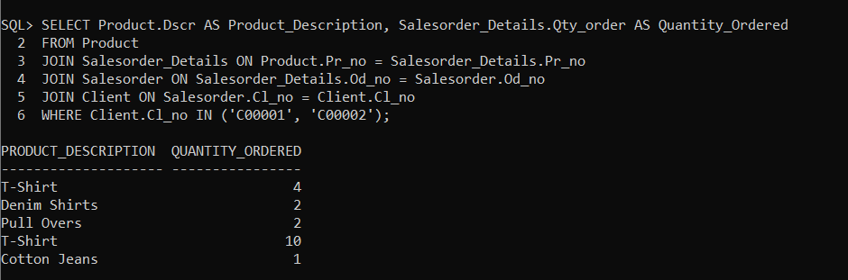

1. **List the client details who place order no. O19001.**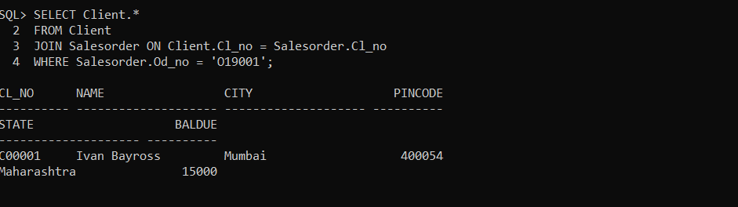
2. **List the name of clients who have placed orders worth Rs. 10000 or more.**

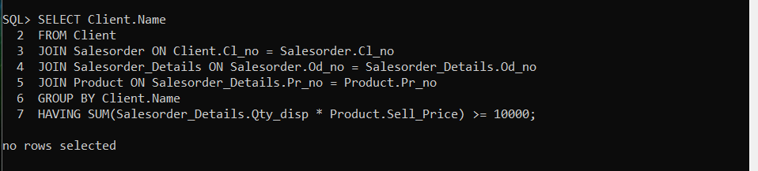

1. **Find the total of Qty ordered for each Order**