# Practical - No. 9

## Find the average rate for each Order.

### Query:

SELECT OD_NO, AVG(RATE) FROM SALESORDER_DETAILS GROUP BY OD_NO;

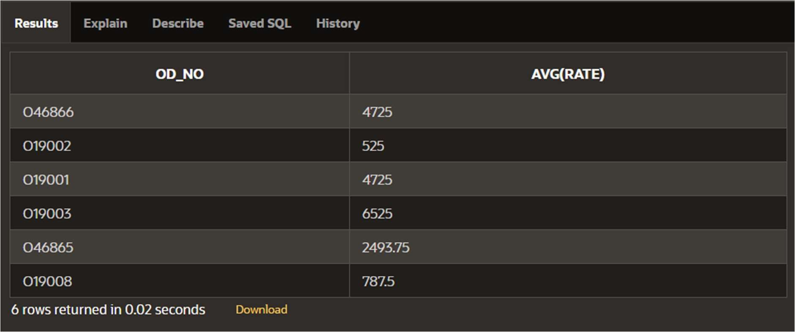

## Give the loan details of all the customers.

### Query:

SELECT B.* FROM CUSTOMERS C ,BORROW B WHERE C.CNAME = B.CNAME;

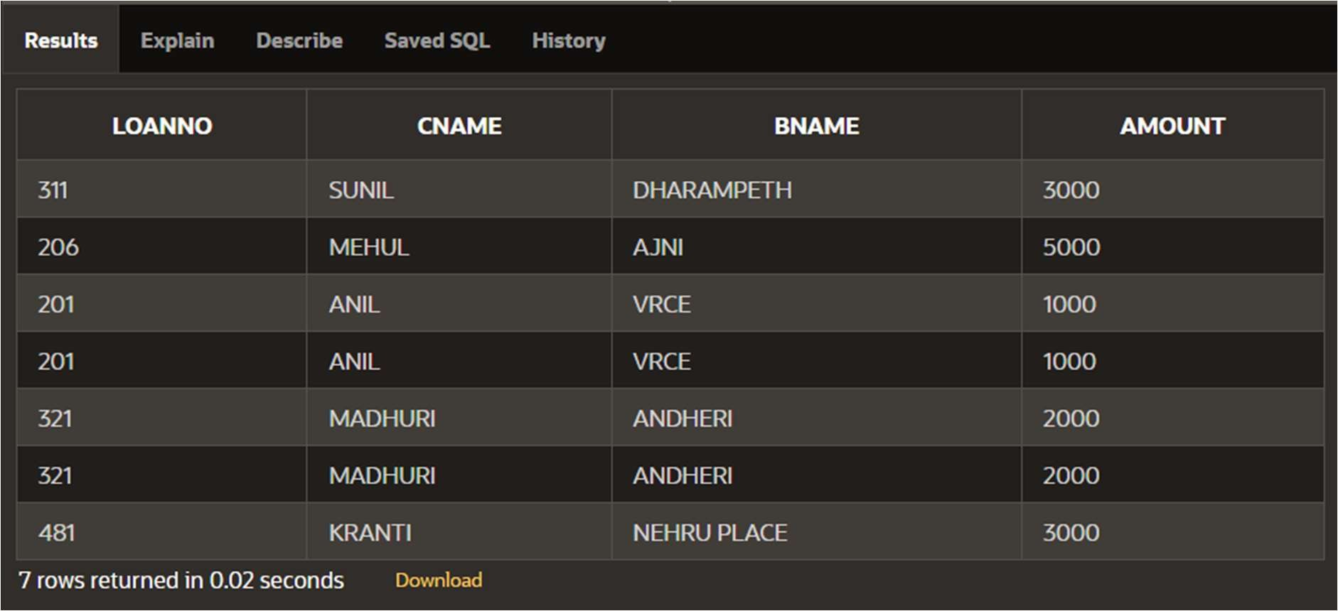

## List the customer name having loan account in the same branch city they live in.

### Query:

SELECT B.CNAME FROM BORROW B, BRANCH BR, CUSTOMERS C WHERE B.CNAME = C.CNAME AND B.BNAME = BR.BNAME AND BR.CITY = C.CITY;

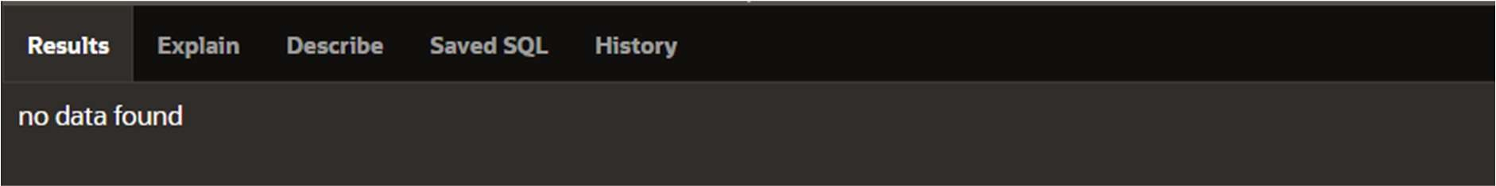

## Provide the loan details of all the customers who have opened their accounts after August’95.

### Query:

SELECT B.* FROM DEPOSIT D, BORROW B WHERE B.CNAME = D.CNAME AND D.D_DATE > '08-30-95';

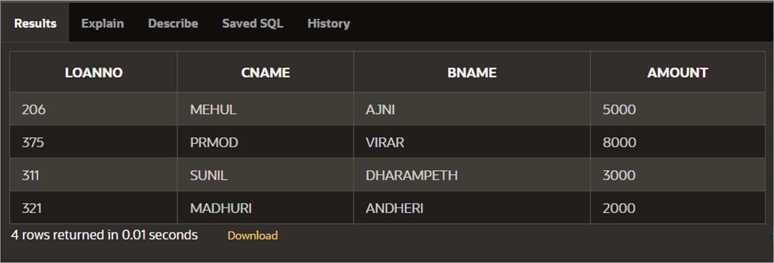

## List the order information for client C00001 and C00002.

### Query:

SELECT * FROM SALESORDER S, SALESORDER_DETAILS SD WHERE S.OD_NO = SD.OD_NO AND S.CL_NO IN ('C00001','C00002') ORDER BY S.OD_NO;

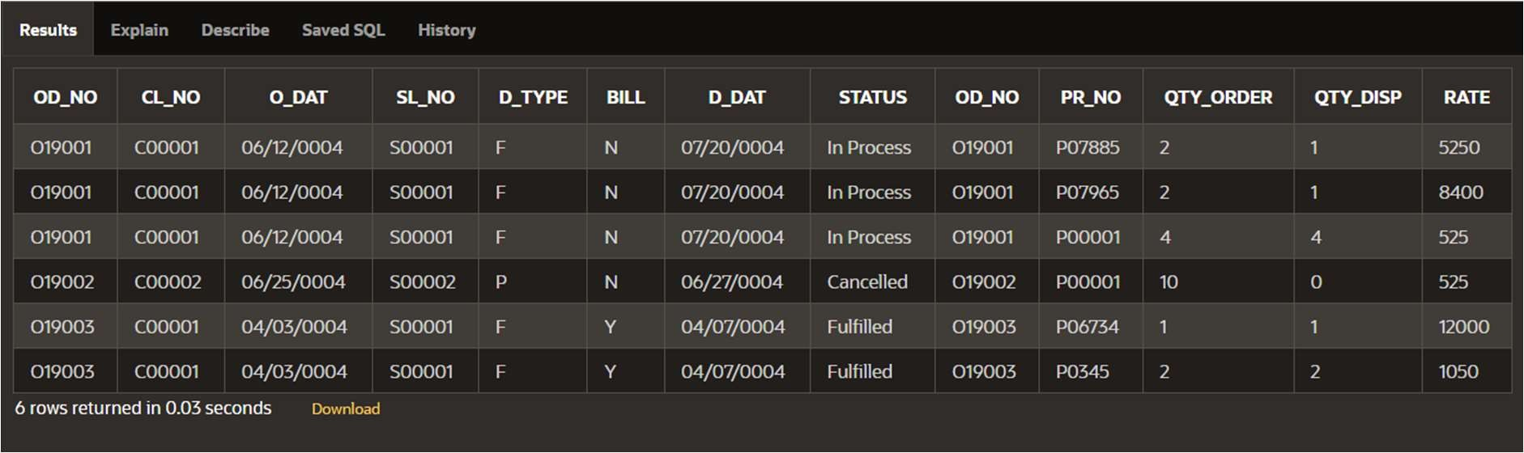

## List all the information for the orders placed in the month of June.

### Query:

SELECT * FROM SALESORDER S, SALESORDER_DETAILS SD WHERE S.OD_NO = SD.OD_NO AND O_DAT LIKE '06%';

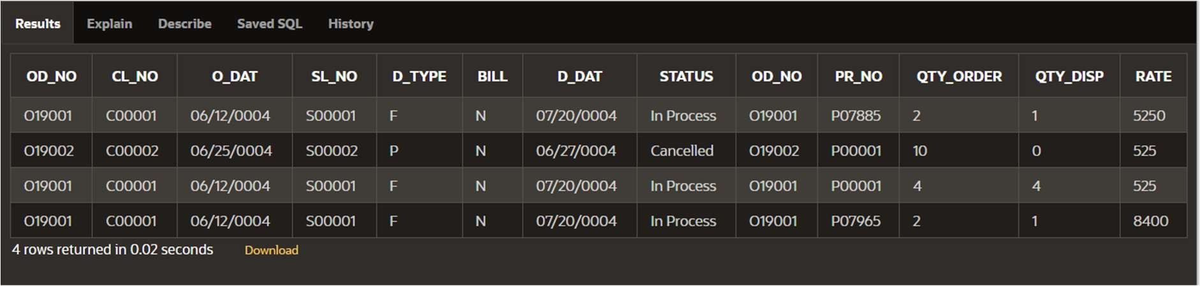

## List the details of clients who do not stay in Maharashtra.

### Query:

SELECT * FROM CLIENT WHERE NOT STATE = 'Maharashtra';

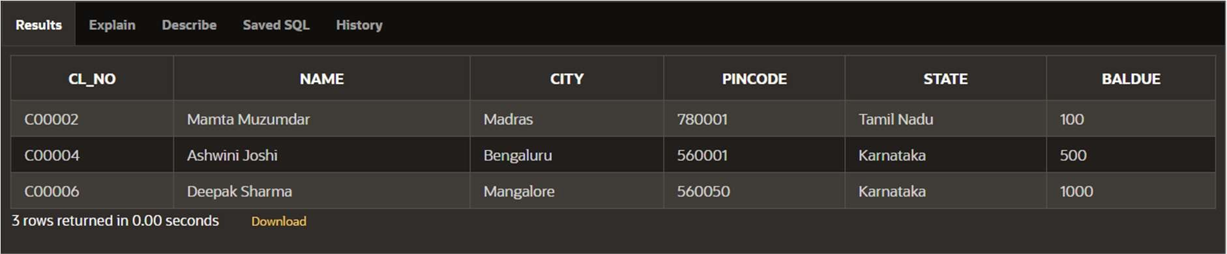

## Determine the maximum and minimum product price. Rename the output as “Max_Price” and “Min_Price”.

### Query:

SELECT MAX(SELL_PRICE) AS MAX_PRICE , MIN(SELL_PRICE) AS MIN_PRICE FROM PRODUCT;

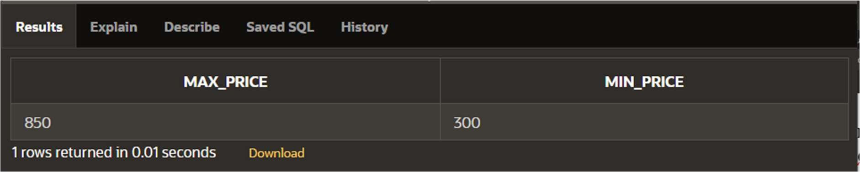

## Count the number of products having price less than or equal to 500.

### Query:

SELECT COUNT(*) FROM PRODUCT WHERE SELL_PRICE <= 500;

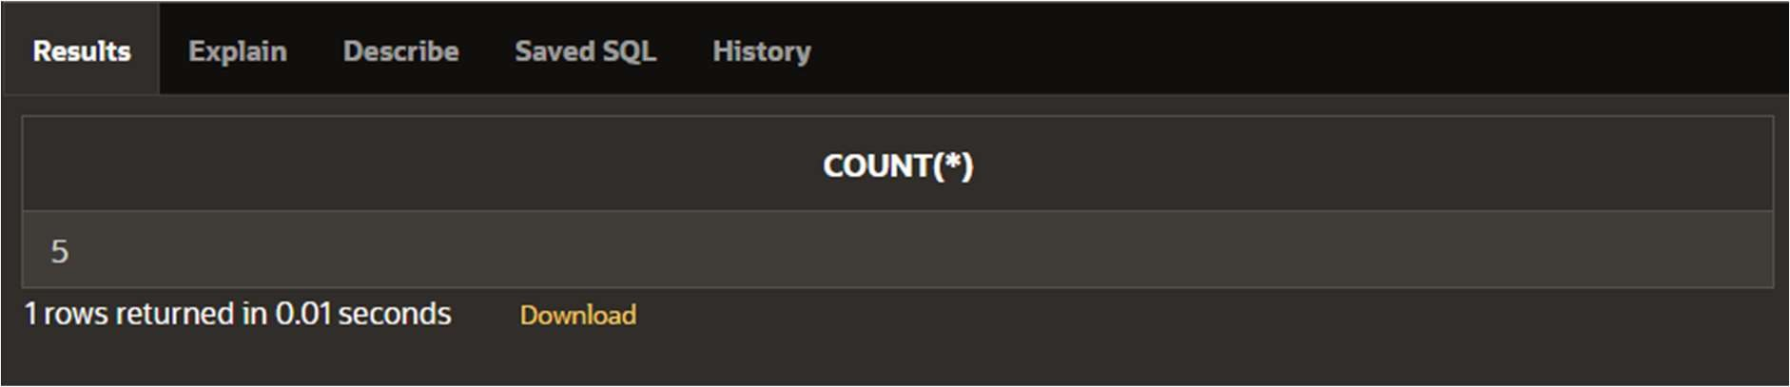

## List the order number and the day on which client placed an order.

### Query:

SELECT CL_NO, OD_NO, O_DAT FROM SALESORDER;

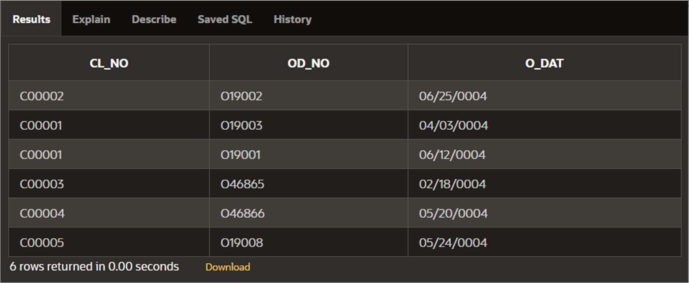

## List the month and the date on which an order is to be delivered.

### Query:

SELECT OD_NO, EXTRACT(MONTH FROM O_DAT) AS MONTH, EXTRACT(DAY FROM O_DAT) AS DAY FROM SALESORDER;

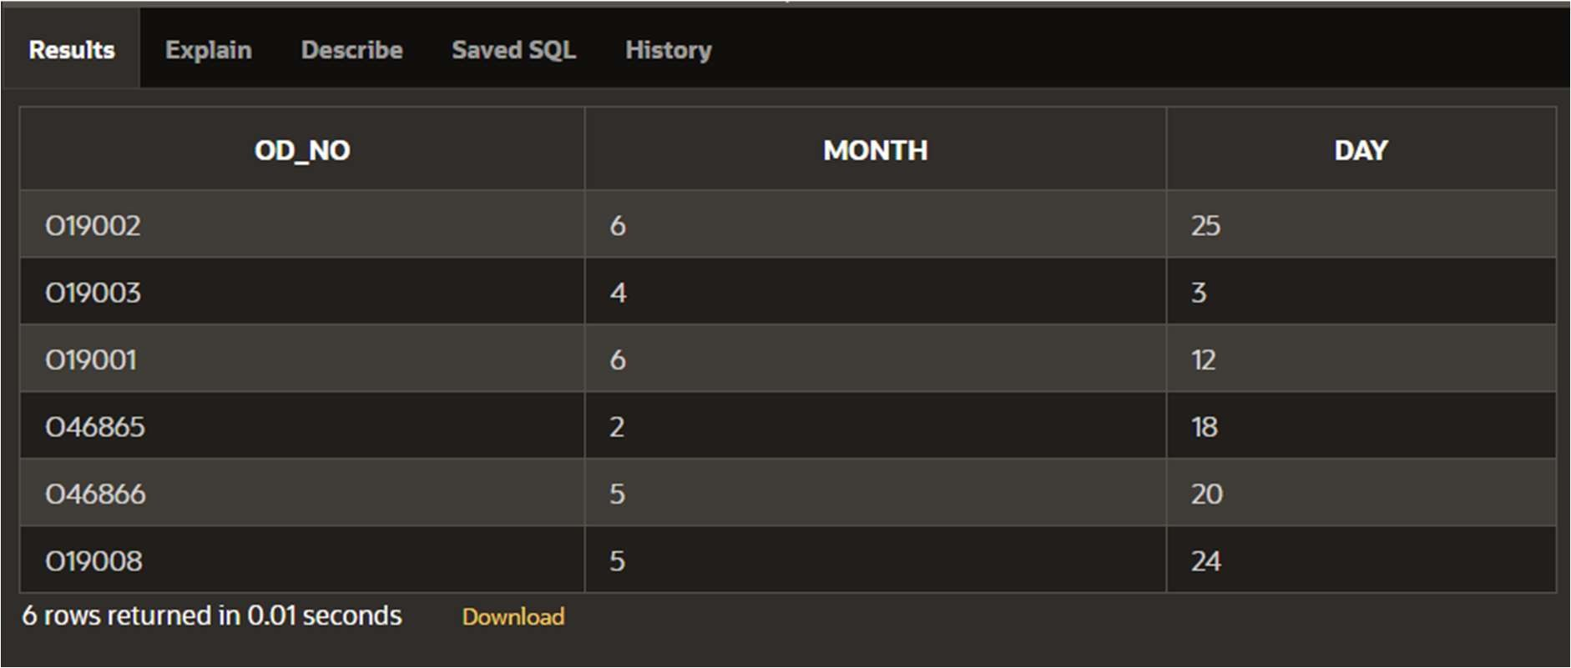

## List the date, 25 days after today’s date.

### Query:

SELECT SYSDATE + 25 AS DATEAFTER25DAYS FROM DUAL;

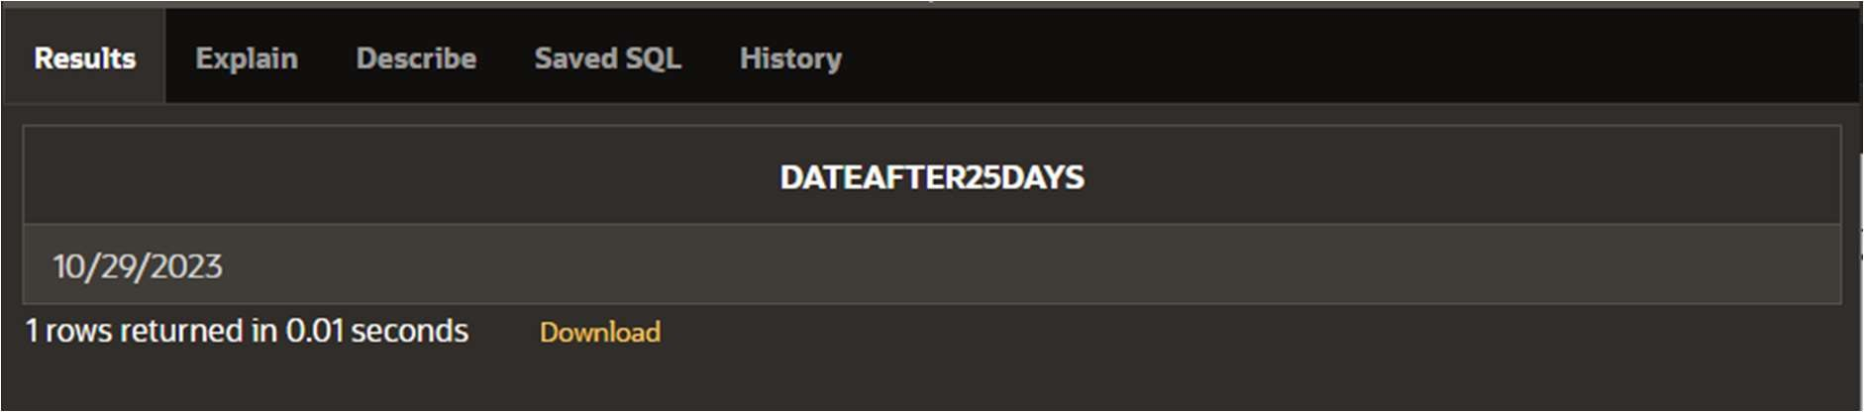

## Find the total of all the billed orders in the month of June.

### Query:

SELECT COUNT(*) FROM SALESORDER WHERE BILL = 'Y' AND D_DAT LIKE

'06%';

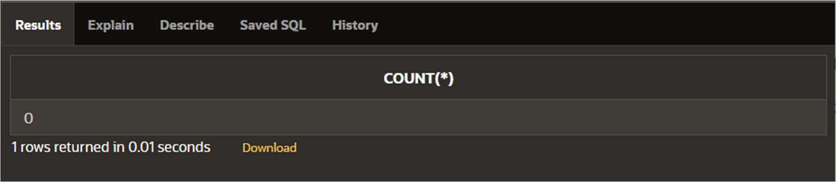

## List the products and orders from customers who have ordered less than 5 units of “Pull Overs”.

### Query:

SELECT S.CL_NO, SD.OD_NO,P.DSCR FROM SALESORDER S, SALESORDER_DETAILS SD, PRODUCT P WHERE P.PR_NO = SD.PR_NO AND SD.OD_NO = S.OD_NO AND S.CL_NO IN (SELECT S.CL_NO FROM SALESORDER S, SALESORDER_DETAILS SD, PRODUCT P WHERE P.PR_NO = SD.PR_NO AND SD.OD_NO = S.OD_NO AND P.DSCR = 'PULL OVERS' AND QTY_ORDER < 5) ORDER BY S.CL_NO;

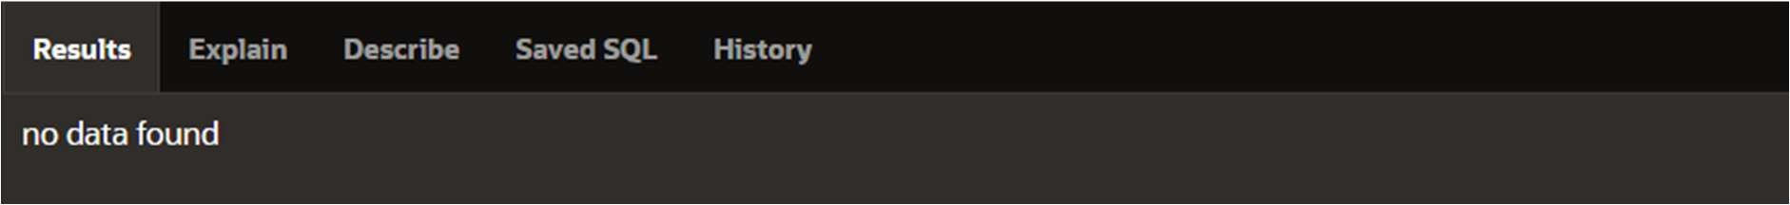

## Find the list of products and orders placed by “Ivan Bayross” and “Mamta Muzumdar”.

### Query:

SELECT S.CL_NO, SD.OD_NO, SD.PR_NO, P.DSCR FROM SALESORDER_DETAILS SD, PRODUCT P, SALESORDER S WHERE SD.OD_NO = S.OD_NO AND P.PR_NO = SD.PR_NO AND S.CL_NO IN (SELECT CL_NO FROM CLIENT WHERE NAME IN

('Ivan Bayross','Mamta Muzumdar'));

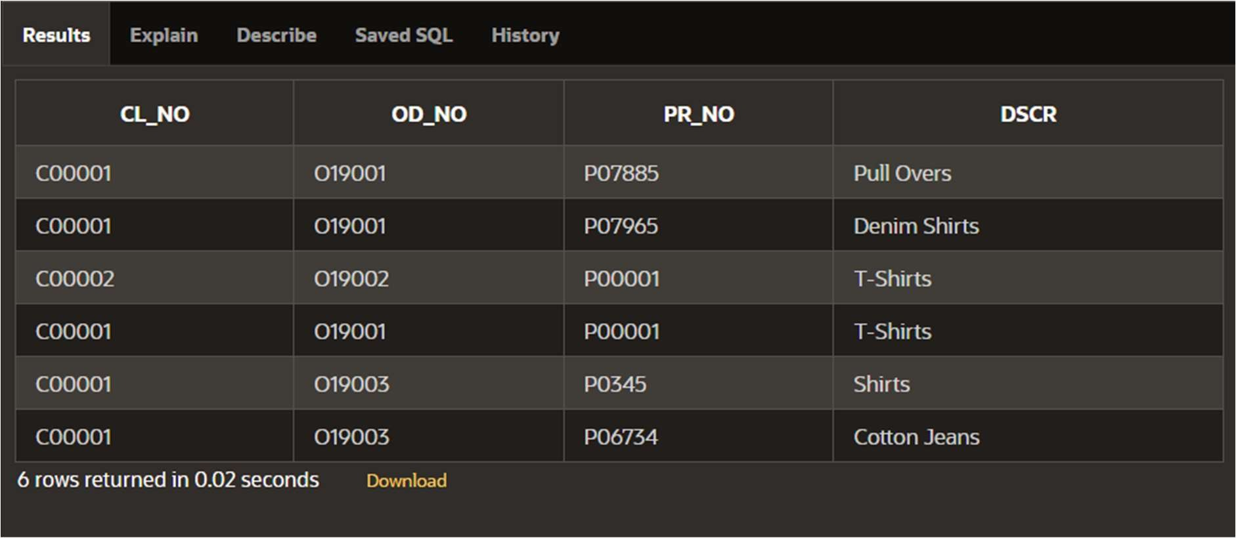

## List the clients who placed order before June’04.

### Query:

SELECT CL_NO FROM SALESORDER WHERE D_DAT < '06-01-2004';

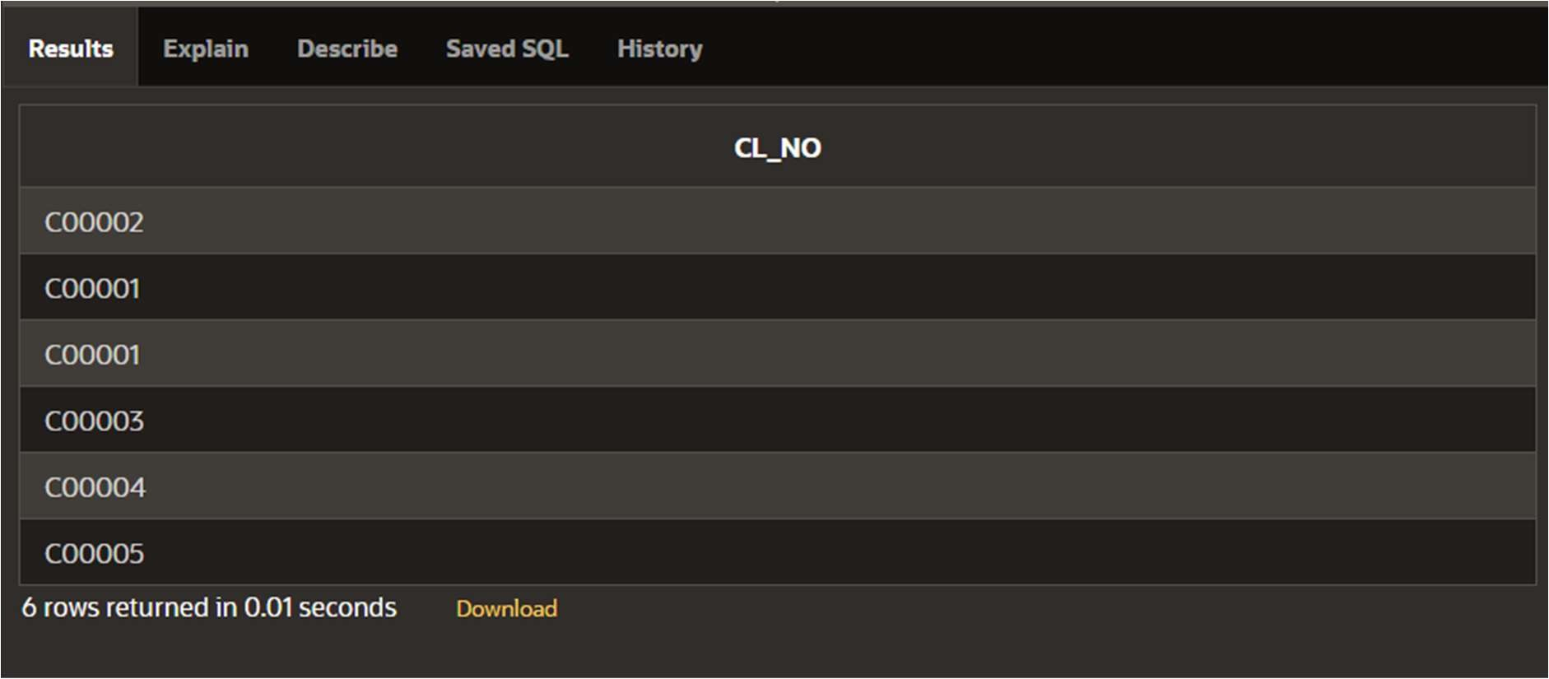

## List all the clients who stays in “Bengaluru” or “Mangalore”.

### Query:

SELECT NAME FROM CLIENT WHERE CITY IN ('Bengaluru', 'Mangalore');

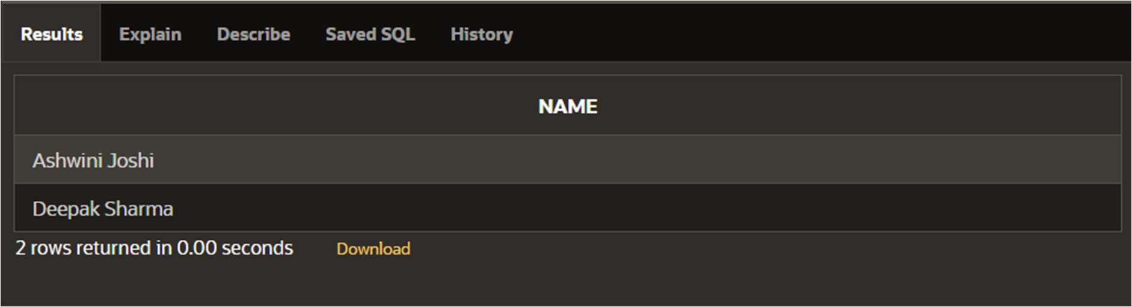

# Practical - No. 10

## Write a PL/SQL Block to Add 2 Numbers

DECLARE

X NUMBER(5); Y NUMBER(5); Z NUMBER(8); BEGIN

X:=3;

Y:=5; Z:=X+Y;

DBMS_OUTPUT.PUT_LINE('SUM IS '||Z); END;

/

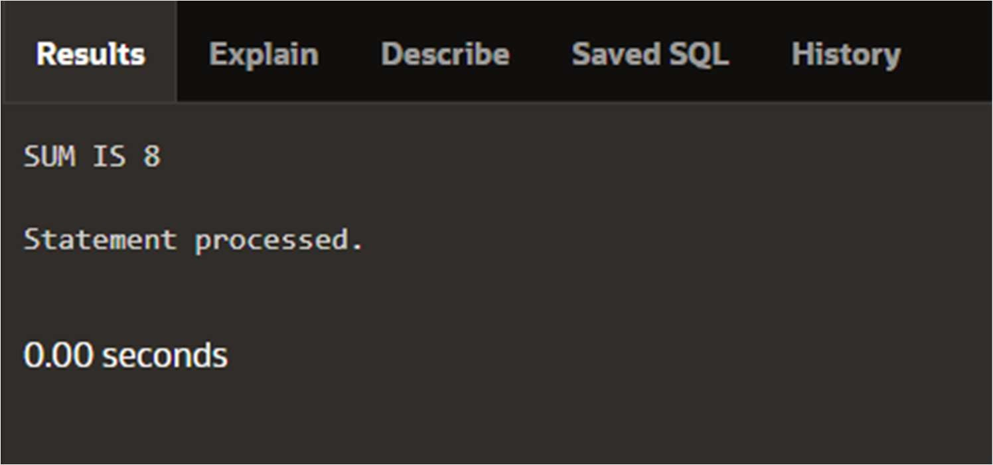

## Write a PL/SQL Block to find Area of Rectangle, Triangle and Square.

DECLARE

LENGTH NUMBER(5); BREADTH NUMBER(5); SIDE NUMBER(5);

AREATRIANGLE NUMBER(8); AREARECTANGLE NUMBER(8); AREASQUARE NUMBER(8); BEGIN

LENGTH:=30; BREADTH:=6; SIDE:=6;

AREATRIANGLE:=(0.5*LENGTH*BREADTH); AREARECTANGLE:=(LENGTH*BREADTH); AREASQUARE:=(SIDE*SIDE);

DBMS_OUTPUT.PUT_LINE('AREA OF RECTANGLE IS '||AREARECTANGLE); DBMS_OUTPUT.PUT_LINE('AREA OF TRIANGLE IS '||AREATRIANGLE);

DBMS_OUTPUT.PUT_LINE('AREA OF SQUARE IS '||AREASQUARE); END;

/

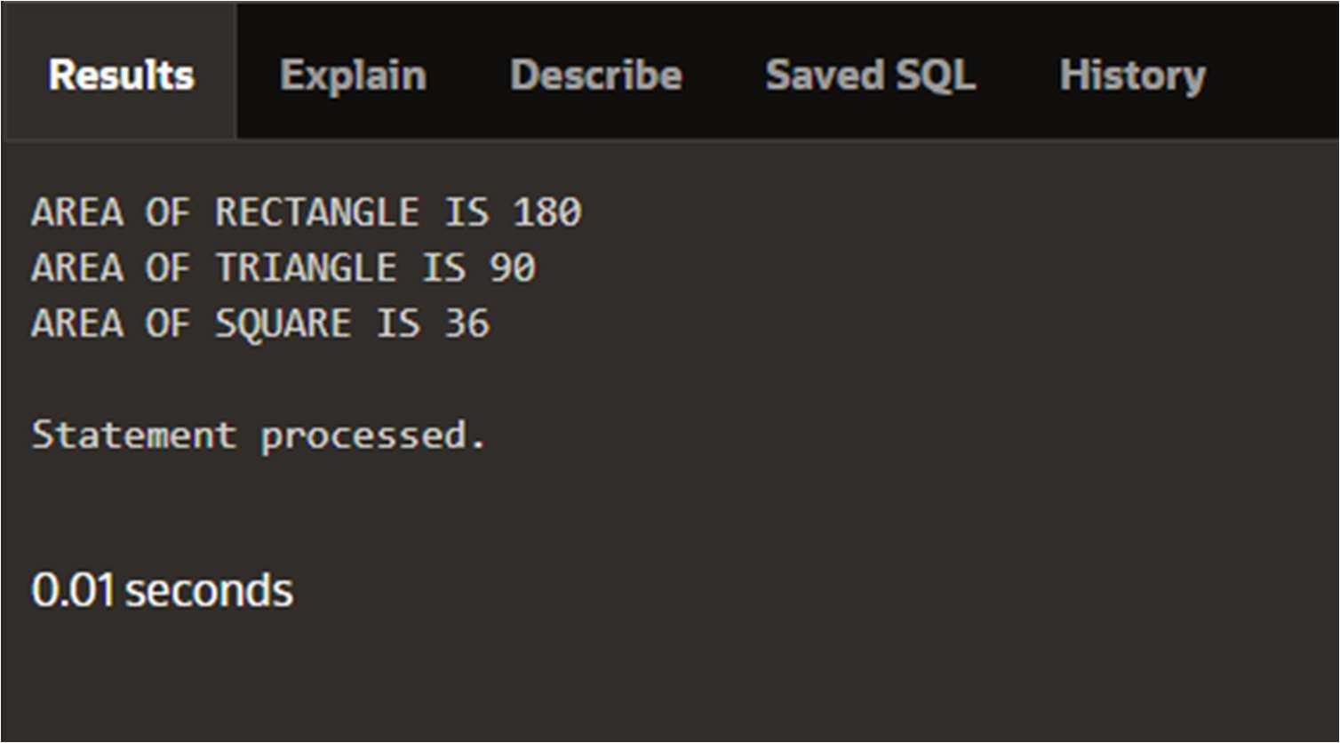

## Write a PL/SQL Block to find Maximum of 3 numbers

DECLARE

A NUMBER := 46; B NUMBER := 67; C NUMBER := 21; BEGIN

IF A > B

AND A > C THEN

DBMS_OUTPUT.PUT_LINE('GREATEST NUMBER IS ' ||A); ELSIF B > A

AND B > C THEN

DBMS_OUTPUT.PUT_LINE('GREATEST NUMBER IS '||B); ELSE

DBMS_OUTPUT.PUT_LINE('GREATEST NUMBER IS ' ||C); END IF;

END;

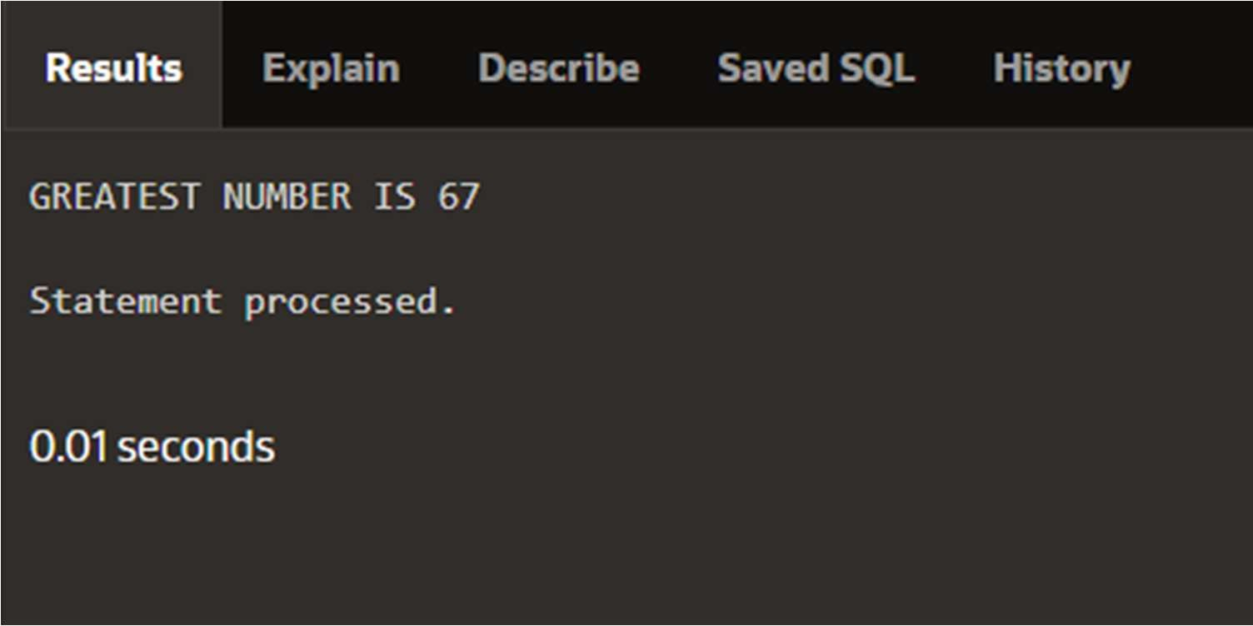

## Write a PL/SQL Block to print sum of N Numbers using For Loop.

DECLARE

X NUMBER; N NUMBER; I NUMBER;

FUNCTION FINDMAX(N IN NUMBER) RETURN NUMBER

IS

SUMS NUMBER := 0; BEGIN

FOR I IN 1..N LOOP

SUMS := SUMS + I*(I+1)/2; END LOOP;

RETURN SUMS; END;

BEGIN N := 4;

X := FINDMAX(N); DBMS_OUTPUT.PUT_LINE('SUM: '|| X); END;

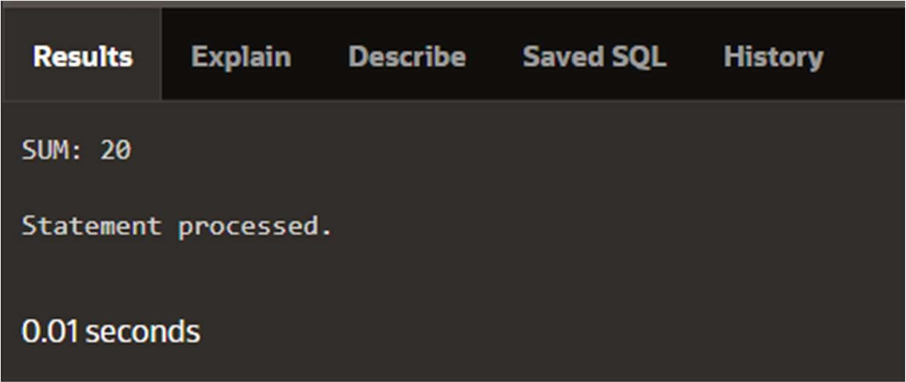

## Write a PL/SQL Block to generate Fibonacci series of N numbers.

DECLARE

FIRST NUMBER := 0; SECOND NUMBER := 1; TEMP NUMBER;

N NUMBER := 5; I NUMBER; BEGIN

DBMS_OUTPUT.PUT_LINE('SERIES:'); DBMS_OUTPUT.PUT_LINE(FIRST); DBMS_OUTPUT.PUT_LINE(SECOND); FOR I IN 2..N

LOOP TEMP:=FIRST+SECOND; FIRST := SECOND; SECOND := TEMP;

DBMS_OUTPUT.PUT_LINE(TEMP); END LOOP;

END;

