**Snehil Gupta 20006959**

**Defect Analysis**

**High**

**Defect ID**

<some-id>

**Descriptive defect name and type**Add Account Button visible but not working

P1 type

**Defect severity**Critical

**Defect priority**high priorirty

**Defect status (e.g., open, fixed, closed, user error, design, and so on) – more robust tools provide a status history for the defect**Open

**Detailed description, including the steps necessary to reproduce the defect**1) Press on the login button

2) reach a page

3) click on add account button

4) the home page is opened again

**Screen prints, logs, etc., that will aid the developer in the resolution process**

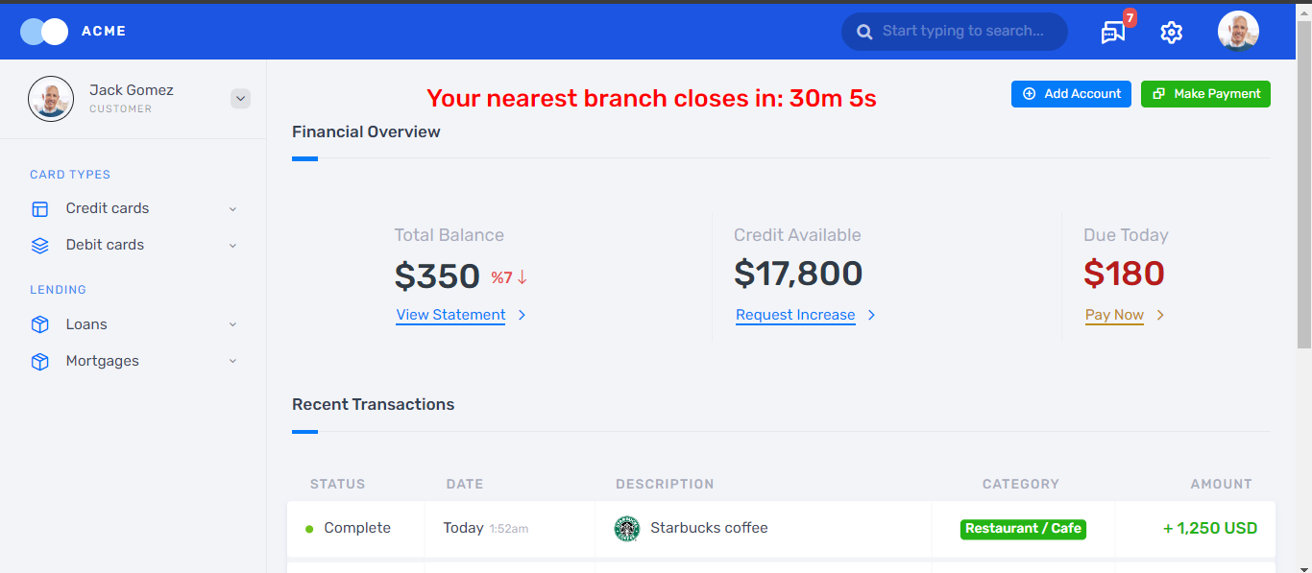

**Medium**

**Defect ID**

<some-id> **Descriptive defect name and type**Credit card view option on left side not working

P2 type

**Defect severity**

**Defect priority**Medium priorirty

**Defect status (e.g., open, fixed, closed, user error, design, and so on) – more robust tools provide a status history for the defect**Open

**Detailed description, including the steps necessary to reproduce the defect**1) Press on the login button

2) reach a page

3) click on credit card button

4) the home page is opened again

**Screen prints, logs, etc., that will aid the developer in the resolution process**

**Low**

**Defect ID**

<some-id> **Descriptive defect name and type**View Profile picture not working

P1 type

**Defect severity**

**Defect priority**low priorirty

**Defect status (e.g., open, fixed, closed, user error, design, and so on) – more robust tools provide a status history for the defect**Open

**Detailed description, including the steps necessary to reproduce the defect**1) Press on the login button

2) reach a page

3) click on profile picture

4) the home page is opened again

**Screen prints, logs, etc., that will aid the developer in the resolution process**

