TASK-1

MOVIE AND REVIEW

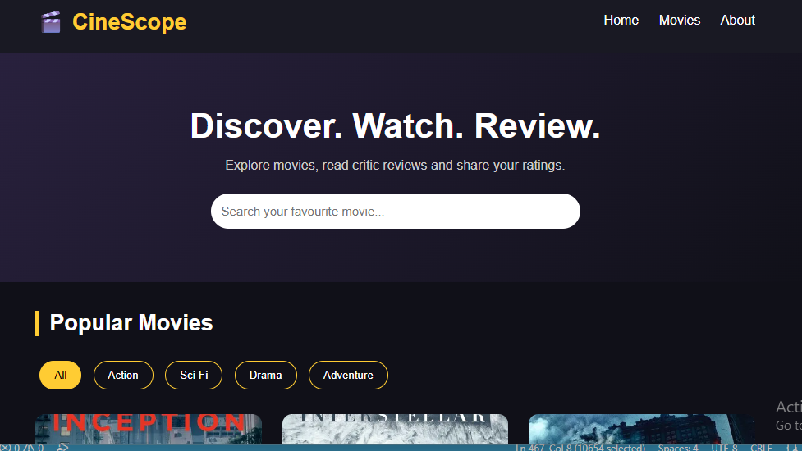

TASK-2

EDUCATION ONLINE LEARNING PLATFORM

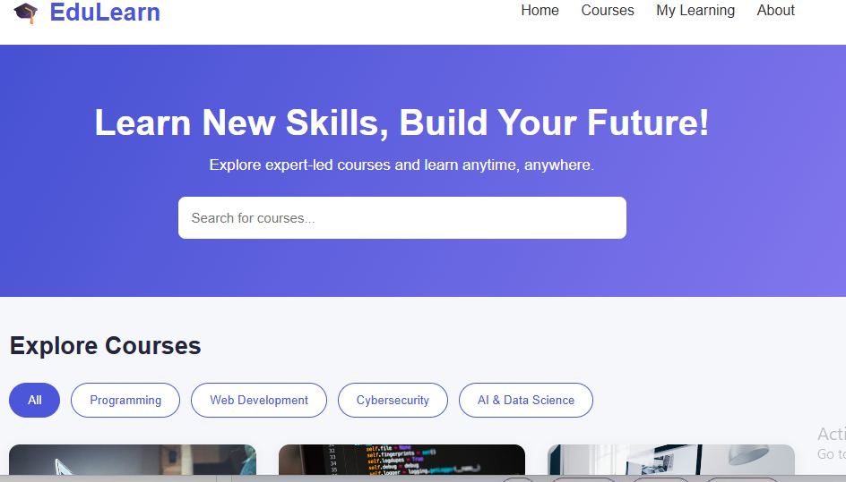

TASK-3

CAKE AND BAKERY SHOP



