MediPredict
AI-Powered Medicine Demand & Inventory Management System
Project Report
Track: Healthcare & MedTech
Submitted for: Course Project Evaluation
Student: Sneha Jadhav
Registration No: 25BAI11265
Date: September 2026

1. Introduction
MediPredict is a Java desktop application built for Jan Aushadhi stores, pharmacies, and small healthcare centers across India. It uses historical sales records, configurable seasonal patterns, and lightweight statistical forecasting to help pharmacy staff decide what medicines to order, how much to order, when to order, and which medicines need immediate attention.
The project was built to satisfy a course requirement to apply subject concepts — object-oriented design, data structures, algorithms, database design, and software engineering practice — to a realistic, socially useful problem. Rather than a toy exercise, MediPredict models a genuine operational pain point faced by pharmacies: balancing the risk of running out of essential medicines against the risk of medicines expiring unused.
The system is explicitly scoped as a decision-support tool. It forecasts, predicts, flags, and recommends — it never diagnoses patients, prescribes or substitutes medicines, declares outbreaks, or moves stock between locations without a human pharmacist's approval. This safety boundary was treated as a first-class design constraint throughout the project, not an afterthought.

2. Problem Statement
Healthcare centers and Jan Aushadhi stores frequently order medicines based on manual estimation and staff experience rather than data. This produces two opposite failures at the same time:
- Stockouts: patients are unable to obtain essential medicines exactly when they need them, because reordering happens reactively, after stock has already run low.
- Wastage: medicines with low or seasonal demand are over-ordered and expire on the shelf before they can be dispensed, wasting scarce pharmacy budget.
Both failures stem from the same root cause — the absence of a systematic, data-driven way to translate past sales into a forecast of future demand, and from a forecast into a concrete, reviewable reorder decision. MediPredict directly targets this gap by answering one central question for every medicine in stock:
“What medicines should we order, how much should we order, when should we order them, and which medicines require immediate attention?”
Target users are pharmacy staff (data entry and day-to-day stock handling) and pharmacy administrators (approving reorders and transfers, reviewing dashboards). The system is designed to be usable by staff with no data-science background — every prediction is expressed as a plain LOW/MEDIUM/HIGH/CRITICAL risk label rather than a raw statistic.

3. Objectives
- Replace manual, experience-based reordering with a repeatable, data-driven forecasting process.
- Reduce the frequency and severity of medicine stockouts for essential drugs.
- Reduce medicine wastage caused by expiry through First-Expiry-First-Out (FEFO) issuing and expiry-risk alerts.
- Give pharmacy staff a single dashboard that surfaces the medicines that need attention right now, ranked by priority.
- Keep every automated suggestion (reorder, transfer, anomaly) subject to human review — the system supports decisions, it does not make them.
- Demonstrate sound object-oriented design, modular architecture, and testable business logic using core Java, independent of any external AI service.

4. Functional Requirements
The system is organized into eleven functional modules, each with a clearly defined input/output structure:

4.1 User & Pharmacy Management
Handles registration and authentication for Admin and Pharmacist/Staff roles, pharmacy/health-center registration, and role-based access control.
- Input: username, password, role, pharmacy/center.
- Output: authenticated session with a role-specific dashboard, or a rejected login with a clear error message.

4.2 Medicine & Inventory Management
Full CRUD (Create, Read, Update, Delete) operations for medicines and stock batches, including batch numbers, expiry dates, suppliers, and minimum stock levels.
- Input: medicine details (ID, name, category, essential status, unit price, minimum stock, reorder level) and batch details (batch ID, medicine ID, quantity, expiry date, purchase price, supplier).
- Output: updated inventory records and current stock levels per medicine and per batch.

4.3 Sales & Data Processing
Records each sale, immediately updates inventory, and computes daily, weekly, and monthly consumption figures plus recent demand trends.
- Input: sale ID, medicine ID, quantity sold, date, pharmacy ID.
- Output: updated stock, average daily demand, and trend data feeding the forecasting engine.

4.4 AI Demand Forecasting
A lightweight statistical forecasting engine (no external AI API) that projects demand 7, 14, and 30 days ahead using:
Predicted Demand = Historical Average × Seasonal Factor × Recent Trend Factor
- Input: historical sales, configurable seasonal factors, recent trend data.
- Output: 7/14/30-day predicted demand per medicine.

4.5 Stockout Prediction
Estimates how many days of usable stock remain and classifies the risk of running out:
Days Until Stockout = Current Usable Stock ÷ Predicted Daily Demand
- Output: risk classification (LOW / MEDIUM / HIGH / CRITICAL) and an alert when stockout is projected within 14 days.

4.6 Smart Reorder Recommendation
Calculates a reorder point and a recommended order quantity, factoring in supplier lead time, safety stock, and essential-medicine status. Every recommendation requires pharmacist review and approval before being acted on.

4.7 Expiry Risk & FEFO
Identifies medicines likely to expire before being sold and enforces First-Expiry-First-Out issuing, so the batch with the earliest expiry date is always dispensed first. Generates EXPIRING SOON and HIGH WASTAGE RISK alerts.

4.8 Demand Anomaly Detection
Compares recent demand against historical demand and flags unusual swings (e.g. a sudden +80% weekly increase) for authorized staff to investigate. The system deliberately never claims an outbreak exists — it only raises a flag.

4.9 Medicine Priority Scoring
Combines essentiality, current stock, predicted demand, days until stockout, days until expiry, and supplier lead time into a single 0–100 priority score, so staff can see at a glance which medicines need attention first.

4.10 Multi-Pharmacy Stock Transfer
Compares stock positions across participating pharmacies and suggests transferring surplus stock from a pharmacy with excess to one facing a predicted stockout. Transfers require explicit staff approval and never happen automatically.

4.11 Dashboard & Reporting
A single view summarizing total medicines, inventory value, low-stock items, predicted stockouts, expiring medicines, demand anomalies, recommended orders, and the highest-priority medicines, with supporting charts for historical and predicted demand.

5. Non-Functional Requirements
Requirement | How it is addressed
Performance | HashMap/ArrayList-based in-memory lookups for O(1) medicine and batch access; forecasting only scans each medicine's own sales history rather than the full dataset.
Security | SHA-256 password hashing, role-based authorization checks before sensitive actions, mandatory PreparedStatement usage in the JDBC layer, credentials read only from environment variables.
Usability | Menu-driven console interface, plain LOW/MEDIUM/HIGH/CRITICAL risk labels, friendly validation error messages, minimal required input per action.
Reliability | Input validation rejects negative quantities and past expiry dates; inventory batches cannot go below zero stock; database failures are caught and reported rather than crashing the app.
Scalability | A dedicated DAO seam (DataStore) isolates storage, so the same service layer can run against thousands of medicines or be pointed at a MySQL backend without changing business logic.
Maintainability | Strict separation into model / service / dao / ui packages; forecasting logic is fully independent of the UI; consistent naming conventions throughout.
Error Handling | A dedicated ValidationException for user-facing errors, a top-level exception guard in the main menu loop, and division-by-zero protection in every forecasting formula.
Logging & Monitoring | A logging utility built on java.util.logging records logins, stock changes, sales, forecast runs, reorder approvals, transfers, and errors to a log file.
Resource Efficiency | In-memory demo mode avoids unnecessary database round-trips; the JDBC scaffolding is written to close connections via try-with-resources.

6. System Architecture
MediPredict follows a four-layer architecture that keeps presentation, business logic, and data access independent of one another so any single layer can be replaced without touching the others:
- Presentation Layer — medipredict.ui (ConsoleUI): handles all user interaction and input/output.
- Service / Business Logic Layer — medipredict.service: ForecastEngine, StockoutPredictor, ReorderEngine, ExpiryAnalyzer, DemandAnomalyDetector, MedicinePriorityCalculator, TransferAdvisor, DashboardService.
- DAO / Data Layer — medipredict.dao: DataStore (in-memory repository used by default), SampleDataLoader, and DatabaseConnection (optional JDBC/MySQL scaffolding).
- Model Layer — medipredict.model: Medicine, InventoryBatch, SalesRecord, Supplier, Pharmacy, User, Alert, ReorderRecommendation.
By default the DAO layer uses an in-memory DataStore so the whole system can be compiled and demonstrated in under a minute with no external setup. A parallel MySQL schema (database/medipredict.sql) and a JDBC DatabaseConnection factory are provided for teams that want real persistence; because the service layer only talks to the DataStore interface, swapping in a JDBC-backed implementation does not require any change to the forecasting, prediction, or reporting logic.

6.1 Process Flow
The system follows a single, consistent workflow from login through to an updated dashboard:
- Login → Dashboard → Select Pharmacy
- Manage Medicines / Inventory → Enter Sales
- System processes historical data → Demand Forecast → Stockout Prediction → Expiry Analysis → Priority Calculation
- Reorder Recommendation generated → Staff reviews → Approve / Reject
- Inventory updated → Reports & Dashboard refreshed

6.2 Use Case Overview
Two roles interact with the system. The Pharmacist/Staff actor logs in, manages medicines and batches, records sales, reviews alerts, and approves or rejects reorder and transfer recommendations. The Admin actor additionally manages user accounts, pharmacy records, and views system-wide reports across all participating pharmacies. Both actors share the core “view dashboard” and “review alerts” use cases, while approval actions (reorder approval, transfer approval) are restricted to authorized roles via role-based access control.

6.3 Class / Component Relationships
The model classes (Medicine, InventoryBatch, SalesRecord, Supplier, Pharmacy, User) are simple data holders with encapsulated fields and validated setters. Each service class depends only on model classes and on the DataStore interface — never on the UI — which keeps the business logic independently testable. ForecastEngine feeds its output into StockoutPredictor and ReorderEngine; ExpiryAnalyzer and DemandAnomalyDetector run independently over the same sales and batch data; MedicinePriorityCalculator combines the outputs of all four into a single ranked score consumed by DashboardService.

6.4 Sequence: Recording a Sale
A representative sequence, illustrating how a single user action ripples through the layers: ConsoleUI captures the sale input → Validator checks quantity and medicine ID → SalesDAO/DataStore persists the SalesRecord and decrements the matching InventoryBatch (earliest-expiry batch first, per FEFO) → ForecastEngine recalculates the medicine's rolling averages → StockoutPredictor and MedicinePriorityCalculator recompute risk and priority → AppLogger records the event → ConsoleUI confirms the update and, if a new alert was triggered, displays it immediately.

7. Database / Storage Design
The optional MySQL schema (database/medipredict.sql) defines the following tables, connected by primary and foreign keys, with appropriate indexes on medicine ID, pharmacy ID, and expiry date for fast lookups:
Table | Purpose
users | Login credentials, hashed passwords, role, and linked pharmacy.
pharmacies | Registered pharmacy/health-center records.
medicines | Medicine catalog: name, category, essential status, unit price, reorder level.
inventory_batches | Individual stock batches with quantity, expiry date, and supplier link.
sales_records | Per-sale transactions used to derive demand and trends.
suppliers | Supplier details and lead times.
reorder_recommendations | Generated reorder suggestions and their approval status.
alerts | Stockout, expiry, and anomaly alerts raised by the service layer.
stock_transfers | Suggested and approved inter-pharmacy transfers.
The in-memory DataStore used for the day-to-day demo mirrors this schema's structure in plain Java collections (HashMap keyed by ID, ArrayList for batch/sales history), so migrating to the JDBC-backed implementation requires no change to how the service layer queries or updates data.

8. Design Decisions & Rationale
- In-memory default, JDBC optional: prioritizing a zero-setup demo experience for evaluation, while still delivering a complete, correct MySQL schema and JDBC scaffolding for teams that want real persistence.
- Statistics over machine learning: the forecasting engine deliberately uses simple, explainable arithmetic (average × seasonal factor × trend factor) rather than a black-box ML model, so pharmacy staff can trust and sanity-check every number, and so the engine runs with zero external dependencies.
- Human approval on every automated suggestion: reorder recommendations, transfer suggestions, and anomaly alerts are all designed as suggestions, not actions — this was treated as a non-negotiable safety boundary given the healthcare context.
- FEFO enforced in code, not left to staff discretion: expiry-driven wastage is one of the two core problems the project targets, so First-Expiry-First-Out batch selection is enforced automatically whenever stock is issued.
- Strict layering (model/service/dao/ui): chosen specifically so the forecasting and prediction logic could be unit-tested in isolation, without needing a running UI or database.

9. Implementation Details
The project contains 20+ Java classes/files organized under src/medipredict, split across model, service, dao, util, and ui packages, plus a separate test/ directory. Core OOP concepts are applied throughout: encapsulation in every model class (private fields, validated accessors), inheritance and interfaces for the DAO abstraction, polymorphism in the alert/risk-classification logic, and collections (HashMap, ArrayList, and where useful PriorityQueue for ranking by priority score) for all in-memory data handling.
Key implementation classes include:
- ForecastEngine.java — calculateAverageDemand(), calculateTrendFactor(), calculateSeasonalFactor(), predictDemand().
- StockoutPredictor.java — days-until-stockout calculation and LOW/MEDIUM/HIGH/CRITICAL classification.
- ReorderEngine.java — reorder point and recommended order quantity calculation.
- ExpiryAnalyzer.java — expiry-risk detection and FEFO batch selection.
- DemandAnomalyDetector.java — recent-vs-historical demand comparison.
- MedicinePriorityCalculator.java — composite 0–100 priority scoring.
- AppLogger, Validator, SecurityUtil — cross-cutting concerns (logging, input validation, password hashing) used by every layer.
Sample data covers 12 demonstration medicines (including Paracetamol, ORS, Amoxicillin, Cetirizine, Ibuprofen, Azithromycin, and basic diabetes medicines) across 2 pharmacies, with multiple batches, varying expiry dates, suppliers, lead times, and 90 days of reproducible (fixed random seed) sales history — including a deliberate demand spike on one medicine so the anomaly detector has a real event to flag during demonstration.

10. Screenshots / Results
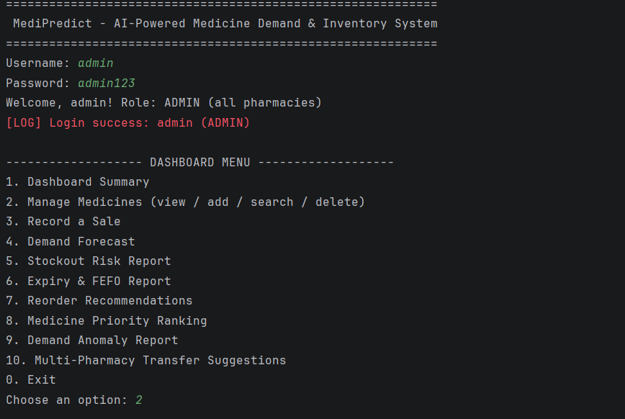
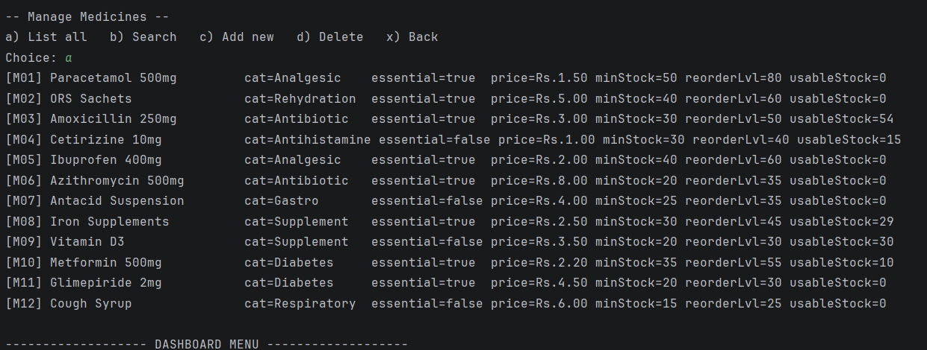

11. Testing Approach
Business logic is covered by a small, dependency-free test runner (no JUnit required) under test/, executed via run-tests.sh. Coverage includes both normal and edge cases:
- Forecasting: correct average-demand math, trend-factor division-by-zero safety, correct seasonal scaling, and guaranteed non-negative output.
- Stockout prediction: days-until-stockout math across different stock/demand scenarios, zero-demand safety, and correct LOW/MEDIUM/HIGH/CRITICAL boundary classification.
- Reorder calculation: correct recommended order quantities, a correctly handled “no order needed” case, CRITICAL priority assignment for an essential medicine at zero stock, and a guarantee that recommended quantities never go negative.
- Expiry detection: medicines at different distances from their expiry date are correctly classified as EXPIRING SOON or not.
- Input validation: negative quantities, invalid dates, empty medicine names, invalid login attempts, and duplicate medicine IDs are all rejected with a clear error rather than corrupting data.

12. Challenges Faced
- Balancing statistical simplicity with usefulness: the forecasting formula needed to be simple enough to run with zero external dependencies and be fully explainable to non-technical pharmacy staff, while still being responsive enough to catch real seasonal and trend shifts in the demo data.
- Avoiding false alarms: an early version of the anomaly detector flagged too many routine demand fluctuations; thresholds had to be tuned so that only genuinely unusual swings (not ordinary week-to-week noise) generated an alert.
- Keeping automation within safe limits: it was tempting to let the system auto-approve small reorders or auto-execute obviously beneficial transfers, but this was deliberately avoided to preserve the “human-in-the-loop” safety principle appropriate for a healthcare-adjacent system.
- Designing for an optional database without duplicating logic: keeping the DataStore interface identical between the in-memory and JDBC implementations required careful upfront interface design so the service layer would never need to change.

13. Learnings & Key Takeaways
- Clear separation between business logic and storage/UI made the forecasting and prediction code far easier to test and reason about in isolation.
- Simple, explainable statistics can deliver genuinely useful decision support — a full machine-learning pipeline is not a prerequisite for solving a real operational problem.
- Designing safety boundaries (no auto-diagnosis, no auto-prescribing, no automatic transfers) early in the project shaped almost every subsequent design decision, and was easier to enforce consistently because it was decided upfront rather than retrofitted.
- Writing tests for the forecasting math early caught several division-by-zero and negative-quantity edge cases that would otherwise have surfaced only during a live demo.

14. Future Enhancements
The current Java statistical engine is intentionally isolated in ForecastEngine so it can later be upgraded without disturbing the rest of the system:
- Machine-learning demand forecasting (e.g. time-series models such as ARIMA or Prophet).
- Integration of real-time disease/outbreak and weather datasets to improve seasonal forecasting.
- Regional demand analysis across a larger network of pharmacies.
- Cloud deployment — the MySQL schema is already structured to support this.
- A companion mobile application for pharmacy staff.
- Integration with government/public-health APIs for essential-medicine availability reporting.

15. References
- Course project specification document: Scope & Requirements, Functional/Non-functional Requirements, Technical Expectations, Design & Documentation Requirements, GitHub Repository Requirements, and Project Report Submission guidelines.
- Oracle Java SE Documentation — java.util.logging, Collections Framework, JDBC API.
- MySQL 8 Reference Manual — schema design, indexing, and PreparedStatement usage for JDBC.
- Ministry of Health & Family Welfare, Government of India — Pradhan Mantri Bhartiya Janaushadhi Pariyojana (Jan Aushadhi scheme), for domain context on generic-medicine store operations.

