WHEN YOU PRESS POWER BUTTON?
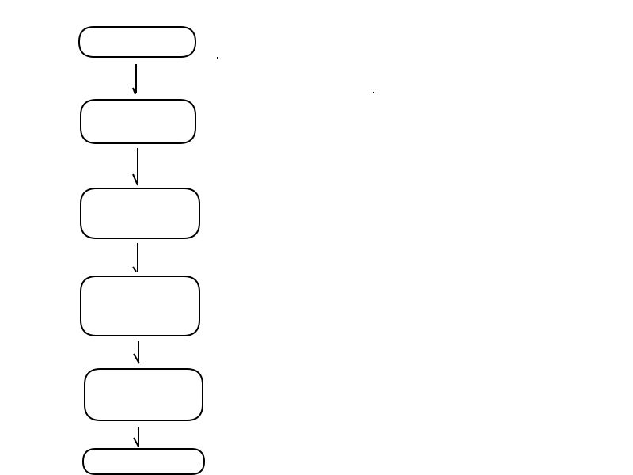
Power On
POST
BIOS
Boot Loader I
Boot Loader II
OS Kernel
Power On Self Test
+ Computer hardware diagonostic
+ Load BIOS at end of physical memory location
Basic Input Output System
+ Set up Interrupt vector table
+ Loads boot sector of boot drive at 0x7c00
+ Limited to 512 Bytes
+ Find and load second stage boot Loader
+ Enable A20, setup Global Discriptor table
+ Setup Interrupt vector table
+ Find and load Kernel
+ Switch to protected mode
+ Our own OS, whatever we wish ;)

POST is a firmware software that perform diagonistic on computer components, for example if enough power supply is present.
Its responsibility includes loading BIOS at the end of physical memory, a jump instruction is placed at physical memory 0x0 to BIOS routine.

Control is transffered to BIOS, whoes major responsibility is to load boot sector of boot drive in memory at location 0x7c00 and pass control to 0x7c00

Boot Loader I loaded at 0x7c00 by BIOS is limited of size of 512 bytes. Due to its size constraint its major task is to find and load second stage boot loader from boot drive to memory and transfer control to second stage boot loader using BIOS interrupts, we will start our operating system implemetation from this stage, Boot Loader I :)

Boot Loader II loaded at memory location 0x500 (becouse we choosed to load at this location), major responsibility is to enable Address line 20, install GDT, install IDT, load kernel in memory,
switch to protected mode and transfer control to our operating system kernel.

TOOLS AND ENVIRONMENT SETUP

BOCHS
An x86 architecture simulator, will be used for testing and debugging Operating system.

1) Bochs installation :

sudo apt-get install bochs bochs-x bochs-sdl

2) Bochs configuration file (bochsrc.txt):

megs: 32
romimage: file="/usr/share/bochs/BIOS-bochs-latest"
vgaromimage: file ="/usr/share/bochs/VGABIOS-lgpl-latest"
floppya: image=myfloppy.img, status=inserted
boot: floppy
display_library: x, options="gui_debug"

3) Bochs usage:

run : bochs -f bochsrc.txt
break-point (debugger) : b <memory location>
continue (debugger) : c

Install script

This will be used to create, mount virtual floppy and copy bootloader in bootsector.

sudo dd if=/dev/zero of=myfloppy.img bs=512 count=2880
sudo losetup /dev/loop0 myfloppy.img
sudo mkdosfs -F 12 /dev/loop0
sudo mount /dev/loop0 myfloppy -t msdos -o "fat=12"
sudo dd if=LOADER.SYS of=/dev/loop0
sudo cp KRNLDR.SYS myfloppy
sudo umount myfloppy
sudo losetup -d /dev/loop0

*note myfloppy is folder that we have created as mount point of our virtual floppy.
*LOADER.SYS will be our stage one boot loader in binary format.
*KRNLDR.SYS will be our stage two boot loader in binary format.

BOOT LOADER STAGE ONE

Tasks of stage one boot loader

+ Print a messege on screen.
+ load Stage two boot loader
+ load root directory at (0x7c00 + 0x0200)
+ search stage two boot loader in root directory
+ save 1st cluster of stage two.
+ load FAT at (0x7c00 + 0x0200)
+ load clusters from FAT table starting from save cluster at 0x500
+ Jump to stage two

Boot loader stage one implemetation prerequesite knowledge

1) Drive structure of FAT12 floppy

Boot Sector | Extra Reserved Sectors | FAT 1 | FAT 2 | Root Directory | Data Region for files

*Structure of disk will be defined by BPB entry(refer code) to let other drivers know about disk stucture

2) FAT is linked list structure, each cluster entry( 12 bits each) stores value of next cluster

Value marks free cluster : 0x00
Value marks Reserved cluster : 0x01
This cluster is in use--the value represents next cluster : 0x002 through 0xFEF
Reserved values : 0xFF0 through 0xFF6
Value marks bad clusters : 0xFF7
Value marks this cluster as the last in the file : 0xFF8 through 0xFFF

3) ROOT directory structure

Bytes 0-7 : DOS File name (Padded with spaces)
Bytes 8-10 : DOS File extension (Padded with spaces)
Bytes 11 : File attributes. This is a bit pattern:
Bit 0 : Read Only
Bit 1 : Hidden
Bit 2 : System
Bit 3 : Volume Label
Bit 4 : This is a subdirectory
Bit 5 : Archive
Bit 6 : Device (Internal use)
Bit 6 : Unused
Bytes 12 : Unused
Bytes 13 : Create time in ms
Bytes 14-15 : Created time, using the following format:
Bit 0-4 : Seconds (0-29)
Bit 5-10 : Minutes (0-59)
Bit 11-15 : Hours (0-23)
Bytes 16-17 : Created year in the following format:
Bit 0-4 : Year (0=1980; 127=2107
Bit 5-8 : Month (1=January; 12=December)
Bit 9-15 : Hours (0-23)
Bytes 18-19 : Last access date (Uses same format as above)
Bytes 20-21 : EA Index (Used in OS/2 and NT, dont worry about it)
Bytes 22-23 : Last Modified time (See byte 14-15 for format)
Bytes 24-25 : Last modified date (See bytes 16-17 for format)
Bytes 26-27 : First Cluster
Bytes 28-32 : File Size

Implmentation of boot loader I

1) Print messege

we will use BIOS interrupt 0x10 – video teletyping output
AH = 0x0E
AL = character to write
BH = Page number (should be zero)
BL = Foreground color (graphic mode only)

2) load Stage two boot loader

we will use BIOS interuppt 0x13 – reading sectors
AH = 0x02
AL = no of sectors to read
CH = low 8 bits of cylinder number
CL = sector number
DH = Head Number
DL = drive number
ES:BX = buffer to read to

returns:
AH = status code
AL = number of sectors read
CF = set if failure, cleared if success

we will also use BIOS interrupt 0x13 to reset floppy disk
AH = 0x0
DL = drive to reset

returns
AH = status code
CF = set if failure, cleared if success

BOOTLOADER STAGE TWO

+ Print loading messege
+ Find and load kernel at 0x30000 using bios interrupts as in boot loader1
+ Install default GDT
+ Enable A20 using output port of keyboard controller
+ Switch to protected mode
+ Copy kernel image at 0x100000
+ Jump to kernel

Boot loader stage one implemetation prerequesite knowledge

1) Rings of Assembly

Ring 0, Ring 1, Ring 2, Ring 3.The smaller the ring number, the more control (and less level of protection), the software has.

2) Real mode V/S Protected mode

Real mode
+ No memory protection, all programs text/data are dumped into a single piece of memory.
+ No support for virtual memory
+ 20 bit address line
+ 16 bit register
+ Segment:offset model, physical address = segment* 2⁴ + offset
+ Limited to 1MB of memory access
+ No rings of Protection

Protected mode
+ Provides memory protection
+ Virtual memory and TSS
+ 4 Rings of protection
+ 32 bit address line and 32 bit register
+ Access to 4GB of memory
+ Descriptor:offset model, desriptor defines memory protection and offset is physical address in memory

3) Global Descriptor table structure
Bits 56-63: Bits 24-32 of the base address
Bit 55: Granularity
0: None
1: Limit gets multiplied by 4K
Bit 54: Segment type
0: 16 bit
1: 32 bit
Bit 53: Reserved-Should be zero
Bits 52: Reserved for OS use
Bits 48-51: Bits 16-19 of the segment limit
Bit 47: Segment is in memory (Used with Virtual Memory)
Bits 45-46: Descriptor Privilege Level
0: (Ring 0) Highest
3: (Ring 3) Lowest
Bit 44: Descriptor Bit
0: system Descriptor
1: Code or Data Descriptor
Bits 41-43: Descriptor Type
Bit 43: Executable segment
0: Data Segment
1: Code Segment
Bit 42: Expansion direction (Data segments), conforming (Code Segments)
Bit 41: Readable and Writable
0: Read only (Data Segments); Execute only (Code Segments)
1: Read and write (Data Segments); Read and Execute (Code Segments)
Bit 40: Access bit (Used with Virtual Memory)
Bits 16-39: Bits 0-23 of the Base Address
Bits 0-15: Bits 0-15 of the Segment Limit

4) CR0 register structure

CR0 is the primary control register. It is 32 bits, which are defined as follows:
Bit 0 (PE) : Puts the system into protected mode
Bit 1 (MP) : Monitor Coprocessor Flag This controls the operation of the WAIT instruction.
Bit 2 (EM) : Emulate Flag. When set, coprocessor instructions will generate an exception
Bit 3 (TS) : Task Switched Flag This will be set when the processor switches to another task.
Bit 4 (ET) : ExtensionType Flag. This tells us what type of coprocesor is installed.
0 - 80287 is installed
1 - 80387 is installed.
Bit 5 (NE): Numeric Error
0 - Enable standard error reporting
1 - Enable internal x87 FPU error reporting
Bits 6-15 : Unused
Bit 16 (WP): Write Protect
Bit 17: Unused
Bit 18 (AM): Alignment Mask
0 - Alignment Check Disable
1 - Alignment Check Enabled (Also requires AC flag set in EFLAGS and ring 3)
Bits 19-28: Unused
Bit 29 (NW): Not Write-Through
Bit 30 (CD): Cache Disable
Bit 31 (PG) : Enables Memory Paging.
0 - Disable
1 - Enabled and use CR3 register

5) Keyboard Port Mapping
Port Read/Write Descripton
0x60 Read Read Input Buffer
0x60 Write Write Output Buffer
0x64 Read Read Status Register
0x64 Write Send Command to controller

6) Keyboard controller commands
0xD0 | Read Output Port
0xD1 | Write Output Port
0xDD | Enable A20 Address Line
0xDF | Disable A20 Address Line

BOOTLOADER STAGE TWO IMPLEMENTATION

1)Installing GDT

Default Code GDT
11111111 11111111 00000000 00000000 00000000 10011010 11001111 00000000

Default Data GDT
11111111 11111111 00000000 00000000 00000000 10010010 11001111 00000000

Install GDT : x86 gdtr instruction

2)Enabling Address line 20 through Keybord controller output port

- Send read output port command(0xD0) t0 keyboard controler port (0x64).
- Read Input Buffer (port 0x60) and store it.
- Send Write output port command(0xD1) to keyboard controller port (0x64).
- Write stored date with bit 1 set to enable A20 to output port (0x60).

3)Switch to protected mode

Enable protected mode bit in control register CR0.

C KERNEL

Tool for compiling C kernel

We will be compiling all programs in ELF format, But to avoid hectics of parsing ELF format and other formats in our own bootlaoder for now, we will be converting kernel image (after it is being linked with other object files) from ELF to pure binary using objcopy. However we have planned to build our kernel in ELF format and parse it in future.

1) Linker Script

Used to specify entry point and for calcutation of address of data by linker.

ENTRY( start )
SECTIONS {
.text 0x100000 :
{
code = .; _code = .; __code = .;
*(.text)
. = ALIGN(4096);
}
.data :
{
data = .; _data = .; __data = .;
*(.data)
*(.rodata)
. = ALIGN(4096);
}
.bss :
{
bss = .; _bss = .; __bss = .;
*(.bss)
. = ALIGN(4096);
}
end = .; _end = .; __end = .;
}

2) Build Script

nasm -f elf loader.asm

gcc -m32 -nostdlib -nostdinc -fno-builtin -fno-stack-protector -c -o kmain.o kmain.c

ld -m elf_i386 -T link.ld -o KERNEL.ELF loader.o kmain.o

objcopy -O binary KERNEL.ELF KERNEL.SYS

*loader.asm is kernel entry point (start lable defined here)
*kmain.c is C kernel
*link.ld is loader script

