NATURAL LANGUAGE UNDERSTANDING

NLU, a subset of [natural language processing (NLP)](https://research.aimultiple.com/nlp/) and conversational AI, helps conversational AI applications to determine the purpose of the user and direct them to the relevant solutions.

NLU is an AI-powered solution for recognizing patterns in a human language. It enables [conversational AI](https://research.aimultiple.com/conversational-ai/) solutions to accurately identify the intent of the user and respond to it. When it comes to conversational AI, the critical point is to [understand what the user says or wants to say in both speech and written language](https://research.aimultiple.com/nlu-vs-nlp/).

NLU helps computers to understand human language by understanding, analyzing and interpreting basic separately

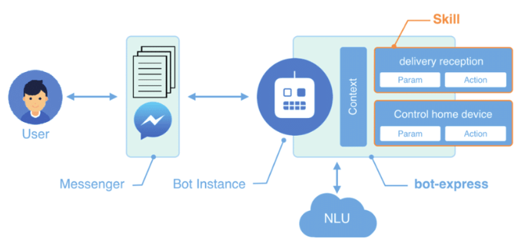

## IMPLEMENTATION OF NLU :

* NAMED ENTITY RECOGNITION

The named entity recognition (NER) is one of the most popular data preprocessing task. It involves the identification of key information in the text and classification into a set of predefined categories. An entity is basically the thing that is consistently talked about or refer to in the text.

NLP is just a NER is the form of NLP.

At its coretwo-step process, below are the two steps that are involved:

* Detecting the entities from the text
* Classifying them into different categories
* SENTIMENT ANALYSIS

**Sentiment analysis** (also known as **opinion mining** or **emotion AI**) is the use of [natural language processing](https://en.wikipedia.org/wiki/Natural_language_processing), [text the analysis](https://en.wikipedia.org/wiki/Text_analytics), [computational the linguistics](https://en.wikipedia.org/wiki/Computational_linguistics), and [biometrics](https://en.wikipedia.org/wiki/Biometrics) to systematically identify, extract, quantify, and study affective states and subjective information. Sentiment analysis is widely applied to [voice of the customer](https://en.wikipedia.org/wiki/Voice_of_the_customer) materials such as reviews and survey responses, online and social media, and healthcare materials for applications that range from [marketing](https://en.wikipedia.org/wiki/Marketing) to [customer service](https://en.wikipedia.org/wiki/Customer_relationship_management) to clinical medicine. With the rise of deep language models, such as [RoBERTa](https://en.wikipedia.org/w/index.php?title=RoBERTa&action=edit&redlink=1), also more difficult data domains can be analyzed, e.g., news texts where authors typically express their opinion/sentiment less explicit

* CONTEXT AWARNESS

Natural Language Understanding (NLU) is a core component of dialog systems. It typically involves two tasks - intent classification (IC) and slot labeling (SL), which are then followed by a dialogue management (DM) component. Such NLU systems cater to utterances in isolation, thus pushing the problem of context management to DM. However, contextual information is critical to the correct prediction of intents and slots in a conversation. Prior work on contextual NLU has been limited in terms of the types of contextual signals used and the understanding of their impact on the model. In this work, we propose a context-aware self-attentive NLU (CASA-NLU) model that uses multiple signals, such as previous intents, slots, dialog acts and utterances over a variable context window, in addition to the current user utterance. CASA-NLU outperforms a recurrent contextual NLU baseline on two conversational datasets, yielding a gain of up to 7% on the IC task for one of the datasets.

## ADVANCED FEATURES OF NLU :

* USE A VAREITY OF TRAINING DATA

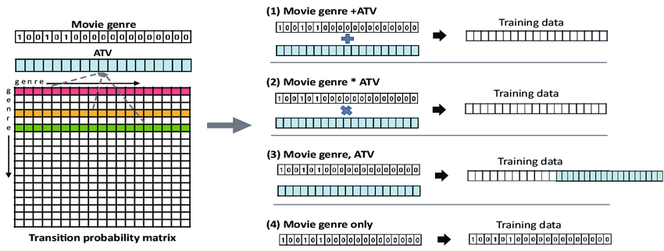

NLU training data consists of example user utterances categorized by intent. To make it easier to use your intents, give them names that relate to what the user wants to accomplish with that intent, keep them in lowercase, and avoid spaces and special characters.

* USE A ROBUST NLU LIBRARY

NLP libraries are built-in packages to incorporate NLP solutions into your application. Such libraries are really useful as they enable developers to focus on what really matters for the project. Below is an introduction to some of the most popular NLP Libraries that can be used to build intelligent applications.

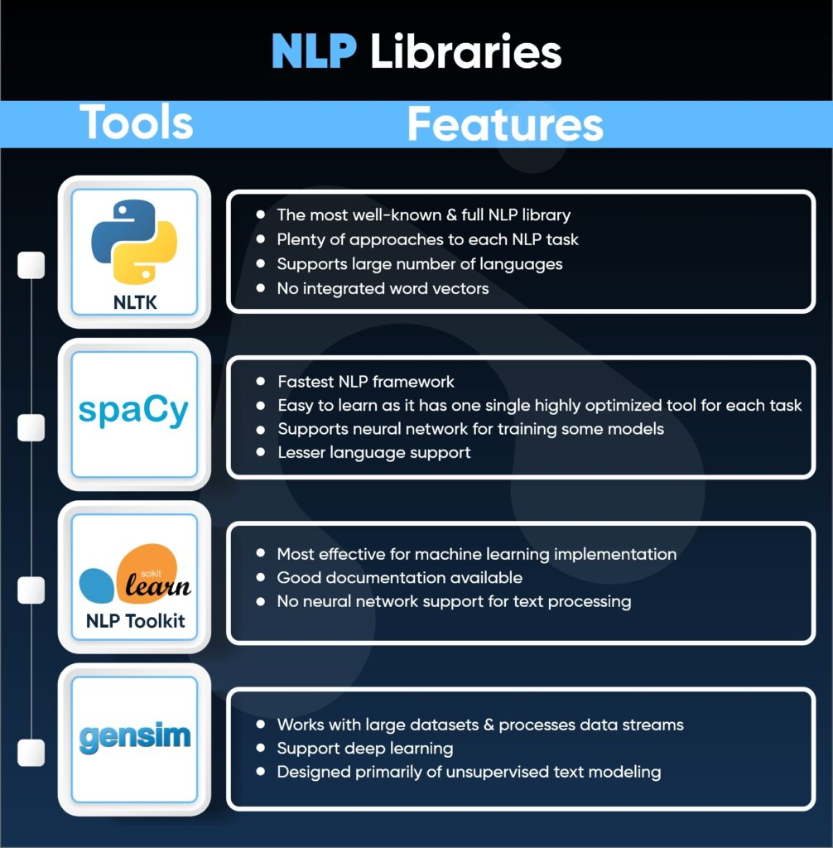

* TUNE THE NLU MODEL

When building conversational assistants, we want to create natural experiences for the user, assisting them without the interaction feeling too clunky or forced. To create this experience, we typically power a conversational assistant using an **NLU**.

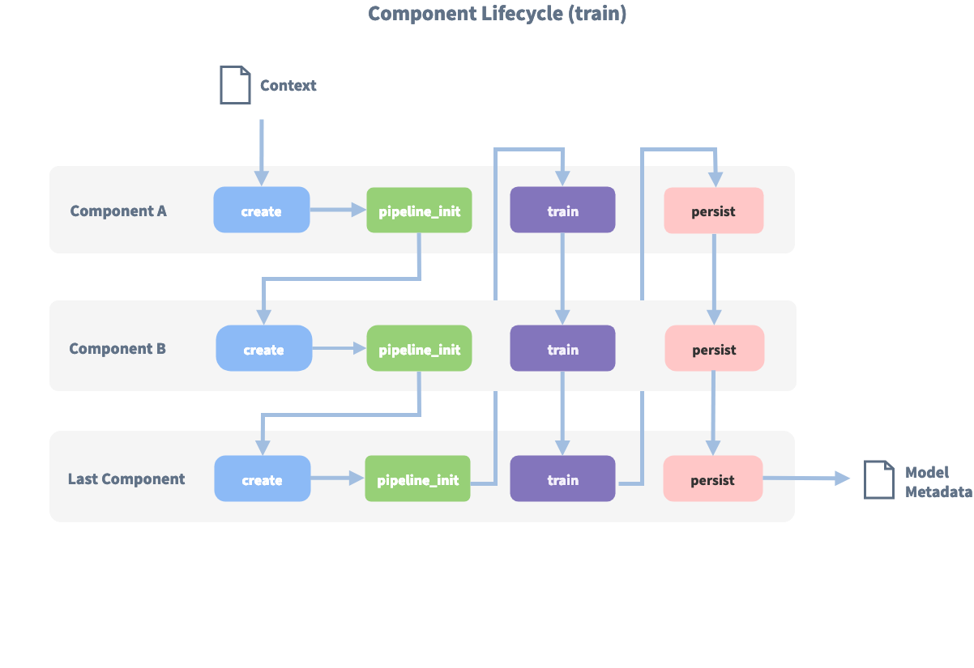

* USE NLU FEATURES IN YOUR SYSTEM

Natural Language Understanding provides a workbench and an NLU inference service that you can use to enable the system to learn and respond to human-expressed intent. By entering natural language examples into the system, you help it understand word meanings and contexts so it can infer user or system actions

The goal of NLU (Natural Language Understanding) is to extract structured information from user messages. This usually includes the user's [intent](https://rasa.com/docs/rasa/glossary#intent) and any [entities](https://rasa.com/docs/rasa/glossary#entity) their message contains. You can add extra information such as [regular expressions](https://rasa.com/docs/rasa/nlu-training-data/#regular-expressions) and [lookup tables](https://rasa.com/docs/rasa/nlu-training-data/#lookup-tables) to your training data to help the model identify intents and entities correctly.

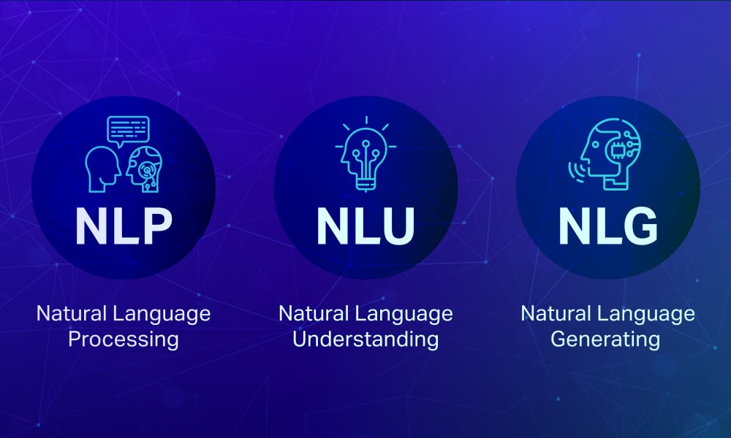

Certainly! Here's an example of performing more advanced NLU tasks using Python and the Natural Language Toolkit (NLTK), including Named Entity Recognition (NER) and Sentiment Analysis:

```python

import nltk

from nltk.tokenize import word_tokenize

from nltk import pos_tag, ne_chunk

from nltk.sentiment.vader import SentimentIntensityAnalyzer

nltk.download('punkt')

nltk.download('averaged_perceptron_tagger')

nltk.download('maxent_ne_chunker')

nltk.download('words')

nltk.download('vader_lexicon')

# Sample text

text = "Apple Inc. is planning to launch a new product next week. " \

"Customers seem excited about it."

# Tokenize the text into words

words = word_tokenize(text)

# Perform part-of-speech tagging

pos_tags = pos_tag(words)

# Perform Named Entity Recognition (NER)

ner_tags = ne_chunk(pos_tags)

# Sentiment Analysis

analyzer = SentimentIntensityAnalyzer()

sentiment_score = analyzer.polarity_scores(text)

print("Tokens:", words)

print("POS tags:", pos_tags)

print("NER tags:", ner_tags)

print("Sentiment Score:", sentiment_score)

```

## In this example:

1. We tokenize the text into words.

2. We perform part-of-speech tagging to identify the grammatical components of the text.

3. We use Named Entity Recognition (NER) to identify entities like "Apple Inc." as an organization.

4. We conduct Sentiment Analysis to determine the sentiment of the text.

You can further customize and expand these features based on your specific NLU requirements.

TIPS OF NLU

## ****3 ways to begin using NLU—here’s why and how****

The good news is that despite many challenges, [NLU is breaking out](http://cacm.acm.org/magazines/2016/3/198856-deep-or-shallow-nlp-is-breaking-out/fulltext). This means that whether you work with product reviews, receive user feedback, or interact with customers, you can start using NLU methods today. Here are three tips for how and why to get started:

**1. You can choose the smartest algorithm out there without having to pay for it**Most algorithms are publicly available as open source. It’s astonishing that if you want, you can download and start using the same algorithms Google used to beat the world’s [Go champion](http://googleresearch.blogspot.co.nz/2016/04/deepmind-moves-to-tensorflow.html), right now. Many machine learning toolkits come with an array of algorithms; which is the best depends on what you are trying to predict and the amount of data available. While there may be some [general guidelines](http://scikit-learn.org/stable/tutorial/machine_learning_map/), it’s often best to [loop through them](http://scikit-learn.org/stable/auto_examples/classification/plot_classifier_comparison.html) to choose the right one.

**2. Your knowledge of the business is more important than the best algorithm**  
When integrating NLU into a new product or service, it is more important to understand the specific business field—how it works and its priorities—than to have the best algorithm at hand. Consider this example: [an app that lets you query Salesforce in natural language](http://venturebeat.com/2014/01/24/salesforce-prize-winner-upshot-teases-investors-with-voice-triggered-analytics/). Knowing which questions users are likely to ask and which data can be queried from Salesforce is more important than having the most accurate language parser. After all, it’s more important to solve the right problem with an “okay” algorithm than the wrong problem with the best algorithm out there.

# **3. It’s likely that you already have enough data to train the algorithms** Google may be the most prolific producer of successful NLU applications. The reason why its search, machine translation and ad recommendation work so well is because Google has access to huge data sets. For the rest of us, current algorithms like [word2vec](http://deeplearning4j.org/word2vec) require significantly less data to return useful results.

Indeed, companies have already started integrating such tools into their [workflows](https://wise.io/2015/04/25/five-takeaways-on-the-state-of-natural-language-processing/). If your business has as a few thousand product reviews or user comments, you can probably make this data work for you using word2vec, or other language modelling methods

NLP Examples

1. Spam filtering is a common example of NLP.  
2. Other examples of NLP tasks include automatic summarization, sentiment analysis, topic extraction, named entity recognition, machine translation, and question answering.

conclusion

natural language processing is a field of computer science and linguistics that deals with the interaction between computers and human languages. NLP enables computers to understand human language and respond in a way that is natural for humans.

Aim of NLUto help computers understand human language well enough that they can converse in a natural way.