Project Design Phase-II
Technology Stack (Architecture & Stack)
Date | 01 October 2026
Team ID | [Enter Team ID]
Project Name | Script-Controlled ACL – Restrict Record Access Based on Field Value
Maximum Marks | 4 Marks
Technical Architecture:
The architectural diagram below shows how users and administrators reach the Institution Details records through the ServiceNow interface and the ACL evaluation engine. The components and technologies are listed in Table-1 and Table-2.
Script-Controlled ACL – Restrict Record Access Based on Field Value (ServiceNow)
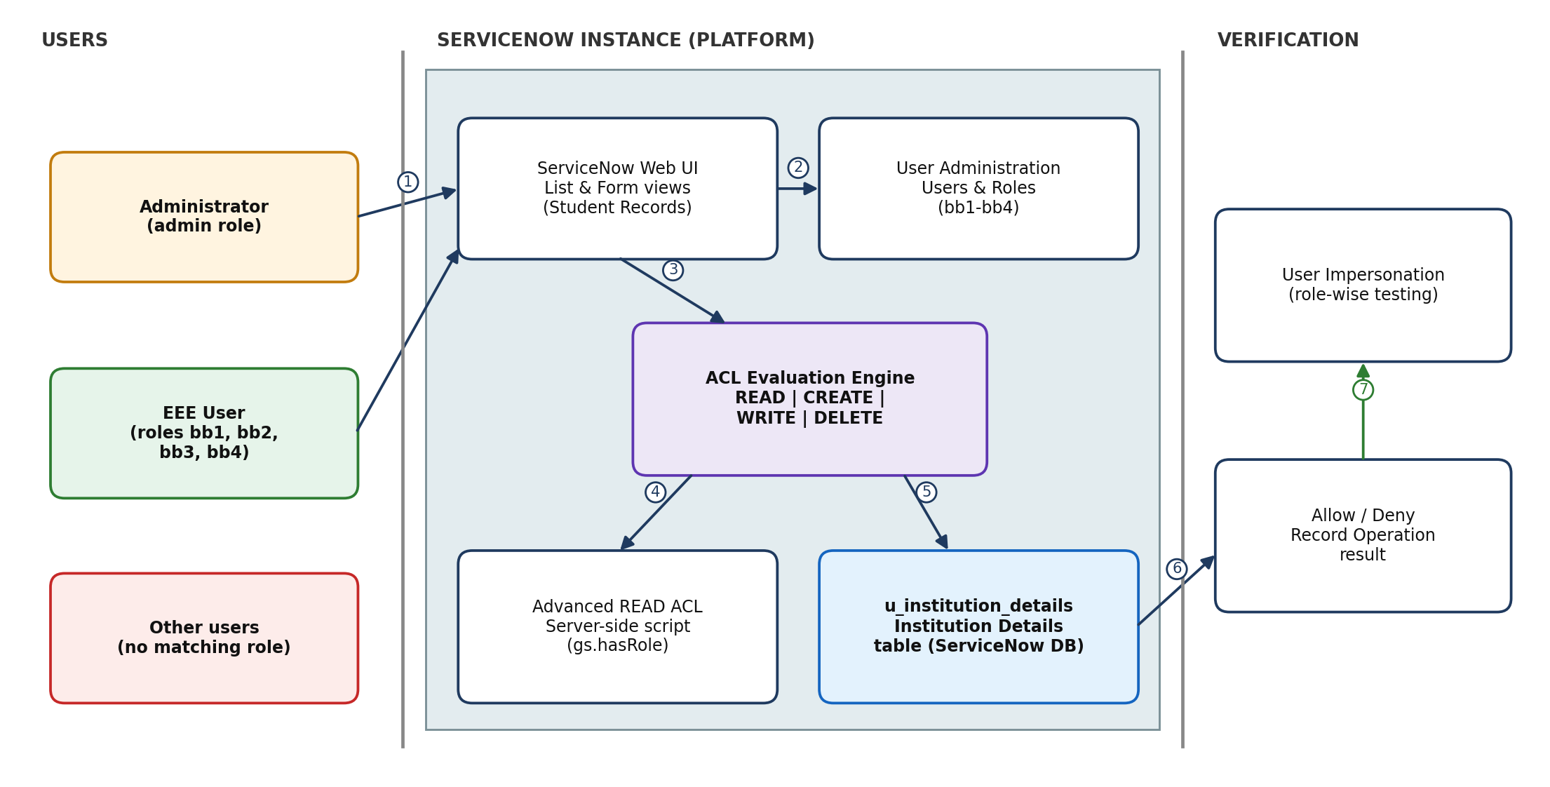
Figure 1: Technical architecture. 1 – User or administrator opens the interface; 2 – roles from User Administration; 3 – request is sent to the ACL engine; 4 – READ ACL script is evaluated; 5 – decision is applied to the u_institution_details table; 6 – allow/deny result; 7 – verified through impersonation.
Table-1 : Components & Technologies:
S.No | Component | Description | Technology
1. | User Interface | Users and administrators interact through the ServiceNow web interface: Student Records list view and record form, plus the User, Role, Table and ACL configuration screens. | ServiceNow platform web UI (list and form views)
2. | Application Logic-1 | Advanced READ ACL script that decides record visibility: returns true for admin and for users with role bb1, otherwise false. | ServiceNow server-side JavaScript (GlideSystem – gs.hasRole())
3. | Application Logic-2 | Role-based CREATE, WRITE and DELETE ACLs on the Institution Details table: bb2 for create, bb3 for write, bb4 for delete. | ServiceNow ACL engine (role-based access control)
4. | Application Logic-3 | User and role setup (EEE User, roles bb1–bb4) and verification of CRUD behaviour through user impersonation. | ServiceNow User Administration and Impersonate User feature
5. | Database | Custom table u_institution_details (label: Institution Details) with fields: Student Roll Number (Auto Number), Student Name (Reference – User), Faculty Name (Reference – User), Branch (Choice: ECE, EEE, CSE), Email (String), Phone Number (String), Description (Multi String). | ServiceNow platform database (System Definition → Tables)
6. | Cloud Database | The table data is stored in the database of the cloud-hosted ServiceNow instance; no separate database service is configured. | ServiceNow cloud instance database
7. | File Storage | No file storage is required by the application. Project configuration and documentation are shared through a Git repository. | GitHub (github.com/dhaarani21/ACL) / local filesystem
8. | External API-1 | Not used – no external API integration is part of this project. | Not applicable
9. | External API-2 | Not used – no REST API endpoints are specified in the project. | Not applicable
10. | Machine Learning Model | Not used – access decisions are rule-based (roles and script), not predicted by a model. | Not applicable
11. | Infrastructure (Server / Cloud) | Application is configured and demonstrated directly on a ServiceNow instance with administrator privileges (elevation to security_admin is needed for ACL changes). Local server configuration: none required. Cloud server configuration: ServiceNow-managed cloud instance. | ServiceNow Now Platform (cloud-hosted instance)
Table-2: Application Characteristics:
S.No | Characteristics | Description | Technology
1. | Open-Source Frameworks | The solution is built on the proprietary ServiceNow platform and uses no open-source application framework. Git/GitHub is used to share the project configuration. | Git, GitHub
2. | Security Implementations | Separate ACLs for READ, CREATE, WRITE and DELETE; custom roles bb1–bb4 enforce least-privilege access; advanced READ ACL script denies users who are neither admin nor bb1; ACL editing requires security_admin elevation; administrator keeps full access; behaviour is verified by impersonating users. | ServiceNow ACLs, roles, gs.hasRole(), security_admin role
3. | Scalable Architecture | Platform-managed multi-tier architecture (user interface, application server, database). The role + ACL + script pattern can be reused for other branches, departments and custom tables without changing the platform. | ServiceNow Now Platform (multi-tier)
4. | Availability | Availability is provided by the cloud-hosted ServiceNow instance; no custom load balancer or distributed servers are configured by the project team. | ServiceNow-managed cloud hosting
5. | Performance | The READ ACL script is lightweight (two role checks, no database queries) and is evaluated server-side by the ACL engine, so access decisions add minimal overhead per request. | ServiceNow ACL engine, server-side script
References:
https://c4model.com/
https://www.servicenow.com/docs/
https://github.com/dhaarani21/ACL

