I need a responsive company website with Home, About and Con
Status: Approved by reviewer
Run: 4550496b - 2026-10-08 12:17
Domains: frontend

1. Executive summary
I need a responsive company website with Home, About and Contact pages. Frontend only.
Project type: Mock project - medium complexity. Mock estimate.
At a glance: 2.5 FTE team, about 47 person-days of effort, about 7 weeks to deliver.
Reviewer: Solution matches the scope; security gap closed.

2. Solution architecture
Mock architecture: users reach a web application through a managed edge; services, data and (where needed) AI components run inside one cloud boundary.

2.1 High-level solution architecture diagram

High-level solution architecture
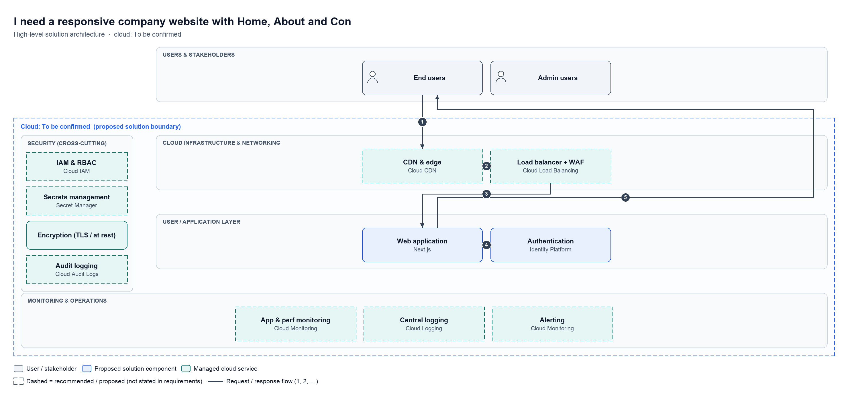

Cloud: To be confirmed. Boxes are grouped by layer and coloured by type (client system, proposed component, third-party, managed cloud service, AI, data store). Dashed boxes are recommended additions that the requirement did not state.

2.2 End-to-end data flow
Request / response
- 1. End users → CDN & edge: HTTPS request
- 2. CDN & edge → Load balancer + WAF: Route + filter
- 3. Load balancer + WAF → Web application: Serve app
- 4. Web application → Authentication: Sign in
- 5. Web application → End users: Rendered page

2.3 Major components
Layer | Component | Technology | Type | Status | Purpose
Users & stakeholders | End users | - | actor | required | Mock: end users
Users & stakeholders | Admin users | - | actor | required | Mock: admin users
User / application layer | Web application | Next.js | proposed | required | Mock: web application
User / application layer | Authentication | Identity Platform | proposed | required | Mock: authentication
Cloud infrastructure & networking | CDN & edge | Cloud CDN | cloud service | recommended | Mock: cdn & edge
Cloud infrastructure & networking | Load balancer + WAF | Cloud Load Balancing | cloud service | recommended | Mock: load balancer + waf
Security | IAM & RBAC | Cloud IAM | cloud service | recommended | Mock: iam & rbac
Security | Secrets management | Secret Manager | cloud service | recommended | Mock: secrets management
Security | Encryption (TLS / at rest) | - | cloud service | required | Mock: encryption (tls / at rest)
Security | Audit logging | Cloud Audit Logs | cloud service | recommended | Mock: audit logging
Monitoring & operations | App & perf monitoring | Cloud Monitoring | cloud service | recommended | Mock: app & perf monitoring
Monitoring & operations | Central logging | Cloud Logging | cloud service | recommended | Mock: central logging
Monitoring & operations | Alerting | Cloud Monitoring | cloud service | recommended | Mock: alerting

2.4 Requirement traceability
Requirement | Delivered by
As described in the requirement | IAM & RBAC, Secrets management
Responsive | Web application, Authentication
Secure | IAM & RBAC, Secrets management
Maintainable | Web application, Authentication

2.5 Key assumptions
- Mock: single region deployment
- Mock: corporate SSO is available

2.6 Recommended technology stack
Layer | Technology | Purpose | Status
User / application layer | Next.js | Mock: web application | required
User / application layer | Identity Platform | Mock: authentication | required
Cloud infrastructure & networking | Cloud CDN | Mock: cdn & edge | recommended
Cloud infrastructure & networking | Cloud Load Balancing | Mock: load balancer + waf | recommended
Security | Cloud IAM | Mock: iam & rbac | recommended
Security | Secret Manager | Mock: secrets management | recommended
Security | Cloud Audit Logs | Mock: audit logging | recommended
Monitoring & operations | Cloud Monitoring | Mock: app & perf monitoring | recommended
Monitoring & operations | Cloud Logging | Mock: central logging | recommended
Monitoring & operations | Cloud Monitoring | Mock: alerting | recommended

2.7 Security considerations
- Mock: TLS everywhere, least-privilege IAM, secrets in a vault

2.8 Scalability and future enhancements
Scalability
- Mock: stateless services scale horizontally
Future enhancements
- Mock: add analytics warehouse once usage grows

3. Solution design

Recommended architecture
Style: Mock architecture
Mock overview of the reviewed design.
- Presentation: mock
- Services: mock

Agents used
- frontend: needed for frontend
- uiux: needed for frontend
- security: needed for frontend
- performance: needed for frontend

Components
Component | Responsibility | From
Frontend module | Handles frontend concerns | frontend
Uiux module | Handles uiux concerns | uiux
Security module | Handles security concerns | security
Performance module | Handles performance concerns | performance

Recommended technology stack
Category | Choice | Rationale | Alternatives | From
frontend_framework | Next.js | SSR/SSG for fast, SEO-friendly pages | Astro, Nuxt | frontend
styling_ui | Tailwind CSS | Fast responsive layouts | CSS Modules | frontend
styling_ui | shadcn/ui | Accessible, unstyled primitives | Material UI | uiux
auth | Identity Platform | Managed authentication service | Auth0, Keycloak | security
testing_quality | Lighthouse | Core Web Vitals checks in CI | k6 | performance

4. Resources and estimate

Required human resources
Role | FTE | Seniority | Responsibilities | Phases
Frontend developer | 1 | mid | Mock: frontend developer work | Build
UI/UX designer | 0.5 | mid | Mock: ui/ux designer work | Build
Security engineer | 0.25 | senior | Mock: security engineer work | Build
QA engineer | 0.5 | mid | Mock: testing | Testing
Project manager | 0.25 | senior | Mock: delivery | Discovery, Build, Testing

Team size: 2.5 FTE across 5 roles.

Required AI and technical resources
Type | Resource | Purpose | Sizing
hosting | Vercel | Mock hosting | Pro plan
testing | Playwright | Mock E2E tests | CI runs

No AI models or services are needed for this solution.

Estimated development effort
Phase | Roles | Low | Likely | High
Discovery | Frontend developer, Project manager | 3 | 5 | 7
Build | Frontend developer, UI/UX designer, Security engineer | 26.25 | 35 | 43.75
Testing | QA engineer, Frontend developer | 5 | 7 | 10
Total (person-days) |  | 34.25 | 47 | 60.75

About 2.4 person-months likely (20 working days per month).

Estimated timeline
Phase | Weeks | Duration | Depends on | Schedule
Discovery | 1 | 1 wk | - | ███░░░░░░░░░░░░░░░░░░░░░
Build | 2–5 | 4 wk | Discovery | ░░░██████████████░░░░░░░
Testing | 6–7 | 2 wk | Build | ░░░░░░░░░░░░░░░░░███████

Total: about 7 weeks with the team above (range 5.1–9 weeks, following the effort range).
What could change the estimate:
- Mock risk to estimate

5. Specialist findings

frontend
Mock frontend design for the requirement.
- Mock design note from the frontend agent.

uiux
Mock uiux design for the requirement.
- Mock design note from the uiux agent.

security
Mock security design for the requirement.
- Mock design note from the security agent.
- Added MFA for admin users and rate limiting on all authentication endpoints.

performance
Mock performance design for the requirement.
- Mock design note from the performance agent.

6. Alternatives
Listed per technology choice in section 3.

7. Risks
Risk | Severity | Likelihood | Mitigation | From
Mock frontend risk | low | low | Review during pilot | frontend
Mock uiux risk | low | low | Review during pilot | uiux
Mock security risk | low | low | Review during pilot | security
Mock performance risk | low | low | Review during pilot | performance

8. Quality score
Overall: 88.0/100
Dimension | Weight % | Score
requirement_fit | 25.0 | 88
architecture | 20.0 | 88
accessibility | 15.0 | 88
security | 15.0 | 88
performance | 15.0 | 88
maintainability | 10.0 | 88

9. Assumptions
- Mock analysis: replace with a real model for meaningful output
- frontend: mock assumption
- uiux: mock assumption
- security: mock assumption
- performance: mock assumption
- Mock estimate: replace with a real model for meaningful numbers

10. Review history
Round | Decision | Score | Findings (severity)
1 | REWORK | 74.0 | high: No MFA or rate limiting on authentication endpoints
2 | APPROVED | 88.0 | low: Add a component diagram

