ConnectHub
TEAM INFO

Team Id SWTID-2026-1738

Team Size:4

Team Leader:
SNEKHA B email id-snekhababu2006@gmail.com

Team Member:
SIVA SANKARI V email id-sivasankariv9@gmail.com

SOWMIYA S email id –sowmivenkatesh09@gmail.com

SHERIN J email id - jsherin1402@gmail.com

PROJECT OVERVIEW
The ConnectHub is a backend web application designed to solve the common problem of scattered contact information across multiple platforms. It provides users with a centralized, organized system to store, search, and categorize their professional and personal contacts.

Key Objectives:
• Provide secure user authentication and data isolation
• Enable efficient contact management through CRUD operations
• Implement flexible categorization using tags
• Offer fast search and filtering capabilities
• Deliver a responsive, cross-device user experience

Target Users:
• Freelancers and consultants managing client relationships
• Small business owners tracking vendor and customer contacts
• Students and young professionals building their network
• Event organizers managing attendee and volunteer information
• Anyone seeking a simple, privacy-focused contact management solution

PROJECT INSTRUCTION

1️⃣ Install Node.js (If Not Installed)

Download and install Node.js from: https://nodejs.org/

After installation, verify:
node -v
npm -v

2️⃣ Create a Backend Project Folder
• Choose or create a directory where you want your backend.
• Open your terminal or command prompt.
• Navigate to the selected directory:
cd your-project-folder
• Create a new backend folder:
mkdir server
cd server

3️⃣ Initialize Node Project
Run: npm init -y
This will create a package.json file.

4️⃣ Install Required Dependencies
Install Express:
npm install express
npm install mongoose
For development (auto-restart server):
npm install nodemon --save-dev

5️⃣ Create Basic Server File
Inside the server folder:
• Create a file called: server.js
Add this code :
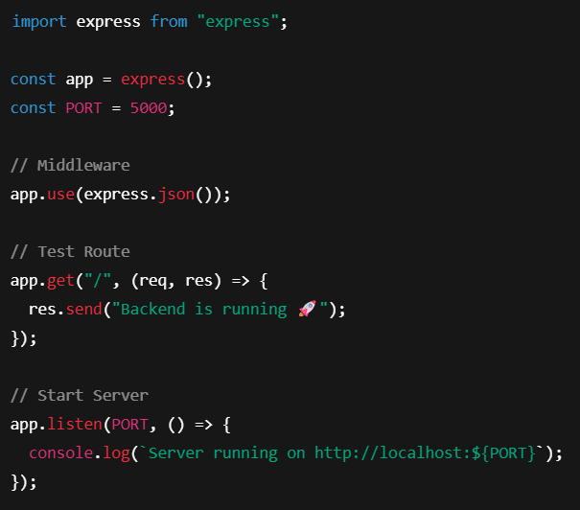

6️⃣ Enable ES Modules (Important)
Open package.json and add: "type": "module"
Example:
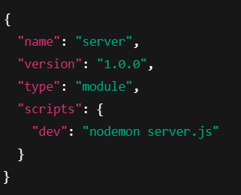

7️⃣ Start the Backend Server
Run: npm run dev
OR if not using nodemon: node server.js

8️⃣ Open in Browser
Open: http://localhost:5000
You should see: Backend is running

PRE-REQUISITES

Software Requirements
Software | Purpose
Node.js | JavaScript runtime for backend
MongoDB | NoSQL database for data storage
npm | Package manager
Git | Version control system
Code Editor | VS Code, WebStorm, or similar

Knowledge Requirements
• JavaScript ES6+ syntax and concepts
• Node.js and Express.js for RESTful API development
• MongoDB and Mongoose ODM
• JWT authentication and bcrypt password hashing
• Git version control workflow
PROJECT THUMBNAIL
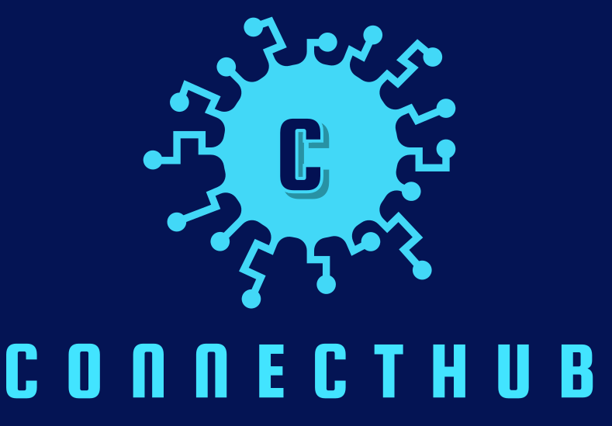
PROJECT ARCHITECTURE

High-level architecture diagram illustrating the three-tier backend structure.
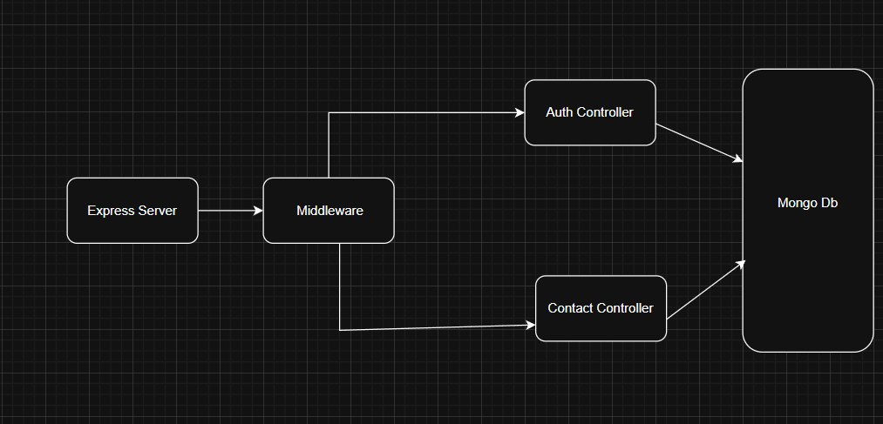

Node.js + Express Backend
• RESTful API architecture
• JWT authentication middleware
• MVC pattern (Models, Controllers, Routes)
• Input validation and error handling

MongoDB Database
• Document-based NoSQL storage
• Mongoose ODM for schema modeling
• Two collections: Users and Contacts
• Indexed fields for optimized queries

TECHNICAL ARCHITECTURE

Backend Architecture (Node.js + Express)
• Controllers: Business logic for authentication and CRUD operations
• Models: Mongoose schemas defining data structure
• Routes: API endpoint definitions with HTTP methods
• Middleware: JWT verification, error handling, validation
• Configuration: Database connection and environment variables

Database Architecture (MongoDB)
• Users Collection: _id, name, email, password (hashed), timestamps
• Contacts Collection: _id, userId (FK), name, email, phone, notes, tags[], timestamps
• Relationships: Many-to-One (Contacts → User)
• Indexes: email (unique), userId, name, tags (for search)

ER Diagram

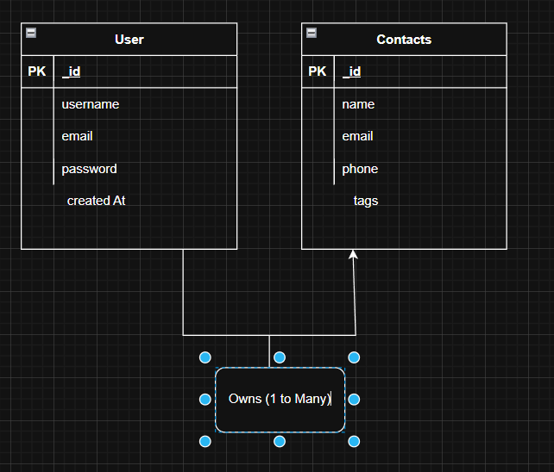

Features

Core Features

# | Feature | Description
1 | User Authentication | JWT-based registration, login, and session management with bcrypt password hashing
2 | Contact CRUD | Create, read, update, and delete contacts with full validation and error handling
3 | Tag Categorization | Organize contacts with multiple tags (Work, Family, Friends, etc.) and filter by category
4 | Real-time Search | Debounced search across name, email, and tags with instant results

Roles and Responsibility

- User -

- Registration - Register on the application using the name, email , password
- Login - Login on the application using the email and registered password
- Search - Search for a contact using name , email or tags
- Add Contact - Add new contact - name , email , phone , notes , tags
- Edit Contact - Edit the existing contact
- Delete Contact - Delete any contact

User Flow
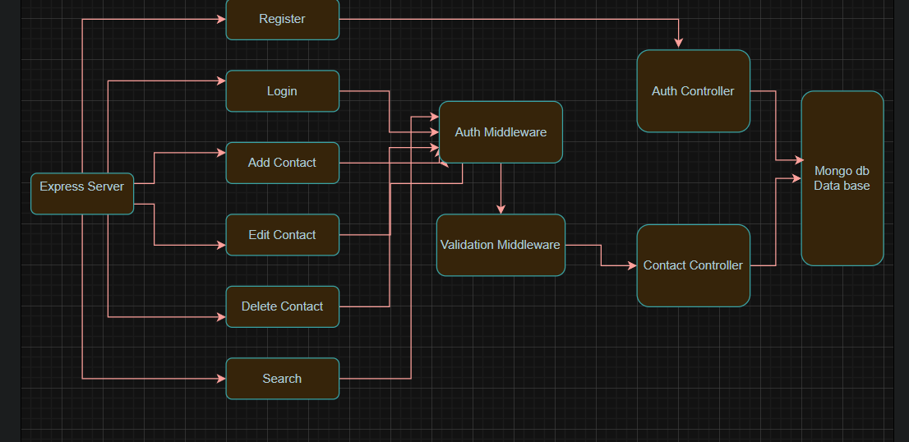

Project Setup and Configuration

Folder Structure

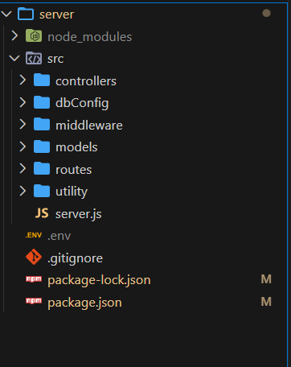

Project Setup

1. Install required tools and software:
• Node.js.
• MongoDB.
2. Create project folders and files:
• Server folders.
3. Install Packages:
Backend npm Packages
• Express.
• Mongoose.
• Cors.

Backend Development
• Setup express server
• Create index.js file in the server (backend folder).
• Create a .env file and define port number to access it globally.
• Configure the server by adding cors, body-parser.
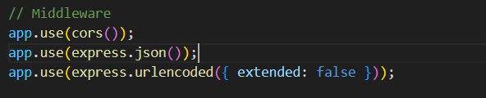
• User Authentication:
• Create routes and middleware for user registration, login, and
• Set up authentication middleware to protect routes that require user authentication.
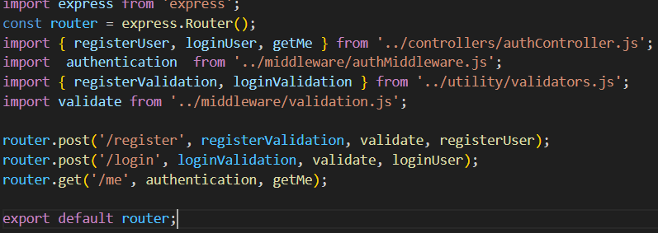
• Define API Routes:
• Create separate route files for different API functionalities such as user authentication and crud operation for contacts
• Implement route handlers using Express.js to handle requests and interact with the database.
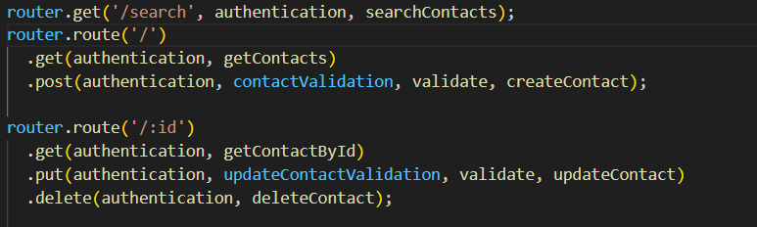
• Implement Data Models:
• Define Mongoose schemas for the different data entities like user and contact
• Create corresponding Mongoose models to interact with the MongoDB database.
• Implement CRUD operations (Create, Read, Update, Delete) for each model to perform database operations. 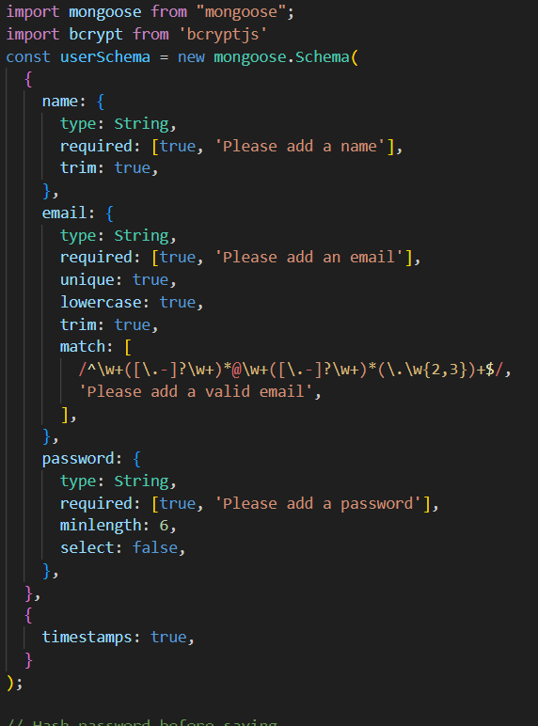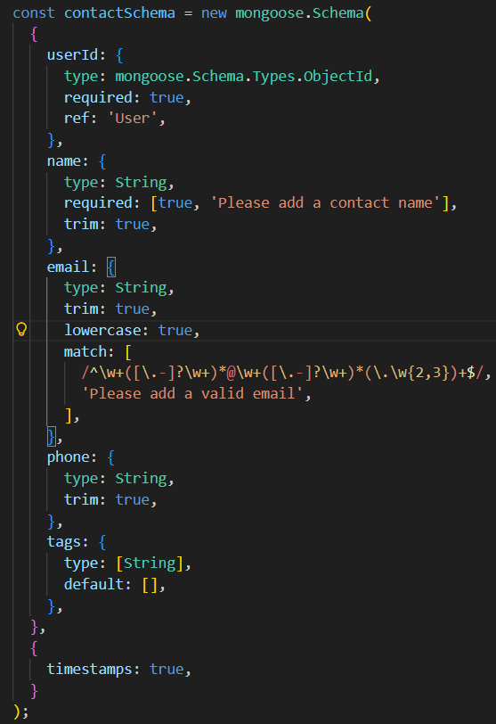
• Error Handling:
• Implement error handling middleware to catch and handle any errors that occur during the API requests.
• Return appropriate error responses with relevant error messages and HTTP status codes.
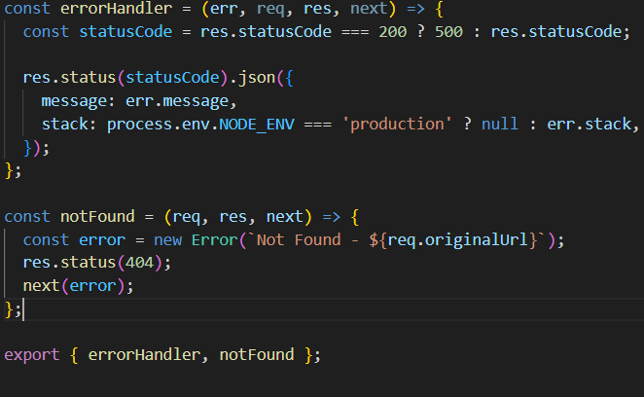

Database Configuration and Setup
1. Configure MongoDB:
• Install Mongoose.
• Create database connection.
• Create Schemas & Models.

2. Connect database to backend:
Now, make sure the database is connected before performing any of the actions through the backend. The connection code looks similar to the one provided below.

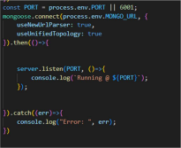

3. Configure Schema:
Firstly, configure the Schemas for MongoDB database, to store the data in such pattern. Use the data from the ER diagrams to create the schemas.
The schemas are looks like for the Application.
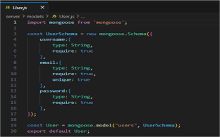

Project Execution

Execution Steps
- Open the project folder in the terminal
- Make sure you have a start script in the package.js file
- Use the command npm start to start the server
- You will the Running on PORT message on the successfully starting the server
- You will also see the database connected message if the database is connected successfully
- Use the Thunder client or Postman for using the created api’s

Output Screenshots
- Register Api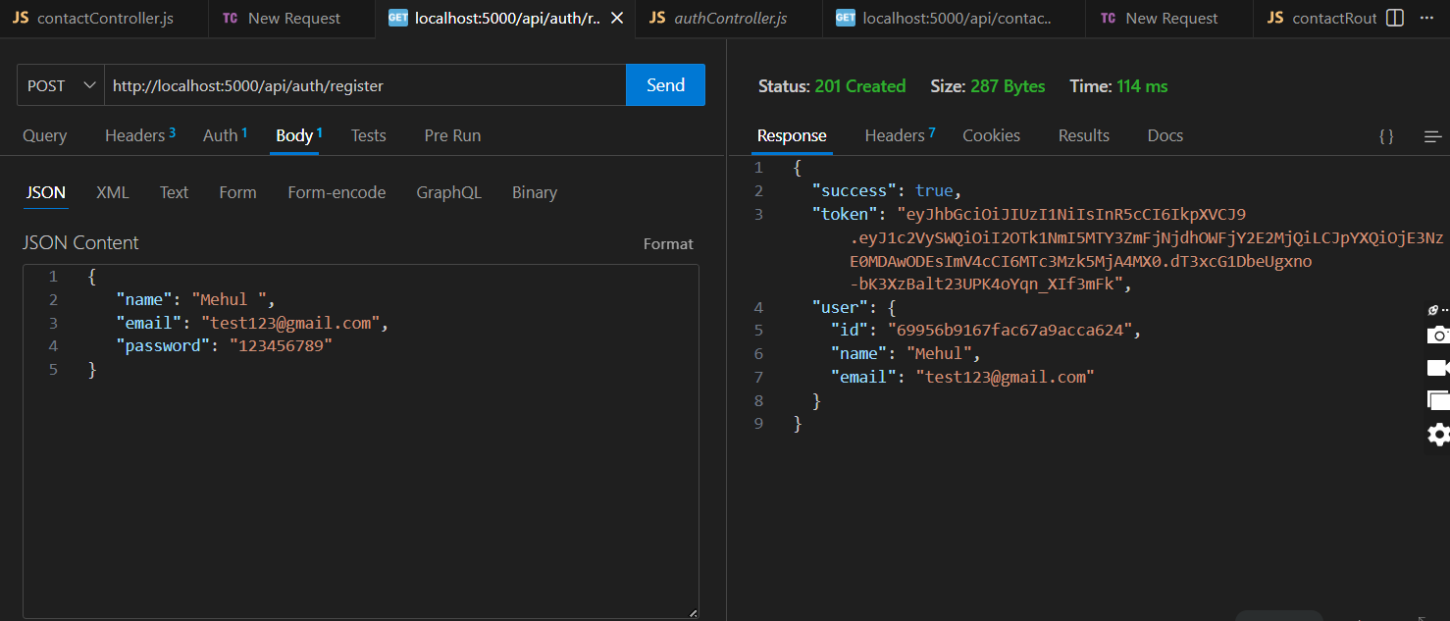
- Login Api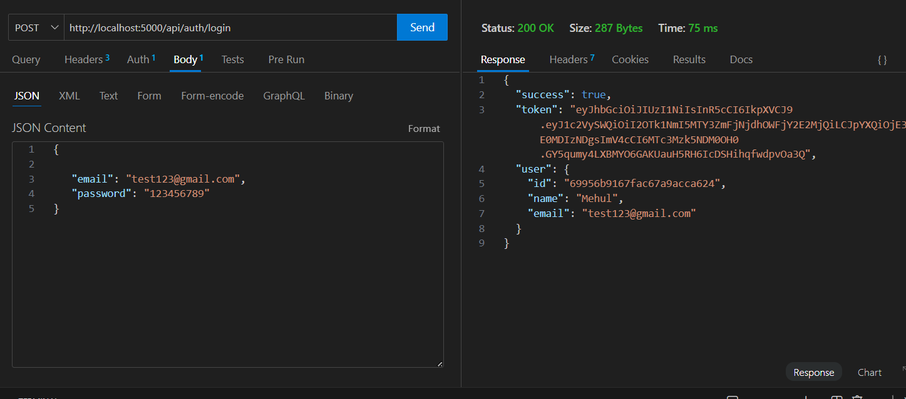

- Create New Contact
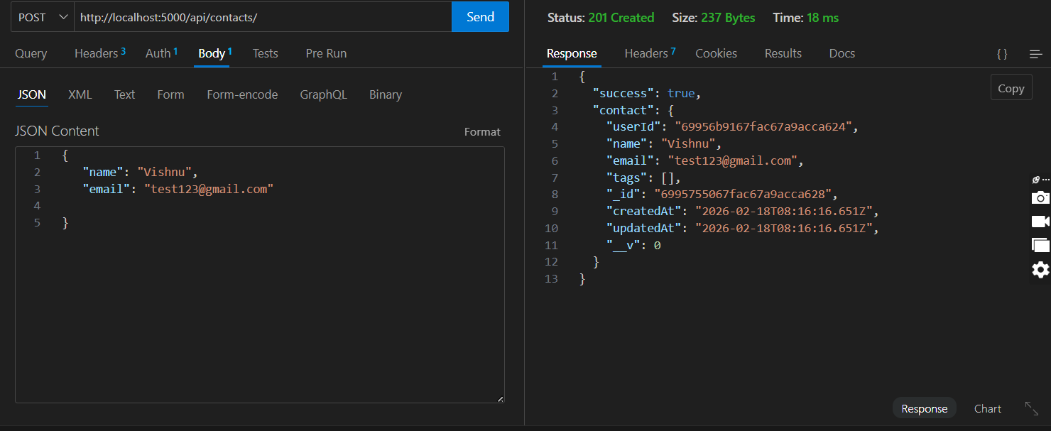

- Update Contact
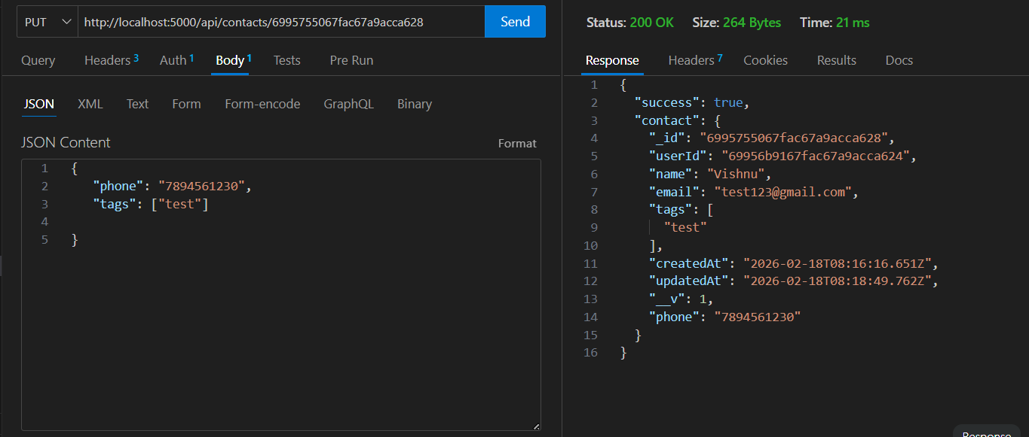

- Delete Contact
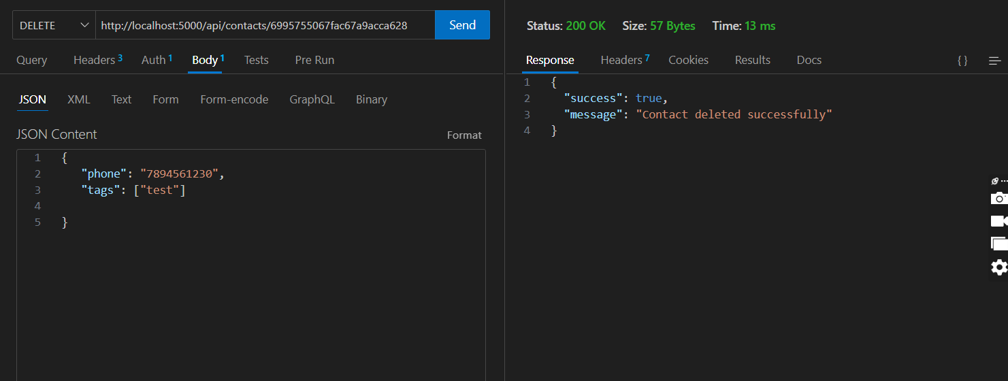

- Search Contact
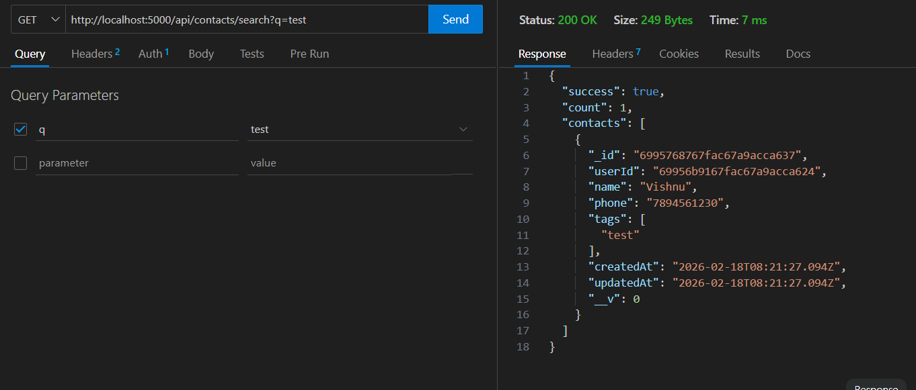

- Get The Current User

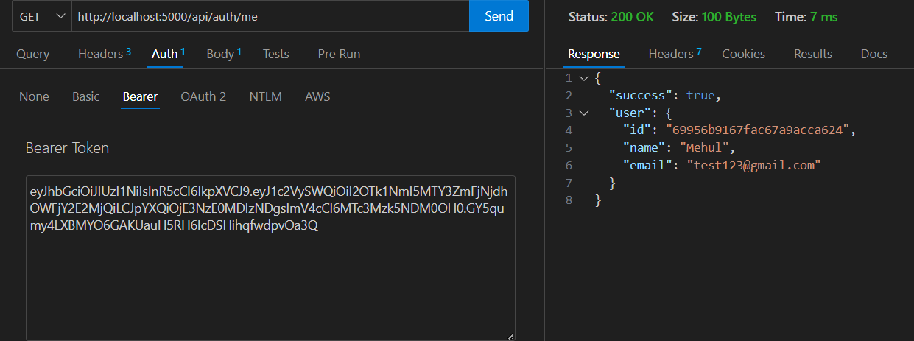

Project demo:
https://drive.google.com/drive/folders/1JxafmCppOSIRaLssVrCCh3OfENQqwE4-

