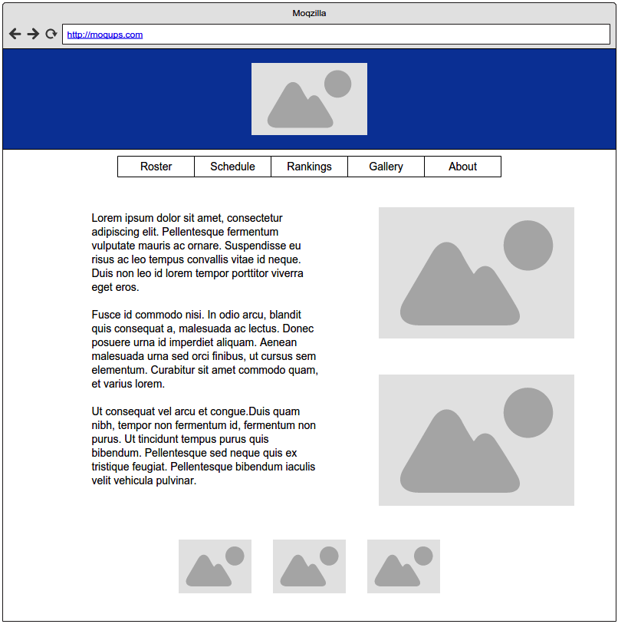Danny Snell

CS 318

Design Document

Home – UWEC MVB

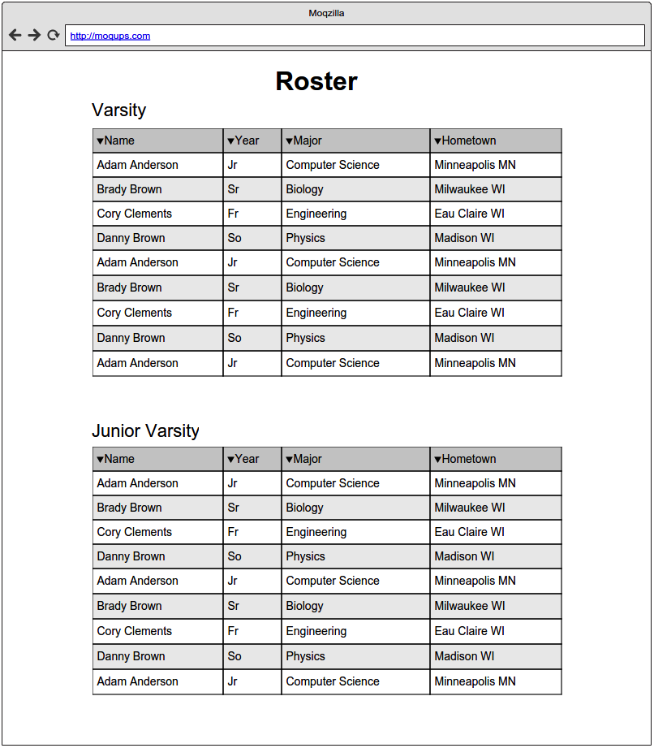

Roster – UWEC MVB

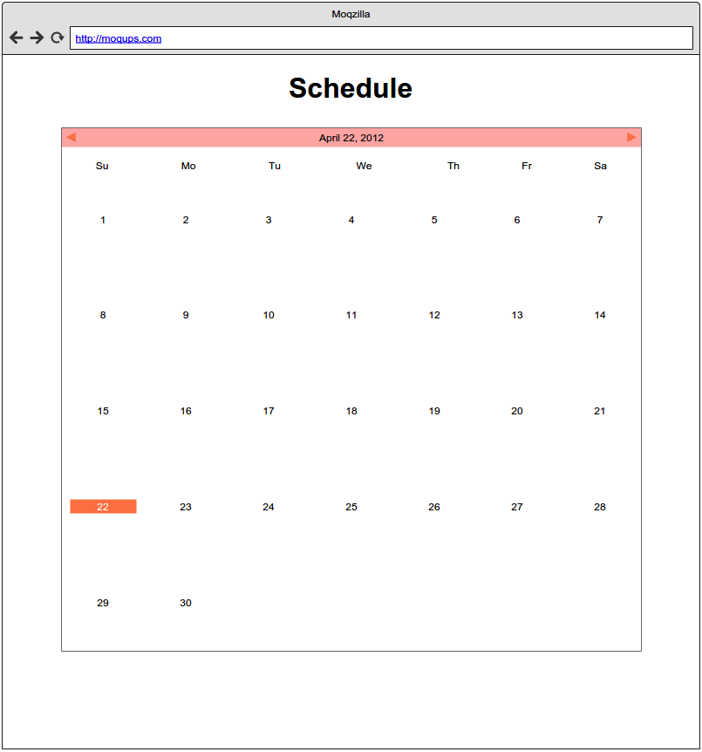

Schedule – UWEC MVB

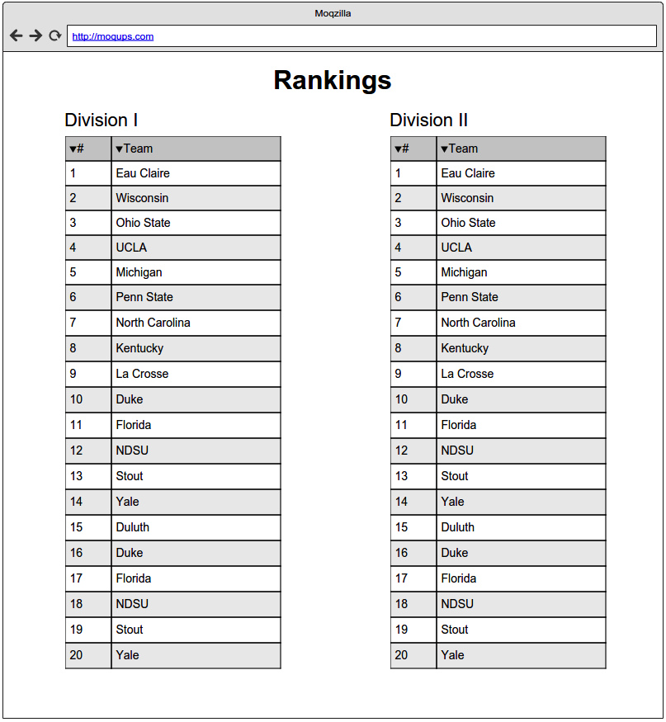

Rankings – UWEC MVB

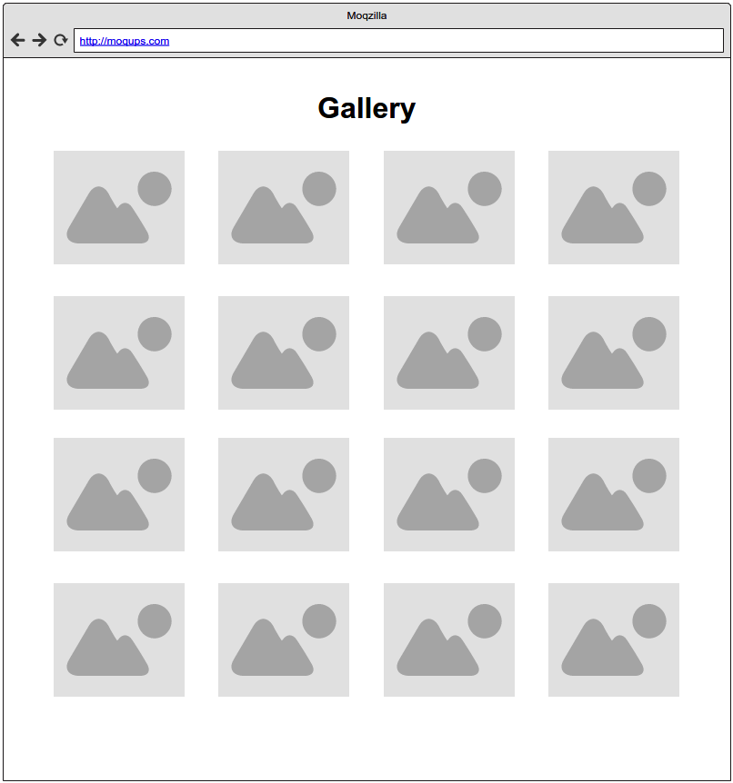

Gallery – UWEC MVB

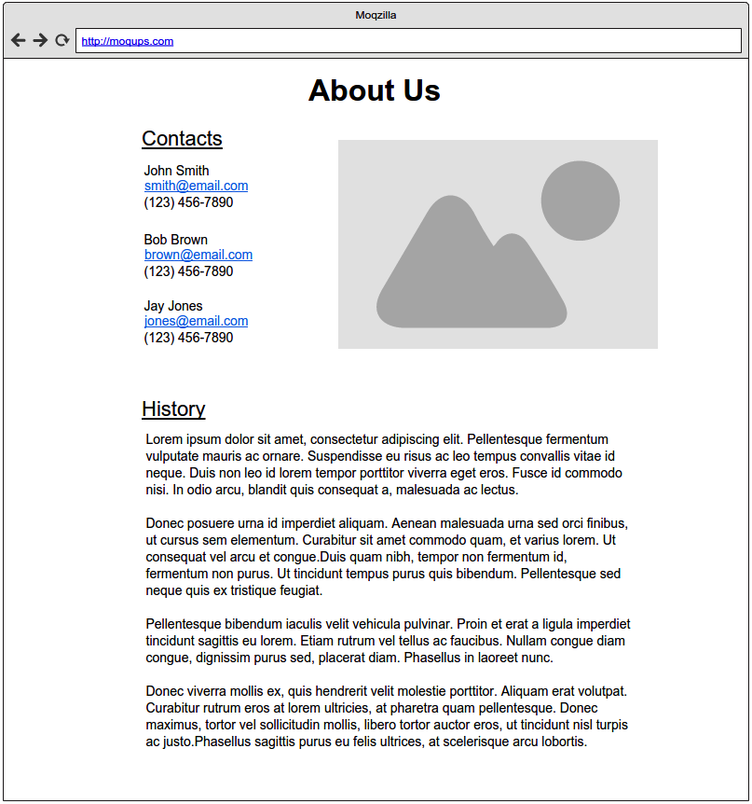

About – UWEC MVB

Danny Snell

CS 318 – Mockups, Client Evaluation

Overall, we were both very satisfied with how the mockups looked. One thing that was a concern was the images, which obviously were not able to show the client too much since the images do not exist yet, but he is very confident with how it looks so far. One idea that he presented was to have the nav bar on every page, so users could always navigate easily between pages. Because I left that out of the mockups, I’ll be sure to add it to the website. Another thing that I added to the mockups was the logos at the bottom of the screen (represented by image blocks in the mockups), which I can use as links to a couple of the conference pages, so our users can learn more about the conferences, divisions, and leagues that the UWEC MVB team plays in. He really didn’t mark up too much, but he is excited to see the website with all the content added, or at least a little bit more detailed preview. We were considering putting History in its own page, but we decided to stay with the original plan because we came to the conclusion that there wouldn’t be enough information to put History in its own page, so instead we are keeping it in the About page. We are considering a different look for the schedule page, but we plan on deciding that when I get a more detailed version coded up. Overall the Roster, Home, About, and Gallery pages were pretty satisfactory to the client, and the webpage as a whole was definitely a thumbs up.