Shawn Newsome

UFID: 66393993

shawnmnewsome@ufl.edu

**How to compile and run in either windows powershell or linux bash**

**Get all 1 files – 1 .txt file and compile**

Javac linkstate.java

**Run binary**

Java linkstate network.txt

* Text document must be

**Code structure**

Parsing

Dijkstra’s

**Example**

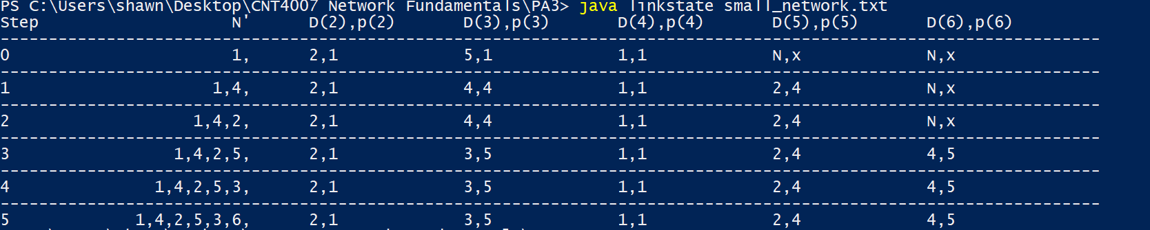

**Bug, errors, limitations**

Starts to get really messy when large networks are examined

**Additional Comments**

None