Simeon Ngalamou

Prof. Omari

Algorithms and Data Structures

11/15/2022

WA 6

**Chapter-10:**

**R-10.1:** Give a concrete implementation of the pop method in the context of the MutableMapping class, relying only on the five primary abstract methods of that class.

1. **def pop(self, last=True):**

**if not self:**

**raise KeyError("dictions is empty")**

**key = next(reversed(self) if last else iteration(self))**

**return key, MutableMapping.pop(self, key)**

**R-10.4:** What is the worst-case running time for inserting n key-value pairs into an initially empty map M that is implemented with the UnsortedTableMap class?

1. n/k

**R-10.9:** Draw the 11-entry hash table that results from using the hash function, h(i)=(3i+5) mod 11, to hash the keys 12, 44, 13, 88, 23, 94, 11, 39, 20, 16, and 5, assuming collisions are handled by chaining.

|  |
| --- |
| 13 |
| 94 |
| 39 |
| 16 |
| 5 |
| 44 |
| 88 |
| 11 |
| 12 |
| 23 |
| 20 |

**C-10.42:** Suppose that each row of an n×n array A consists of 1’s and 0’s such that, in any row of A, all the 1’s come before any 0’s in that row. Assuming A is already in memory, describe a method running in O(nlogn) time (not O(n2) time!) for counting the number of 1’s in A.

1. Find the index of the last 1 of each row
2. Take the index + 1 and add it in a running counter for 1s

**Chapter-11:**

**R-11.2:** Insert, into an empty binary search tree, entries with keys 30, 40, 24, 58, 48, 26, 11, 13 (in this order). Draw the tree after each insertion.

1. 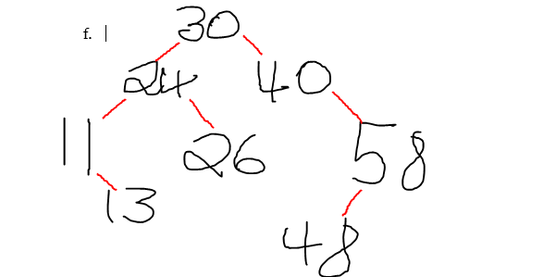

**R-11.5:** Dr. Amongus claims that the order in which a fixed set of entries is inserted into an AVL tree does not matter—the same AVL tree results every time. Give a small example that proves he is wrong.

1. (Left) insert(2,1,4,3,5) (Right) insert(4,2,1,3,5)

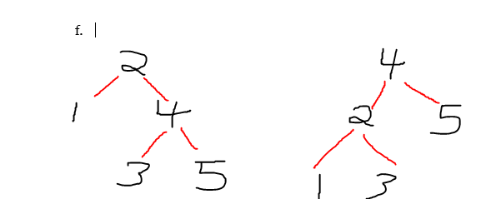

**R-11.8:** Draw the AVL tree resulting from the insertion of an entry with key 52 into the AVL tree of Figure 11.14b.

1. 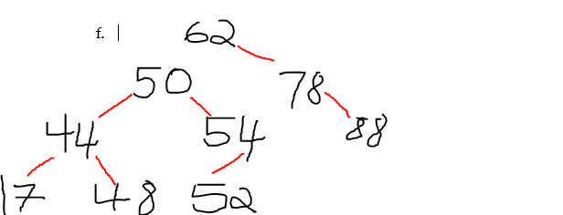

**C-11.29:** Explain how to use an AVL tree or a red-black tree to sort n comparable elements in O(nlogn) time in the worst case.

1. Insert n elements into an AVL tree: O(nlogn)
2. find and remove the minimum element n number of times from the AVL tree: O(nlogn)
3. O(nlogn) + O(nlogn) = O(nlogn)