## **UC Berkeley MIDS W209 – Data Visualization**

## **Final Project Usability Study for Meeting Insights**

1. **Project Team**
   1. Rama Rangavajjula
   2. Scott Gatzemeier
   3. Naga Chandrasekaran
2. **Introduction**

The project, "Meeting Insights," is about analyzing three hypotheses viz. meetings:

1. Work-Life Balance Issues
2. Financial Impact on the firm
3. Meeting Efficacy

The Hypotheses were studied using project data provided by the MIDS W209 course instructor Fereshteh Amini. The project team performed Exploratory Data Analysis (EDA) on the dataset to determine a few initial data insights. The EDA results are available at [Meeting Insights EDA](https://colab.research.google.com/drive/1QHnhhZXp9HYLE_h4ZPSp0OF5YRUIGR7M)

1. **Usability Study**

The project team built a comprehensive website with a *dedicated page each for the hypotheses* mentioned above. The pages have background information on the topic, relevant articles/publications, and data visualization charts to help actual users educate themselves and derive conclusions about the theories quickly.

Additionally, the website provides an overview of the "Meeting Insights" topic on the *About* page

The team would like to perform a *Usability Study* of the website to evaluate how easy it is for actual users to use it, i.e., is the website intuitive for users to navigate and achieve their goals. In our specific request, the users' goals are to review the website, understand the Test Tasks and complete a Survey Questionnaire.

After receiving feedback from the users, the team will prioritize their feedback per the MoSCoW Prioritization method

The Test Tasks, Survey Questions, and MoSCoW Prioritization survey questions are provided in this document's subsequent sections.

The team will attempt to improve the website based on user feedback and MoScOW Prioritization

Three actual users were selected for the Usability Study. The first user is a Senior Executive from a Pharmaceutical Firm. The following user is a Mid-Senior Level Executive from an Investment Bank, and the last user is a Team Contributor from a Software Consulting Firm. From different domains, all three users have high exposure to meetings and are competent to analyze the three hypotheses, understand the Test Tasks, and complete the survey.

The website link [MeetingInsights](https://people.ischool.berkeley.edu/~rrangava/index.html) was provided to the users.

1. **Group's test tasks and survey questions**

***Test Tasks with answers:***

* Work-Life Balance
  + Task 1: What is the most disruptive department for collaboration times?
    - Answer: Operations or IT are both acceptable answers
  + Task 2: What is the Personal ID of the Senior Executive who scheduled the most meetings?
    - Answer: 05F69F4A7768799D59CA8AFA5BA4A198E8631043165CA54C3F0FA4FA6FC447A1
  + Task 3: What two organization levels scheduled the most marketing meetings during July 2020?
    - Answer: Support and Senior IC
* Financial Impact
  + Task 1: Approximately what % of the total cost for meetings is considered wasteful
    - Between 45% to 55%
  + Task 2: Which top 3 Function Types (Departments) incur the maximum cost for holding meetings?
    - Answer: Marketing, Operations, and Sales
  + Task 3: Which month had the highest number of redundant hours, potentially causing meeting costs to go up?
  + Answer: March 2020
* Effective Meetings
  + Task 1: On average, what percentage of meeting invitees accept the meeting invitation? Which organization has the best meeting acceptance?
    - Answer: 75% and Sales has ~78%
  + Task 2: What is the most predominant meeting duration across the organization? Which organization function type and meeting organizer level have the most number of meetings greater than 2 hours?
    - Answer: 0.5 hours; Marketing function type; the Support level
  + Task 3: What is the relationship of average emails sent during meetings as a function of meeting hours? What are the average emails sent in 2-hour sessions?
    - Answer: Linear increase. Five emails in 2-hour meetings
  + Task 4: Which organization function has most attendees multitasking in meetings? Which organization function has the most attendees with conflicts?
    - Answer: Marketing; Sales

1. **MoSCow Prioritization**

***Survey Questions:***

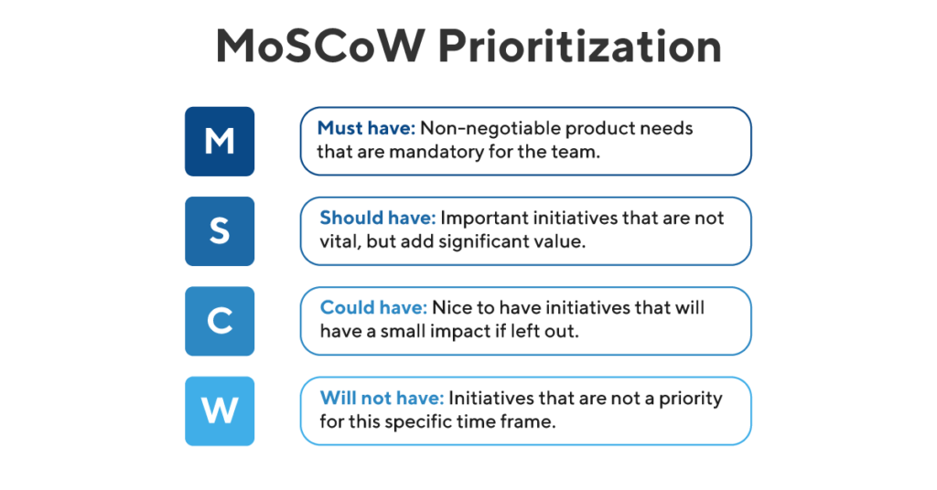

* 1. From your review, what is a must-have for the Meeting Insights Web tool?
  2. Found it difficult to associate with the website offering right away. A robust Purpose/Functionality/Offering of the website should be the starting point. An Audio/Visual demo will be perfect
     1. The "About" menu item navigates the user to a page that attempts to provide an overview; however, it is hard to follow
  3. The website navigation did not seem very intuitive, i.e., it was challenging to go through the content seamlessly without the developers' help. A graphical navigation help explaining menu items, drill-downs, and other resources is required
  4. Deadlinks on the website are confusing. They should be removed, e.g., "MeetingInsights" on the first page
  5. The individual hypotheses page organization seemed clunky with several navigational buttons; the navigational links, buttons, images, articles should follow an intuitive and best practice-based GUI layout
  6. The tool should have the predictive capability, not just display the past/current snapshot
  7. Data/Attribute Catalogue is required with definitions and meanings
  8. Chart Labels and description should be made more precise
  9. What should be added to the Meeting Insights tool, i.e., reports, features, interactions?
  10. The tool should link meeting hours spent to goals achieved by the organization
  11. The tool should prompt the users about their meeting schedule, highlight multiple bookings and encourage the users to resolve meeting booking issues
  12. The tool should provide additional reports that highlight the optimal level of organizational staffing each month
  13. The tool should have audio recording capability-based of which meeting minutes summary/detailed discussions and next steps should be auto-sent after the meetings
  14. The tool should prompt the users to come prepared to meetings per the meeting agenda. Based on intelligent algorithms, the tool should determine three days ahead of time if the meeting needs to stay or be canceled. Cancellation reasons could be many, such as appropriate participants not being available or not prepared.
  15. The tool should be able to hook into repositories having project plans, schedules, documents, etc.
  16. The tool should allow the addition of simulation data enabling a standardized set of reports as well as customizable reports
  17. What is a simply nice feature that is non-essential and could be left out with minimal Impact?
  18. It's not clear how the report Meeting Scheduled By department (work-life balance page) explains a work-life balance issue. Therefore, it can be dropped.
  19. The no. of the meetings chart in the Effective Meetings page doesn't seem to provide any info. on meeting effectiveness. Therefore, it can be dropped.
  20. In general, there seems to be an overdose of articles that don't link up well to the reports. Many articles can be dropped and relevant ones introduced
  21. What did you see that isn't useful and could be eliminated or improved? Why?
  22. Report 5 Bubble Chart visualization in the Financial Impact page and the Length Of Meetings visualization in the effective meetings page attempt to display a similar metric. One of the visualizations should be dropped
  23. On a Likert scale of 1-5:

***Questions:***

* 1. Were the visualizations helpful?
  2. Were the visualizations easy to understand?

***Results:***

***Table 1: Rating provided by actual users to the two questions listed below***

|  |  |  |  |
| --- | --- | --- | --- |
| **#** | **Question for  Actual Users** | **Rating  (Likert Scale 1-5)** | **Actual  User** |
| 1 | Were the visualizations helpful? | 5 | 1 |
| 4 | 2 |
| 3 | 3 |
| 2 | Were the visualizations easy to understand? | 5 | 1 |
| 4 | 2 |
| 3 | 3 |

***Chart for Table 1***

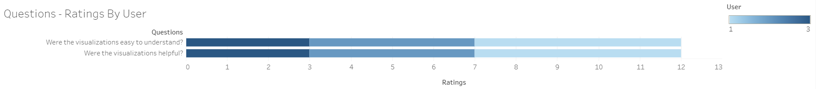

***Table 2: Test Task questions answered Correctly listed in Section 4***

|  |  |  |  |
| --- | --- | --- | --- |
| **Actual User** | **Hypothesis** | **Task Number** | **Result** |
| 1 | Work-Life Balance | 1 | Correct |
| 2 | Correct |
| 3 | Correct |
| Financial Impact | 1 | Correct |
| 2 | Correct |
| 3 | Correct |
| Effective Meetings | 1 | Correct |
| 2 | Correct |
| 3 | Incorrect |
| 4 | Incorrect |
| 2 | Work-Life Balance | 1 | Correct |
| 2 | Incorrect |
| 3 | Correct |
| Financial Impact | 1 | Correct |
| 2 | Correct |
| 3 | Correct |
| Effective Meetings | 1 | Correct |
| 2 | Correct |
| 3 | Incorrect |
| 4 | Correct |
| 3 | Work-Life Balance | 1 | Correct |
| 2 | Incorrect |
| 3 | Correct |
| Financial Impact | 1 | Correct |
| 2 | Correct |
| 3 | Correct |
| Effective Meetings | 1 | Correct |
| 2 | Correct |
| 3 | Incorrect |
| 4 | Incorrect |

***Chart for Table 2***

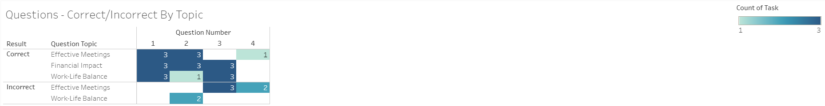

***Table 3: Time taken by the Actual User to answer Test Task questions listed in Section 4***

|  |  |  |  |
| --- | --- | --- | --- |
| **#** | **Hypothesis** | **Actual User** | **Time (min)** |
| 1 | Work-Life Balance | 1 | 12 |
| 2 | 14 |
| 3 | 15 |
| 2 | Financial Impact | 1 | 15 |
| 2 | 12 |
| 3 | 8 |
| 3 | Effective Meetings | 1 | 10 |
| 2 | 7 |
| 3 | 12 |

***Chart for Table 3***

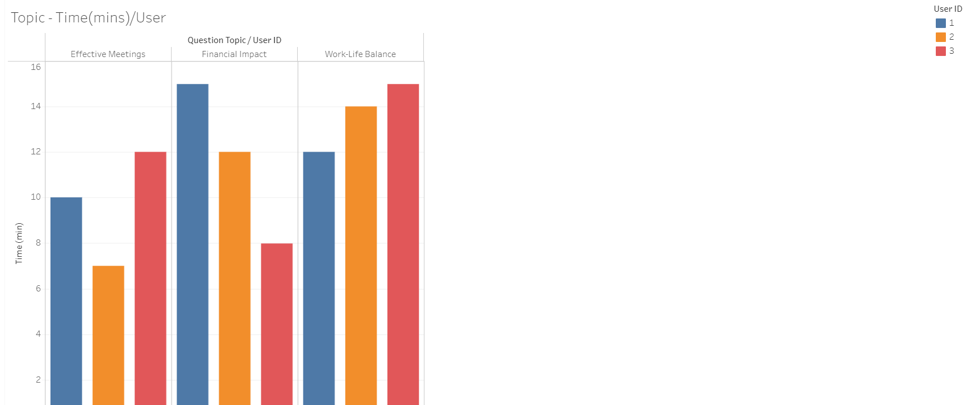

1. **Any other feedback?**

* It was an excellent initial attempt

1. **Recommendations of Usability Study per MoSCoW Prioritization**
   1. **Must have**
   2. Drill down and interactive capability
   3. Clearly define the information text below each graph
   4. Verify if visualizations can lead to clear actions
   5. Easy to revert from a drilled in view to the overview
   6. **Should have**
   7. Meeting hours by day and time of the week - Circles colored by working/non-working hours and weekends to provide color encoding for work-life balance
   8. Re-evaluate the circle chart under the effective meeting webpage and assess if it can be simplified
   9. Re-evaluate or clarify meeting cost per month and meeting cost per organizer graphs and the purpose of them. If appropriate, remove them
   10. Re-evaluate some of the graphs and connectivity between work-life balance, financial Impact, and effective meeting pages and remove redundant charts. Stay more faithful to the individual tap headline
   11. Re-evaluate the Effective Meeting Section and resolve the issues that lead to incorrect responses on Task 1 and 3.
   12. **Could have**
   13. Clarify the purpose of the "go back" button in the effective meetings web page
   14. Re-evaluate all graphs to see if the animated feature is valuable or not. If not applicable, remove the animated features (especially in the effective meetings webpage)
   15. **Will not have**
   16. Action driven insights and action plan - We provide the visualizations for users to work with and generate their action plan. Our intent is not to develop an action plan for users.
   17. Industry benchmark data - We have provided a different collection of articles and industry data. We are not planning to add more industry benchmark information at this point.
   18. Support - is this admin/exec admin, and who is it for? We do not have this level of detail in the data set and cannot provide this information.
   19. Meeting count by start day/time - can we provide more information about collaborating teams? We cannot provide this information as the data does not give information about invitees (attendees).
   20. Average attendees by job level and functional group - We do not have this information. We do not have information about individual attendees in the dataset.
2. **Conclusions and Future Work**

Many of the user feedback is focused on futuristic tasks for the web page. Users would like to understand network collaboration, information about attendees, action-based insights, and additional details on organizer-attendee interaction. Unfortunately, with the current dataset, we do not have information about the attendees and network collaboration. The current data set is limited. Besides, from a scope and timeline perspective, some of the requests are outside the project's time limit. We understand from the feedback that there are significant interest and demand for interactive data analysis and visualization product in this area. The corporate world might well receive a more detailed effort in setting up a project to develop a meetings analysis product.

1. **References**

* <https://meeting-report.com>
* <https://hbr.org/2017/07/stop-the-meeting-madness>
* Book by Tamara Munzner
* <https://meeting-report.com>
* Wall street journal [article](https://www.wsj.com/articles/a-manifesto-to-end-boring-meetings-1482249683)