Частное учреждение образования

«Колледж бизнеса и права»

ОТЧЕТ ПО ЛАБОРАТОРНОЙ РАБОТЕ КПиЯП №25

Т.091005

Руководитель практики Е.Н.Коропа

Учащийся А.О.Зеневич

2022

«WPF»

«Вариант 5»

Задание один

Условие

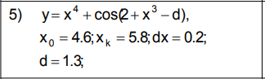

Код программы

Task1Window.xaml

<Window x:Class="Lab25.Task1Window"

xmlns="http://schemas.microsoft.com/winfx/2006/xaml/presentation"

xmlns:x="http://schemas.microsoft.com/winfx/2006/xaml"

xmlns:d="http://schemas.microsoft.com/expression/blend/2008"

xmlns:mc="http://schemas.openxmlformats.org/markup-compatibility/2006"

xmlns:local="clr-namespace:Lab25"

mc:Ignorable="d"

Title="Task1Window" Height="450" Width="800" Loaded="Window_Loaded" Closing="Window_Closing" WindowStartupLocation="CenterScreen">

<Grid>

<Grid.ColumnDefinitions>

<ColumnDefinition Width="31*"/>

<ColumnDefinition Width="369*"/>

</Grid.ColumnDefinitions>

<TextBox x:Name="x0TextBox" HorizontalAlignment="Left" Margin="73,76,0,0" TextWrapping="Wrap" VerticalAlignment="Top" Width="120" Grid.Column="1"/>

<TextBox x:Name="xkTextBox" HorizontalAlignment="Left" Margin="73,113,0,0" TextWrapping="Wrap" VerticalAlignment="Top" Width="120" Grid.Column="1"/>

<TextBox x:Name="dxTextBox" HorizontalAlignment="Left" Margin="73,154,0,0" TextWrapping="Wrap" VerticalAlignment="Top" Width="120" Grid.Column="1"/>

<TextBox x:Name="xTextBox" HorizontalAlignment="Left" Margin="73,192,0,0" TextWrapping="Wrap" VerticalAlignment="Top" Width="120" Grid.Column="1"/>

<TextBox x:Name="dTextBox" HorizontalAlignment="Left" Margin="73,232,0,0" TextWrapping="Wrap" VerticalAlignment="Top" Width="120" Grid.Column="1"/>

<Label Content="x0" HorizontalAlignment="Left" Margin="46,72,0,0" VerticalAlignment="Top" Grid.Column="1"/>

<Label Content="xk" HorizontalAlignment="Left" Margin="46,109,0,0" VerticalAlignment="Top" RenderTransformOrigin="0.546,0.387" Grid.Column="1"/>

<Label Content="dx" HorizontalAlignment="Left" Margin="46,150,0,0" VerticalAlignment="Top" RenderTransformOrigin="0.546,0.387" Grid.Column="1"/>

<Label Content="x" HorizontalAlignment="Left" Margin="52,188,0,0" VerticalAlignment="Top" RenderTransformOrigin="0.546,0.387" Grid.Column="1"/>

<Label Content="d" HorizontalAlignment="Left" Margin="52,228,0,0" VerticalAlignment="Top" RenderTransformOrigin="0.546,0.387" Grid.Column="1"/>

<Button x:Name="EnterButton" Content="Старт" HorizontalAlignment="Left" Margin="98,273,0,0" VerticalAlignment="Top" Height="27" Width="95" Click="EnterButton_Click" Grid.Column="1"/>

<TextBox x:Name="resultTextBox" HorizontalAlignment="Left" Margin="250,59,0,0" TextWrapping="Wrap" VerticalAlignment="Top" Width="406" Height="262" Grid.Column="1"/>

</Grid>

</Window>

Task1Window.xaml.cs

using System;

using System.Windows;

namespace Lab25

{

public partial class Task1Window

{

public Task1Window()

{

InitializeComponent();

}

private void EnterButton_Click(object sender, RoutedEventArgs e)

{

var x0 = double.Parse(this.x0TextBox.Text);

var xk = double.Parse(this.xkTextBox.Text);

var dx = double.Parse(this.dxTextBox.Text);

var x = double.Parse(this.xTextBox.Text);

var d = double.Parse(this.dTextBox.Text);

for (var i = x0; i < xk; i += dx)

{

var y = Math.Pow(x, 4) + Math.Cos(2 + Math.Pow(x, 3) - d);

this.resultTextBox.Text += $"x={i.ToString()}; y={y.ToString()}\n";

}

}

private void Window_Loaded(object sender, RoutedEventArgs e)

{

this.x0TextBox.Text = "4,6";

this.xkTextBox.Text = "5,8";

this.dxTextBox.Text = "0,2";

this.xTextBox.Text = "2";

this.dTextBox.Text = "1,3";

}

private void Window_Closing(object sender, System.ComponentModel.CancelEventArgs e)

{

this.Hide();

MainWindow mainWindow = new MainWindow();

mainWindow.Show();

}

}

}

Результат программы

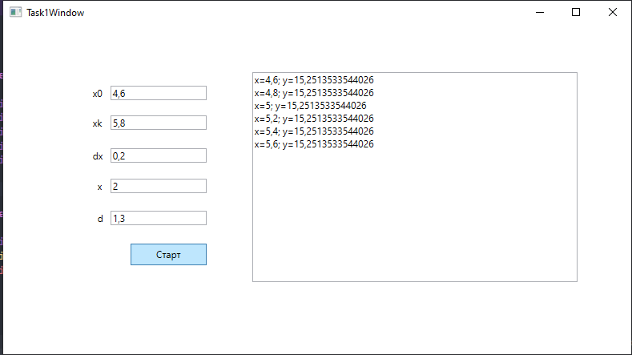

Задание два

Условие

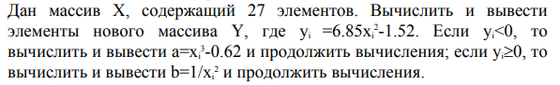

Код программы

Task2Window.xaml

<Window x:Class="Lab25.Task2Window"

xmlns="http://schemas.microsoft.com/winfx/2006/xaml/presentation"

xmlns:x="http://schemas.microsoft.com/winfx/2006/xaml"

xmlns:d="http://schemas.microsoft.com/expression/blend/2008"

xmlns:mc="http://schemas.openxmlformats.org/markup-compatibility/2006"

xmlns:local="clr-namespace:Lab25"

mc:Ignorable="d"

Title="Task2Window" Height="450" Width="800" Closing="Window_Closing" WindowStartupLocation="CenterScreen">

<Grid>

<TextBox x:Name="InputTextBox" HorizontalAlignment="Center" Height="37" Margin="0,64,0,0" TextWrapping="Wrap" VerticalAlignment="Top" Width="242" Text="1, 2, 3, 4, 5, 6, 7, 8, 9, 10, 11, 12, 13, 14, 15, 16, 17, 18, 19, 20, 21, 22, 23, 24, 25, 26, 27"/>

<Button x:Name="CalculateButton" Content="Вычислить" HorizontalAlignment="Center" Margin="0,106,0,0" VerticalAlignment="Top" Width="242" Click="CalculateButton_Click" Height="31"/>

<ListBox x:Name="ResultListBox" HorizontalAlignment="Center" Height="226" VerticalAlignment="Top" Width="242" Margin="0,142,0,0"/>

</Grid>

</Window>

Task2Window.xaml.cs

using System;

using System.Collections.Generic;

using System.Linq;

using System.Windows;

namespace Lab25

{

public partial class Task2Window

{

public Task2Window()

{

InitializeComponent();

}

private void CalculateButton_Click(object sender, RoutedEventArgs e)

{

try

{

string input = InputTextBox.Text;

List<double> xList = input.Split(new char[] { ',', ' ' }, StringSplitOptions.RemoveEmptyEntries)

.Select(s => double.Parse(s)).ToList();

List<double> yList = new List<double>();

foreach (double x in xList)

{

var y = 6.85 * Math.Pow(x, 2) - 1.5 * x;

if (y < 0)

{

var a = Math.Pow(x, 3) - 0.62;

yList.Add(a);

}

else

{

var b = 1 / Math.Pow(x, 2);

yList.Add(b);

}

}

ResultListBox.ItemsSource = yList;

}

catch (Exception ex)

{

MessageBox.Show(ex.Message);

}

}

private void Window_Closing(object sender, System.ComponentModel.CancelEventArgs e)

{

this.Hide();

MainWindow mainWindow = new MainWindow();

mainWindow.Show();

}

}

}

Результат программы

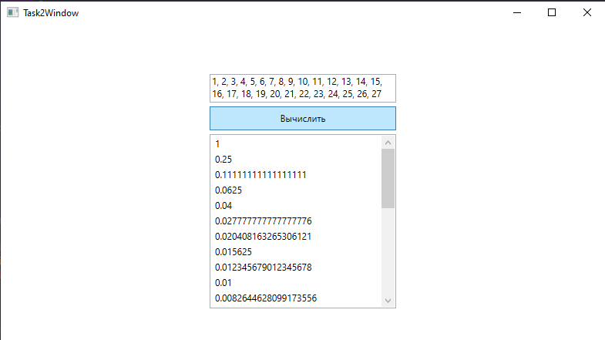

Задание три

Условие

Дана матрица A(4,3). Вычислить наибольший элемент матрицы. Вывести исходную матрицу и наибольший элемент.

Код программы

Task3Window.xaml

<Window x:Class="Lab25.Task3Window"

xmlns="http://schemas.microsoft.com/winfx/2006/xaml/presentation"

xmlns:x="http://schemas.microsoft.com/winfx/2006/xaml"

xmlns:d="http://schemas.microsoft.com/expression/blend/2008"

xmlns:mc="http://schemas.openxmlformats.org/markup-compatibility/2006"

xmlns:local="clr-namespace:Lab25"

mc:Ignorable="d"

Title="Task3Window" Height="500" Width="900" Closing="Window_Closing" WindowStartupLocation="CenterScreen">

<Grid>

<Grid.RowDefinitions>

<RowDefinition Height="*" />

<RowDefinition Height="Auto" />

</Grid.RowDefinitions>

<DataGrid x:Name="matrixGrid" Margin="5" Grid.Row="0">

<DataGrid.Columns>

<DataGridTextColumn Header="1" Binding="{Binding Path=[0]}" Width="*" />

<DataGridTextColumn Header="2" Binding="{Binding Path=[1]}" Width="*" />

<DataGridTextColumn Header="3" Binding="{Binding Path=[2]}" Width="*" />

</DataGrid.Columns>

</DataGrid>

<StackPanel Orientation="Horizontal" Margin="5" Grid.Row="1">

<Button Content="Вычислить" Click="CalculateButton_Click" Margin="5" />

<Button Content="Сбросить" Click="ResetButton_Click" Margin="5" />

</StackPanel>

</Grid>

</Window>

Task3Window.xaml.cs

using System;

using System.Collections.Generic;

using System.Windows;

namespace Lab25

{

public partial class Task3Window

{

private int[,] _matrix;

public Task3Window()

{

InitializeComponent();

ResetMatrix();

}

private void CalculateButton_Click(object sender, RoutedEventArgs e)

{

if (_matrix == null)

{

return;

}

int maxElement = _matrix[0, 0];

for (int i = 0; i < 4; i++)

{

for (int j = 0; j < 3; j++)

{

if (_matrix[i, j] > maxElement)

{

maxElement = _matrix[i, j];

}

}

}

string matrixText = "";

for (int i = 0; i < 4; i++)

{

for (int j = 0; j < 3; j++)

{

matrixText += _matrix[i, j] + "\t";

}

matrixText += "\n";

}

MessageBox.Show(matrixText + "\nНаибольший элемент: " + maxElement);

}

private void ResetButton_Click(object sender, RoutedEventArgs e)

{

ResetMatrix();

}

private void ResetMatrix()

{

_matrix = new int[4, 3];

Random random = new Random();

for (int i = 0; i < 4; i++)

{

for (int j = 0; j < 3; j++)

{

_matrix[i, j] = random.Next(-50, 50);

}

}

List<int[]> rows = new List<int[]>();

for (int i = 0; i < 4; i++)

{

int[] row = new int[3];

for (int j = 0; j < 3; j++)

{

row[j] = _matrix[i, j];

}

rows.Add(row);

}

matrixGrid.ItemsSource = rows;

}

private void Window_Closing(object sender, System.ComponentModel.CancelEventArgs e)

{

this.Hide();

MainWindow mainWindow = new MainWindow();

mainWindow.Show();

}

}

}

Результат программы

