Частное учреждение образования

«Колледж бизнеса и права»

ОТЧЕТ ПО ЛАБОРАТОРНОЙ РАБОТЕ КПиЯП №28

Т.091005

Руководитель практики Е.Н.Коропа

Учащийся А.О.Зеневич

2022

«WPF»

«Вариант 5»

Задание один

Условие

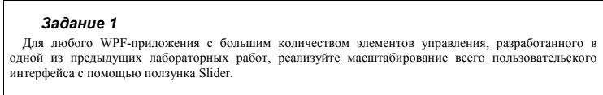

Код программы

Task1Window.xaml

<Window x:Class="Lab28.FirstTask"

xmlns="http://schemas.microsoft.com/winfx/2006/xaml/presentation"

xmlns:x="http://schemas.microsoft.com/winfx/2006/xaml"

xmlns:d="http://schemas.microsoft.com/expression/blend/2008"

xmlns:mc="http://schemas.openxmlformats.org/markup-compatibility/2006"

xmlns:local="clr-namespace:Lab28"

mc:Ignorable="d"

Title="FirstTask" Height="450" Width="800"

RenderOptions.BitmapScalingMode="NearestNeighbor" Closing="Window_Closing">

<Grid x:Name="MainGrid">

<Slider x:Name="ZoomSlider" Minimum="0.5" Maximum="2" Value="1" Margin="10,10,10,10"

ValueChanged="ZoomSlider_ValueChanged"/>

<StackPanel HorizontalAlignment="Center" VerticalAlignment="Center">

<Button>Обычная кнопка</Button>

<TextBox>Текстовое поле</TextBox>

<StackPanel Orientation="Horizontal">

<CheckBox>Красный</CheckBox>

<CheckBox>Зеленый</CheckBox>

<CheckBox>Синий</CheckBox>

</StackPanel>

<Rectangle Width="200" Height="30" Fill="Wheat" Stroke="Brown" StrokeThickness="2"

RadiusX="15" RadiusY="15" />

<StackPanel.RenderTransform>

<RotateTransform Angle="30" CenterX="0" CenterY="0" />

</StackPanel.RenderTransform>

</StackPanel>

</Grid>

</Window>

Task1Window.xaml.cs

using System.Windows;

using System.Windows.Media;

namespace Lab28

{

public partial class FirstTask : Window

{

public FirstTask()

{

InitializeComponent();

}

private void ZoomSlider_ValueChanged(object sender, RoutedPropertyChangedEventArgs<double> e)

{

double zoom = e.NewValue;

ScaleTransform scaleTransform = new ScaleTransform(zoom, zoom);

MainGrid.LayoutTransform = scaleTransform;

}

private void Window_Closing(object sender, System.ComponentModel.CancelEventArgs e)

{

this.Hide();

MainWindow mainWindow = new MainWindow();

mainWindow.Show();

}

}

}

Результат программы

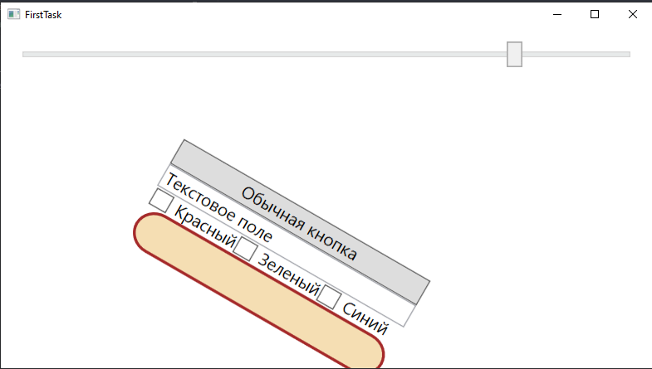

Задание два

Условие

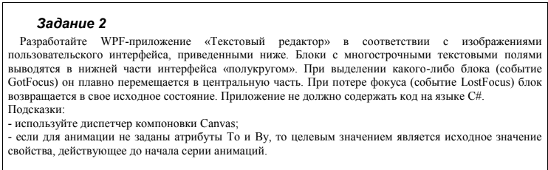

Код программы

Task2Window.xaml

<Window x:Class="Lab28.SecondTask"

xmlns="http://schemas.microsoft.com/winfx/2006/xaml/presentation"

xmlns:x="http://schemas.microsoft.com/winfx/2006/xaml"

xmlns:d="http://schemas.microsoft.com/expression/blend/2008"

xmlns:mc="http://schemas.openxmlformats.org/markup-compatibility/2006"

xmlns:local="clr-namespace:Lab28"

mc:Ignorable="d"

Title="SecondTask" Height="450" Width="800" Closing="Window_Closing" WindowStartupLocation="CenterScreen">

<Window.Resources>

<!-- Анимация перемещения блока в центр -->

<Storyboard x:Key="moveToCenter">

<DoubleAnimation Duration="0:0:1" From="0" To="275"

Storyboard.TargetProperty="(Canvas.Left)" />

<DoubleAnimation Duration="0:0:1" From="0" To="125"

Storyboard.TargetProperty="(Canvas.Top)" />

<DoubleAnimation Duration="0:0:1" From="250" To="0"

Storyboard.TargetProperty="(FrameworkElement.Width)" />

<DoubleAnimation Duration="0:0:1" From="80" To="400"

Storyboard.TargetProperty="(FrameworkElement.Height)" />

</Storyboard>

<!-- Анимация возврата блока в исходное состояние -->

<Storyboard x:Key="moveToBottom">

<DoubleAnimation Duration="0:0:1" To="0"

Storyboard.TargetProperty="(Canvas.Left)" />

<DoubleAnimation Duration="0:0:1" To="350"

Storyboard.TargetProperty="(Canvas.Top)" />

<DoubleAnimation Duration="0:0:1" To="250"

Storyboard.TargetProperty="(FrameworkElement.Width)" />

<DoubleAnimation Duration="0:0:1" To="80"

Storyboard.TargetProperty="(FrameworkElement.Height)" />

</Storyboard>

</Window.Resources>

<Grid>

<Canvas>

<!-- Блоки с многострочными текстовыми полями -->

<Border x:Name="block1" BorderBrush="Gray" BorderThickness="1" Canvas.Left="50" Canvas.Top="300"

Width="250" Height="80" CornerRadius="20">

<TextBox VerticalScrollBarVisibility="Auto" AcceptsReturn="True" />

</Border>

<Border x:Name="block2" BorderBrush="Gray" BorderThickness="1" Canvas.Left="150" Canvas.Top="300"

Width="250" Height="80" CornerRadius="20">

<TextBox VerticalScrollBarVisibility="Auto" AcceptsReturn="True" />

</Border>

<Border x:Name="block3" BorderBrush="Gray" BorderThickness="1" Canvas.Left="250" Canvas.Top="300"

Width="250" Height="80" CornerRadius="20">

<TextBox VerticalScrollBarVisibility="Auto" AcceptsReturn="True" />

</Border>

<Border x:Name="block4" BorderBrush="Gray" BorderThickness="1" Canvas.Left="350" Canvas.Top="300"

Width="250" Height="80" CornerRadius="20">

<TextBox VerticalScrollBarVisibility="Auto" AcceptsReturn="True" />

</Border>

<Border x:Name="block5" BorderBrush="Gray" BorderThickness="1" Canvas.Left="450" Canvas.Top="300"

Width="250" Height="80" CornerRadius="20">

<TextBox VerticalScrollBarVisibility="Auto" AcceptsReturn="True" />

</Border>

<!-- Три кнопки управления -->

<Button Content="Open" Width="100" Height="50" Canvas.Left="50" Canvas.Top="50" />

<Button Content="Save" Width="100" Height="50" Canvas.Left="200" Canvas.Top="50" />

<Button Content="Close" Width="100" Height="50" Canvas.Left="350" Canvas.Top="50" />

</Canvas>

</Grid>

</Window>

Task2Window.xaml.cs

using System.Windows;

namespace Lab28

{

/// <summary>

/// Логика взаимодействия для SecondTask.xaml

/// </summary>

public partial class SecondTask : Window

{

public SecondTask()

{

InitializeComponent();

}

private void Window_Closing(object sender, System.ComponentModel.CancelEventArgs e)

{

this.Hide();

MainWindow mainWindow = new MainWindow();

mainWindow.Show();

}

}

}

Результат программы

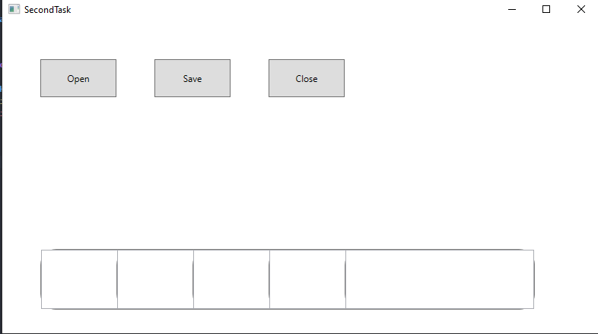

Задание три

Условие

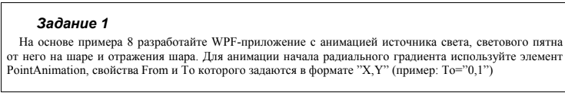

Код программы

Task3Window.xaml

<Window x:Class="Lab28.ThirdTask"

xmlns="http://schemas.microsoft.com/winfx/2006/xaml/presentation"

xmlns:x="http://schemas.microsoft.com/winfx/2006/xaml"

xmlns:d="http://schemas.microsoft.com/expression/blend/2008"

xmlns:mc="http://schemas.openxmlformats.org/markup-compatibility/2006"

xmlns:local="clr-namespace:Lab28"

mc:Ignorable="d"

Title="ThirdTask" Height="450" Width="800" WindowStartupLocation="CenterScreen" Closing="Window_Closing">

<Window.Resources>

<!-- Анимация перемещения источника света -->

<Storyboard x:Key="moveLight">

<DoubleAnimation Duration="0:0:5" To="1"

Storyboard.TargetName="light"

Storyboard.TargetProperty="(UIElement.RenderTransform).(TranslateTransform.Y)" />

</Storyboard>

<!-- Радиальный градиент -->

<RadialGradientBrush x:Key="radialGradient" GradientOrigin="1,0" Center="0.5,0.5">

<GradientStop Color="#FFAA0000" Offset="0"/>

<GradientStop Color="#FF00AA00" Offset="0.5"/>

<GradientStop Color="#FF0000AA" Offset="1"/>

</RadialGradientBrush>

<!-- Отражение шара -->

<DrawingBrush x:Key="reflectionBrush" Stretch="None">

<DrawingBrush.Drawing>

<DrawingGroup>

<GeometryDrawing Brush="White">

<GeometryDrawing.Geometry>

<EllipseGeometry Center="100,100" RadiusX="100" RadiusY="100"/>

</GeometryDrawing.Geometry>

</GeometryDrawing>

<GeometryDrawing Brush="#80000000">

<GeometryDrawing.Geometry>

<EllipseGeometry Center="100,120" RadiusX="100" RadiusY="20"/>

</GeometryDrawing.Geometry>

</GeometryDrawing>

</DrawingGroup>

</DrawingBrush.Drawing>

</DrawingBrush>

</Window.Resources>

<Grid>

<Ellipse Fill="{StaticResource radialGradient}" Width="200" Height="200"

Margin="50" RenderTransformOrigin="0.5,0.5">

<Ellipse.RenderTransform>

<RotateTransform Angle="0"/>

</Ellipse.RenderTransform>

<Ellipse.Effect>

<DropShadowEffect BlurRadius="20" ShadowDepth="0" Direction="-90"/>

</Ellipse.Effect>

<Ellipse.Triggers>

<!-- Анимация перемещения источника света при загрузке окна -->

<EventTrigger RoutedEvent="Loaded">

<BeginStoryboard Storyboard="{StaticResource moveLight}"/>

</EventTrigger>

</Ellipse.Triggers>

</Ellipse>

<!-- Отражение шара -->

<Rectangle Fill="{StaticResource reflectionBrush}" Width="200" Height="200"

Margin="50,250,0,0" RenderTransformOrigin="0.5,0.5">

<Rectangle.RenderTransform>

<ScaleTransform ScaleY="-1"/>

</Rectangle.RenderTransform>

</Rectangle>

<!-- Источник света -->

<Ellipse x:Name="light" Fill="White" Width="20" Height="20"

Margin="-10,-10,0,0" RenderTransformOrigin="0.5,0.5">

<Ellipse.Effect>

<DropShadowEffect BlurRadius="20" ShadowDepth="0" Direction="-90"/>

</Ellipse.Effect>

</Ellipse>

</Grid>

</Window>

Task3Window.xaml.cs

using System.Windows;

namespace Lab28

{

/// <summary>

/// Логика взаимодействия для ThirdTask.xaml

/// </summary>

public partial class ThirdTask : Window

{

public ThirdTask()

{

InitializeComponent();

}

private void Window_Closing(object sender, System.ComponentModel.CancelEventArgs e)

{

this.Hide();

MainWindow mainWindow = new MainWindow();

mainWindow.Show();

}

}

}

Результат программы

