Частное учреждение образования

«Колледж бизнеса и права»

ОТЧЕТ ПО САМОСТОЯТЕЛЬНОЙ РАБОТЕ №2

Т.091005

Руководитель практики Е.Н.Коропа

Учащийся А.О.Зеневич

2022

**«WPF»**

**Вариант 2**

MainWindow.xaml

<Window x:Class="Prac07.MainWindow"

xmlns="http://schemas.microsoft.com/winfx/2006/xaml/presentation"

xmlns:x="http://schemas.microsoft.com/winfx/2006/xaml"

xmlns:d="http://schemas.microsoft.com/expression/blend/2008"

xmlns:mc="http://schemas.openxmlformats.org/markup-compatibility/2006"

xmlns:local="clr-namespace:Prac07"

mc:Ignorable="d"

Title="MainWindow" Height="450" Width="800">

<Grid>

<Menu>

<MenuItem Header="FirstTask" Click="MenuItem_Click"/>

<MenuItem Header="SecondTask" Click="MenuItem_Click_1"/>

<MenuItem Header="ThirdTask" Click="MenuItem_Click_2"/>

</Menu>

</Grid>

</Window>

MainWindow.xaml.cs

using System;

using System.Collections.Generic;

using System.Linq;

using System.Text;

using System.Threading.Tasks;

using System.Windows;

using System.Windows.Controls;

using System.Windows.Data;

using System.Windows.Documents;

using System.Windows.Input;

using System.Windows.Media;

using System.Windows.Media.Imaging;

using System.Windows.Navigation;

using System.Windows.Shapes;

namespace Prac07

{

/// <summary>

/// Логика взаимодействия для MainWindow.xaml

/// </summary>

public partial class MainWindow : Window

{

public MainWindow()

{

InitializeComponent();

}

private void MenuItem_Click(object sender, RoutedEventArgs e)

{

FirstTask firstTask = new FirstTask();

firstTask.Owner = this;

firstTask.ShowDialog();

}

private void MenuItem_Click_1(object sender, RoutedEventArgs e)

{

SecondTask secondTask = new SecondTask();

secondTask.Owner = this;

secondTask.ShowDialog();

}

private void MenuItem_Click_2(object sender, RoutedEventArgs e)

{

ThirdTask thirdTask = new ThirdTask();

thirdTask.Owner = this;

thirdTask.ShowDialog();

}

}

}

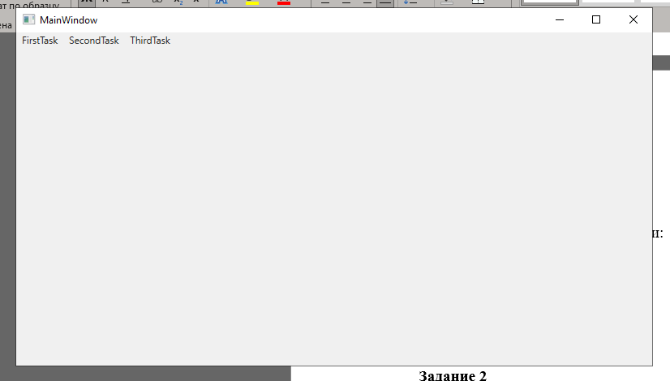

**Задание 1**

Условие

Выполнить табулирование функции:

y = 0.8 * 10^-5 (x^3 + b^3) ^7/6

x0 = -0.05; xk = 0.15; dx = 0.01;

b = 6.74;

Код программы

FirstTask.xaml

<Window x:Class="Prac07.FirstTask"

xmlns="http://schemas.microsoft.com/winfx/2006/xaml/presentation"

xmlns:x="http://schemas.microsoft.com/winfx/2006/xaml"

xmlns:d="http://schemas.microsoft.com/expression/blend/2008"

xmlns:mc="http://schemas.openxmlformats.org/markup-compatibility/2006"

xmlns:local="clr-namespace:Prac07"

mc:Ignorable="d"

Title="FirstTask" Height="450" Width="800">

<Grid>

<TextBox x:Name="TextBoxResult" HorizontalAlignment="Center" Margin="0,56,0,0" TextWrapping="Wrap" VerticalAlignment="Top" Width="292" Height="126"/>

<Button Content="Выполнить" HorizontalAlignment="Center" Margin="0,253,0,0" VerticalAlignment="Top" Height="54" Width="146" Background="#FFAF4646" Click="Button_Click"/>

</Grid>

</Window>

FirstTask.xaml.cs

using System;

using System.Collections.Generic;

using System.Linq;

using System.Text;

using System.Threading.Tasks;

using System.Windows;

using System.Windows.Controls;

using System.Windows.Data;

using System.Windows.Documents;

using System.Windows.Input;

using System.Windows.Media;

using System.Windows.Media.Imaging;

using System.Windows.Shapes;

namespace Prac07

{

/// <summary>

/// Логика взаимодействия для FirstTask.xaml

/// </summary>

public partial class FirstTask : Window

{

public FirstTask()

{

InitializeComponent();

}

private void Button_Click(object sender, RoutedEventArgs e)

{

var xk = 0.15;

var dx = 0.01;

var b = 6.74;

for (var x0 = -0.05; x0 < xk; x0 += dx)

{

var y = 0.8 * Math.Pow(10, -5) * Math.Pow((Math.Pow(x0, 3) + Math.Pow(b, 3)), 7 / 6);

this.TextBoxResult.Text += $"x0 = {x0} | y = {y} {Environment.NewLine}";

}

}

}

}

Результат программы

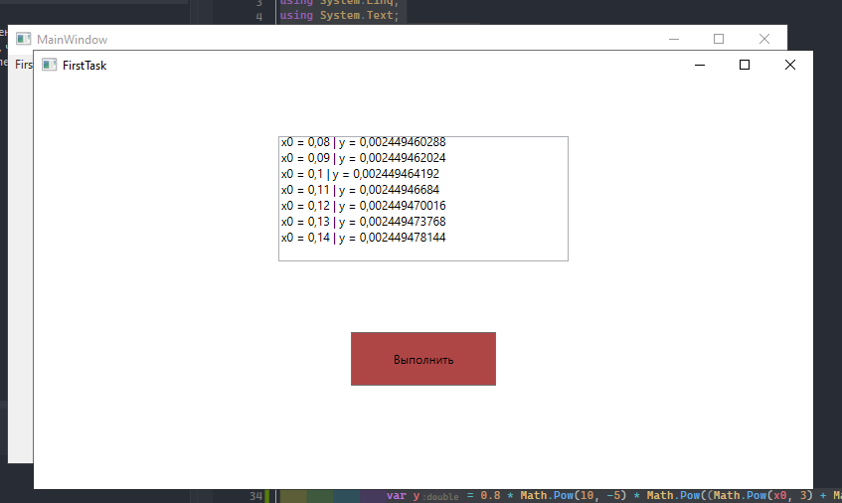

**Задание 2**

Условие

Дан массив, содержащий 14 элементов. Вычислить сумму элементов, стоящих до первого отрицательного элемента. Вывести исходный массив и результат вычислений.

Код программы

SecondTask.xaml

<Window x:Class="Prac07.SecondTask"

xmlns="http://schemas.microsoft.com/winfx/2006/xaml/presentation"

xmlns:x="http://schemas.microsoft.com/winfx/2006/xaml"

xmlns:d="http://schemas.microsoft.com/expression/blend/2008"

xmlns:mc="http://schemas.openxmlformats.org/markup-compatibility/2006"

xmlns:local="clr-namespace:Prac07"

mc:Ignorable="d"

Title="SecondTask" Height="450" Width="800">

<Grid>

<TextBox x:Name="TextBoxResult" HorizontalAlignment="Center" Margin="0,31,0,0" TextWrapping="Wrap" VerticalAlignment="Top" Width="408" Height="132"/>

<Button Content="Вычислить" HorizontalAlignment="Center" VerticalAlignment="Center" Height="39" Width="116" Click="Button_Click"/>

</Grid>

</Window>

SecondTask.xaml.cs

using System;

using System.Collections.Generic;

using System.Linq;

using System.Text;

using System.Threading.Tasks;

using System.Windows;

using System.Windows.Controls;

using System.Windows.Data;

using System.Windows.Documents;

using System.Windows.Input;

using System.Windows.Media;

using System.Windows.Media.Imaging;

using System.Windows.Shapes;

namespace Prac07

{

/// <summary>

/// Логика взаимодействия для SecondTask.xaml

/// </summary>

public partial class SecondTask : Window

{

public SecondTask()

{

InitializeComponent();

}

private void Button_Click(object sender, RoutedEventArgs e)

{

int[] arr = { 1, 2, 3, 4, 5, 6, -7, 8, 9, 10, -11, 12, -13, 14 };

var sum = 0;

int i;

for (i = 0; i < arr.Length && arr[i] >= 0; i++)

{

sum += arr[i];

}

this.TextBoxResult.Clear();

this.TextBoxResult.Text += $"Сумма элементов до первого отрицательного: {sum}" +

$"{Environment.NewLine}";

this.TextBoxResult.Text += $"Исходный массив: {Environment.NewLine}";

for (i = 0; i < arr.Length; i++)

{

this.TextBoxResult.Text += arr[i] + " ";

}

}

}

}

Результат программы

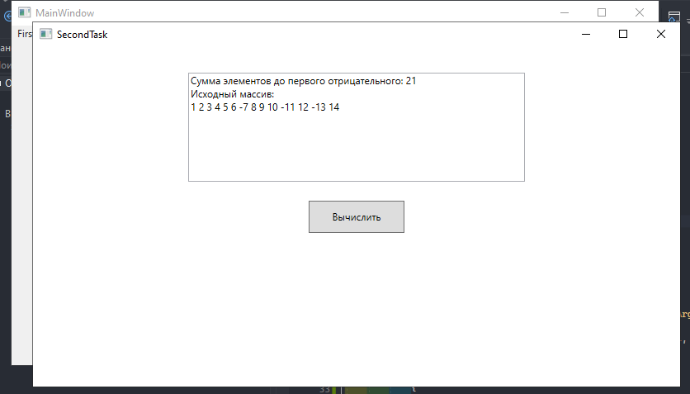

**Задание 3**

Условие

Вычислить и вывести сумму элементов матрицы A(12,12), расположенных над главной диагональю матрицы.

Код программы

ThirdTask.xaml

<Window x:Class="Prac07.ThirdTask"

xmlns="http://schemas.microsoft.com/winfx/2006/xaml/presentation"

xmlns:x="http://schemas.microsoft.com/winfx/2006/xaml"

xmlns:d="http://schemas.microsoft.com/expression/blend/2008"

xmlns:mc="http://schemas.openxmlformats.org/markup-compatibility/2006"

xmlns:local="clr-namespace:Prac07"

mc:Ignorable="d"

Title="ThirdTask" Height="450" Width="800">

<Grid>

<TextBox x:Name="TextBoxResult" HorizontalAlignment="Center" Margin="0,88,0,0" TextWrapping="Wrap" VerticalAlignment="Top" Width="404" Height="142"/>

<Button Content="Вычислить" HorizontalAlignment="Center" Margin="0,272,0,0" VerticalAlignment="Top" Height="60" Width="202" Click="Button_Click"/>

</Grid>

</Window>

ThirdTask.xaml.cs

using System;

using System.Collections.Generic;

using System.Linq;

using System.Text;

using System.Threading.Tasks;

using System.Windows;

using System.Windows.Controls;

using System.Windows.Data;

using System.Windows.Documents;

using System.Windows.Input;

using System.Windows.Media;

using System.Windows.Media.Imaging;

using System.Windows.Shapes;

namespace Prac07

{

/// <summary>

/// Логика взаимодействия для ThirdTask.xaml

/// </summary>

public partial class ThirdTask : Window

{

public ThirdTask()

{

InitializeComponent();

}

private void Button_Click(object sender, RoutedEventArgs e)

{

int[,] A = new int[12, 12];

var sum = 0;

this.TextBoxResult.Clear();

Random rand = new Random();

for (int i = 0; i < 12; i++)

{

for (int j = 0; j < 12; j++)

{

A[i, j] = rand.Next(1, 51);

this.TextBoxResult.Text += $"{A[i, j]}" + $" ";

}

this.TextBoxResult.Text += $"{Environment.NewLine}";

}

for (int i = 0; i < 12; i++)

{

for (int j = i + 1; j < 12; j++)

{

sum += A[i, j];

}

}

this.TextBoxResult.Text += $"Сумма элементов над главной диагональю: {sum}";

}

}

}

Результат программы

