**MACHINE LEARNING   
LAB**

**NAME: Manish Kumar Singh**

**CLASS: CSE-3**

**ROLL NO : 40876802717**

**EXPERIMENT – 1**

* **Problem Statement:**

Study and implement the Naive Bayes learner on a breast cancer dataset.

* **Github Link:**

https://github.com/sngmanish/ML_Assignments/tree/master/LabProgram1

* **Algorithm Description:**
* Naïve Bayes algorithm is a supervised learning algorithm, which is based on **Bayes theorem** and used for solving classification problems.
* It is mainly used in *text classification* that includes a high-dimensional training dataset.
* Naïve Bayes Classifier is one of the simple and most effective Classification algorithms which helps in building the fast machine learning models that can make quick predictions.
* **It is a probabilistic classifier, which means it predicts on the basis of the probability of an object**.
* Some popular examples of Naïve Bayes Algorithm are **spam filtration, Sentimental analysis, and classifying articles**.
* **Loading dataset**

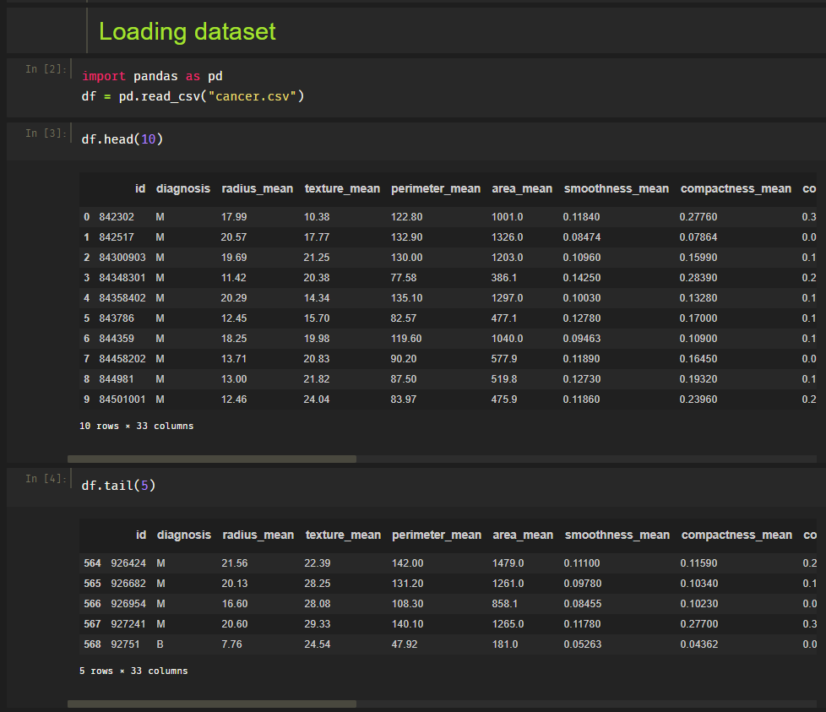

* **Data Cleaning/ Preprocessing**

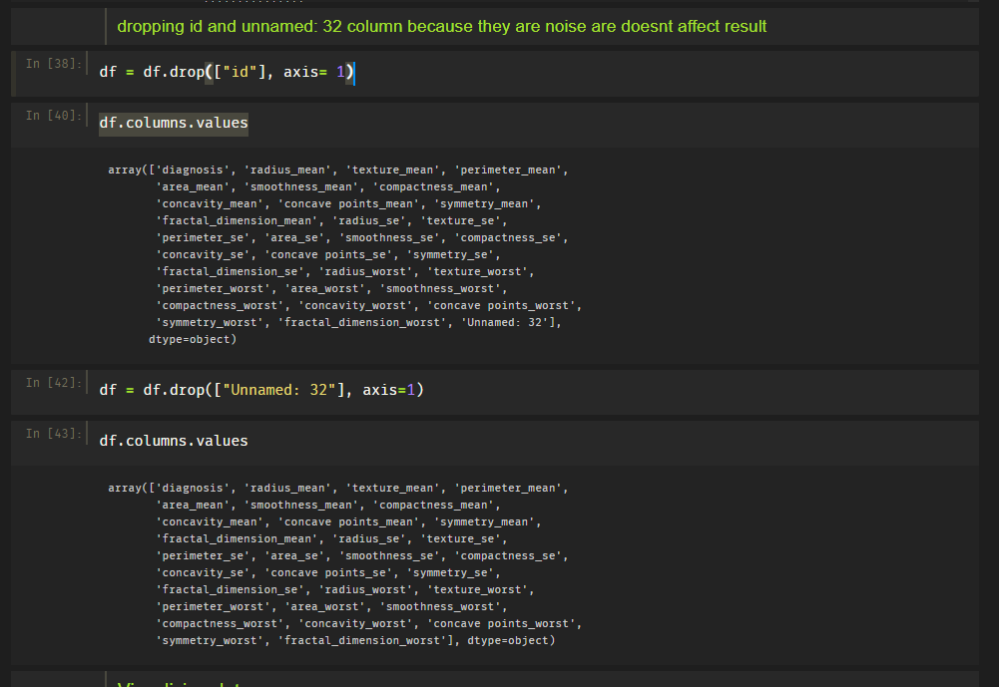

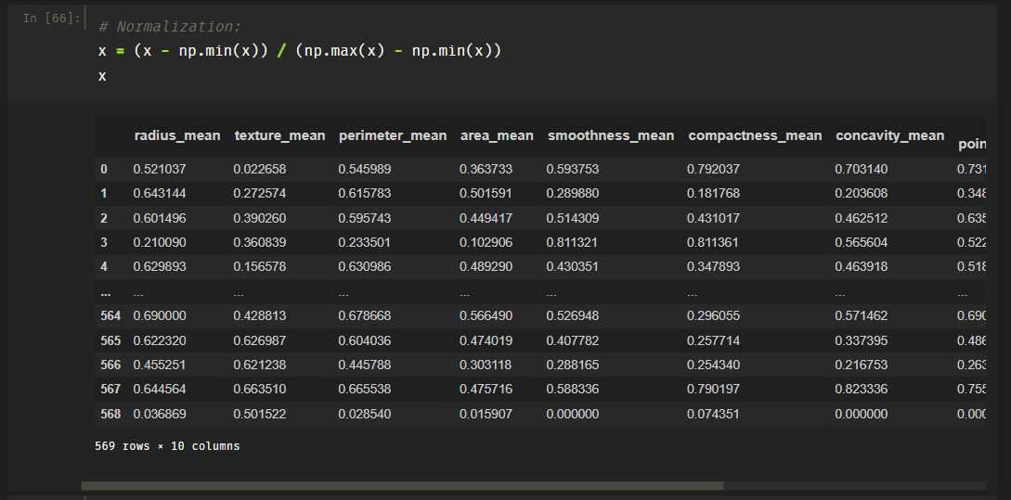

* **Data Visualization**

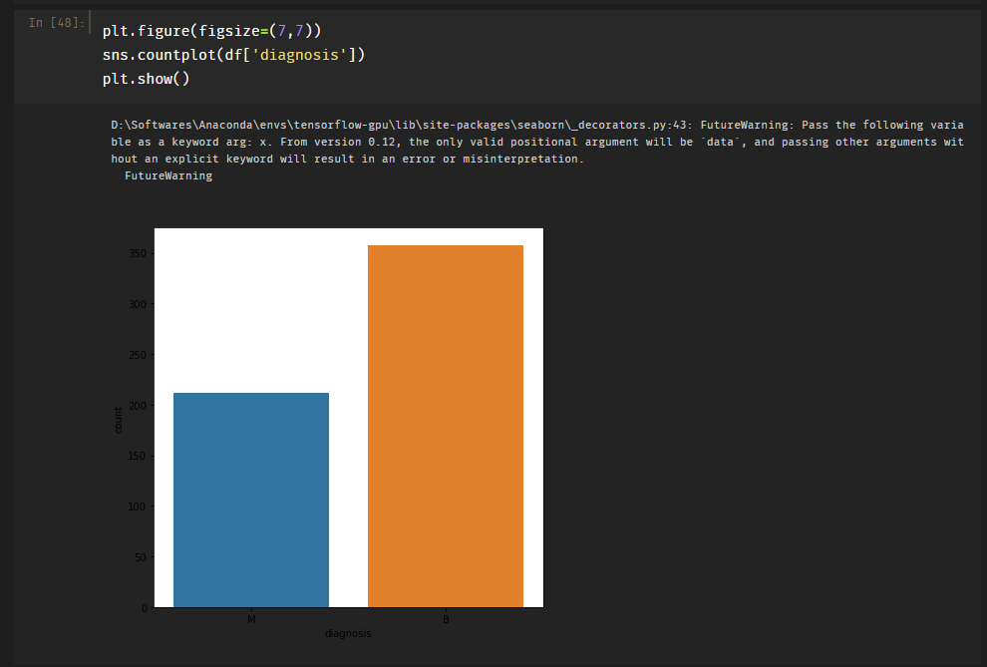

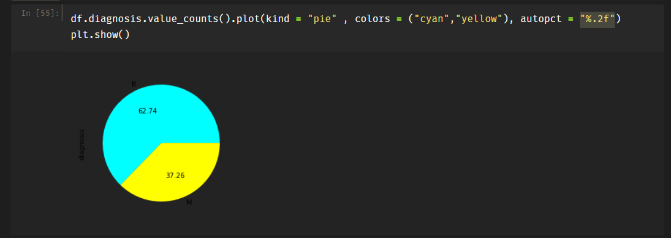

* **Dividing data into train/test splits**

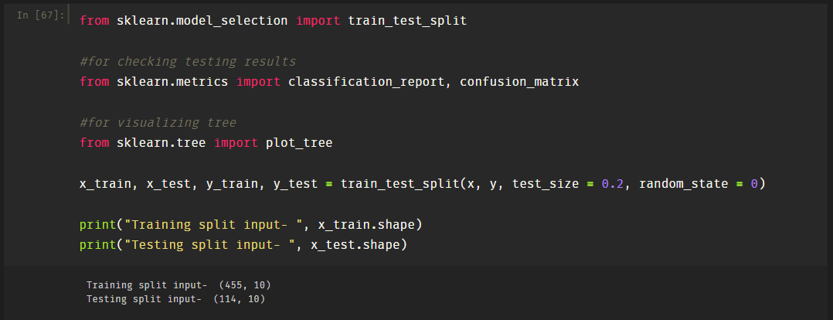

* **Using Naive Bayes gaussian learning method on breast cancer dataset**

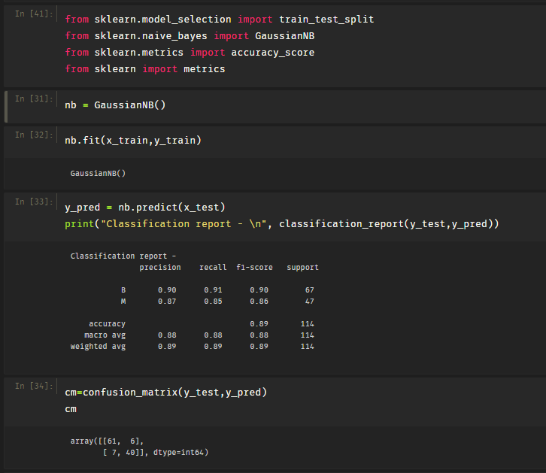

* **Confusion matrix**

