**MACHINE LEARNING   
LAB**

**NAME: Manish Kumar Singh**

**CLASS: CSE-3**

**ROLL NO : 40876802717**

**EXPERIMENT-2**

**Problem Statement**

Implementation of decision tree on a breast cancer dataset using sklearn in python.

**Github Link :** https://github.com/sngmanish/ML_Assignments/tree/master/LabProgram2

**Program Code Snippet**

**Loading Dataset**

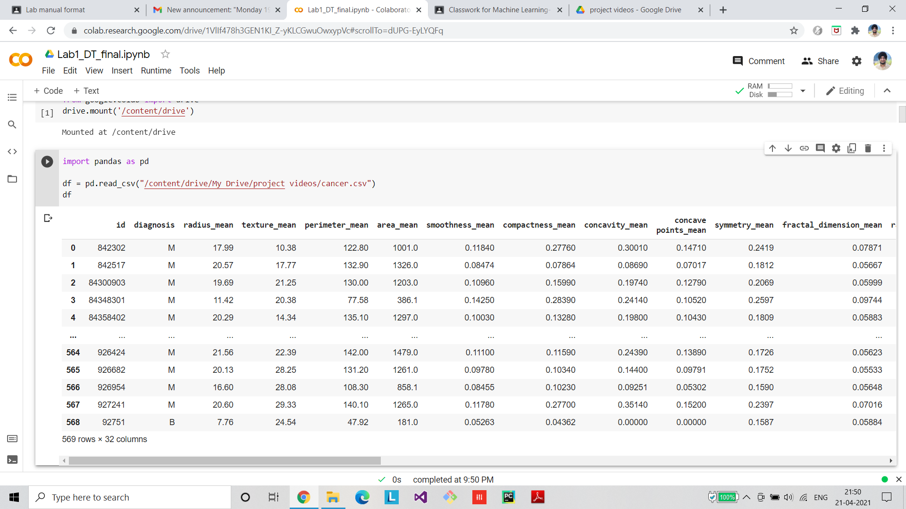

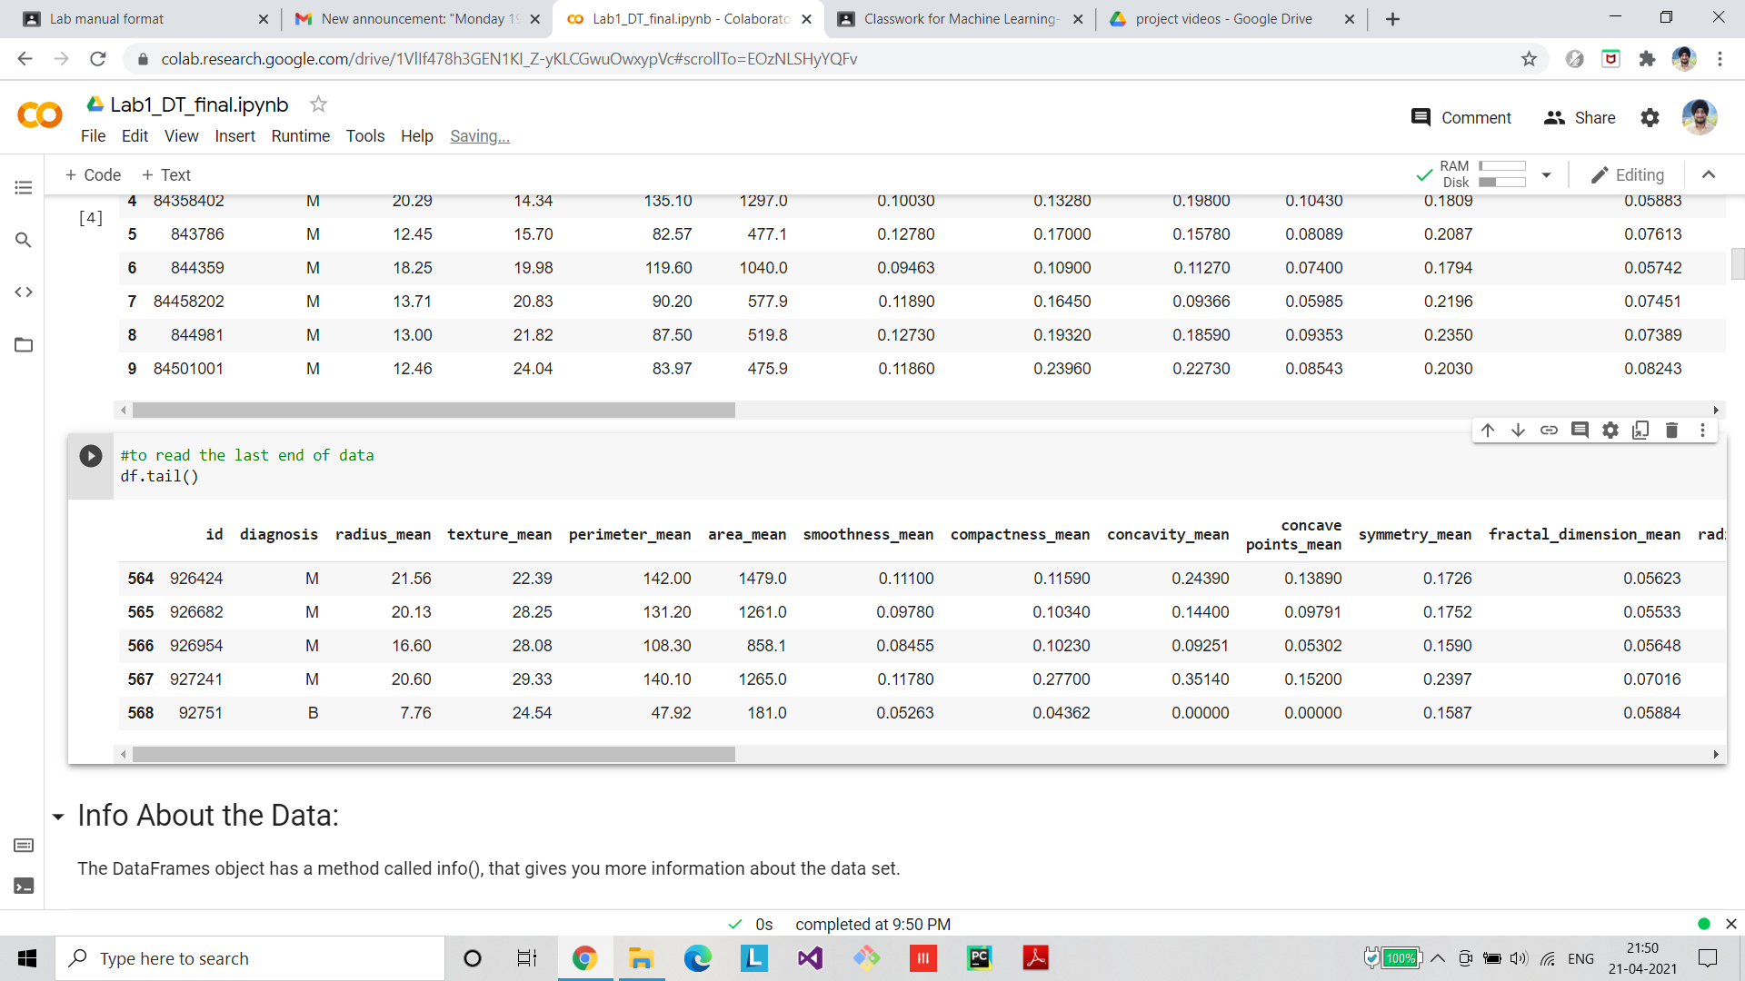

**Preprocessing/Cleaning of dataset**

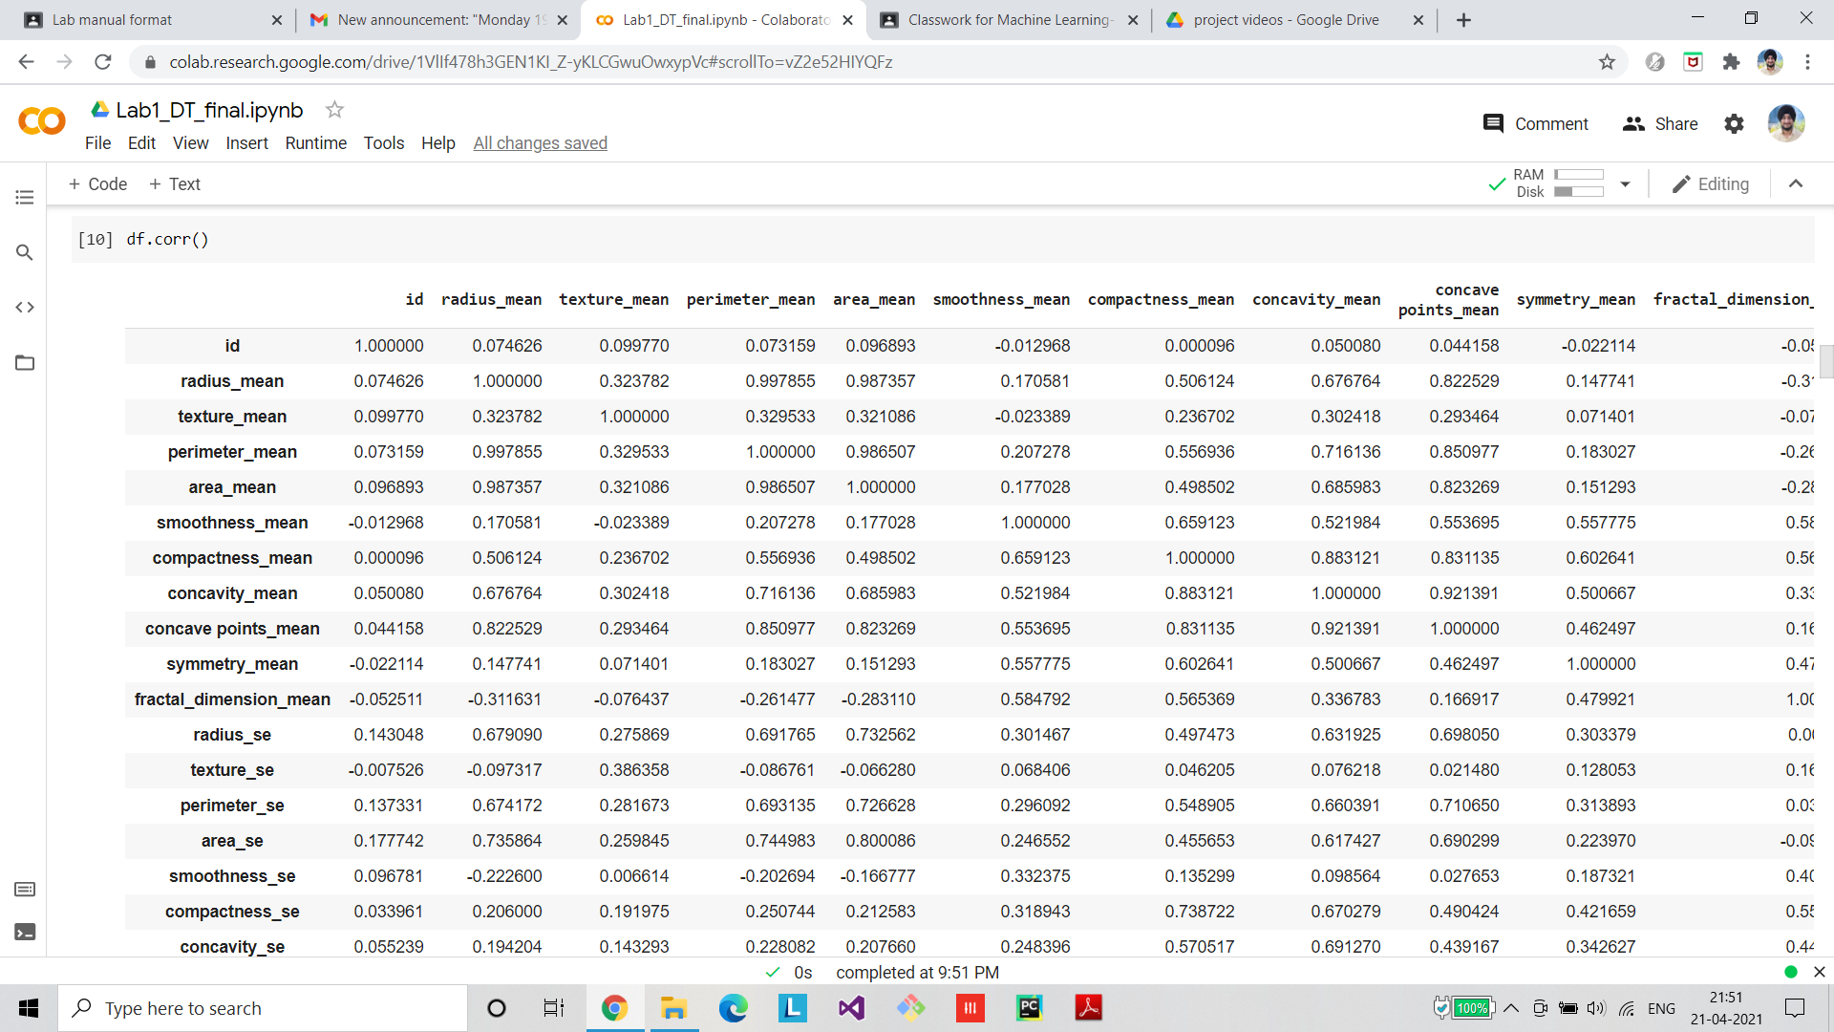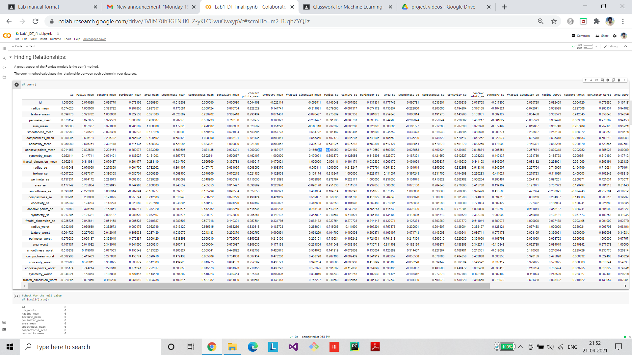

**Visualization**

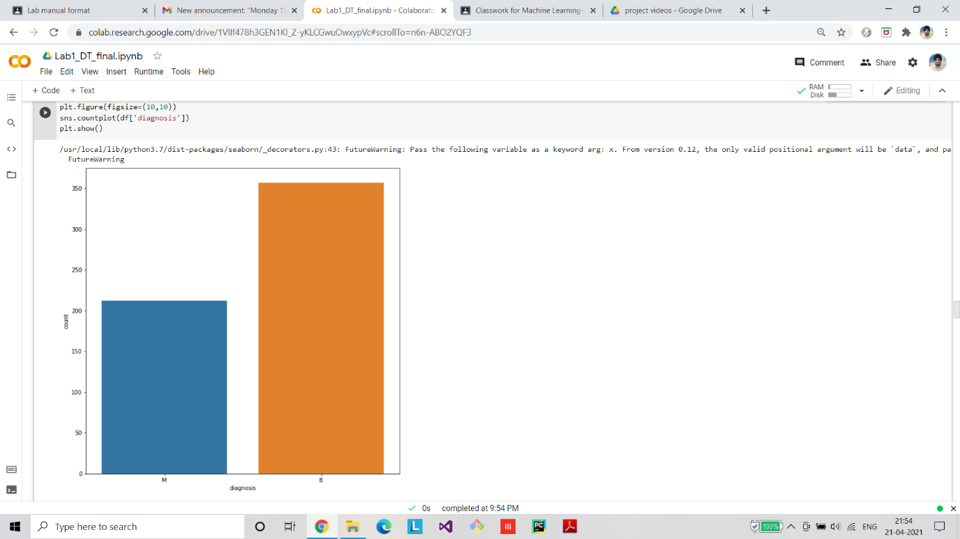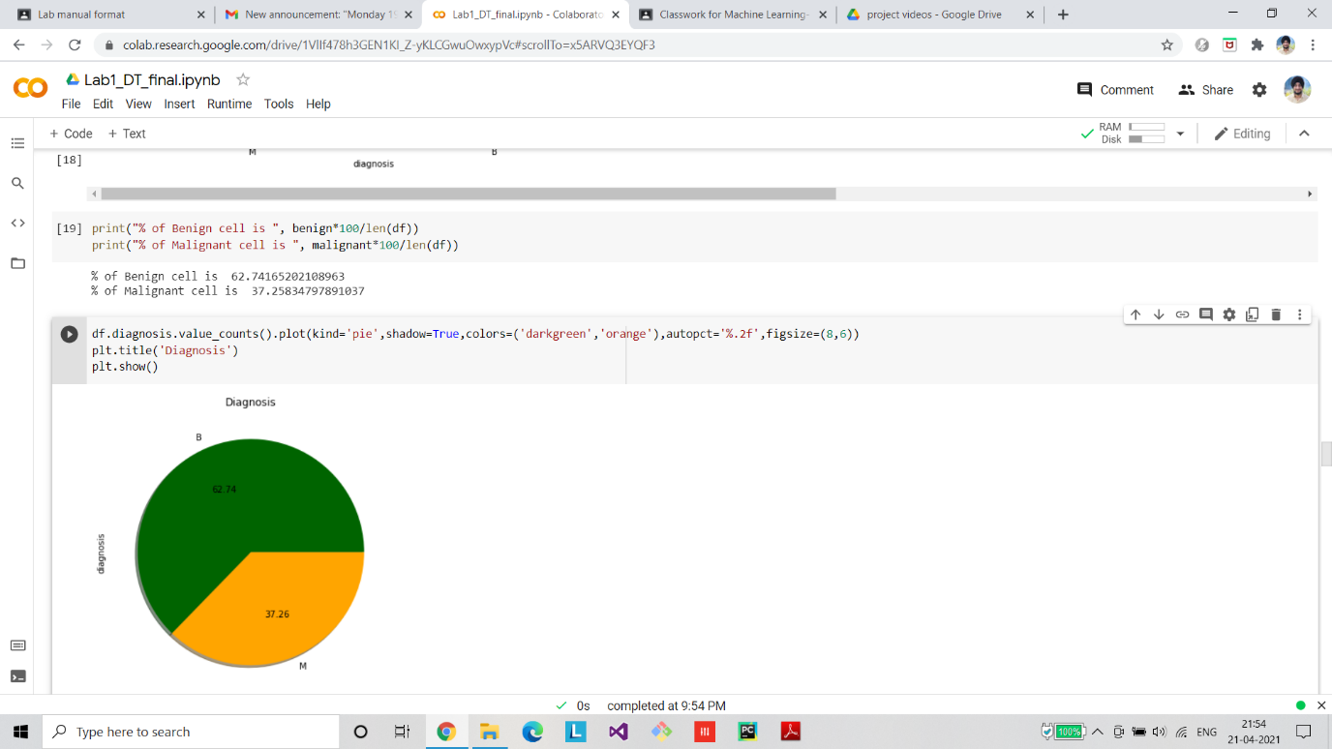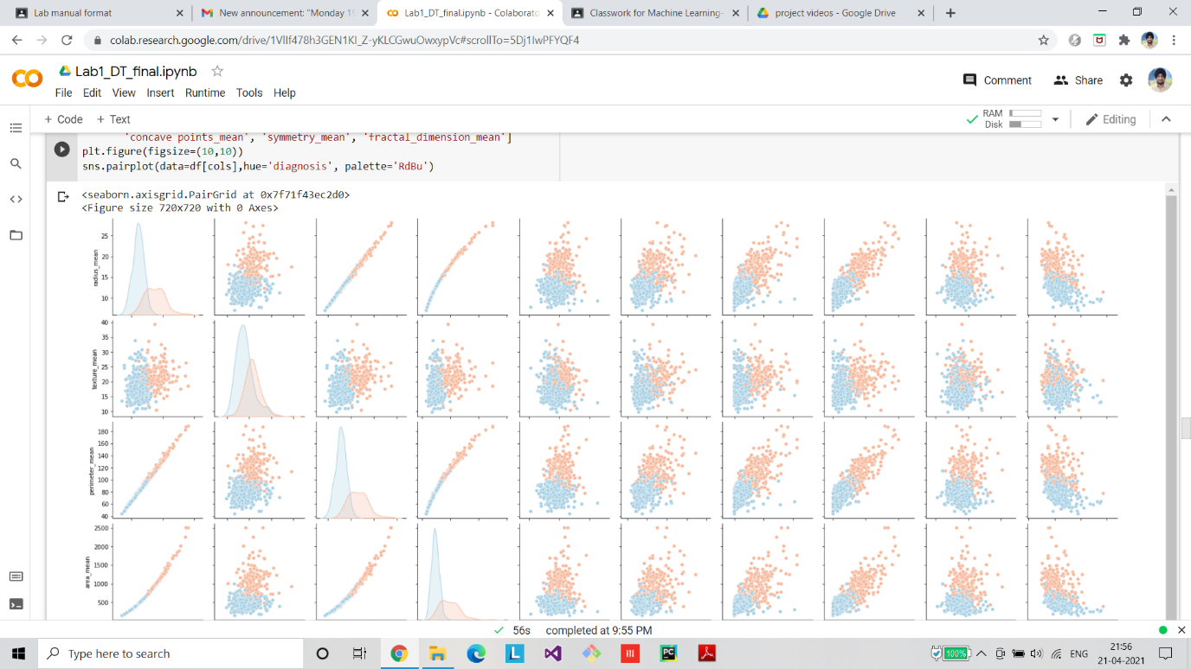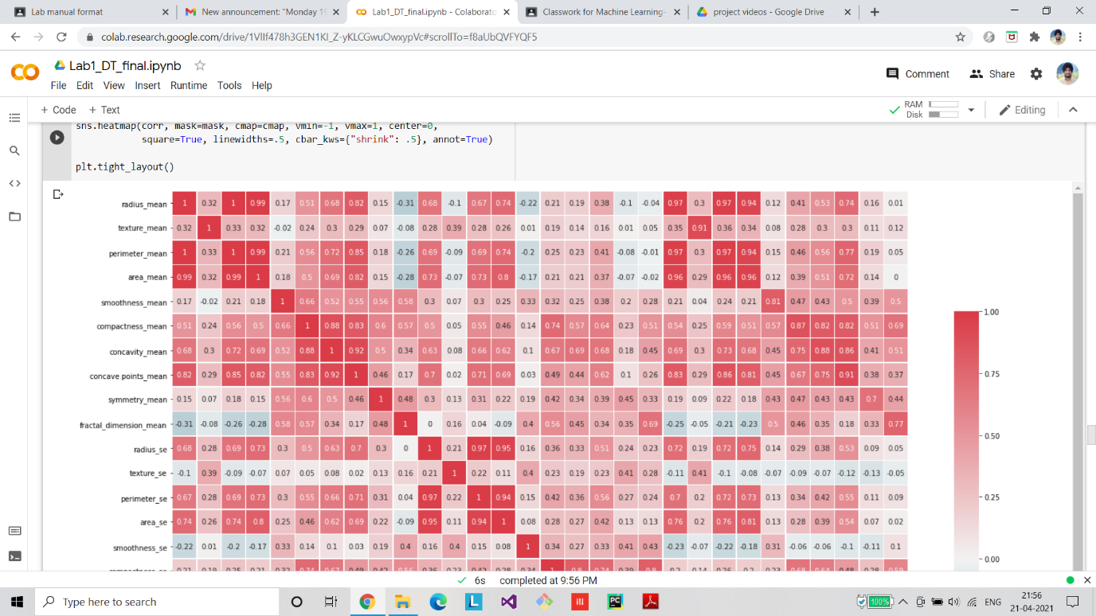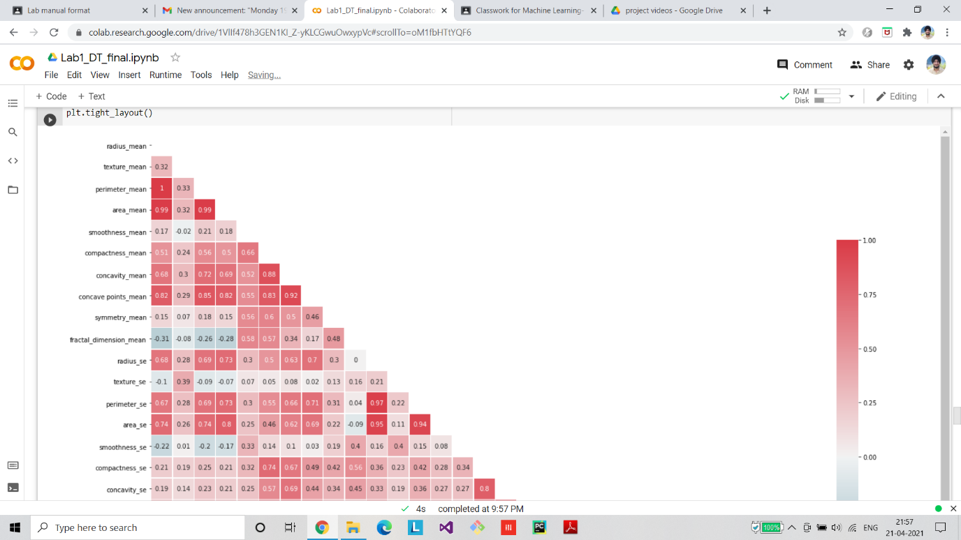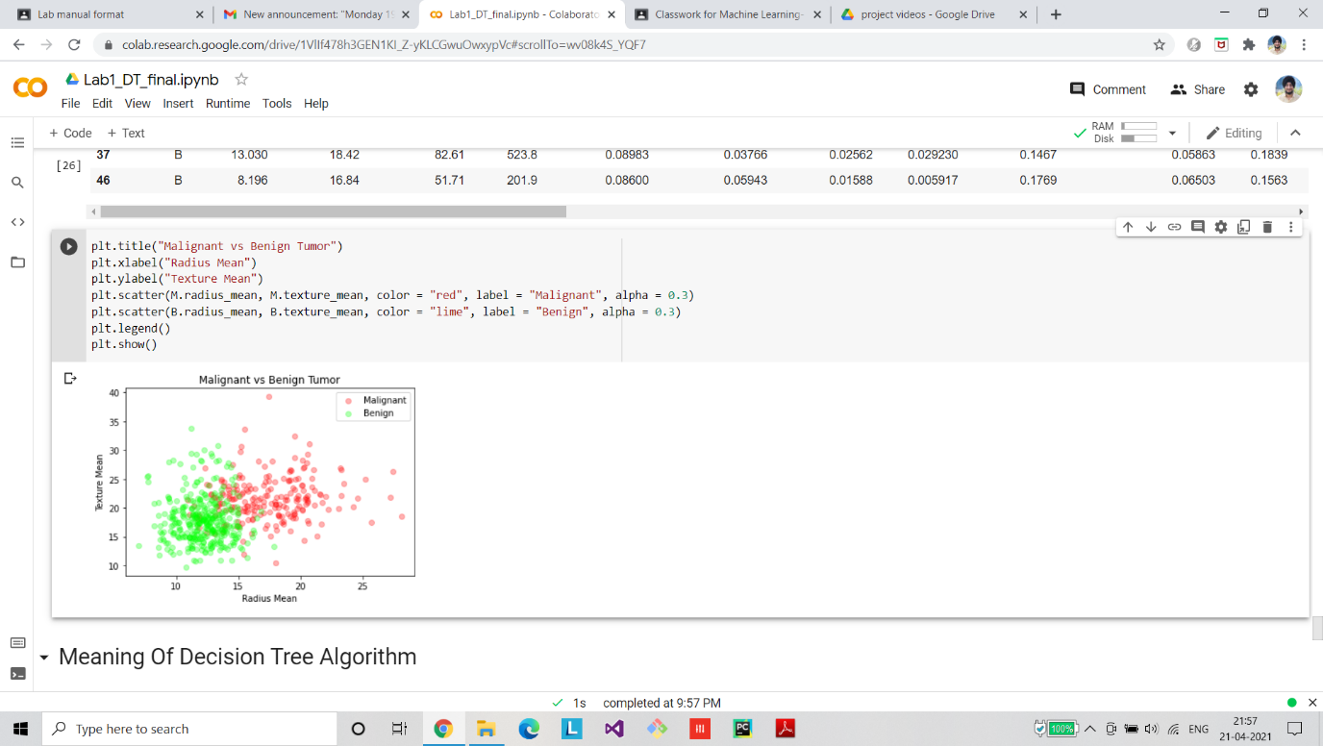

**Algorithm Implementation**

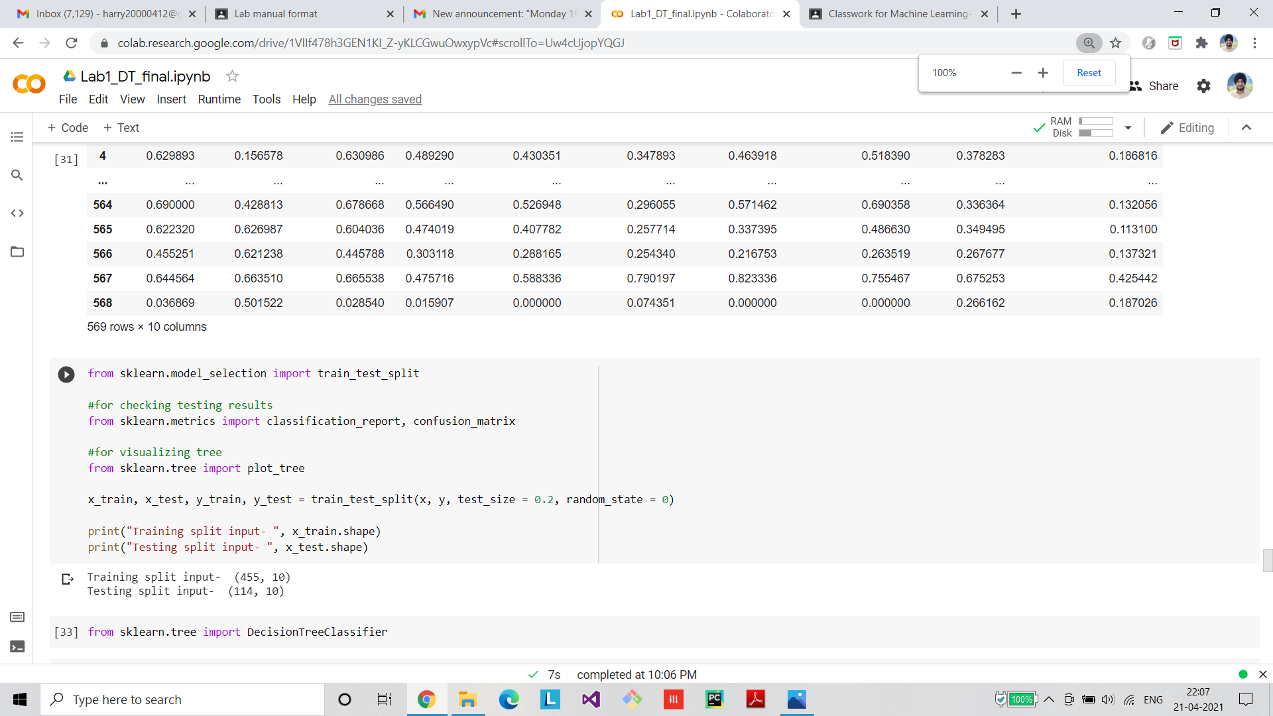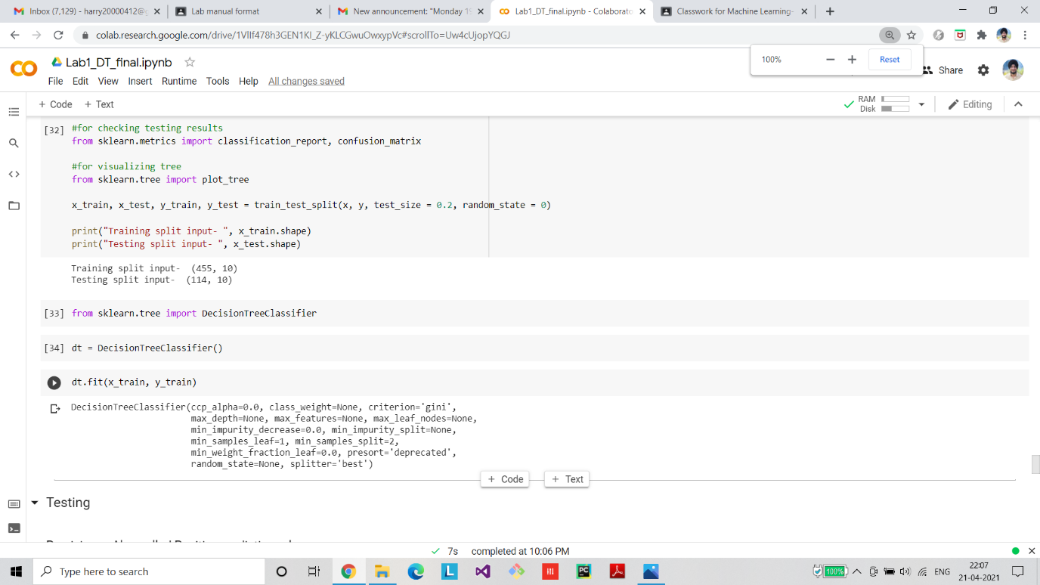

**Final Graph/ROC/Confusion Matrix**

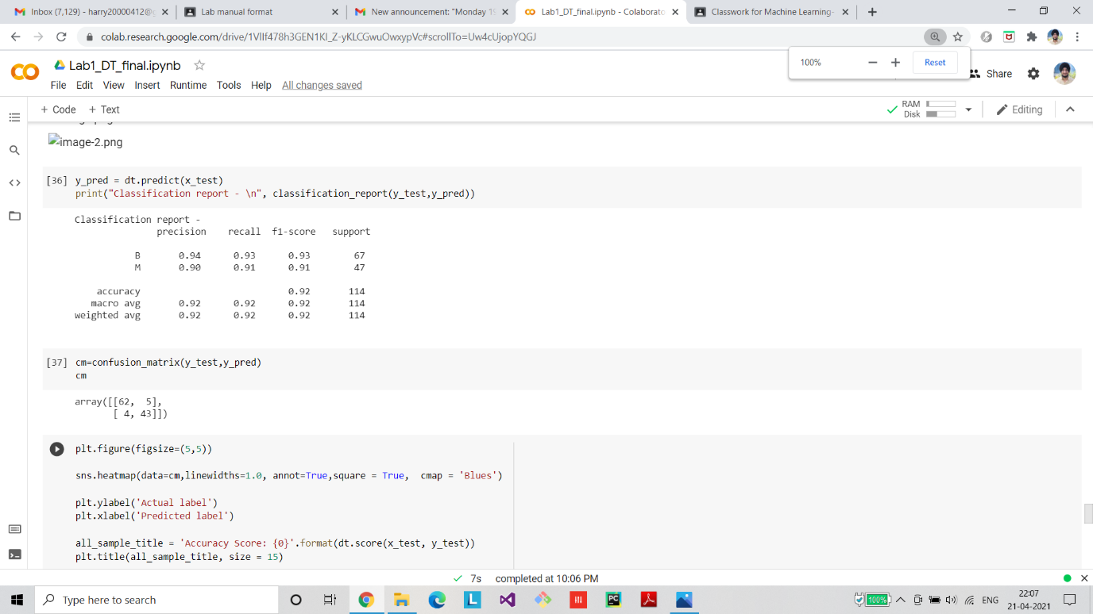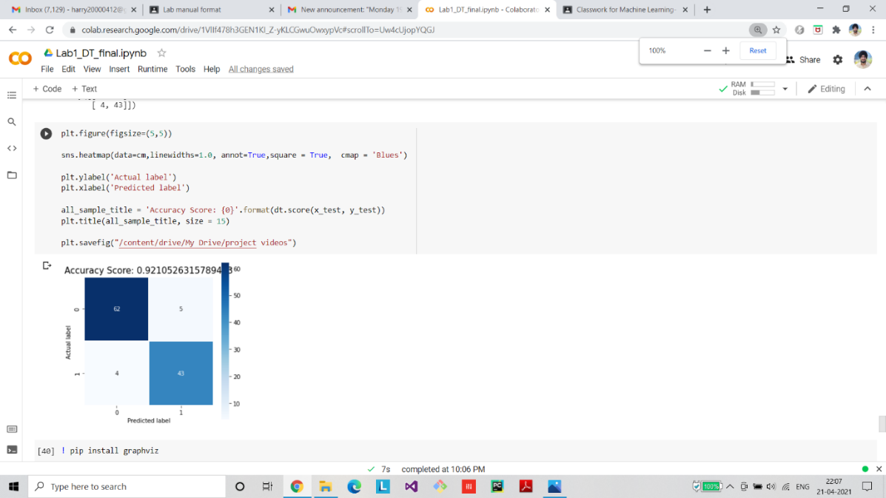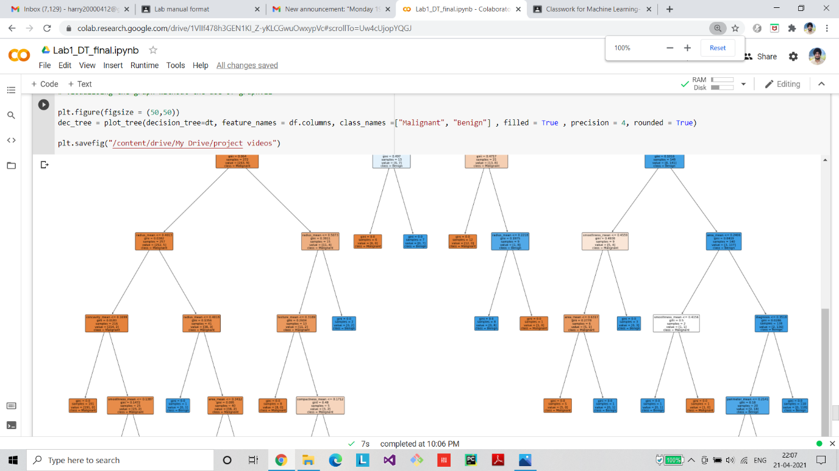

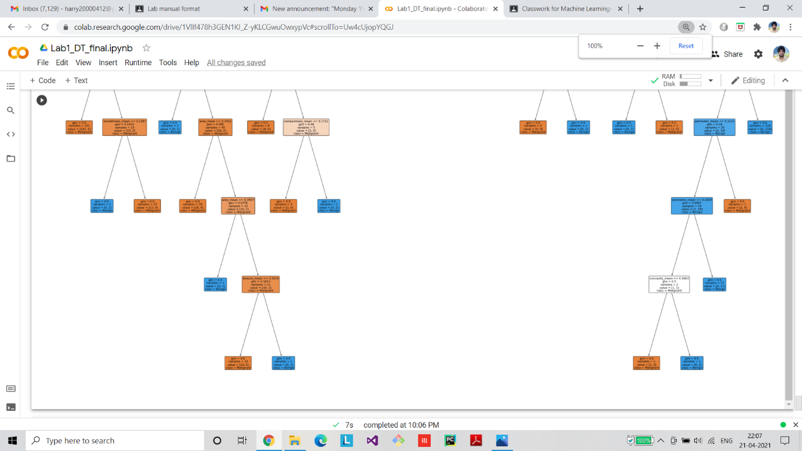

**Github Link**

https://github.com/sngmanish/ML_Assignments/tree/master/LabProgram2