**MACHINE LEARNING**

**LAB**

**NAME: Manish Kumar Singh**

**CLASS: CSE-3**

**ROLL NO.-40876802717**

**EXPERIMENT- 3**

**Problem Statement**

Estimate the accuracy of decision classifier on breast cancer dataset using 5 fold cross validation.

**Github Link :** <https://github.com/sngmanish/ML_Assignments/tree/master/LabProgram3>

**Program Code Snippet**

**Loading Dataset**

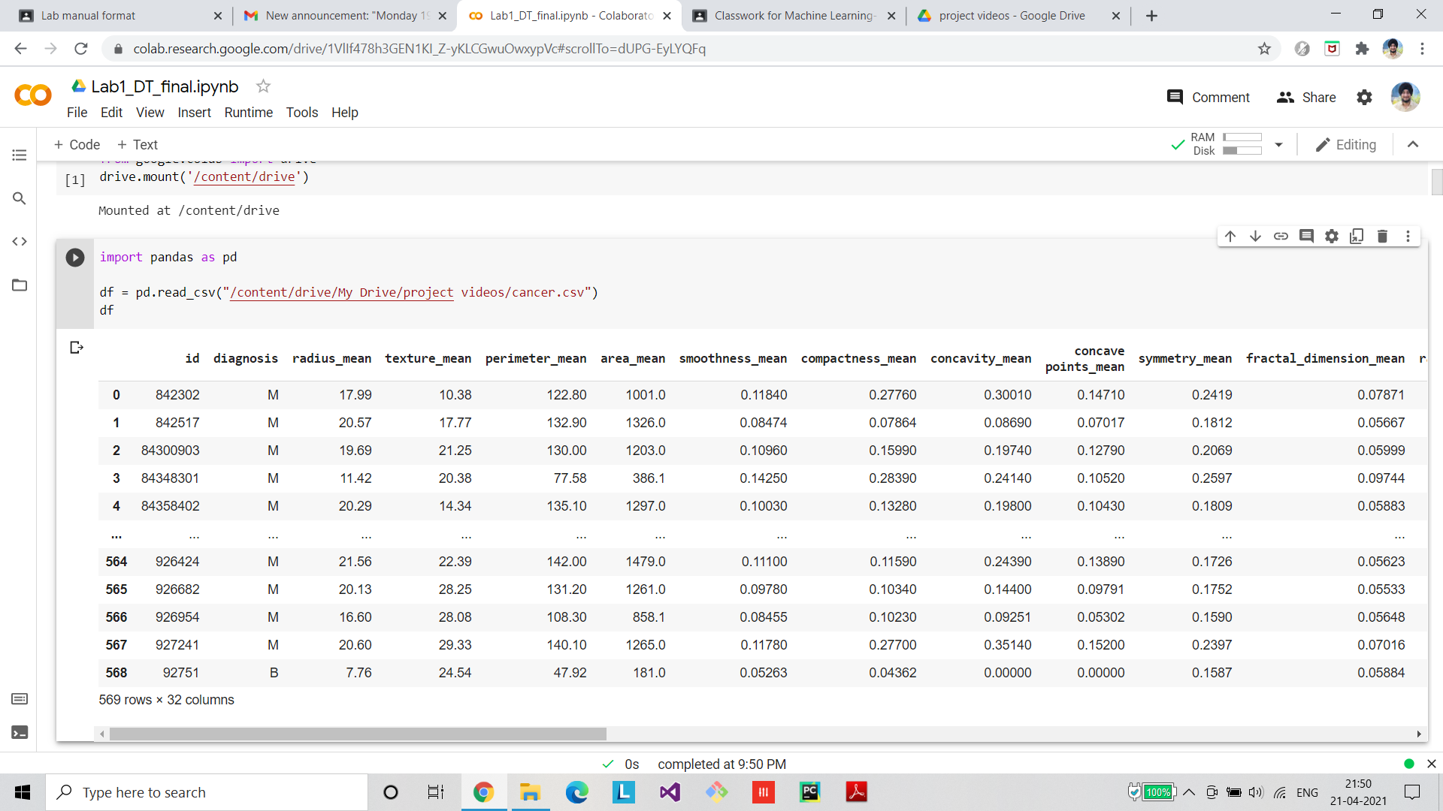

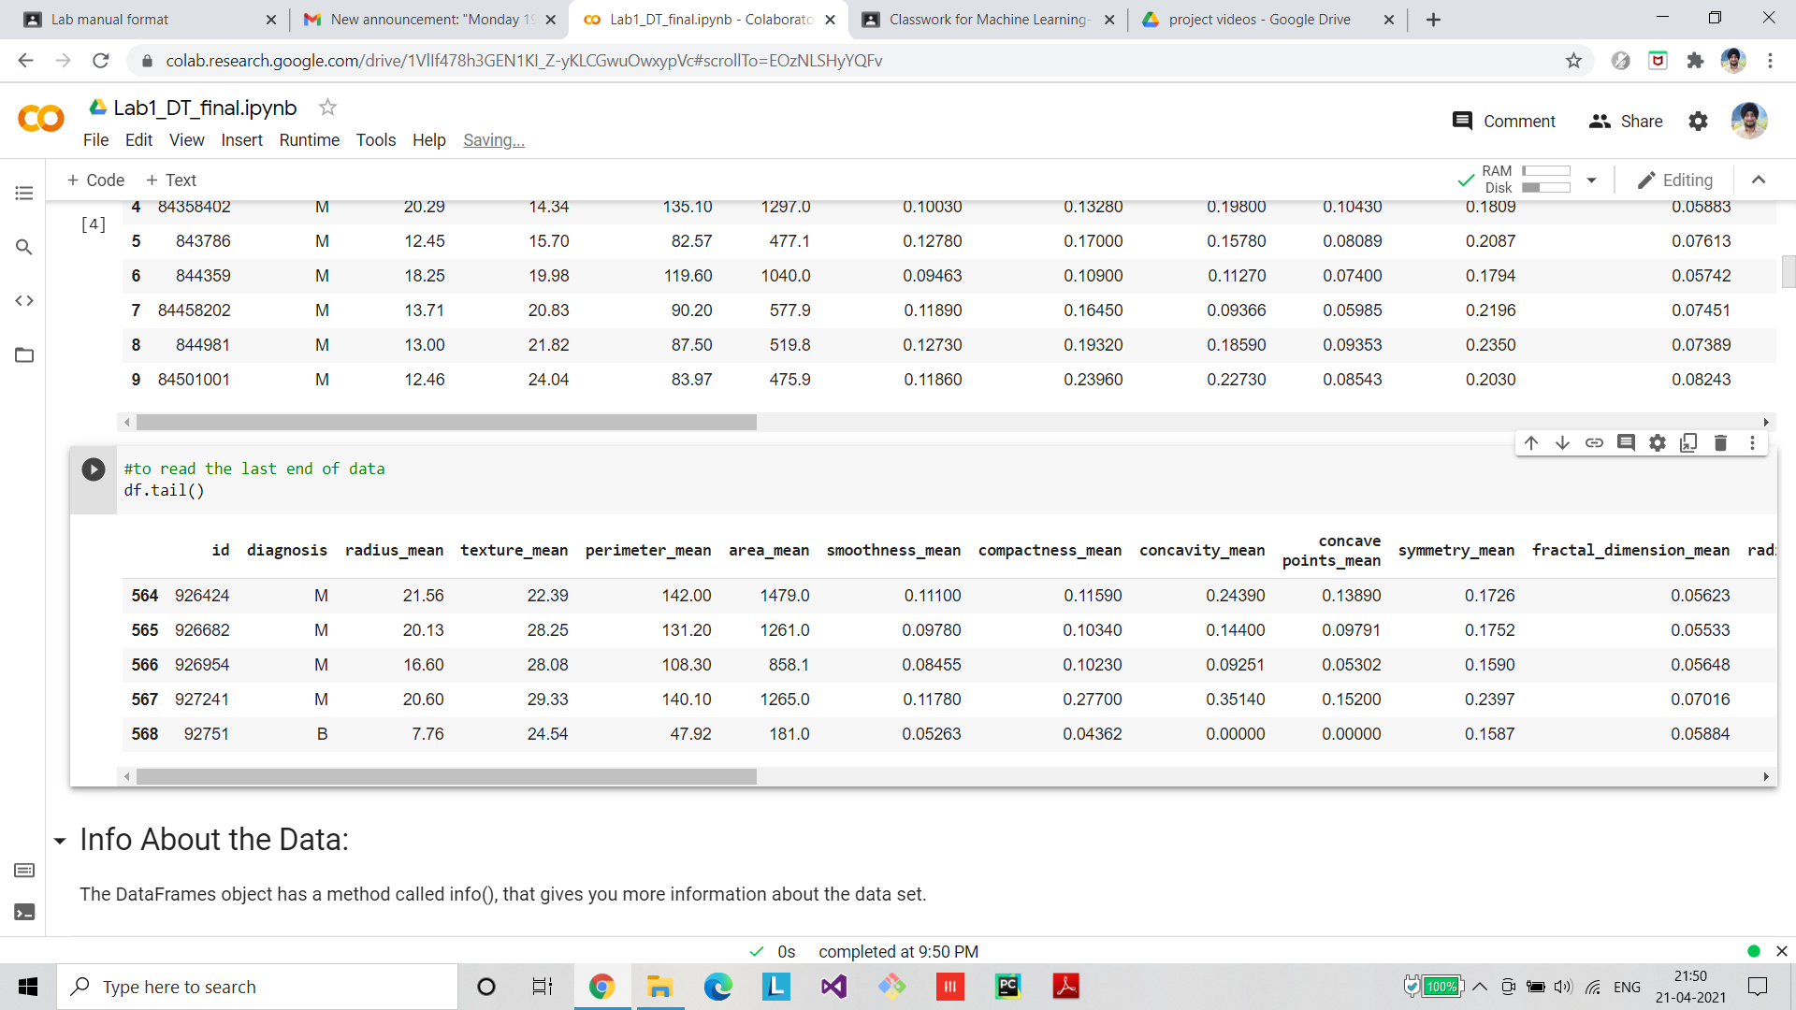

**Preprocessing/Cleaning of dataset**

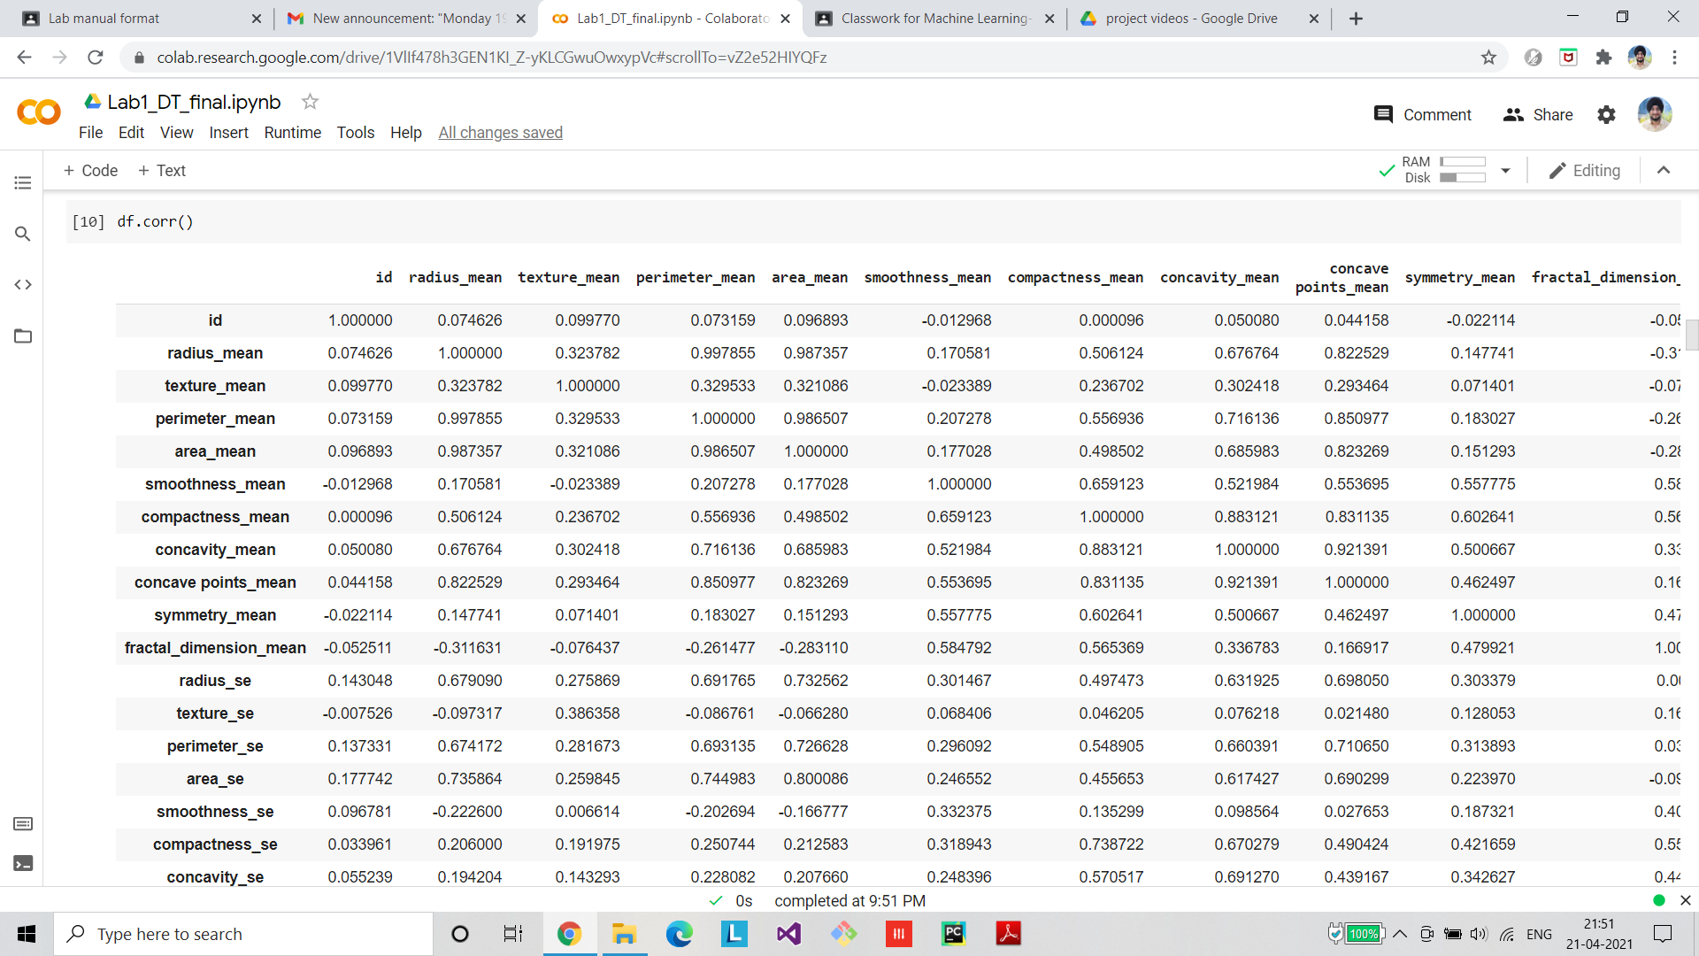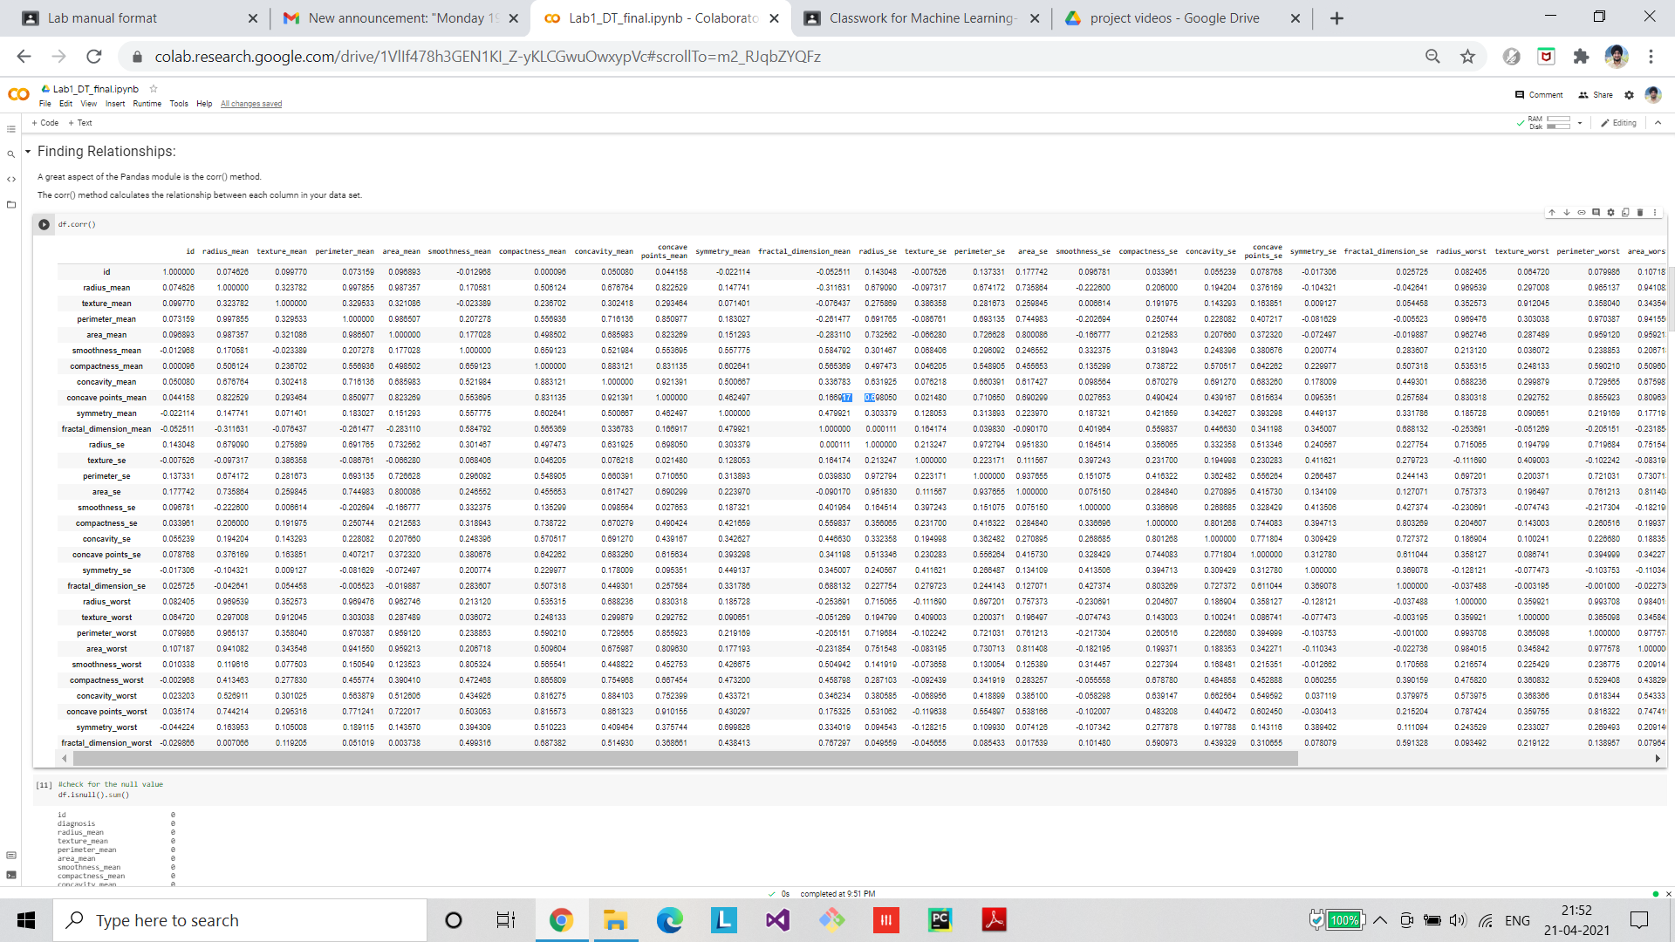

**Visualization**

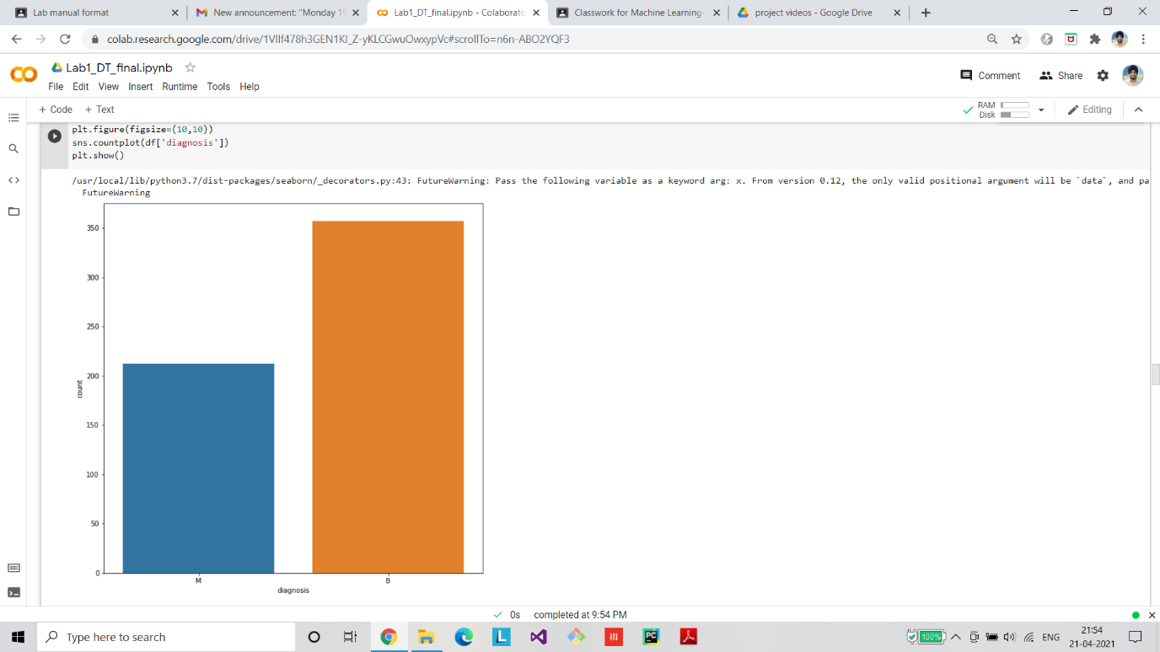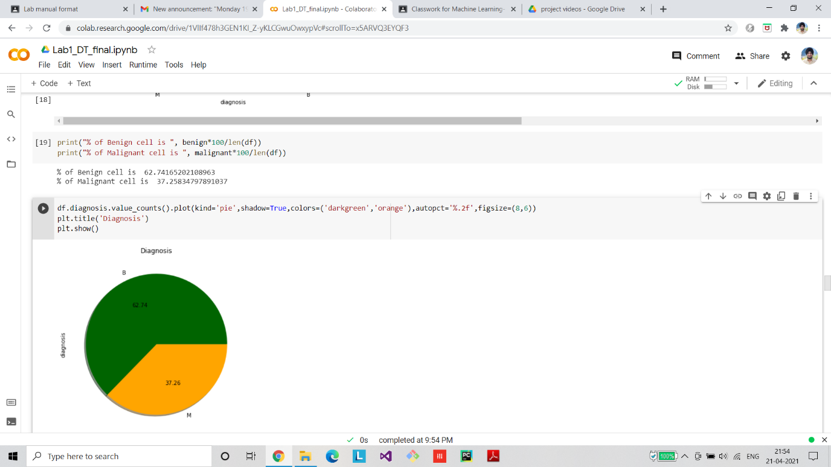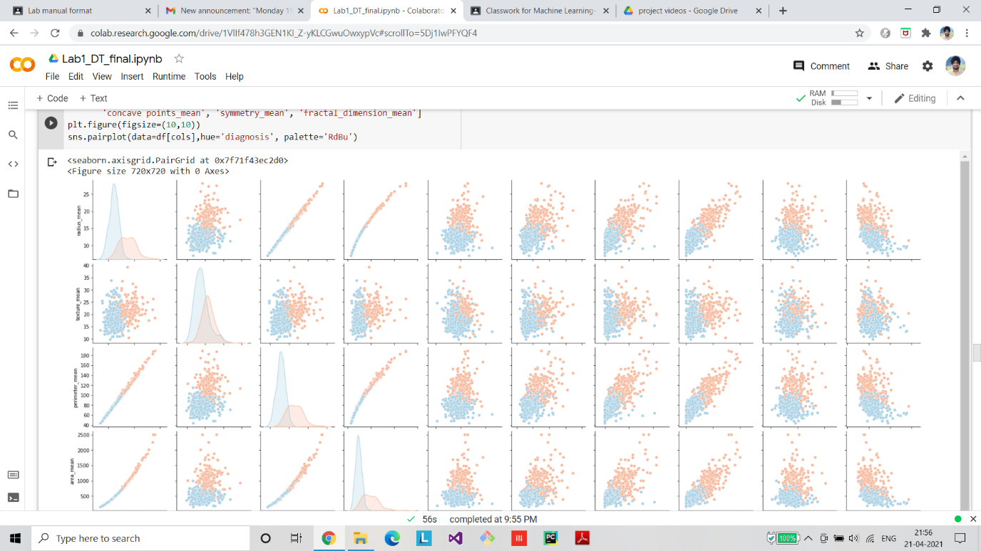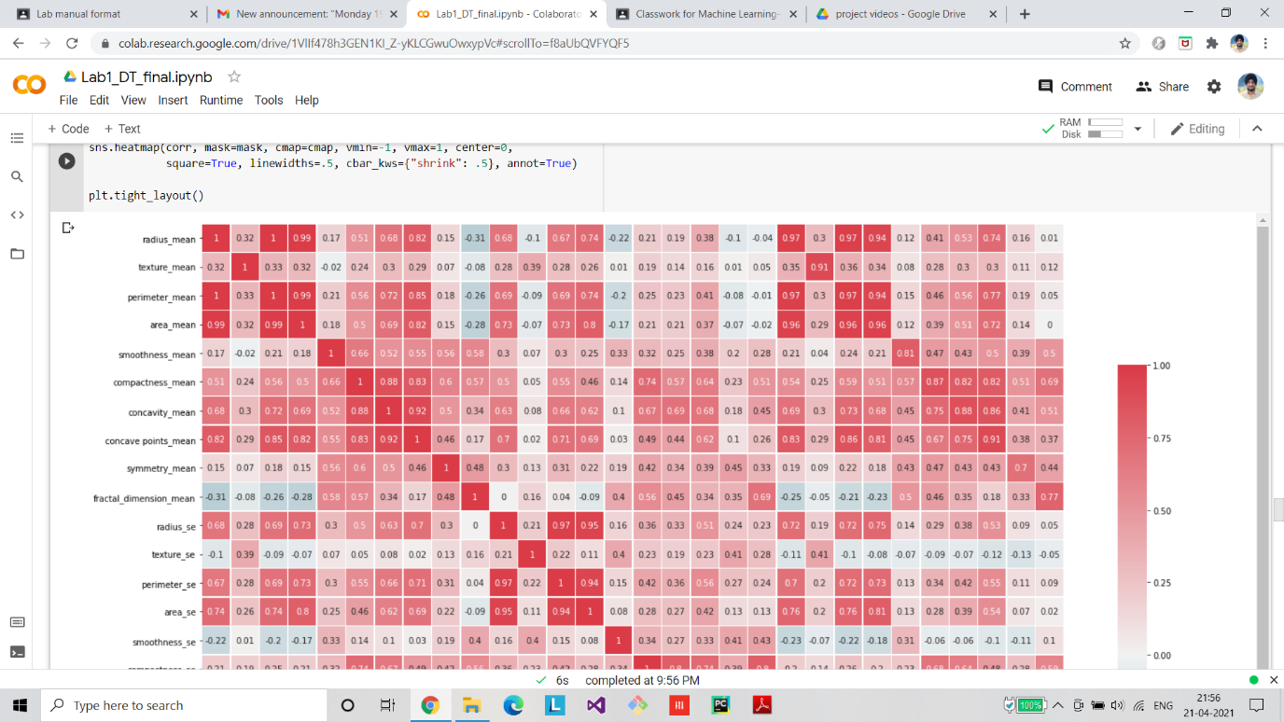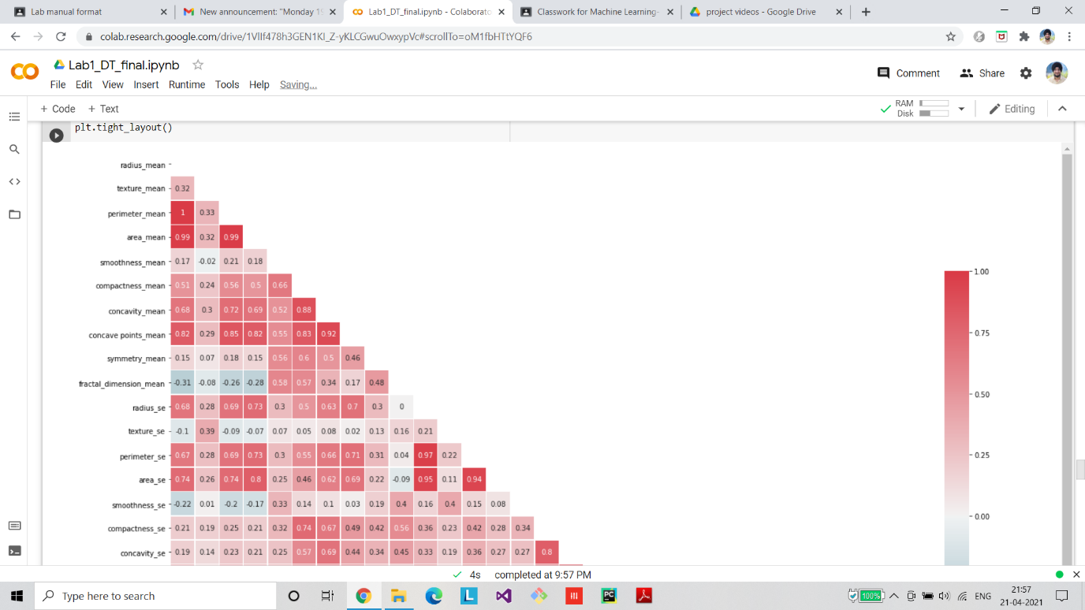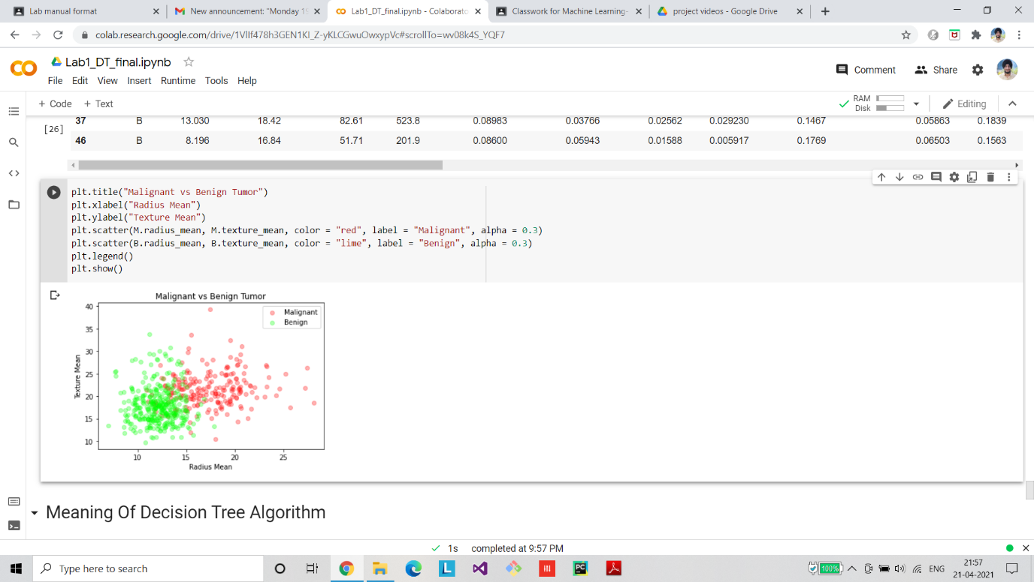

**Algorithm Implementation**

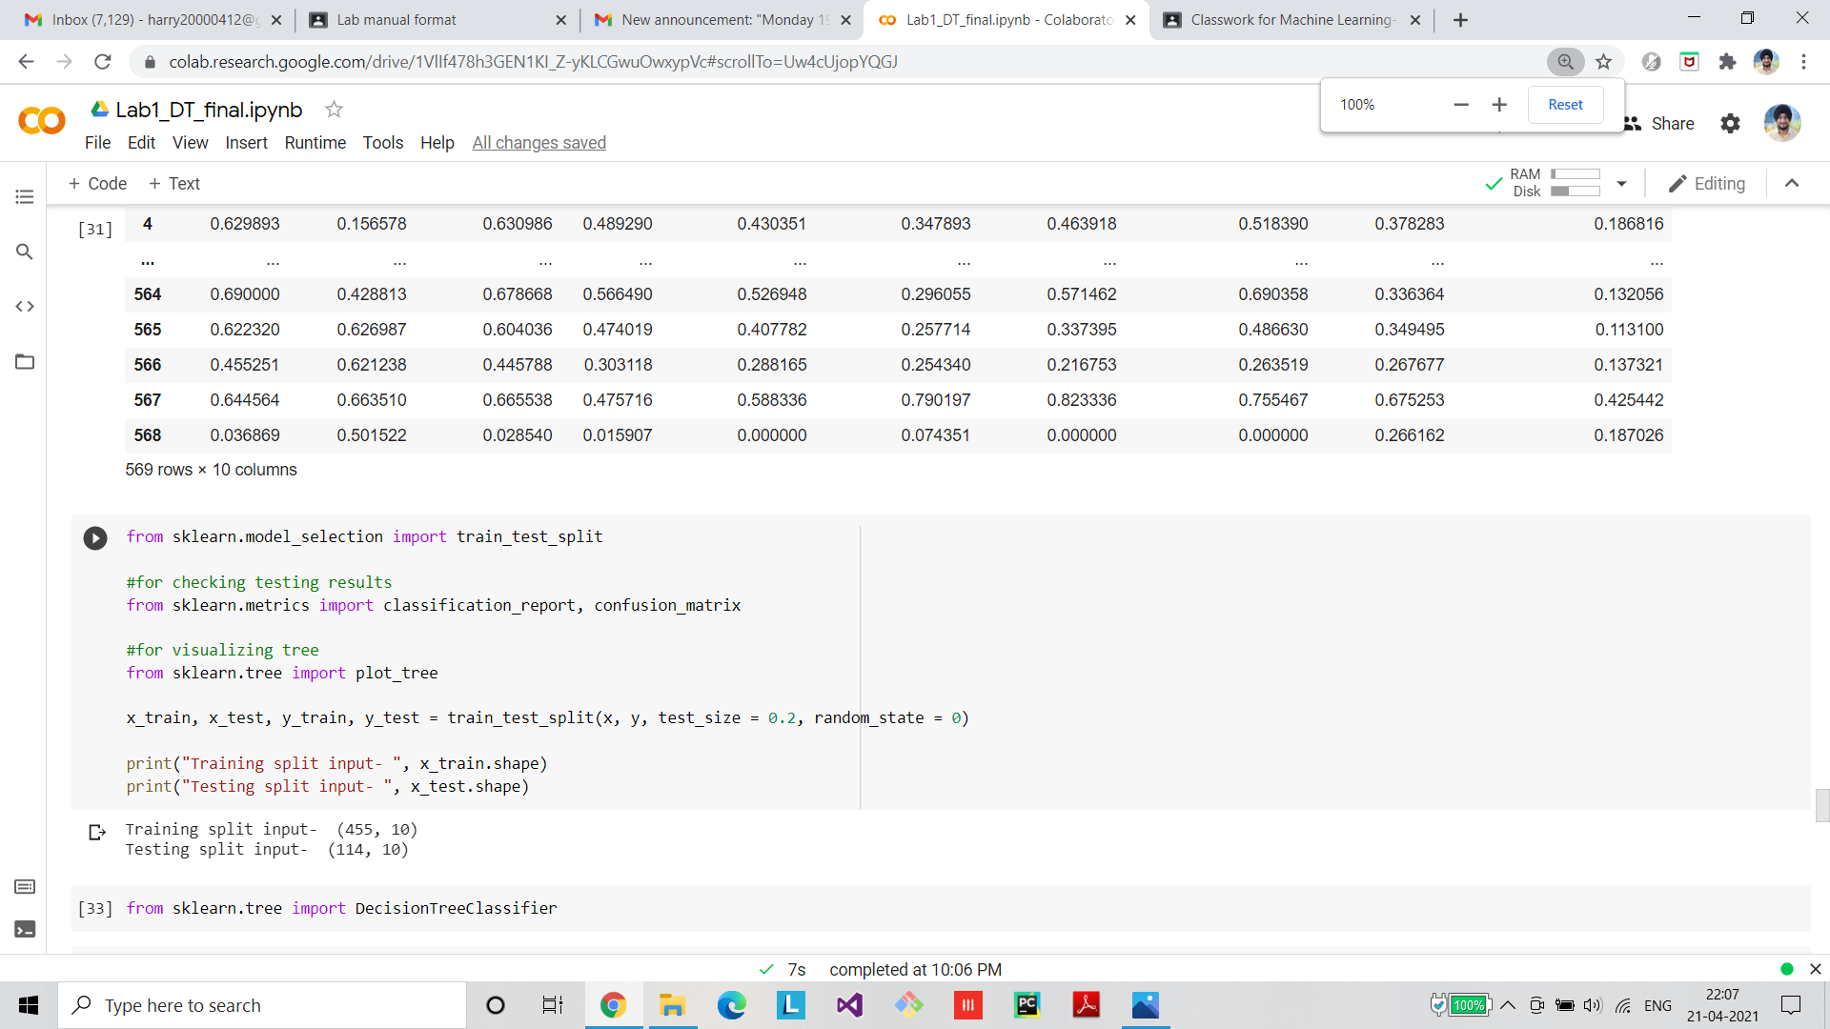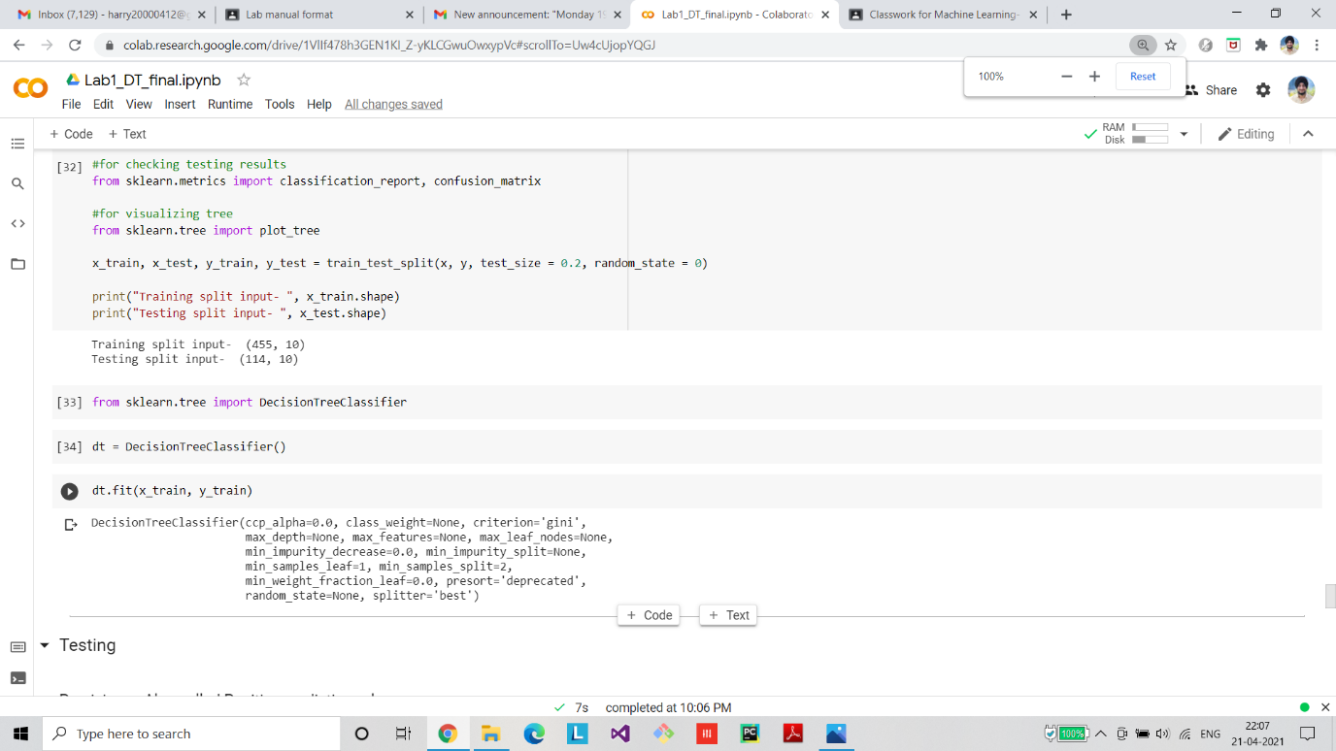

**Final Graph/ROC/Confusion Matrix**

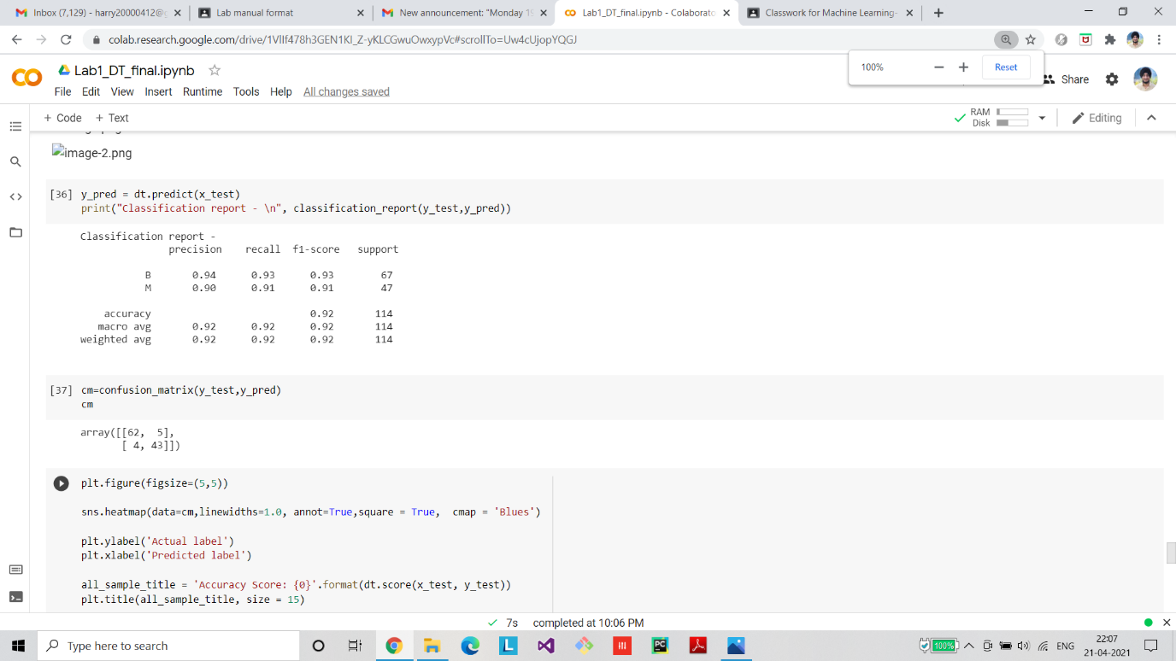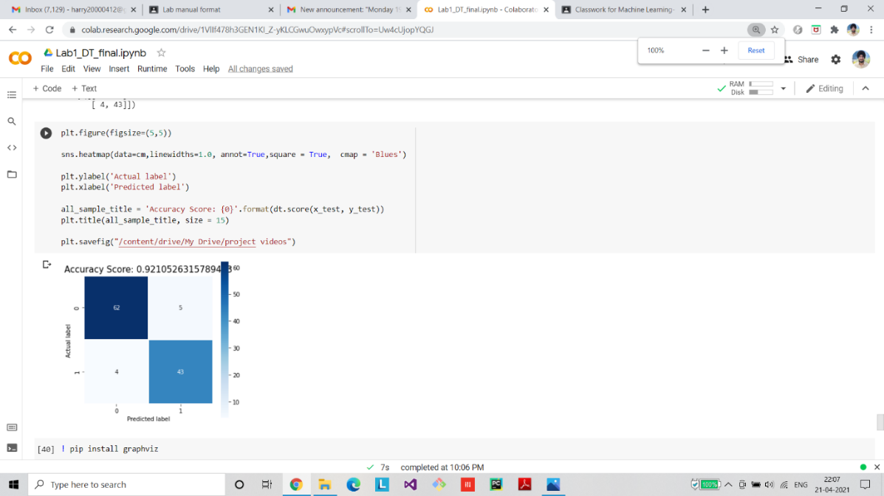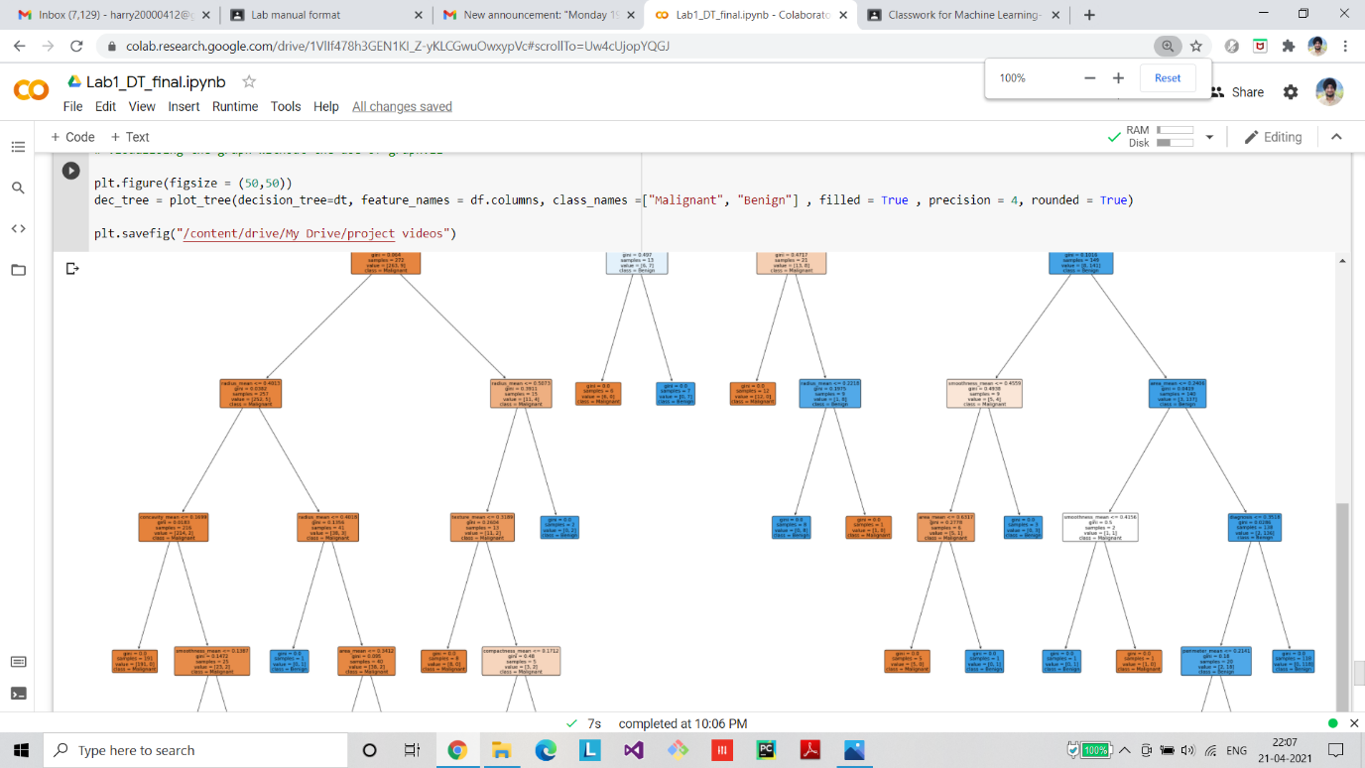

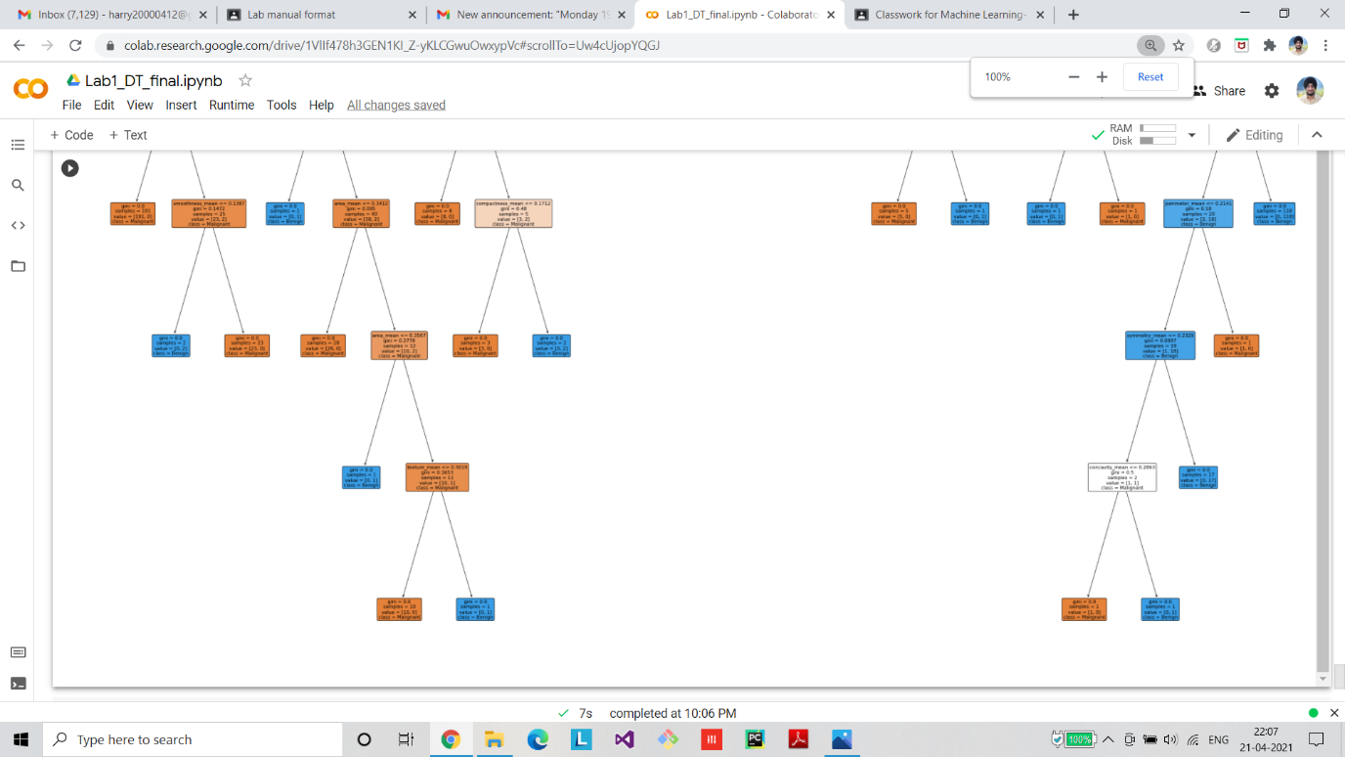

**Applying Fold Cross Validation:**

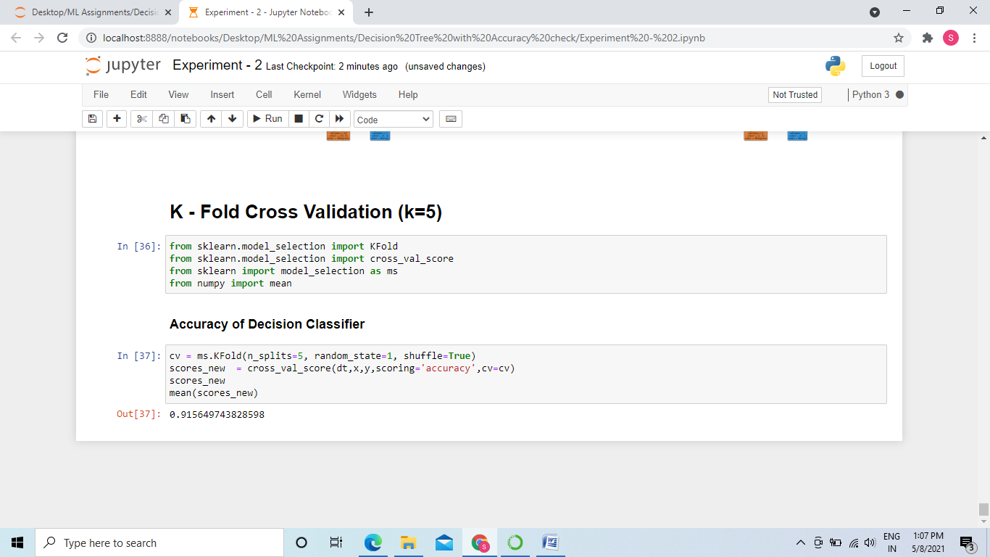

**Github Link**

[https://github.com/sngmanish/ML_Assignments/tree/master/LabProgram3](https://github.com/sngmanish/ML_Assignments/tree/master/LabAssignment2)