MACHINE LEARNING
LAB

NAME: Manish Kumar Singh

CLASS: CSE-3

ROLL NO.: 40876802717

EXPERIMENT – 4

Problem Statement:

Estimate the precision recall accuracy f-measure of the decision classifier on a breast cancer dataset using 10-Fold cross validation

Github Link:

https://github.com/sngmanish/ML_Assignments/tree/master/LabProgram4

Algorithm Description:

Decision Tree:A Decision Tree is a supervised Machine learning algorithm. It is used in both classification and regression algorithms. The decision tree is like a tree with nodes. The branches depend on a number of factors. It splits data into branches like these till it achieves a threshold value. A decision tree consists of the root nodes, children nodes, and leaf nodes.

K-Fold Means:K-fold cross validation is one way to improve the holdout method. This method guarantees that the score of our model does not depend on the way we picked the train and test set. The data set is divided into k number of subsets and the holdout method is repeated k number of times. Precision:The ratio tp / (tp + fp) where tp is the number of true positives and fp the number of false positives. The precision is intuitively the ability of the classifier not to label as positive a sample that is negative.

Recall:The ratio tp / (tp + fn) where tp is the number of true positives

and fn the number of false negatives. The recall is intuitively the ability of the classifier to find all the positive samples.

Accuracy: Defined as the ratio of correctly predicted examples by the total examples.
Program Code Snippet:

Loading dataset:
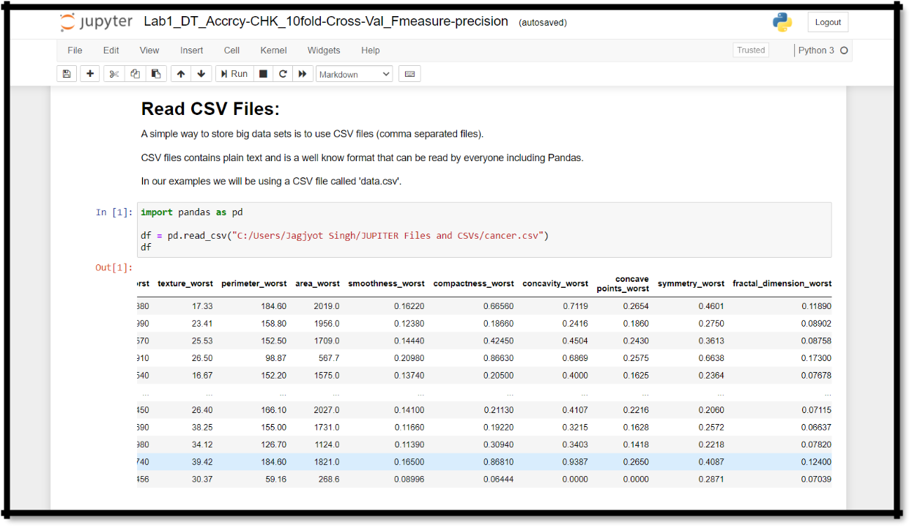

Pre-processing of dataset:
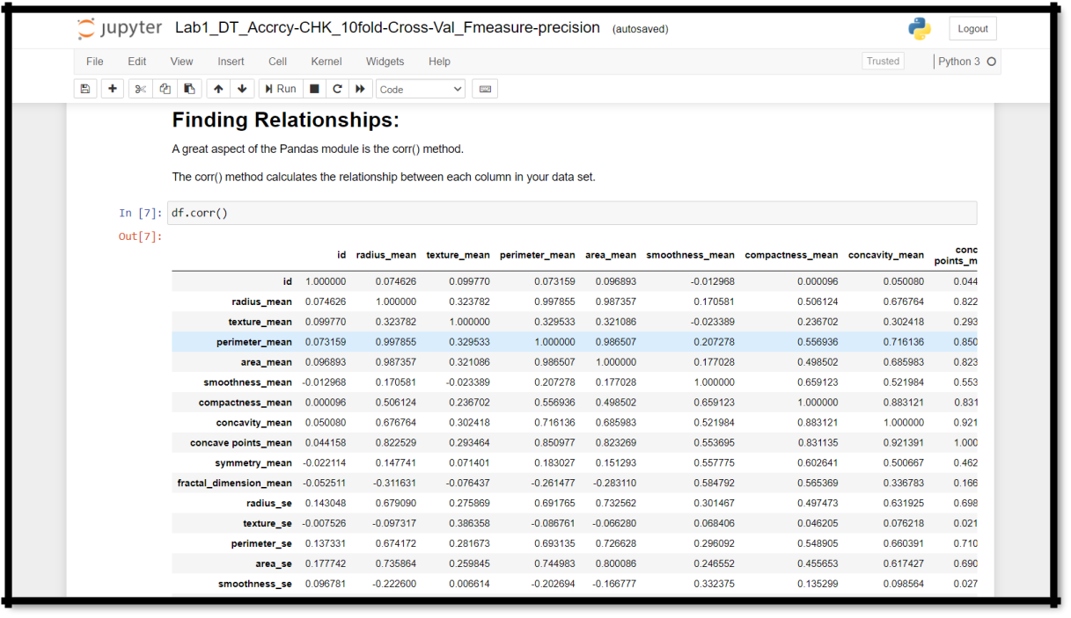

Visualization:
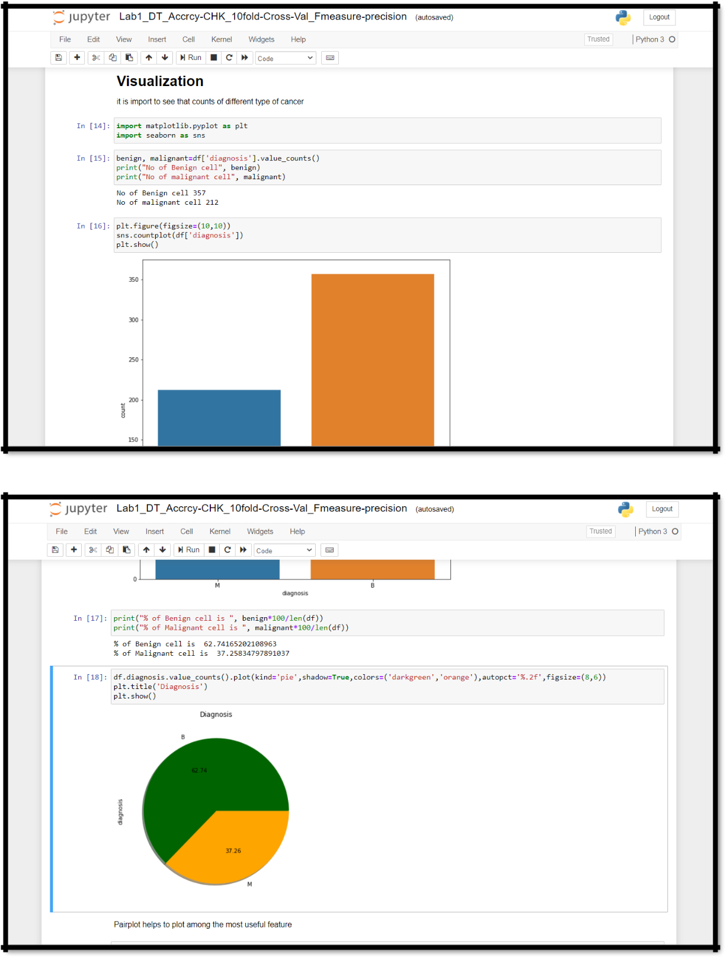

Decision Tree Classifier& 10-Fold Cross Validation:
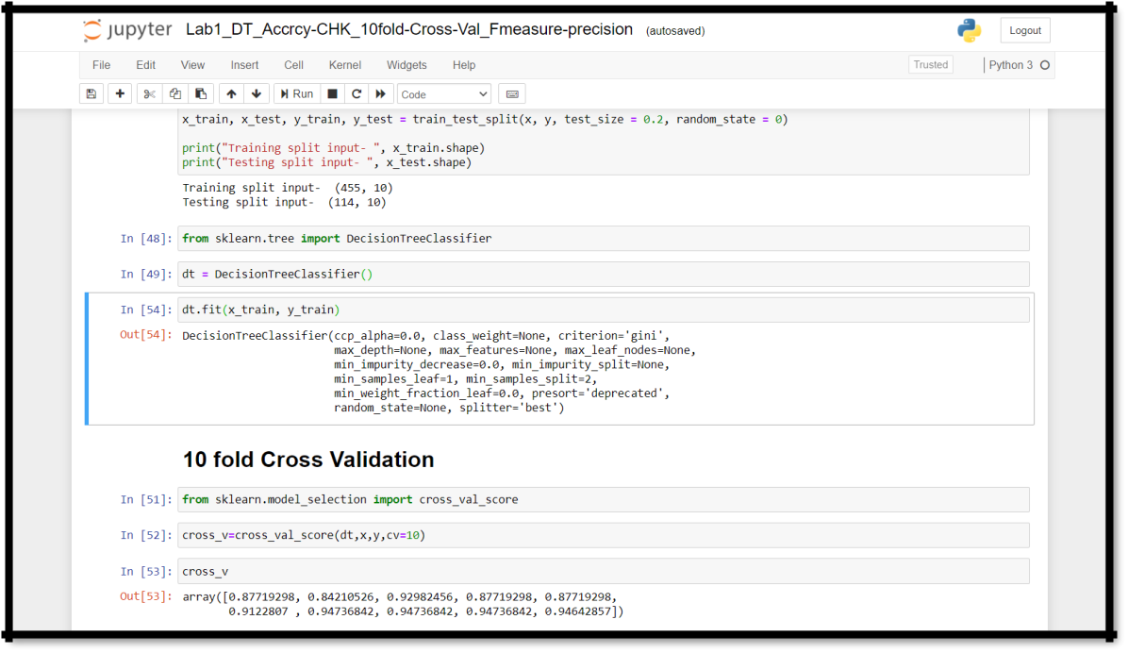

Precision Recall Accuracy and F measure:
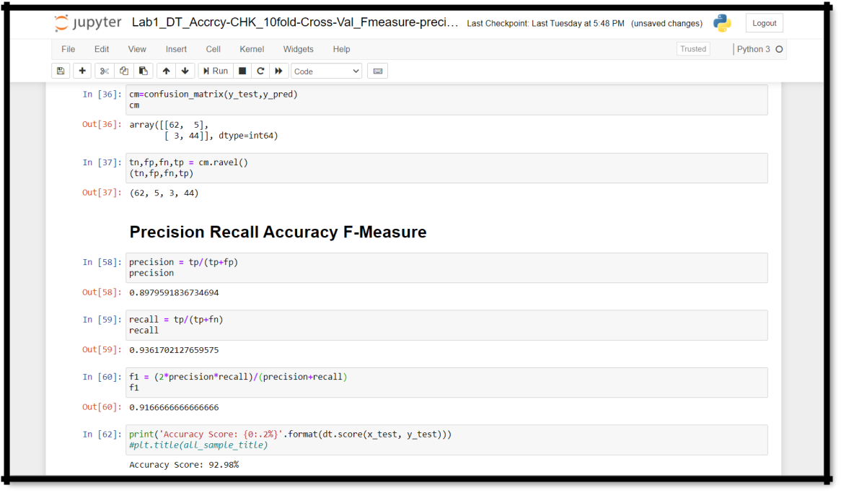

Final Graph
