Main Story:
Money matters, but only to a point. People earning below-market salaries do leave, yet once someone is experienced or highly educated, even well-paid employees walk away if the environment feels wrong.
The real triggers are almost always the same:
- A daily work environment they don’t enjoy (low job or workplace satisfaction)
- Constant overtime1133 and poor work-life balance
- Long, exhausting commutes with no flexibility
- Feeling stuck — years in the same role with no clear next step
- Leaders who ignore low satisfaction signals
Younger and single employees burn out fastest under heavy workloads and long commutes. Mid-career, high-performing, or highly educated employees leave when growth stalls, even if the paycheck is good.
In the end, fair and competitive pay keeps average performers from looking elsewhere. But a supportive, flexible, and engaging environment — plus a visible career path — is what actually keeps the best people from leaving, no matter how much you pay them.

Charts Explanation:
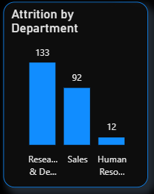
This bar column chart shows the relationship between Department and Attrition.
As we can see, the Research & Development department has the highest number of attrition employees.

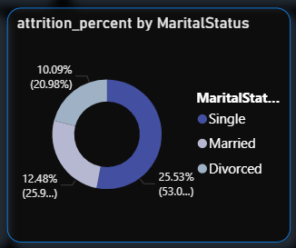
This donut chart shows the relationship between marital status & attrition. 53% of exiting employees are single; probably because they have no responsibilities and are free to take risks for better career opportunities.

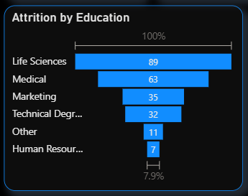
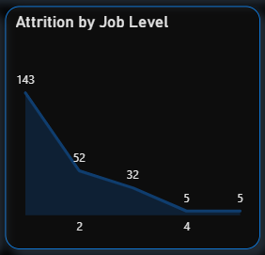
Higher job levels = less attrition.

Attrition is significant for people with Life Sciences backgrounds and is less significant for people with HR backgrounds.

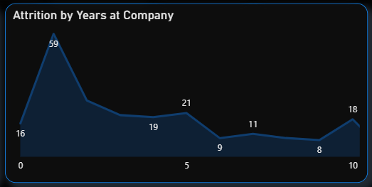
More years in the company = less likely to quit

Attrition is peaking at 1 year tenure.

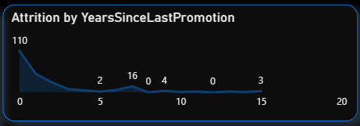
Having a recent promotion doesn’tprevent someone from quitting

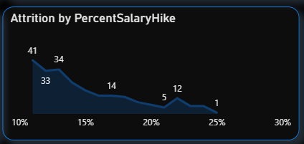
Attrition peaks for those with a lower salary hike percentage

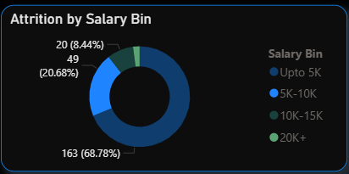
Salary of the majority of employees who left the company didn’t exceed $5k

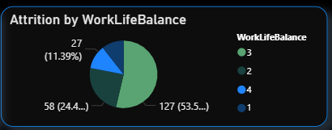
A bad work-life balance doesn’t cause someone to quit. Most employees quitting do have a good work-life balance level.

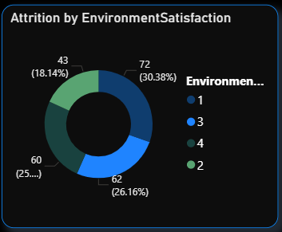
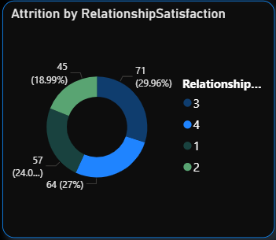
The same thing for relationship satisfaction & environment satisfaction.

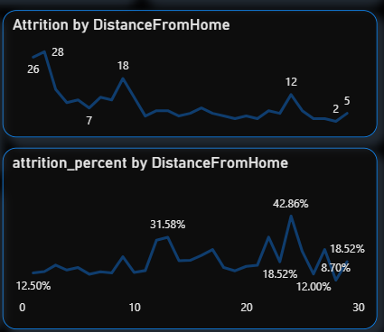
Living closer = less likely to quit

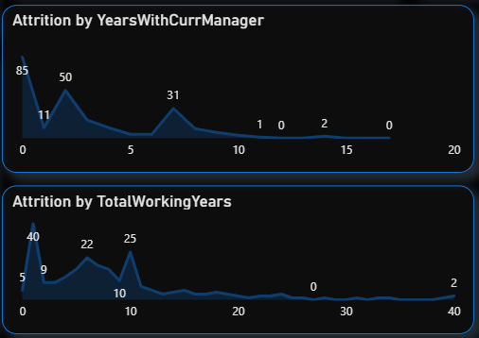
More years with current manager, more total working years, more years in general = less likely to quit.

Insights
- The average age of employees who left the company is 33.61 years.
- The Research & Development department witnessed the highest attrition, accounting for 133 of the total.
- The majority of employees who left the company belonged to the salary range below $5000 per month, comprising 163 individuals.
- Among employees who left, the highest attrition rate was observed among those who spent 1 year at the company (24.89%), followed by 2 years (11.4%) and 5 years (8.86%).
- The educational background of employees who left the company indicates that 89 individuals had a Life Science background, 63 had a medical background, and 35 had a marketing background.
- Male employees experienced an attrition rate of 17%, while female employees had a slightly lower attrition rate of 14.8%.
- The attrition rate in the Research & Development department was the highest at 56%, followed by Sales at 39% and the HR Department at 5%.
- Approximately 69% of employees who left the company fell under the salary range below $5000, while 21% fell under the $5000-$10,000 range, 8% under the $10,000-$15,000 range, and 2% under the $20,000+ range.
- The general trend suggests that the more years an employee spends in the company the less likely it is for them to leave.
- 84% of attrition is happening in the lower performance category, category 3.
- For the number x of employees that live in distance y from the company, the percent of exiting employees is directly proportional with y, distance.
- Single employees are more likely to quit, with 53% of the total exiting employees.

Recommendation:
- Implement retention strategies for employees around 30-35 years old.
- Address attrition in the Research & Development department.
- Enhance compensation and benefits for employees in lower salary ranges.
- Develop employee engagement initiatives for early career employees.
- Provide opportunities for career growth and learning based on educational backgrounds.
- Pay attention to gender disparities in attrition and promote diversity and inclusion.
- Mitigate attrition in the Research & Development and Sales departments with department-specific strategies.
- Regularly review and adjust salary ranges to ensure competitiveness.
- Provide comfortable and fast transportation for those living far away from the company or simply prioritize candidates who live within a reasonable commute during the hiring process.

