# UML

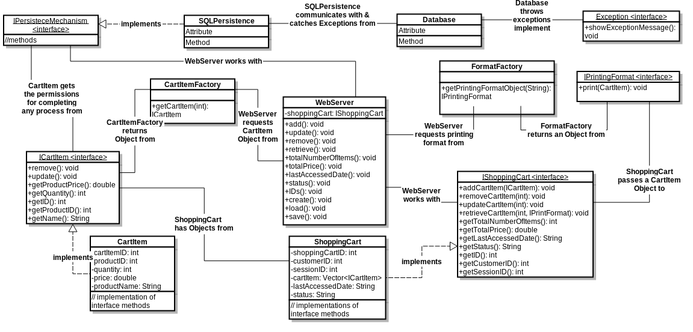

# Sequence Diagram

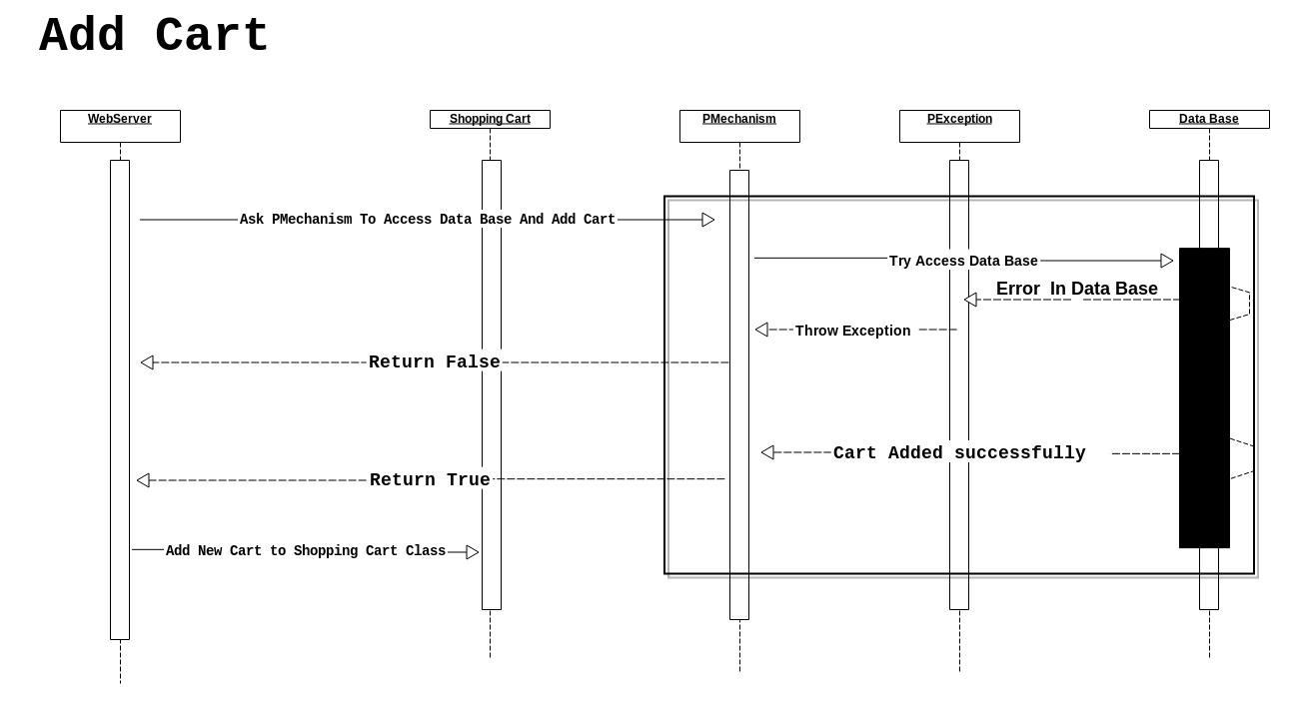

|  |  |
| --- | --- |
| **Seq. Diagram #** | **1** |
| **Related Use Case** |  |
| **Purpose** | **To add new cart** |
| **Involved Actors** | **User** |
| **Involved Classes** | **WebServer , ShoppingCart , PMechanism**  **PException , DataBase** |
| **Note** | **When the user want to add new cart** |

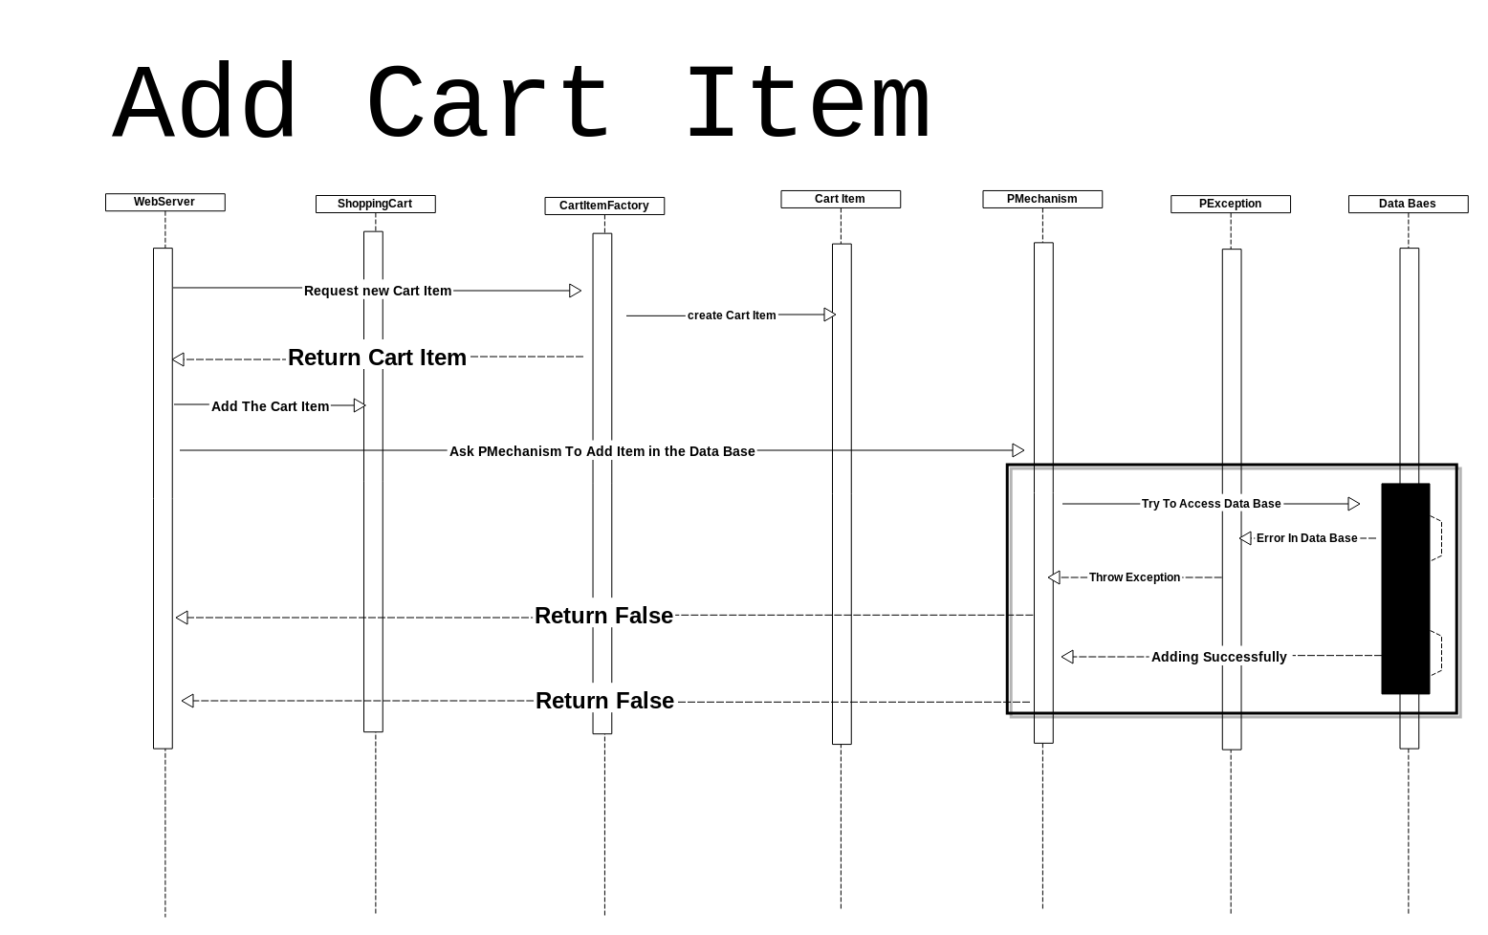

|  |  |
| --- | --- |
| **Seq. Diagram #** | **2** |
| **Related Use Case** |  |
| **Purpose** | **To add New Item in specific Cart** |
| **Involved Actors** | **User** |
| **Involved Classes** | **WebServer , ShoppingCart , PMechanism**  **CartItem , PException , DataBase , CartItemFactory** |
| **Note** | **When the user want to add new item in the cart** |

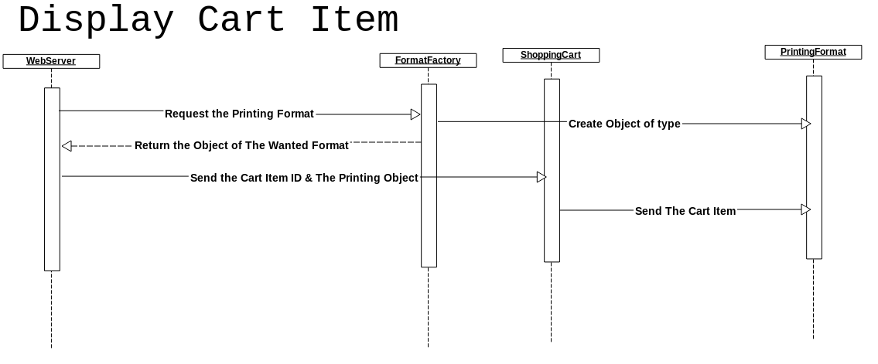

|  |  |
| --- | --- |
| **Seq. Diagram #** | **3** |
| **Related Use Case** |  |
| **Purpose** | **To Display Cart Item Information** |
| **Involved Actors** | **User** |
| **Involved Classes** | **WebServer , ShoppingCart , FormatFactory , PrintingFormat** |
| **Note** | **To retrieve Item information from cart** |

# 

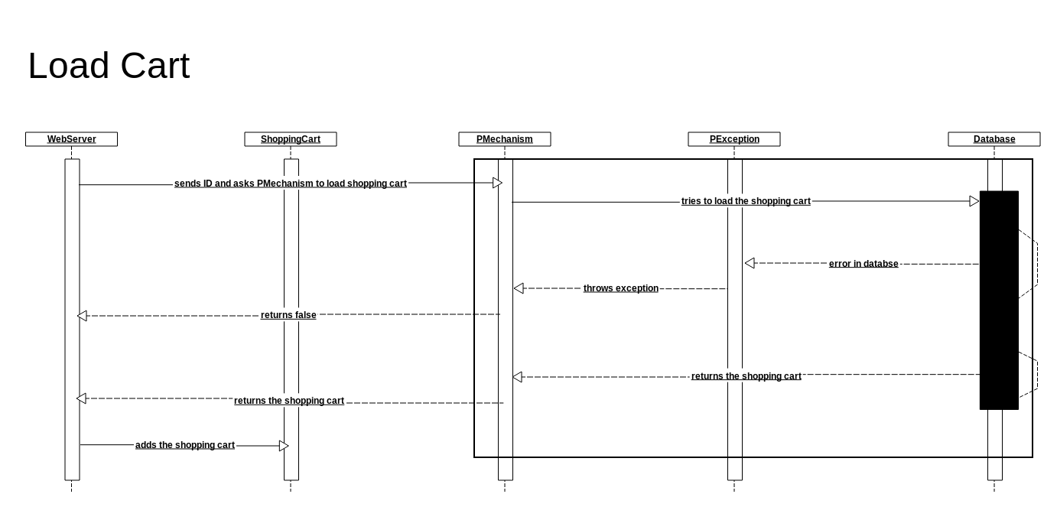

|  |  |
| --- | --- |
| **Seq. Diagram #** | **4** |
| **Related Use Case** |  |
| **Purpose** | **To load Cart From Data Base to Shopping Cart in memory** |
| **Involved Actors** | **System** |
| **Involved Classes** | **WebServer , ShoppingCart , PMechanism, PException , DataBase** |
| **Note** | **If the system want to save some item from data base to memory to do operation on them** |

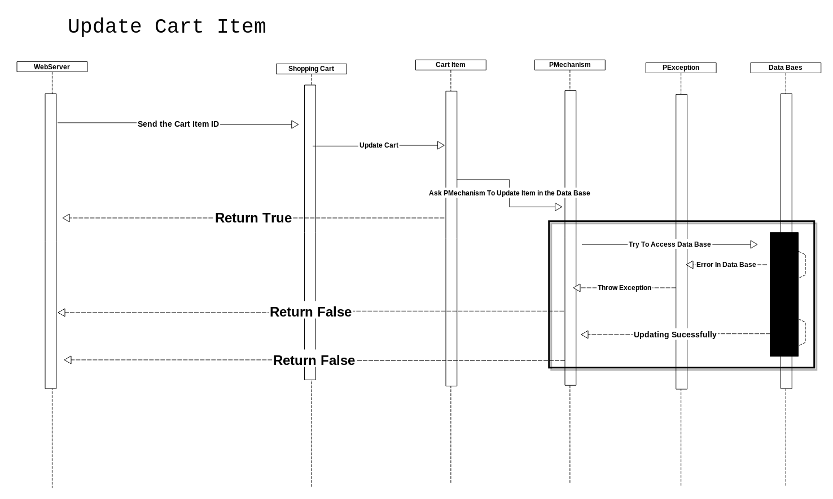

|  |  |
| --- | --- |
| **Seq. Diagram #** | **5** |
| **Related Use Case** |  |
| **Purpose** | **To Update Item In specific Cart** |
| **Involved Actors** | **User** |
| **Involved Classes** | **WebServer , ShoppingCart , CartItem, PMechanism , PException , DataBase** |
| **Note** | **User Ask The system To update Item then Cart Item Ask Pmechansim to Modify it in data base** |

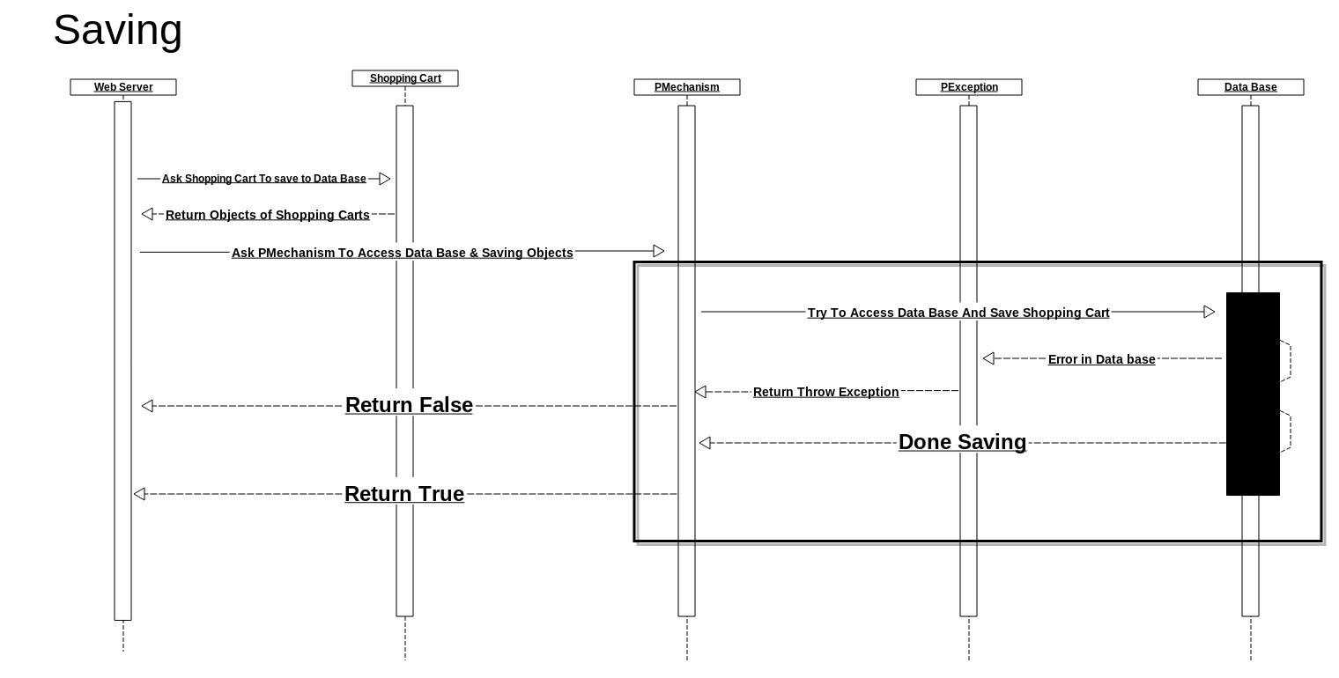

|  |  |
| --- | --- |
| **Seq. Diagram #** | **6** |
| **Related Use Case** |  |
| **Purpose** | **To Save All Carts From memory to Data Base** |
| **Involved Actors** | **System** |
| **Involved Classes** | **WebServer , ShoppingCart , PMechanism, PException , DataBase** |
| **Note** | **When user Want to Exit or press save so the WebServer will save all The Cart to Data Base** |

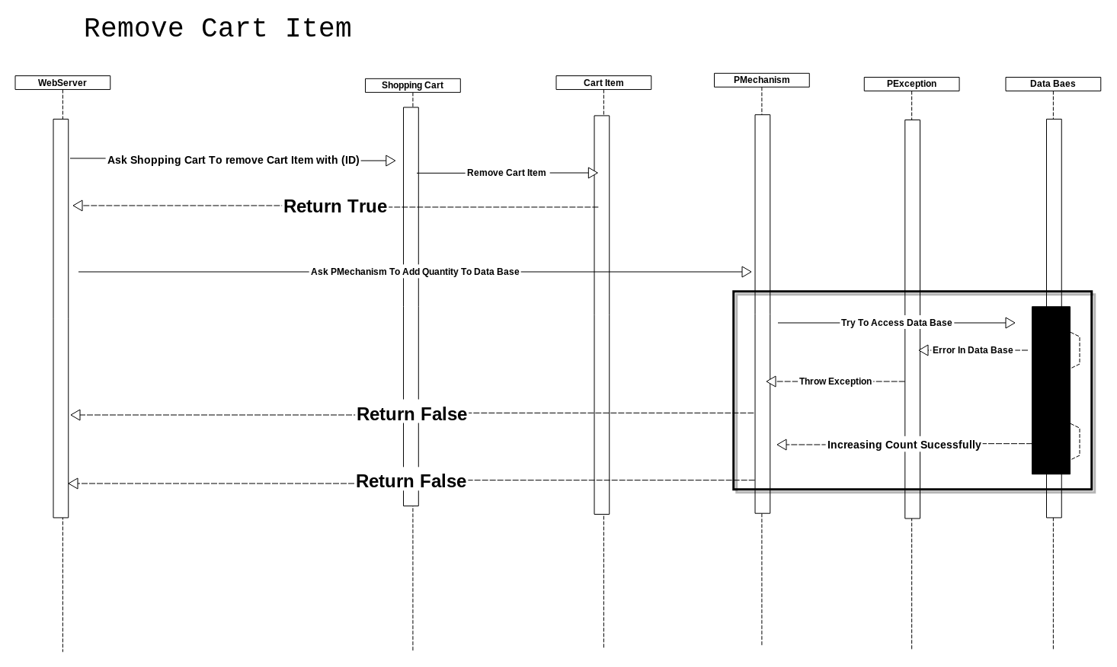

|  |  |
| --- | --- |
| **Seq. Diagram #** | **7** |
| **Related Use Case** |  |
| **Purpose** | **To Remove Item From Specific Cart** |
| **Involved Actors** | **User** |
| **Involved Classes** | **WebServer , ShoppingCart , PMechanism, PException , DataBase , CartItem** |
| **Note** | **When User Want To Remove Item From Specific Cart** |