**Observations on Heroes of Pymoli**

**Observation 1:** Women represent a relatively small portion of total players (i.e., 14.06%) but they spend more per purchase than men do. The players who reported “Other” or did not disclose their gender represent an even smaller portion of total players (i.e., 1.91%) but they spend more than either men or women on average.

**Table 1: Count and Percentage of Players by Gender**

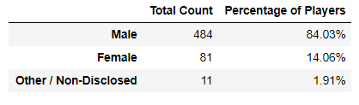

**Table 2: Purchasing Analysis by Gender**

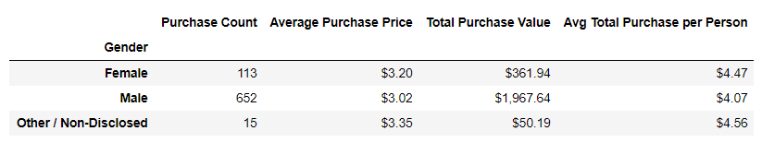

**Observation 2:** The vast majority of players are between the ages of 20 and 24 and they represent the majority of the total purchase value but they spend less on average per purchase than players younger than 10 or between 35 and 39.

**Table 3: Purchasing Analysis by Age**

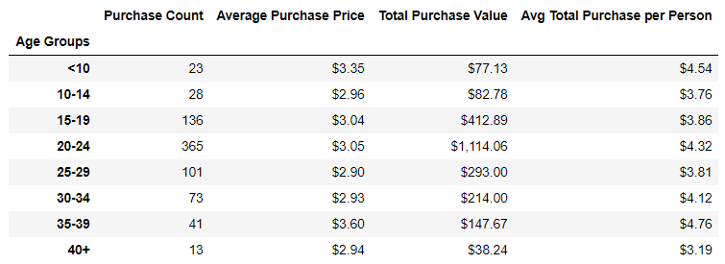

**Observation 3:** There are nearly 200 different items for sale in the game but only one item has been sold more than 10 times – Oathbreaker, Last Hope of the Breaking Storm.

**Table 4: Most Popular Items (first 10 rows)**

