**Observations on Pyber**

**Observation 1:** As the population of a city increases so do the number of rides and the number of drivers but the price of the average fare drops. For example, several of the rural locations have an average fare near $45 while many of the urban locations have average fares around $20.

**Figure 1: Ride Sharing Data by City Type**

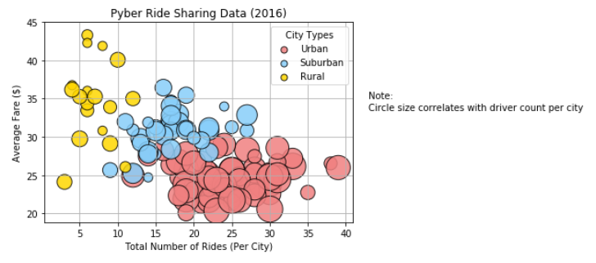

**Observation 2:** While drivers in urban locations represent over 80% of total Pyber drivers, they only generate 62.7% of the total Pyber fares. Considering what we saw in Observation 1 (i.e., that average fares are higher in rural and suburban areas) this isn’t unexpected but it does suggest that the average driver in an Urban area makes less than the average driver in a rural area even though Urban drivers take more rides.

**Figure 2: Drivers by City Compared to Fares by City**

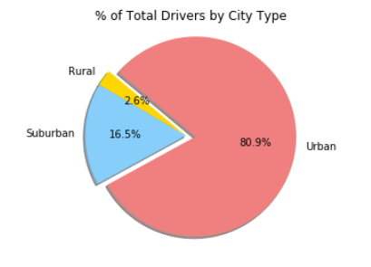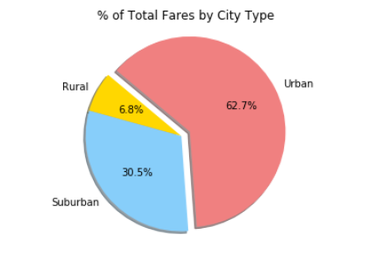

**Observation 3:** Drivers in rural locations account for only 2.6% of total Pyber drivers but they represent 5.3% of total Pyber rides and 6.8% of total fares. This suggests that it’s good to be a Pyber driver in a rural location.

**Figure 3: Pyber drivers, rides, and fares**

