CS 340 Project 2 README
Jason Dunn

Description
The Grazioso Salvare Dashboard is an interactive web-based dashboard built using Dash, Plotly and MongoDB to visualize and filter animal shelter data. It allows users to explore adoptable animals and identifies candidates for different rescue types.

Screenshots
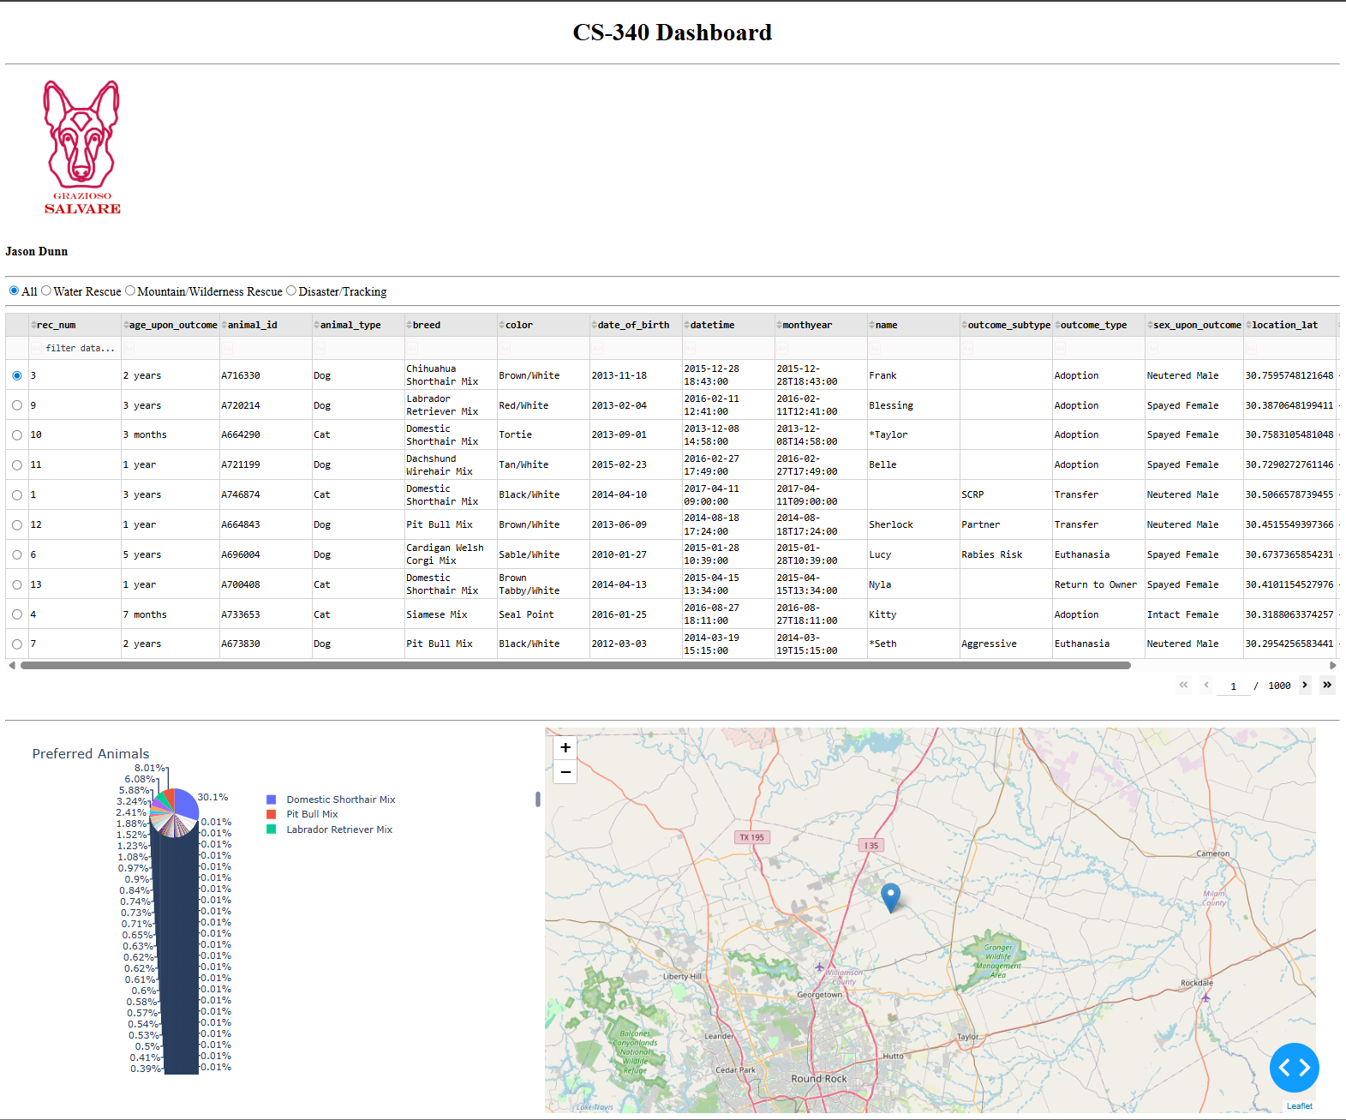
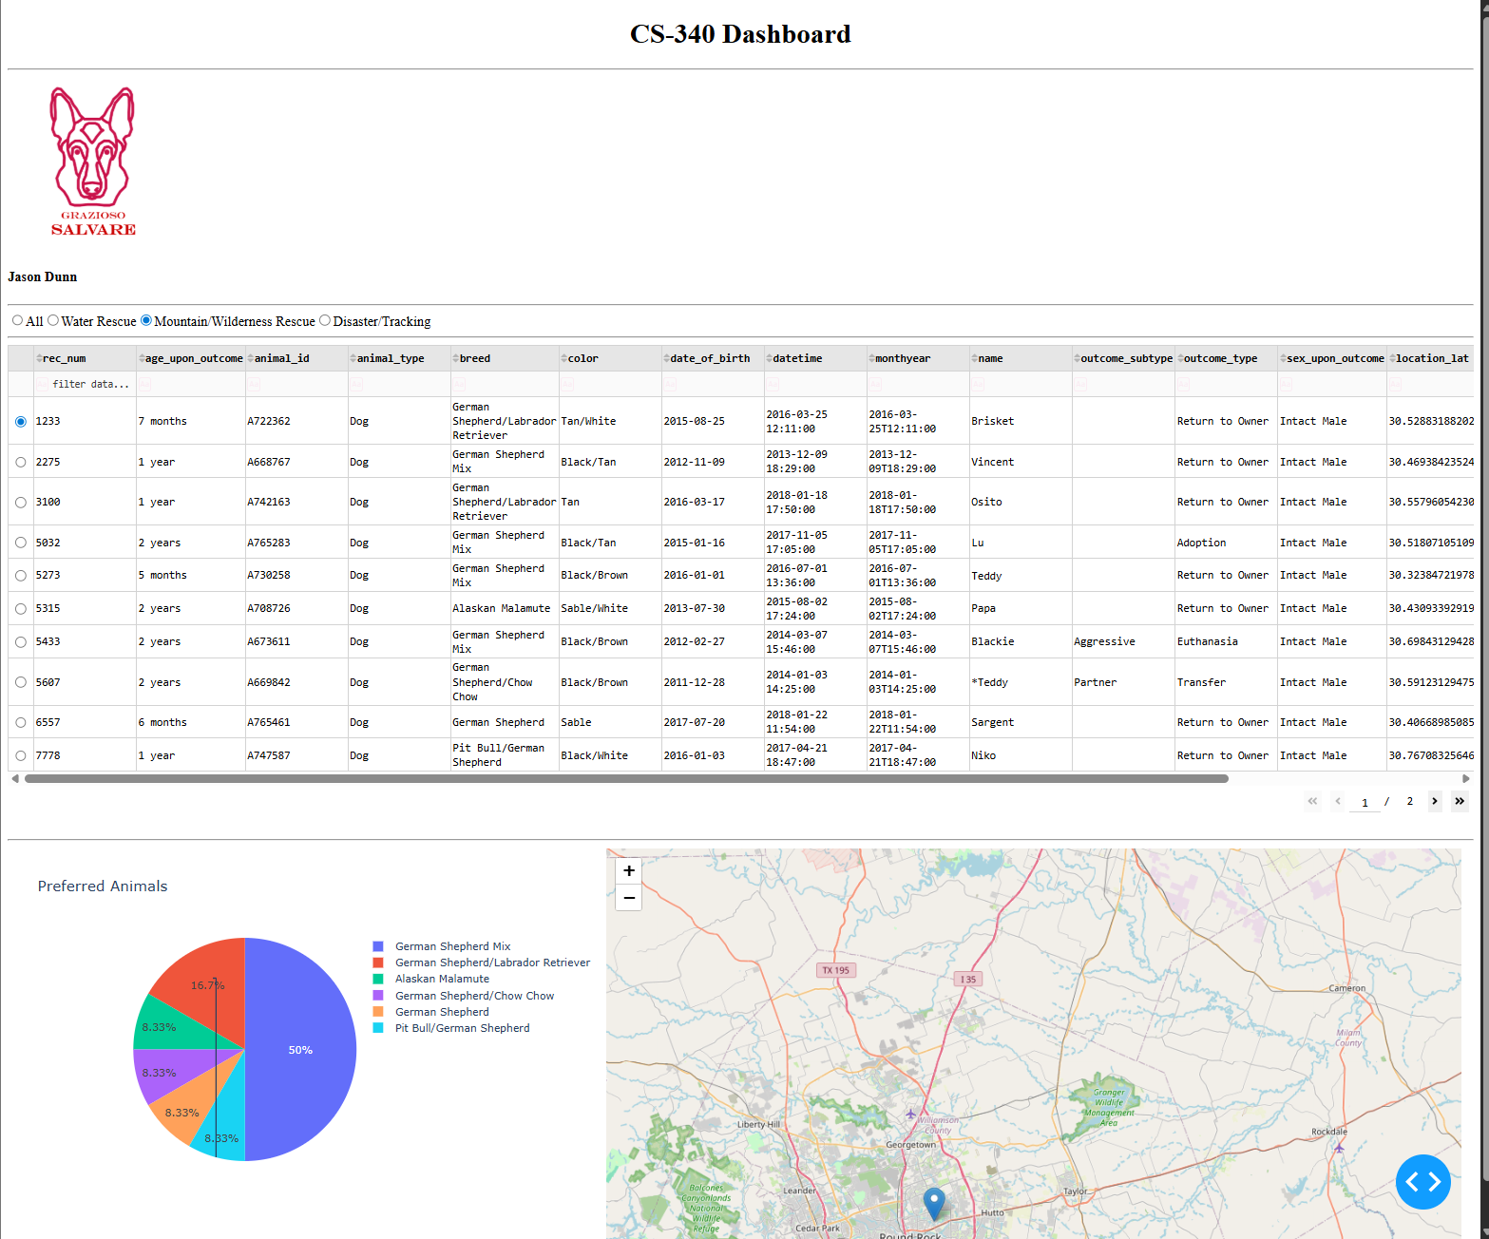

Technologies Used
- Python
  - Core programming language used to build the entire application because of the extensive library support (Pandas, Plotly, NumPy) and integrates well with web frameworks such as Dash.
- MongoDB
  - The chosen database is used to store animal shelter data because of it’s ability to store data in flexible JSON-like documents
- PyMongo
  - The official MongoDB driver for python used to connect and interact with the MongoDB
- Dash
  - Framework for creating interactive web dashboards without the need of JavaScript and supports Python callbacks to dynamically update the UI.
- Plotly
  - Used to create interactive, web-friendly charts that integrate seamlessly with Dash
- Pandas
  - Used to convert MongoDB query results into structured DataFrames.
- NumPy
  - Used to provide efficient handling of arrays and performance optimizations that works well with Pandas.

Steps Taken
- Setup the MongoDB environment by importing the the acc_shelter_outcomes.csv to your MongoDB
mongoimport --type=csv --headerline --db aac --collection animals --drop ./aac_shelter_outcomes.csv
- Develop and test CRUD Operations that are implemented in CRUD_Python_Module.py
- Build Dashboard Layout. Creating an interactive data table to show all animals in the shelter, breaking down breeds in a pie chart and a map to show the animals’ location.
- Created callbacks integrating the filters and updating the Pie Chart and Map information.
- Testing and debugging to ensure all features functioned as expected and meet the client’s expectations.

Challenges
I didn’t run into any challenges when completing this project.

Resources
- MongoDB - https://www.mongodb.com/
- PyMongo - https://pypi.org/project/pymongo/
- Dash - https://dash.plotly.com/
- NumPy - https://numpy.org/
- Pandas - https://pandas.pydata.org/
- Plotly - https://plotly.com/

Author
Jason Dunn

