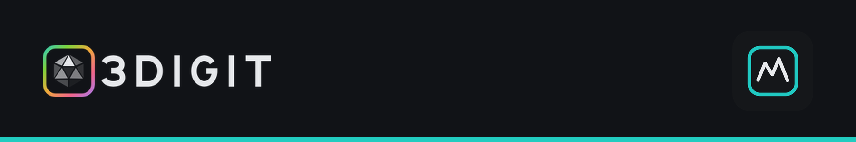
FOR IMMEDIATE RELEASE
3DIGIT launches SynthSYS, a hybrid synthesizer where every sound is built from swappable parts
Four oscillators, six engines, one screen. Intro price of £129 until 28 October, with a free Expansion included.
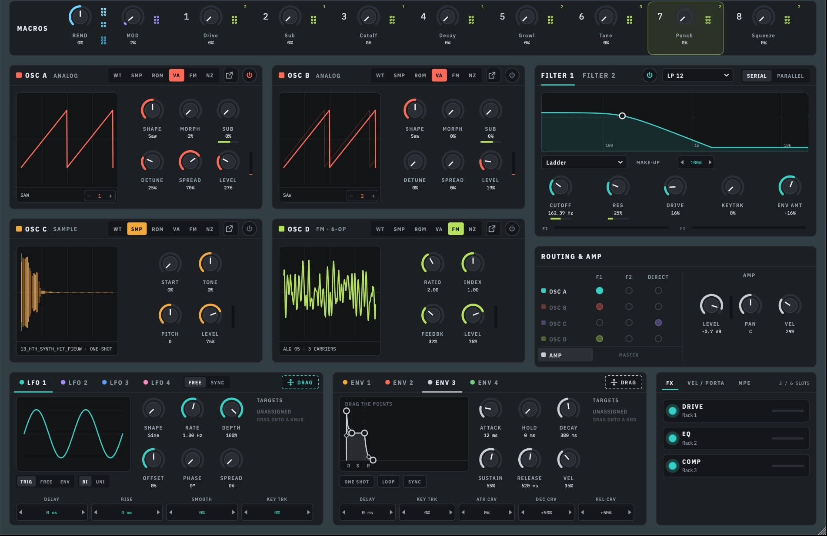
SynthSYS main screen: every oscillator, filter, modulator and effect on one page.
UK, 28 September 2026 — 3DIGIT today released SynthSYS Version 1, a hybrid software synthesizer for VST3, AU and standalone use. Each of its four oscillators can switch between six sound engines, and every oscillator, filter, modulator and effect sits on a single screen with no hidden pages.
SynthSYS is built in parts, so producers can combine very different synthesis methods in one patch. An FM bell, a wavetable pad and a sampled texture can play as a single sound, shaped quickly rather than buried in menus.
“We started out making presets and sample packs, and building thousands of sounds taught us that a preset is only a snapshot. It remembers a sound, but not how it was made. SynthSYS is built around a different idea: every sound is made of parts.”
— Stephen Nicholson, founder, 3DIGIT
BUILT FROM PARTS
Every SynthSYS preset is split into six Parts: Core, FX, Motion, Matrix, Macros and Arp. Each one loads on its own, so users can keep a sound and swap its macros or effects, or keep the effects and try a different arp. SynthSYS ships with 184 factory presets and a library of ready-made Parts:
- Core: oscillators, LFOs, envelopes, filters and voicing.
- FX: complete effects racks that automatically map to the current macros.
- Macros: eight macro sets that can be swapped independently.
- Motion: Motion page shapes and sequences.
- Arp: genre-specific arpeggiator and sequencer setups.
- Matrix: ready-made routings such as PWM, envelope modulation, oscillator detune and wobble, and auto-wah, each loaded with a double-click.
KEY FEATURES
- Four oscillators, six engines each: virtual analogue, wavetable, 6-operator FM, sample and granular, noise, and a multi-sampled ROM engine, with more ROM libraries to follow.
- Six modelled filter circuits: Ladder, MS-20, Diode, SEM, Steiner and Clean, with two filters running in serial or parallel.
- Deep modulation: a 32-slot mod matrix, four LFOs, four envelopes, Motion lanes and eight assignable macros.
- Generative arp and sequencer: writes musical lines from a held chord or a single note.
- Semi-modular effects rack: a Eurorack case and sixteen classic-style 19″ outboard units, patched in any order like a studio patch bay rather than a fixed plugin chain.
PRICING AND AVAILABILITY
Available | Now, from 3digitsamples.com/products/synthsys
Intro price | £129 until 28 October 2026
Regular price | £179
Included | 184 factory presets and one free SynthSYS Expansion
Demo | Free demo available on the product page
Formats | VST3, AU, standalone
Systems | macOS (Apple Silicon and Intel). Windows version in beta.
ABOUT 3DIGIT
3DIGIT is an independent UK developer of software instruments, presets and sample packs.
PRESS CONTACT
Stephen Nicholson, founder · 3digitsamples@gmail.com · Hi-res images and NFR review licences on request.
ENDS

