How to Get Your FreshService API Key
Your API key lets external tools (like the FreshService Claude connector) authenticate with your FreshService account. This article walks you through finding your key — and what to do if you don't see it.

Step 1: Find Your API Key
- Log in to FreshService
- Click your profile picture in the top-right corner
- Select Profile Settings
- Scroll down past the "Delegate Approvals" section
- Complete the CAPTCHA on the right side — your API key will appear once verified
- Copy the key and keep it somewhere safe

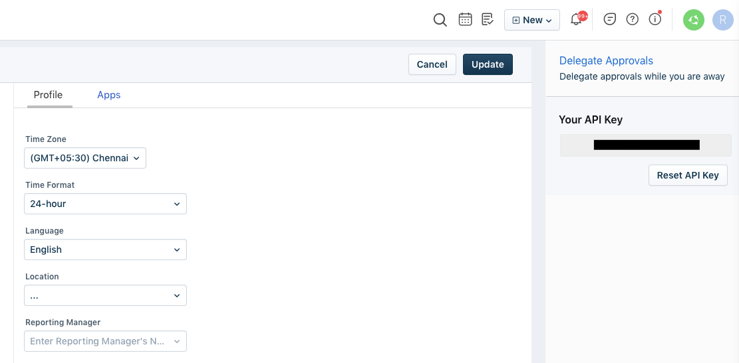
Profile Settings — Your API Key appears on the right after completing the CAPTCHA

Security note: Treat your API key like a password. Anyone with it can access your FreshService account via the API. Do not share it in email, chat, or documents.

Don't See an API Key Option?
API key access must be enabled by a FreshService administrator. There are two common reasons it may be missing:

Option A — API access is disabled at the account level
An admin needs to turn it on:

- Click the Admin gear icon in the left sidebar
- Go to Account Settings (sometimes listed as Global Settings)
- Find the API Settings or API Access section
- Enable API key access
- Save the changes

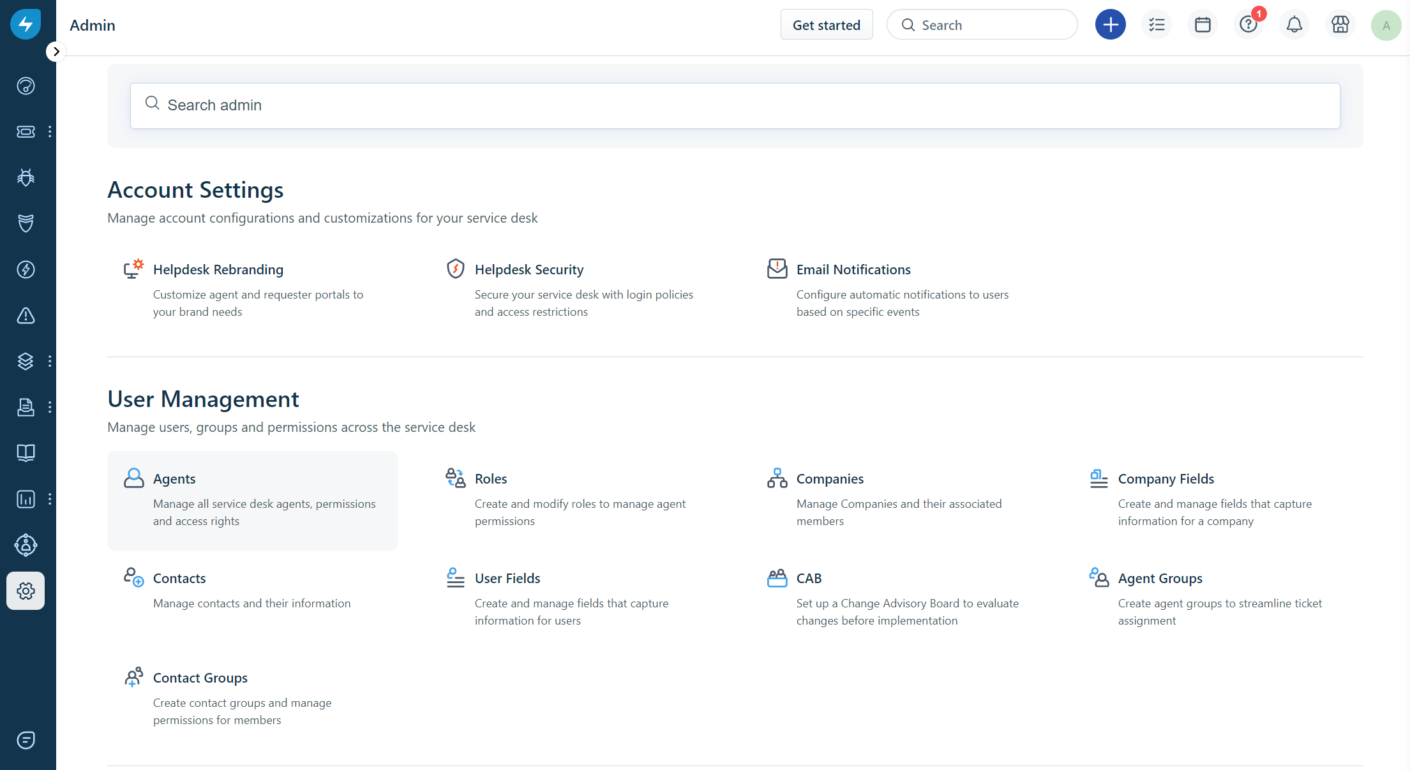
Admin Settings — Account Settings and User Management options

Once enabled, go back to your Profile Settings — your API key should now appear.

Option B — Your agent role doesn't have API permission
Even if API access is on globally, your individual role may not have permission:

- An admin goes to Admin → Agents
- Opens your agent profile
- Goes to the Roles or Permissions section
- Ensures API access is enabled for your role

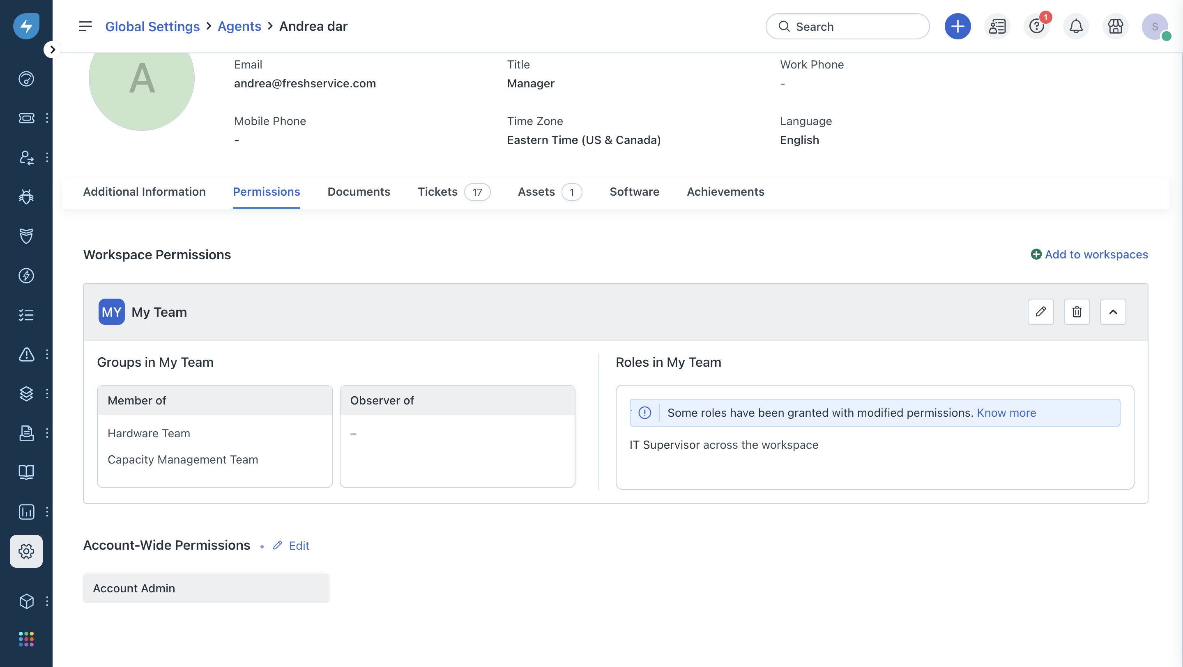
Agent Profile → Permissions tab — shows workspace roles assigned to the agent

Tip: Ask your FreshService administrator to check both settings if the API key still doesn’t appear after enabling account-level access.

Still Having Trouble?
Contact your FreshService administrator, or reach out to FreshService support directly at freshservice.com/support.

Installing for Claude Code
Claude Code is Anthropic’s AI-powered coding tool (available at claude.ai/code). Installing FreshService for Claude Code requires running the install script included in this package. The script handles everything — building the server, configuring Claude Code, and registering FreshService so it’s available in every project automatically.

Step 1: Make sure you have the prerequisites
Before running the installer, confirm you have:

- Node.js v18 or newer — download from nodejs.org if not already installed
- Claude Code — installed and signed in (download from claude.ai/code)
- Your FreshService API key — see Step 1 of this article for how to find it
- Your FreshService domain — the part before .freshservice.com in your URL (e.g. if your URL is acme.freshservice.com, your domain is acme)

Step 2: Run the install script
Open a terminal, navigate to the freshservice-mcp folder, and run:

macOS:
./install.sh

Windows (PowerShell):
.\install.ps1

Step 3: Answer the prompts
The script will ask for two things:

- FreshService API Key — paste your API key from Profile Settings (see Step 1 of this article)
- FreshService Domain — enter just the subdomain portion, e.g. acme (not the full URL)

The installer then automatically:

- Installs dependencies and builds the server
- Registers FreshService with Claude Code at the user level — making it available in every project directory, not just the current one
- Updates your Claude Desktop config (if Claude Desktop is installed)

Step 4: Verify the connection
Open Claude Code in any directory and type:

/mcp

FreshService should appear in the list marked as Connected. If it shows as disconnected, restart Claude Code and try again.

Note: Your API key is stored only on your machine. The installer never transmits it anywhere — it is written directly into your local Claude configuration file.

