**Principles of Data Science - 5530**

**Assignment-1**

**Snigdha Setty Chandaluri**

**Student ID:16352688**

**Question:Frailty Dataset**

**Plot 1:**

The below histogram shows the distribution between the height and frequency for the given population. The height is plotted along the X-axis and the frequency is plotted along the Y-axis.

We can see that the 68 and 70 height are more than any other.

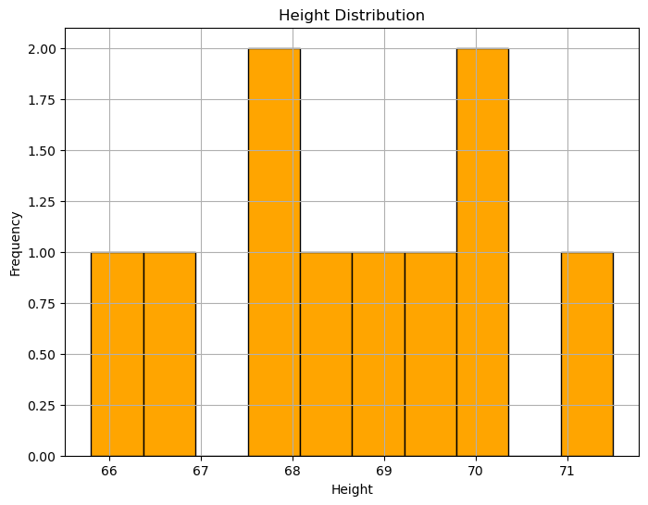

**Plot 2:**

The graph showing the relationship between grip strength and age. It appears to show that grip strength generally decreases with age. Grip strength is measured on the y-axis, and age is measured on the x-axis. The blue line shows the average grip strength for each age group.

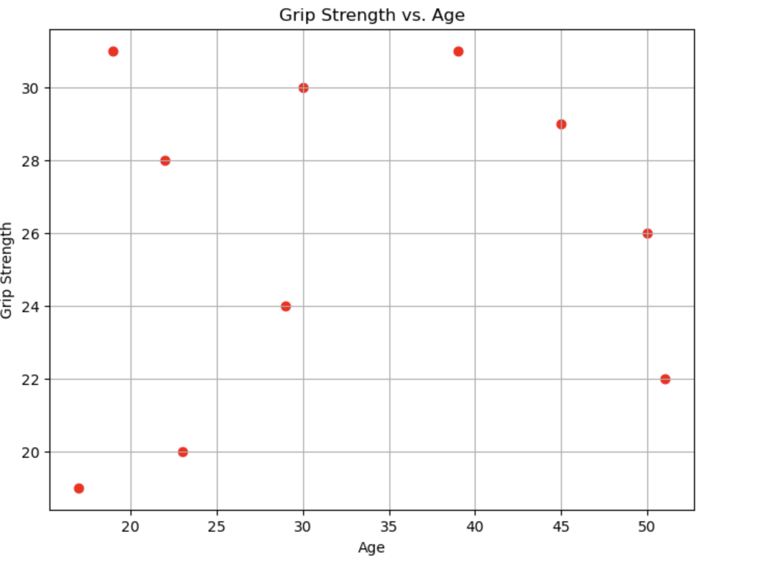

**Plot 3:**

The bar graph shows that the number of people with a faulty status. The yellow bar represents the number of people who do not have a faulty status, while the black bar represents the number of people who do have a faulty status. There are more people who do not have a faulty status than there are people who do.

