**MIS 6308 - SYSTEM ANALYSIS AND PROJECTMANAGEMENT**

**An idea proposed by**

**Shreenidhi Sriram**

**STUDENT ASSISTANT SYSTEM**

**(Project UML)**

**Current Situation**

Students falling behind and struggling to meet deadlines is an ongoing problem in every school. There are various reasons why students miss deadlines, and it varies from student to student. We have noticed that some students miss deadlines or start working on projects/assignments/on-campus job applications too late and then may face issues with technologies or may have questions or are working till the last minute to meet a submission/application deadline. This causes unnecessary stress to students, which can be avoided by starting early. Many students may also feel overwhelmed with schoolwork while also trying to balance other activities. Students involved in such activities or working parallelly are more likely to fall behind with schoolwork. The feeling of having so much going on can sometimes become overwhelming and emotional. Many students hit a point in time when they are so far behind that the willpower to do the work drifts away, and they develop a lack of motivation for trying to balance schoolwork and other activities and events. Regardless of the reasons, this is an ongoing issue for students.

**Objectives**

The main aim of developing the "Students Assistant System" is to provide an easy way not only to automate all the functionalities of a college and to help the students.

 We understand that the Students Assistant System is not a product to be sold, but it is a bridge between the College and the Students. Thus, the core purpose of designing the "Students Assistant System" is to manage the tasks assigned to college students and reduce the time to manage the different tasks.

We wanted to create an application that would help in notifying the students of meeting deadlines for such tasks. This would help to make a student’s life easier by solving a common issue that is faced by students.

This project would create a student assistant application that would provide notifications to remind a student to work on assignments, apply for jobs, register for courses, and submission before deadlines with a robust user interface.

This project would be an educational experience as we would be able to demonstrate the application of UML analysis, design, and implementation techniques

**Scope:**

**Business Process Scope: -**

* Our team wants to implement a system which will send reminder to students to complete assignments, submit job applications, register for classes, and work on the assignments and projects before deadlines.

**Organization Scope: -**

* In this project, application will automatically collect the information after a student uploads their syllabus and the academic calendar, notifying the users of upcoming due dates for assignments, quizzes, and exams as well as new job alert notifications.
* The user will upload the syllabus and academic calendar and our system will notify the user of upcoming deadlines.
* By combining all the information under one roof, the student assistant program can assist them in staying organized and making efficient use of their time.

**Location Scope: -**

* This student assistant application can be applied to several industries, including the manufacturing industry, corporate offices, travel, or the healthcare industry, wherein we can enhance the app according to the requirements of the specific industry to meet their needs.

**Application Scope: -**

* The backend of this application is implemented using MSSQL or MySQL, which is used to design the database.
* To manipulate the data for the system, several tables are built. A database must have two important parameters, including a Primary Key field that is required for every record occurrence a field used to establish relationships between tables known as a foreign key. Redundancy in the tables is prevented by the process of normalization.
* To send reminder notifications using pop-up notifications to the user of this application.

**Data Scope**

* Implementing a SQL database to gather information from syllabus PDF or Excel files supplied by students and save it in a methodical way that will subsequently be utilized to deliver alerts.
* Additionally, the rationale for the grade estimator will be saved in the database so that students can check their projected marks based on their current test results. It will also estimate their ultimate grades by estimating how well they must perform in the next tests to obtain better grades.

**Technology Scope**

The major components of the system include:

* **HTML 5 & CSS** - used for creating the front end of the application.
* **Java** - used in the backend version: JVM 15.0.3
* **Database**: MySQL for storing user information.
* **Version control**: GitHub.

● The application would be enabled for all operating systems – Android, IOS

**Out of Scope:**

* Academic holds, payment alternatives, and employment applications are not included in this.
* This student aid is a straightforward notification tool. It retrieves information such as time and fresh email inbox messages.
* The user will need to visit the relevant website to finish the task after receiving an alert because this capability is not built within the program.

**Assumptions**

For the above-proposed outcome, the following assumptions were considered:

* The end users (Students) will be using the system as a cross-platform app, i.e, the application will be compatible with Mac/Windows, Android/iPhone, iPad, Tablets, etc.
* The sign-in account will be the students’ google account in order to link the google calendar to the application.
* The app is expected to be ad-free. It would also allow access to external calendars and permit larger file attachments.
* Once the syllabus for the course is uploaded/manually entered, the calendar linked to the application would obtain the due dates and deadlines and update it within the system.
* The application automatically notifies the users of forthcoming due dates and deadlines for assignments, quizzes, and exams.
* Students are provided an option to receive notifications via SMS or email by letting them choose the same through the “Contact Options” header.
* The Grade Estimator would help students determine their estimated GPA by entering the grades they received on their assignments and tests.
* The Exam Slot booking feature helps students receive a notification about booking test dates and times about one week before the respective exam.
* The course registration and waitlist feature notifies the students about class availability and allows them to select and sign up for the courses they wish to enroll in.
* The on-campus job postings feature aids in providing students with a pop-up notification as soon as a job posting is made so that they may promptly submit their application through the preferred portal.

**USE CASE DESCRIPTION**

Use Case Diagram - A [UML](https://en.wikipedia.org/wiki/Unified_Modeling_Language) use case diagram is the primary form of system/software requirements for a new software program underdeveloped. Use cases specify the expected behavior (what), and not the exact method of making it happen (how). It is an effective technique for communicating system behavior in the user's terms by specifying all externally visible system behavior.

What does the use case diagram consist of?

Actors: The users that interact with a system (Student)

Functions: The services or the functions the system performs. (Activities from login to alert system)

System: Student assistant system

The actors in this diagram are:

1. Guest user: A new user who uses the services as a guest
2. Logged-in user: User with an existing account with the system and has recurring services

Functions:

1. Sign up
2. Log in
3. Documents uploaded in PDF, CSV, XLS, and doc format
4. Getting dates from the calendar
5. Notification settings
6. Notifying the user through emails and text messages

Usage:

They are helpful in giving notifications to the user, which prevents the student from forgetting critical deadlines.

# Use case Name: Student Assistant System Priority: High

# Primary owner: Student

# Application: Manages the set of activities between the user and the responses from the function

**Brief Description**: The use case describes how a student logs in, upload the documents, and receives the notification promptly.

**Trigger:**

1. **External -** Student trying to log in / sign up to upload the docs.
2. **Internal –** Based on the event timeline the alert is triggered

**Normal Flow of events:**

1. The student opens the homepage of the application and made a click on the sign-in / log-in button
2. If a student is new – A new student flow will be executed, for an old student, the login window opens
3. The student provides a valid username and password and hit the login button
4. The student uploads the documents in the application
5. Student setting the time, and days from the notifications setting tab
6. The system stores the information entered by the student and validates the timeline.
7. The student is then notified in the form of an email or text message.
8. The student will then log out of the system.

Sub flows:

Flow 1:

For a new student:

1. User opens the application
2. Click on Sign up
3. Enter the student information
4. Click create.

**USE CASE DIAGRAM:**

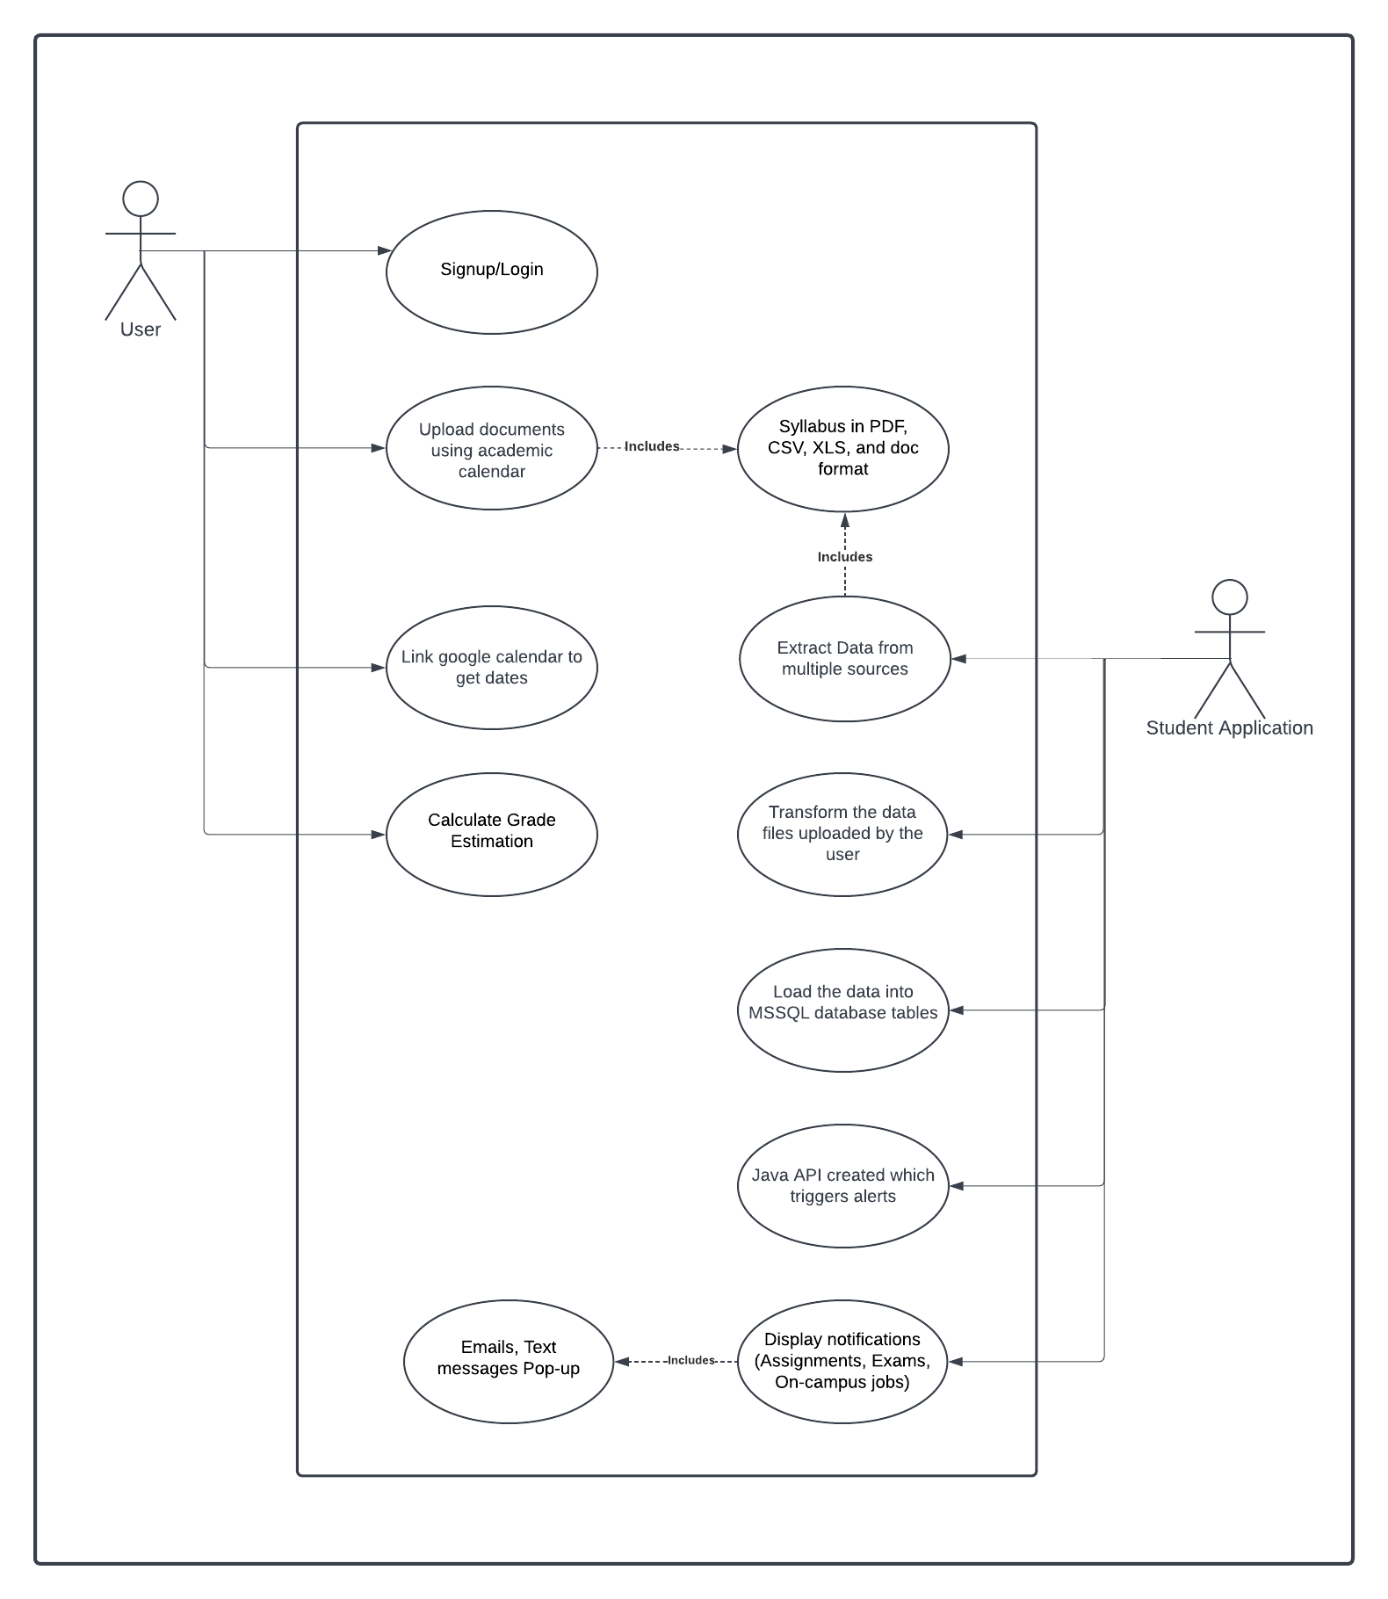

**CLASS DIAGRAM**

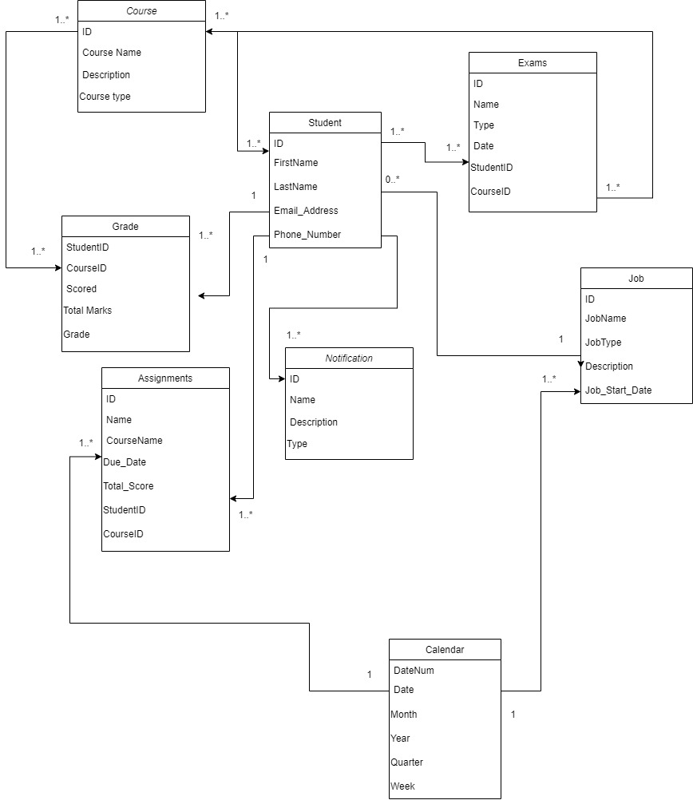

**CONTEXT DESCRIPTION**

Context Diagram represents the interactions of outside entities with a system. It is composed of 3 elements.

* System (Student Assistant)
* Entities outside the system (University, Students, Personal calendar, Grade estimator, Handshake)
* Their interactions with the system (specified below every entity)

**CONTEXT DIAGRAM**

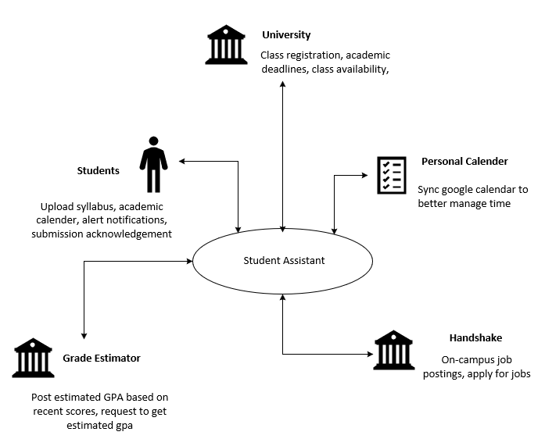

**PROCESS MODEL DESCRIPTION**

The Process Model represents the workflow and its related sub-processes. It shows details of decisions, timing, and resources. A business process model representation is useful to

clearly understand any process step by step. The Process Model representation of a single interaction (booking) is shown below.

Usage: It is helpful in ensuring that processes are visualized properly, can understand procedures accurately, and can work in an efficient way.

**PROCESS MODEL DIAGRAM**

