Instruction

Our method is designed to deal with the image inpainting problem. Given a corrupted face image, our goal is to complete the face with plausible contents so that the completed image looks natural and realistic (see the image below).

Real Image Corrupted Image Completed Image (Fake)

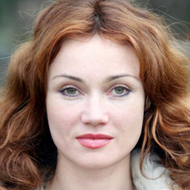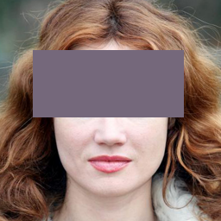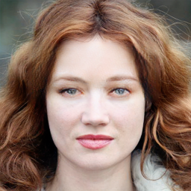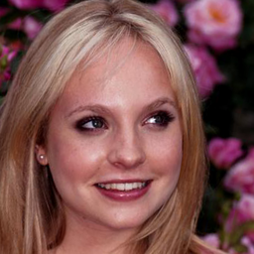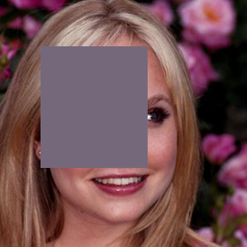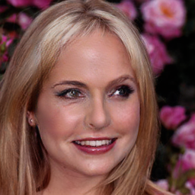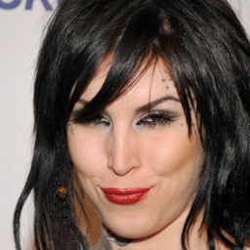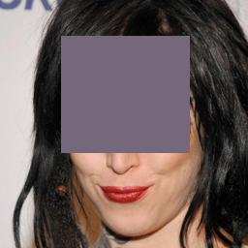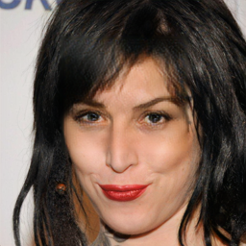

Each time, you will see two images. You task is to choose the more **REALISTIC** one.

In the formal experiment, there are four sessions. In the first session, both images on screen are **FAKE** images that are synthesized by two different algorithms. Choose the one that looks better. You will have unlimited time to decide. In session two to four, one of the shown image is a **REAL** one, the other one is **FAKE**. Your job is to select the **REAL** one. Display time is controlled in session two to four. The images will be shown for 250ms, 1000ms, and 4000ms respectively for session two, three and four. Sometimes, for instance in session two (250ms), maybe you don’t have enough time to see both of images clearly. But probably you will notice some obvious flaws in one image, which means the other one is real.

There are one hundred image pairs in the first session and two hundred pairs in session two to four. There will be a short training session before the formal experiment.

Thanks for your participation!