USER GUIDE
Oracle Fusion SaaS
Network Viewer
Explore role-to-privilege relationships for Oracle Fusion SaaS SKUs

Version 1.0 | August 2026
For analysts, security teams, implementation teams, and application owners
Independent open-source project by Sandor Nieuwenhuijs
Not an Oracle Corporation product. Provided without warranty.

Contents
1. Purpose and scope
2. Quick start
3. Application workspace
4. Workbook requirements and SKU selection
5. Network filters
6. Reading the network
7. Exploring roles and privileges
8. Details panel
9. Exporting results
10. Recommended workflows
11. Troubleshooting
12. Reference and legal notice
Guide convention Button names, field names, and checkbox labels are shown exactly as they appear in the application.

1. Purpose and scope
Oracle Fusion SaaS Network Viewer is a local, read-only Windows application for exploring the relationships between roles and privileges for one SKU and service at a time. It converts workbook assignment data into a bounded, interactive network that remains practical even when the complete SKU contains many roles, privileges, and relationships.
- Use it to identify highly connected roles or privileges, inspect shared-user counts, reveal relationships hidden by display limits, and export evidence for further analysis.
- The source workbook is read but never modified. Processing takes place locally; the application does not send workbook data to an external service.
- Individual users are not displayed as nodes. Distinct-user counts are used only as node and relationship weights.
Sample data in this guide Screenshots were created from the permitted Rotterdam workbook. They illustrate the interface and may not match the counts or names in another workbook.

2. Quick start

2.1 Start the application
- Standalone build: double-click saas-network-viewer.exe.
- Source folder: double-click start_app.bat. The launcher uses Python when available and otherwise falls back to the packaged executable.
- If Windows SmartScreen displays a warning for the unsigned executable, verify that the file came from the project repository before choosing More info and Run anyway.

2.2 Load and explore
- Choose Open workbook and select an .xlsx or .xlsm workbook.
- In SKU selection, type any part of the SKU code or service name. Matching is case-insensitive. Press Enter to select the first match, or select a result from the list.
- Adjust filters if needed, then choose Apply filters. Numeric changes also apply when you press Enter or leave the field.
- Select a role or privilege to highlight its relationships. The node name is copied automatically to the Windows clipboard.
- Choose Show details for a relationship table, or use Export PNG… / Export Excel… to save results.
Important download check The real standalone executable is approximately 43 MB. A file of roughly 151 KB is normally the GitHub web page saved as an .exe, and will not start.

3. Application workspace
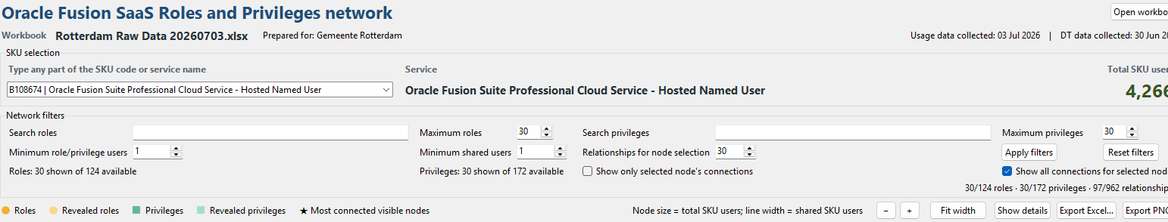
Figure 1. Workbook, SKU, filter, legend, navigation, and export controls.
Area | Purpose
Workbook row | Shows the filename, Prepared for value, and collection dates. Open workbook replaces the current source only after successful validation.
SKU selection | Searches by SKU code or service name and shows the selected service and total distinct SKU users.
Network filters | Limits or searches the initial network and controls selection expansion.
Legend/actions | Explains node colours and weights; provides zoom, details, and export actions.
Network canvas | Displays roles on the left and privileges on the right.
Status line | Reports workbook loading, SKU selection, filter matches, and completed actions.

3.1 Space management
- The relationship details panel starts collapsed so the network receives maximum vertical space.
- Choose Show details to open the panel and Hide details to return the space to the graph.
- Use Fit width after zooming or resizing to restore a useful horizontal scale.

4. Workbook requirements and SKU selection

4.1 Required worksheet
The workbook must contain a worksheet named Raw User Data with these exact columns:
Column | Meaning
SKU | SKU code used to group and select the network.
SERVICE | Service name shown beside the selected SKU.
USER_LOGIN_HASH | Stable anonymised user identifier used for distinct-user counts.
PRIVILEGE | Privilege name displayed as a square node.
ROLE_CODE | Role code displayed as a circular node.

4.2 Optional workbook information
An optional Info worksheet can provide Prepared for, Usage data collected, and DT data collected. Missing optional values do not prevent loading.

4.3 Validation behavior
- Rows missing the SKU, user hash, privilege, or role code are not usable. Duplicate assignments are removed.
- If a newly selected workbook is invalid, an error is shown and the previous valid workbook and network remain active.
- The application always keeps a valid SKU selected after loading. Empty or invalid text restores the current selection.
Data stewardship Only load data you are authorised to use. Although the viewer runs locally, screenshots and exports can contain role names, privilege names, service metadata, and aggregate counts.

5. Network filters
Control | Default | Effect
Search roles | Blank | Case-insensitive substring match on role names.
Maximum roles | 30 | Maximum number of roles in the initial network; minimum 10 and maximum equals the actual SKU total.
Search privileges | Blank | Case-insensitive substring match on privilege names.
Maximum privileges | 30 | Maximum number of privileges in the initial network; minimum 10 and maximum equals the actual SKU total.
Minimum role/privilege users | 1 | Excludes both roles and privileges with fewer total SKU users.
Minimum shared users | 1 | Excludes role–privilege relationships with fewer shared users.
Relationships for node selection | 30 | Coverage budget used to choose the initial connected node set; range 1–500.

The overview first chooses a connected set of strong relationships while maximising useful node coverage. It then draws every qualifying relationship between the selected initial nodes. It does not add additional nodes until you select a node and expansion is enabled.
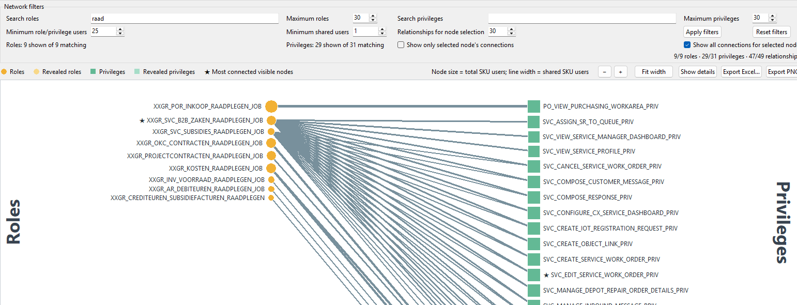
Figure 2. Example filter: role names containing “raad” and at least 25 users.
Why counts can differ “Shown” is the number currently displayed. “Available” or “matching” is the total before the role/privilege maximum is applied. A note below a column indicates when its maximum hides additional matching nodes.

6. Reading the network
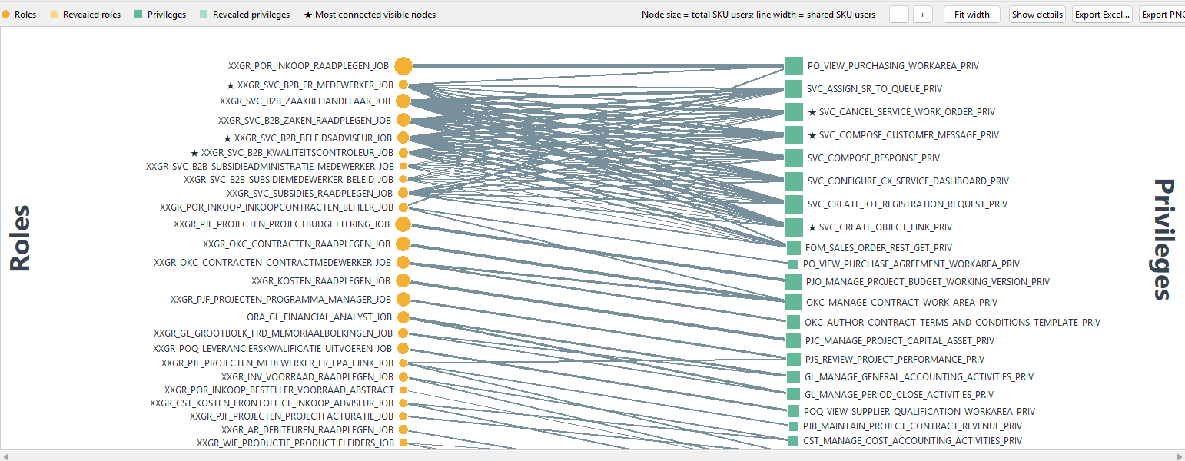
Figure 3. Initial network overview with 30 roles and 30 privileges.
Visual element | Meaning
Orange circle | Role in the initial limited network.
Light orange circle | Role revealed temporarily because of a privilege selection.
Green square | Privilege in the initial limited network.
Light green square | Privilege revealed temporarily because of a role selection.
Node size | Total distinct SKU users for that role or privilege.
Line width | Distinct users shared by the connected role and privilege.
Star | One of the most connected nodes in the currently visible network.
Dark outline | The currently selected node only.

Roles and privileges are packed independently. Larger nodes receive more vertical room and smaller nodes use less, preventing unnecessary white gaps. The initial order starts with total SKU users and name, followed by topology-aware passes that reduce line crossings.

7. Exploring roles and privileges

7.1 Select a role
Select a role circle or its label. Connected lines and privileges remain prominent while unrelated content fades. With Show all connections for selected node enabled (the default), privileges omitted by the initial limit are temporarily revealed in light green.
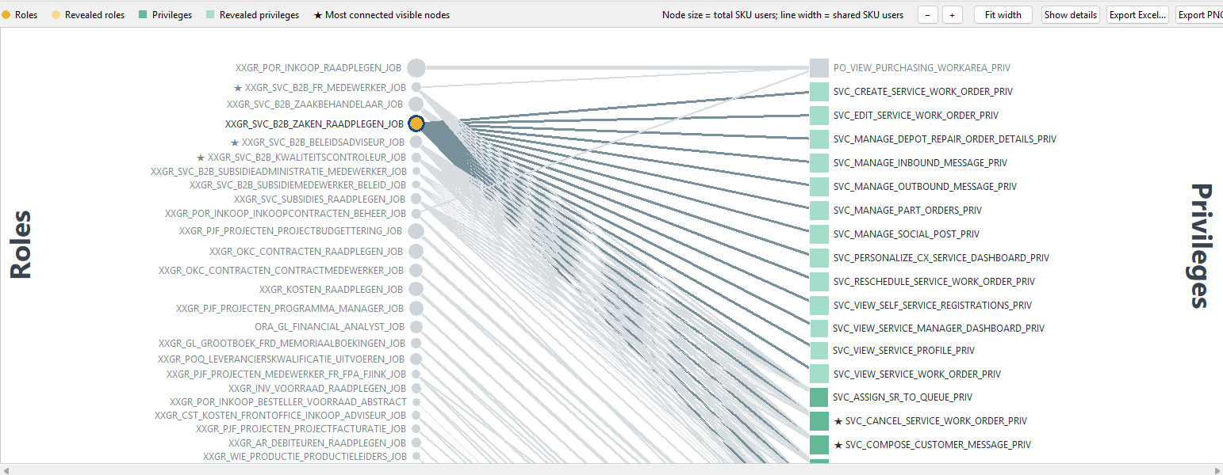
Figure 4. A selected role with all connected privileges highlighted; light-green squares were revealed by the selection.
- Revealed privileges are inserted using the same topology ordering; they are not simply appended at the bottom.
- Roles that were visible before selection retain their relative order, so the selected role does not jump to a confusing new position.
- The exact role name is copied to the Windows clipboard immediately.

7.2 Select a privilege
Selection works symmetrically from right to left. Select a privilege square or label to highlight its roles and temporarily reveal roles omitted by the initial role limit.
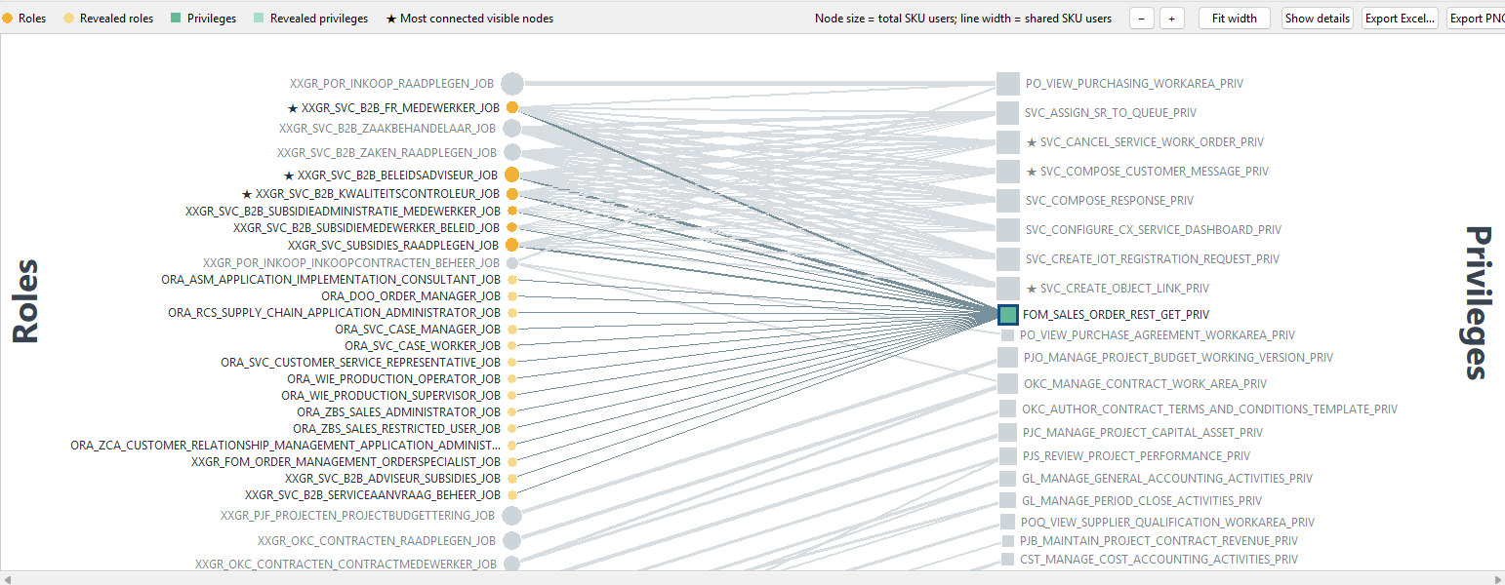
Figure 5. A selected privilege revealing roles that were outside the initial role limit.

7.3 Selection options
- Show all connections for selected node: keeps the initial list and adds qualifying hidden neighbours temporarily. Clear the selection to return to the original limited overview.
- Show only selected node's connections: hides unrelated nodes and lines, producing a focused subnetwork. This can be combined with expansion.
- Search text, Minimum role/privilege users, and Minimum shared users continue to apply during expansion.

7.4 Clear a selection
Select the same node again, select empty graph space, press Esc, or choose Clear selection in the details panel.

8. Details panel
Choose Show details to open the relationship table. It follows the current selection and can remain open while you navigate between nodes.
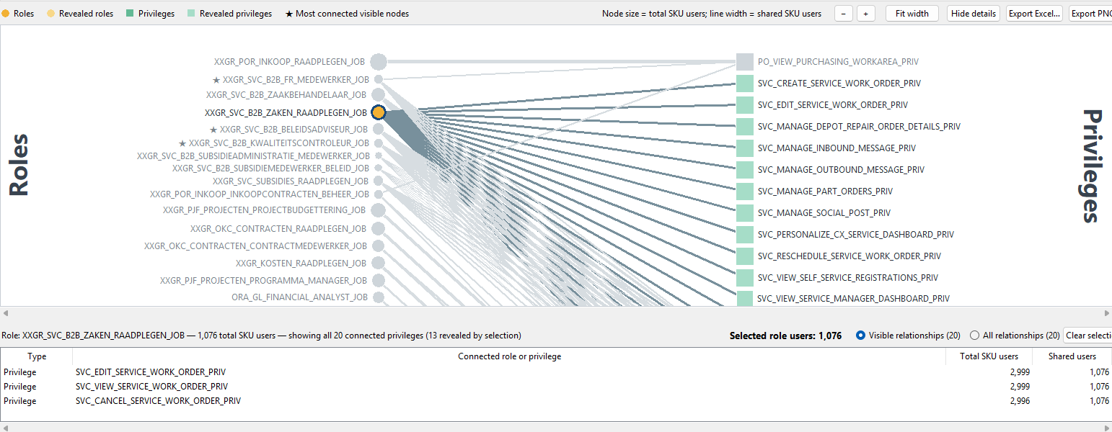
Figure 6. Details panel for a selected role, including counts and relationship scope.
Feature | Use
Visible relationships | Lists relationships currently represented in the displayed graph.
All relationships | Lists every qualifying relationship for the selected node, including relationships outside the current display.
Column headings | Select a heading to sort by type, name, total SKU users, or shared users.
Double-click / Enter | Navigates to the role or privilege represented by the selected row.
Ctrl+C | Copies selected detail rows as tab-separated text.
Clear selection | Returns to the unselected overview and disables selection-only actions.

If Show details appears to do nothing Look below the network canvas. The panel opens at the bottom and reduces the canvas height. In the current version the panel is sized automatically; Hide details collapses it again.

9. Exporting results

9.1 PNG export
- Export PNG… generates a clean image directly from network data; it is not a screen capture.
- The image includes SKU and service context, active filter values, legend, network summary, vertical Roles/Privileges titles, and export time.
- The PNG reflects the current selection and revealed-node state.

9.2 Excel export
Export Excel… creates a workbook containing metadata and analysis-ready tables:
- Workbook information and all active filters.
- Visible nodes and visible relationships.
- Selection state, including whether a node was revealed by selection.
- Visible and complete relationship details for the selected node.
After export The application can open the containing folder. Review exports before sharing because they may include workbook metadata, role and privilege names, and aggregate user counts.

10. Recommended workflows

10.1 Investigate a role
- Load the workbook and select the required SKU/service.
- Search for part of the role name if necessary.
- Select the role. Keep Show all connections for selected node enabled to reveal privileges outside the initial limit.
- Open Show details and compare Visible relationships with All relationships.
- Copy the role name from the Windows clipboard or copy selected table rows with Ctrl+C.
- Export PNG for a visual record or Excel for further analysis.

10.2 Investigate a privilege
- Search for the privilege name or select it directly in the graph.
- Review the highlighted roles; light-orange roles were revealed beyond the initial role limit.
- Enable Show only selected node's connections when a focused subnetwork is easier to read.
- Use All relationships in the details panel to confirm the complete role set.

10.3 Reduce a dense network
- Increase Minimum shared users to keep only stronger role–privilege relationships.
- Increase Minimum role/privilege users to remove rarely used nodes on both sides.
- Use name searches to isolate a functional family, then increase Maximum roles or Maximum privileges only if needed.
- Use Reset filters to restore 30 roles, 30 privileges, 30 relationships for node selection, and minimum values of 1.

11. Troubleshooting
Symptom | Likely cause and action
The downloaded .exe is about 151 KB and does not start. | It is probably a saved GitHub HTML page. Download the raw saas-network-viewer.exe; the complete build is approximately 43 MB.
Windows warns about an unknown publisher. | The executable is currently unsigned. Verify the repository source, then use More info > Run anyway only if you trust it.
Workbook does not load. | Confirm the Raw User Data worksheet exists and contains SKU, SERVICE, USER_LOGIN_HASH, PRIVILEGE, and ROLE_CODE.
No nodes match. | Clear name searches, lower the minimum-user thresholds, or choose Reset filters.
A connected role or privilege is missing initially. | The initial maximum may hide it. Select the visible neighbour with Show all connections for selected node enabled, or increase the applicable maximum.
Network is too busy. | Raise Minimum shared users or Minimum role/privilege users, use a name search, or enable Show only selected node's connections.
Node positions change after filters. | Changing filters creates a new initial topology order. Selection expansion preserves the relative order of previously visible nodes.
A thick node outline is visible. | That node is selected. Clear the selection to remove the outline.
Details panel uses too much space. | Choose Hide details. It starts collapsed the next time the application is launched.
Text or graph appears too small. | Use + or Ctrl+mouse wheel to zoom; choose Fit width to restore the horizontal scale.

11.1 Navigation shortcuts
Input | Action
Mouse wheel | Scroll vertically.
Shift + mouse wheel | Scroll horizontally.
Ctrl + mouse wheel | Zoom in or out.
Middle-button drag | Pan the canvas.
Esc | Clear the current node selection.
Ctrl+C in details | Copy selected detail rows.
Enter in SKU field | Select the first matching SKU/service.
Enter in numeric filter | Apply the current filter value.

12. Reference and legal notice

12.1 Terminology
Term | Definition in this application
SKU user | A distinct USER_LOGIN_HASH associated with the selected SKU and service.
Role users | Distinct SKU users assigned to a role.
Privilege users | Distinct SKU users associated with a privilege.
Shared users | Distinct SKU users present in a specific role–privilege relationship.
Initial node | A role or privilege chosen within the current limits before any selection expansion.
Revealed node | A qualifying connected role or privilege temporarily added because a node was selected.

12.2 Open source and non-affiliation
This software is an independent personal project created and maintained by Sandor Nieuwenhuijs. It is completely open source under the MIT License and may be used, inspected, modified, and redistributed subject to that license. It is not an Oracle Corporation product or project and is not sponsored, endorsed, approved, maintained, supported, or warranted by Oracle or its affiliates. Oracle and related product names are used only for identification.
The software is provided “as is”, without warranty of any kind. Users are responsible for testing, backups, security review, permissions, regulatory and contractual compliance, and decisions based on its output. See the repository LICENSE file for the complete terms, notices, warranty exclusion, and liability limitation.

12.3 Project location
Source repository: https://github.com/snieuwen/saas-network-viewer
Version note This guide describes the application behavior present in source commit b98f1db and the corresponding August 2026 standalone build.

