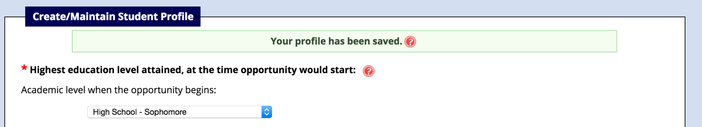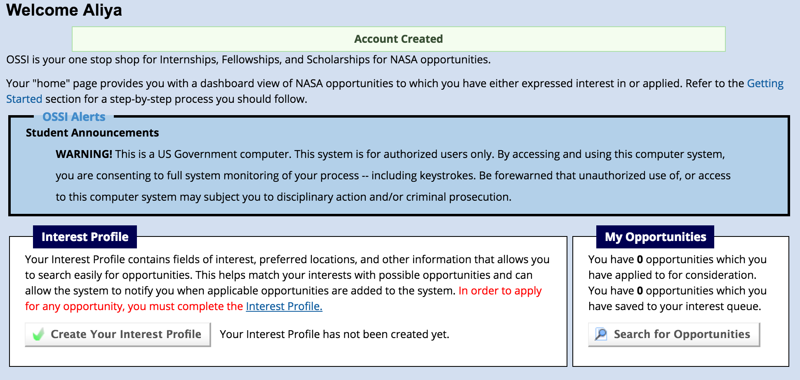Aliya Magnuson

Though I do not have any NASA centers near me, I would like to work at the Langley Research Center in Hampton, VA. I would like to help with projects in biomedical and chemical engineering, and maybe in mechanical engineering. I read that the Langley Research Center offers some of these types of engineering. I do not know much about these fields, but the projects in these fields interest me. Being able to work with people in these fields would give me more information on these careers.