**Gripping technique**

Gripping technique is the way a player holds his badminton racket using their forehand and backhand grip. By learning this technique, you could hold your racket properly and execute strong shots. It can be applied throughout the entire game.

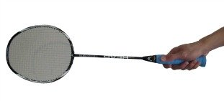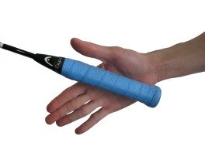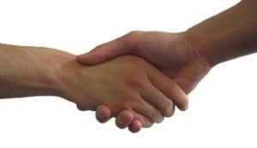To learn this technique, the very first step is to hold your racket in a correct and a proper way.   
It is simple as you just need to hold your racket just like giving a handshake to someone. Imagine that the grip of the racket as a hand approaching to shake your hand. Go ahead and hold the racket as if you are shaking someone’s hand.

Make sure that your thumb is pressing comfortably against of other wider surface of the racket grip while the rest of your hand are holding the racket as if you are shaking the person’s hand.

In order to execute strong badminton strokes with high accuracy, your wrist needs to be flexible. To achieve this**, MAKE SURE**

* **DO NOT GRIP YOUR RACQUET TOO TIGHTLY**. This will make your wrist less flexible in rotating and flicking.
* **USE ONLY YOUR THUMB, INDEX, AND MIDDLE FINGER TO CONTROL THE RACKET.** Your last 2 fingers should rest comfortably on the badminton grip to balance the weight of the racquet. By doing this, it enables your wrist to be more flexible and move more freely.

To summarize, this technique is easy to learn and can be learnt by everyone. As a badminton player, we should master this technique and apply it on the court.

**Serving**

A badminton rally starts with the serve. Master a proper serving will give you an edge over your opponent right from the start of the rally. In this situation, this will not create a chance for your opponent to execute an attacking shot. Therefore, it is important to know how to serve properly so that you will not lose a point after making a service.

There are two methods of learning a badminton serve which are high serve and low serve.

***The High Badminton Serve***

This serve generally executed when you want the shuttle to land at the back end of the court. A decent high serve must have the shuttle dropping sharply downwards at the back end of the court. Learning high serve can avoid your opponent from performing a strong smash. In its place, a lob or a drop is more expected from your enemy. The high serve is beneficial against opponents who cannot perform strong smashes from the back of the court.

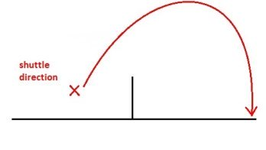Try to serve the shuttlecock to your opponent’s backhand area. The aim is to force your opponent to use his backhand. This is because most badminton players, even world class player, have weaker backhands (compared to their forehands). An example is shown in the picture below.

**Let me show you how to do a high serve…**

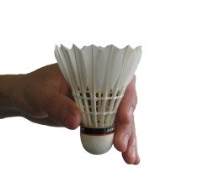

1. Grasp the head of the shuttlecock with its head fronting downwards so that the shuttlecock will drop straight down. (Picture is shown above)
2. Relax your racquet arm (arm that is holding the racquet) and Stand sideways (the side of your body facing the net).
3. Let go of the shuttlecock and swing your racquet arm upwards. As you do this, twist your waist to the extent that your body faces the net. Flick your wrist towards the direction you want the shuttle to land (Flick your wrist upwards, so that the shuttlecock will fly high).
4. Your back leg should lift up naturally (with your toes touching the ground).

***The Low Badminton Serve***

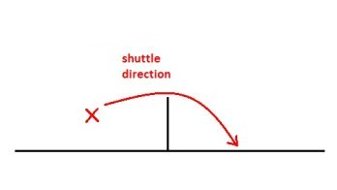When you want the shuttlecock to land in front of the court (in front of your opponent), low serve is the choice you should use. A **GOOD** low serve will have the shuttlecock flying **JUST ABOVE THE NET** to prevent your opponent get a chance to dash forward and smash the shuttle down to you. It will prevent your opponent from making an offensive shot if you executed a perfect low serve. An example is show in the picture below.

**Let me show you how to do a *low serve*…**

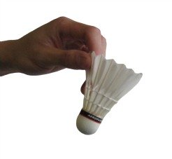

1. Hold the feather of the shuttlecock with the head of the shuttlecock facing downwards. (Picture is show above)
2. Position the racquet behind the shuttlecock.
3. If you are right handed (left handed), step slightly forward with your right (left) leg.
4. Flick your racquet lightly while pushing your thumb forward towards the direction you want the shuttle to land after letting go of the shuttlecock. The power comes mainly from the push of your thumb and the slight flick of your wrist.

***The Flick Serve (“Fake” Low Serve)***

The “fake” low badminton serve can also be used to trick your opponent (deceive your opponent to expect a low serve).

When you stand in a low serve position, your enemy would probably expect a low serve. However, push your thumb and flick your wrist harder so the shuttlecock flies HIGH and heads to the back of the court!

For more information, you can watch a video here by clicking the link below here to understand more.  
<https://www.youtube.com/watch?v=qq9KcC_F-Xc>

In short, this technique can be applied for every player in court and it can be learnt by everyone.

**Footwork and Position**

Footwork and Position are one of the important skill we should learn. Good footwork allows good movement around the court. However, many people neglect badminton footwork because it might not seem important at all. In fact, it is important because an ***effective and organised footwork*** provides superb speed and agility which enables the player to move around the badminton court swiftly and return every shuttlecock.

If you can do a good smash does not means you can reach the shuttlecock in time if you do not have a good footwork and position. Therefore, start to learn footwork and position skill because playing badminton is all about speed. The shuttlecock can move extremely fast and you must move faster than the shuttlecock to be able to hit it.

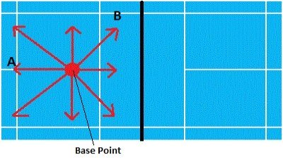***Effective Movement on the Court***

You should always remember your base (starting point) will be at the red dot in the middle. The arrows indicate the possible movements around the court. The moment you move away from your base to hit the shuttle, you **MUST RAPIDLY** return to your base to prepare yourself for your opponent’s shot.

For instance, you move to point A to take a shuttle and then stay there. Your opponent then returns the shuttle back to you at point B. You are less likely able to get to point B in time from point A. Conversely, if you quickly return to your base after hitting the shuttle at point A, you will be able to return the shuttle at point B.

**HOW SHOULD WE MOVE EFFECTIVELY?**

There are few tips that I would like to share which are:

* **Take ONLY 2-3 steps** when moving to the *back* of the court.
* **Stretch ONLY 1 step** towards the *sides* of the court.
* **Take ONLY 2-3 steps** to the *front* of the court.
* **Are you a beginner?** Does it seem difficult to take so few steps? Do not worry as the key is to stretch your legs as wide as possible while maintaining a good balance. If you are a beginner, take more steps. Then slowly reduce the number of steps you take as you move faster while maintaining good balance.
* 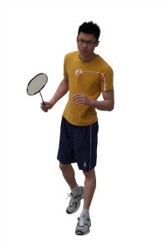**Maintain your balance:** While one of your hands will be holding the racquet, keep the other hand wide open. Not because it looks cool, it is because it helps in balancing. This enables you to return to your base quickly.
* **Good stance:** When you’re in a ready position (before your opponent serves), make sure one leg is in front and one leg behind, opened slightly wide *(refer to the picture above)*.
* **If the shuttle is served to the front**, use your toes of your back leg to push your bodyweight to the front.
* **If the shuttle is served to the back**, use your front leg toes to push your bodyweight to the back. This enables you to move fast once the shuttle is served.

Noted: There are no BEST ways for badminton footwork, you should move in a way you are comfortable with and keep practising.

**Net Shots**

The net shot is played from the net and when played correctly should just tumble over the top of the net and drop as close to the net as possible on the opponents. It is delicate and sensitive. It can used in both singles and doubles, often creating attacking opportunities. For net shots, you do not need any power, but you do need exquisite touch — the ability to control the shuttle precisely.

To learn Net Shots, we need to   
1) **Use a relaxed grip**

Hold the racket gently in the finger. This is because a tight grip causes you to lose control of the shot.

For backhands use a bevel grip, with your thumb extended straight on to the inner side of the bevel, giving support for your backhand shots. For forehands use a basic grip, very similar but now with the thumb relaxed, which allows it to relax gently around the racket handle. The relaxed grip will let you drop the racket head.

2**) Contact the shuttle gently**

As you approach the shuttle, turn your hand out in the direction of the shot. This applies for both forehands and backhands. Bend your wrist to allow the racket head to drop below the level of your hand. If you keep the racket level, the shuttle won’t go over the net. To play the shot just push the shuttle gently over the net.

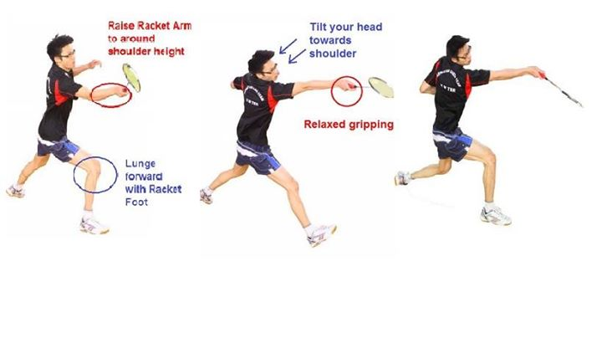The picture below might guide you a better way of learning Net shots.

For this technique (Net Shots), it is easy to learn, and every player should be picked it up quickly.

**Tap**

The tap technique is used when the shuttle is quite close to the net. By using a short tapping action, you can play an accurate net kill without hitting the net with your racket. We usually used this technique to finish a badminton rally decisively.

***Learn the basics***

Prepare by rising your elbow and twisting back your wrist. There should also be a slight bend at the elbow. As you do this, change grip. Move towards a panhandle grip for forehands, and a thumb grip for backhands. Keep the backswing compact. The racket head should stay in front of you, rather than passing behind your shoulders.

Hit the shuttle by straightening your arm at the elbow and flicking your wrist forwards. Use a tapping action, so that the racket head stops after impact or rebounds backwards. In other words, try to stop the racket head from continuing forwards and hitting the net!

***Using the forearm for power***

Forearm rotation will help you get more power. The idea is to begin your hitting action with the racket face angled somewhat sideways, and then twist your forearm so that you contact the shuttle with the racket strings facing directly forwards.

To think it in another way, when you are preparing to hit the shuttle, the outside edge of your racket frame should be slightly nearer the net than the inside edge. When you contact the shuttle, the racket should be square-on to the net.

***What is the technical used?***

For backhands, pronate your forearm on the backswing and supinate it on the forwards swing (twist inwards, then twist outwards).

For forehands, supinate on the backswing and pronate on the forwards swing (twist outwards, then twist inwards).

***When the shuttle is wide of you***

When you are reaching out sideways for a net kill, it’s harder to get the power. The problem here is that your elbow and wrist can’t help you as much, as they are pointing in the wrong direction (sideways, not forwards).

To compensate for this, you will need to use more forearm rotation. You’ll also need to adjust the angle of your grip, so that the racket faces forwards on impact (rather than out the side).

***A common error where players usually do – Hitting Flat***

If you don’t use forearm rotation, then you will be hitting with a flat racket face throughout the stroke. This will cause you to lose power. Hitting flat is often connected with using your grip incorrectly. This is a very subtle point, but important.

To understand better, you can watch a video here which will teach you 7 badminton Tap.

Link in below:  
<https://www.youtube.com/watch?v=ByLMnA1lhqA>

As for this technique, every player can do this once you have mastered it.

**“Lift” or “Lob”**

The lift or lob shot in badminton would normally be played from the forecourt in an underarm action. The aim is to lift or lob the shuttle over your opponent and aim to make the shuttle land as near to the baseline as possible without hitting it out.

There are two types of Lob which are **Forehand Lob** and **Backhand Lob**

***Forehand Lob***

<https://www.youtube.com/watch?time_continue=31&v=bg-Jq8LXAgE>

Move your racket forward with the wrist cocked as you approach the shuttle so that your palm is facing forwards. Move near the shuttle and take a lunge step with the dominant foot towards where the shuttle is due to land. Swing the racket forwards underneath the path of the shuttle when the shuttle is going to drop, then strike it upwards whilst straightening the wrist. The follow through should continue up and finish above the non-racket shoulder.

Firstly, recover back with the dominant foot and then go back to the mid-court. The lob can be played very high and deep as a purely defensive shot. It also can be played as a building shot when it is taken earlier (higher up the net) and this shot would be played with only just enough height to go beyond your opponent’s reach.

***Backhand lob***

<https://www.youtube.com/watch?v=qpTS5qLaTKI>

Backhand Lob would normally be played from the forecourt in an underarm action. The aim is to lift or 'lob' the shuttle over your opponent and aim to make the shuttle land as near to the baseline as possible without hitting it out.

These are the two lobs that you should learn in order to master the lift or lob technique. Everyone is welcomed to learn this technique especially for beginner who are interested in learning badminton.

**Intermediate**

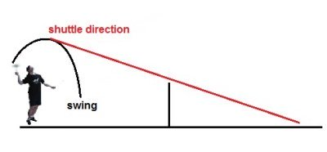**Forehand Smash**

Forehand Smash is a type of offensive shot and is mainly used for attacking. It often acts as a winning shot in any badminton rallies. It is simple to learn this technique as we just need to swing our racket forward as hard as you can to hit the smash. But in order to get a proper forehand smash, the first step is to learn the correct technique.

There are six steps to follow in order to master forehand smash.

***1. Get into position and adopt the Forehand Grip.***

If you intend to hit the smash, you should move quickly towards the shuttle. In professional badminton, we call this ‘injection of pace’. Ideally, your body should face the side of the court. Both your feet should also point sideways.

***2. Stand on a firm position.***

Your smash won’t be strong if you’re not on good balance because your body will concentrate on balancing first rather than doing a strong swing.

***3. Lift your Racket Arm and Non-Racket Arm.***

To ensure you perform a full arm swing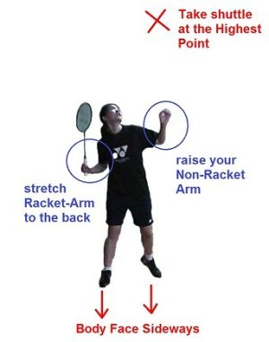 make sure you stretch your racket arm as far back as possible. At the same time, lift your Non-Racket Arm to balance out the weight of your Racket Arm. This is **VERY IMPORTANT** to help you maintain body balance. You are now ready to hit the smash. This is how you should look like…

***4. Take the shuttle at the highest point possible.***

This creates a steep angle for your smash.

***5. Hit the Shuttle with a Full Arm Swing.***

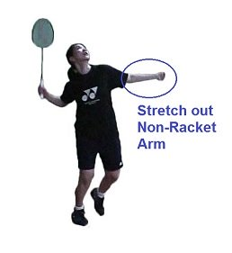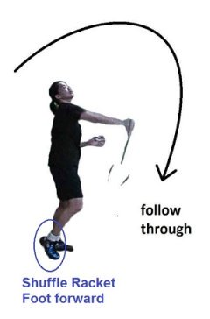First, Take a deep breath. Second, stretch out your chest to the widest extend possible. Third, stretch out your Non-Racket Arm. Then swing your racket forward as you exhale. At the same time, contract your abs. Shuffle your Racket Foot to the front.

***6. Follow Through with your Swing.***

Follow through and complete your swing after you hit the shuttle. Your body should face forward after you swing your racket. Recover and maintain body balance.

To conclude, learning the forehand smash is a **MUST** even if you are beginner as it is useful when playing badminton. As a badminton player, it is a skill that we should learn.

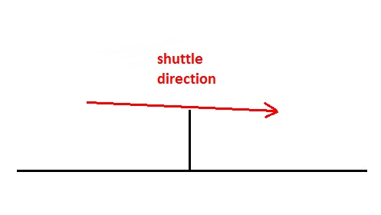**Drive**

Badminton Drive shots are shots that crosses the net flatly in a horizontal trajectory. It can be played both on the forehand and backhand sides. It is an attacking shot that is usually played from the sides of the court when the shuttle has fallen too low for it to be returned with a smash. The shuttle shall be between your shoulder and knee height.

It is widely used in doubles as players want to keep the shuttle low. Although to a lesser extent in the singles, it is an important stroke as well. Of course, it could be learnt by everyone as it does not mean only for players who are playing doubles.

There are two types of drive where I mention above which are the ***forehand drive*** and ***backhand drive***. You can hit a badminton drive either with forehand drive or backhand drive.

Steps by steps of learning the drive.

1. Bend slightly forward until the height where your eyes are approximately level with the top of the net. Adopt the defensive stance.
2. Hit the shuttle when it is infront of you. The movement is same as tossing an object forward. Imagine yourself tossing an object into a box in front of you.
3. For having a body balance, extend your non-racket arm. When you spread out your non-racket arm, you will generate more power for your drive.
4. To generate a greater power and to perform the shot smoothly, allow your bodyweight to follow the momentum of your swing.
5. However, prevent throwing your whole body to the front or you will lose balance. Ensure as your body moves forward, your feet should stay firmly in position. You might lose some degree of body balance as you do this. That is why you should use your non-racket arm to help you maintain balance.
6. Notice that the wrist points downwards after hitting the drive. You will only be able to generate a fast return if you make use of your wrist.
7. The technique to perform a drive using your backhand is same as the technique using the forehand. However, it is just quickly switch from a forehand grip to a backhand grip.

Below is a video for learning drive which is taught by a badminton coach.

<https://www.youtube.com/watch?v=z8ar_TCBVqc>

**Drop shot**

Drop shots are played from your rear court. You hit the shuttle softly downwards to land in your opponent’s forecourt area. Drop shots are used extensively in both singles and doubles. They are primarily an attacking shot. Drop shots are usually disguised to make the opponent expect a smash or clear. A good drop shot can be very deceptive and can cause the opponent to reach the shuttle late and play a poor lift (giving an opportunity to attack).

There are two types of drop shots which are ***Fast Drop Shot*** and ***Slow Drop Shot.***

***Fast Drop Shot:*** Travels down steeply. But lands further away from the net.

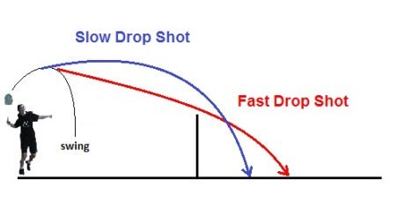***Slow Drop Shot:*** Does not travel down steeply. But lands nearer to the net.

In order to perform drop shot, we must follow these two steps.

* ***Grip and preparation***

Use a relaxed forehand grip, just like your other overhead shots. Your preparation must look as similar as a clear or smash. Turn side-on and get your racket back, so that you look like you can hit the shuttle hard. Drop shots work much better if they are disguised to look like a powerful shot.

If you show a different preparation, your opponents will realise you are playing a drop shot and they will move forwards to attack it.

* ***Hitting action***

As a player, reach up for a high contact point. This situation will make you hit the shuttle at full relaxed reach, ideally above the racket shoulder and slightly in front of you. A high contact point means that your drop shot will travel downwards, not flat; this makes it a more effective attacking shot.

Then, use a soft pushing action to hit the shuttle.

Follow through after hitting. The follow through should initially be in the same direction as your shot, but then let your arm relax across your body.

Below is a video of drop shots  
https://www.youtube.com/watch?v=vfr4cPXxWlU

**Advanced**

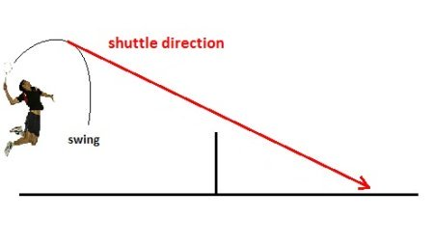**Jumping Smash**

The Badminton Jump Smash is the most powerful shot in badminton. It is a smash performed in mid-air. Players do jump smash to create a steeper angle and it is more powerful than the normal smash. However, to learn jumping smash, players should master their basic smash before learning jump smash.

Step by Step Tutorial

***1. Get into Position and Adopt the Forehand Grip.***

* Move quickly and get BEHIND the shuttle.
* Use the Forehand Grip.
* Stand firmly and maintain a better body balance.
* Perfectly, your body should face sideways. Both your feet should also point towards the side of the court.

**DO NOT** tense your body muscles. A common mistake among casual players is that they tend to subconsciously tense their body muscles while doing the badminton jump smash. Tensing your muscles will restrict the mobility of the muscles. Therefore, you won’t be able to perform a maximum swing.

***2. Lift your Racket Arm and Non-Racket Arm***

Stretch out your Racket Arm as far back as possible. In the meantime, raise you Non-Racket arm to counter the weight of your Racket Arm.

***3. Jump into the Air***

* Adopt your Racket Foot to help push your body up into the air.
* Relax your body and do not tense your muscles.
* Take a deep breath then extend your chest to the widest extend possible.
* Stretch out your Non-Racket Arm.
* Slightly bend your legs to the back. Remember not to force this move. It should happen naturally and normally. When your body have full balance in the air (by stretching out your Non-Racket Arm) and if your body muscles are relaxed, you will indeed lift your legs for more power.

***4. Hit the Shuttle at the Highest Point Possible***

Time your jump as timing is quite important. Ideally, you want to start your swing at the peak of your jump. This should also be your highest contact point with the shuttle.

As you swing your racket forward,

* Take back your Non-Racket Arm back to the side of your body.
* Explosively bond your Abs as hard as you can. If you have strong abs, your smash will be hard.
* Raise your Racket-Foot forward as you contract your abs. Once more, this will happen normally if you contract your abs as hard you can. The point of doing this is to build the speed of your swing and kick in explosive power into your stroke.

***5. Follow Through, Land, and Maintain Body Balance***

After you hit the shuttle, Follow Through with your swing. Rearrange your Racket Foot forward while in the air. Your Racket Foot should be put in front as you land onto the ground. Maintain body balance and recover.

Noted: We should **ONLY** use the jump smash when you’re prepared and when the shuttlecock is still high in the air. The best time to hit the badminton jump smash is when you manage to force your opponent to Lift the shuttle high up to you.

Below is a video of LEE CHOING WEI, a Malaysian professional badminton player, doing the jumping smash.  
<https://www.youtube.com/watch?v=rbx-Xs9dS3E>

**Backhand Smash**

Backhand Smash is the most difficult type of smash. It requires a lot of power to perform this smash. However, if executed perfectly, this shot will definitely surprise your opponent and make him return a weak shot. You should only learn this smash if you have mastered all the other types of smash.

This shot should only be used when you can quickly move to the position for a badminton backhand smash and quickly switch to the backhand grip. **DO NOT** perform this shot unless you are very sure that you can one shot end your opponent rally with your smash.

Tutorial of learning this smash. There are three steps.

***1. Preparation Phase***

Quickly switch to a forehand grip while turning towards your backhand area to face the back of the court.

***2. Preloading Phase***

Keep your racket arm as close as possible to your body so that your backhand swing is maximised.

Keep your non-racket arm ready to help you maintain body balance when you perform your swing.

Remember that the faster you can switch to the backhand grip, the more preloading time you have (the more power you can accumulate)

***3. Execution***

Take the shuttle at the **HIGHEST POINT POSSIBLE** for a steeper and a better angle. Commence the backhand swing motion. Remember, the key for this power is having a correct swinging pattern.

From this point onward, your swing should be smooth and complete motion until you hit the shuttle. Do not stop half way during the swing as this breaks the momentum.

When you are about to make contact with the shuttle, perform a powerful flick with your wrist and hit the shuttle with a quick “snapping” motion with the flick of your wrist.

Your wrist action along with your backhand swinging motion is the source of power for the badminton backhand.

Apart from your wrist action, finger control (your thumb and index finger) is important for better control of your racket. Use your fingers (especially your thumb for a backhand), to help create a more powerful flick.

Direct the shuttle downwards so that it passes the other side of the court just above the net. It’s important NOT to hold your racket too tightly. This enables flexible wrist action as well as finger movement for better control.

Even after you hit the shuttle, follow through to complete your backhand swing. There is a high chance that you will lose body balance after you hit the shuttle, make use of your non-racket arm to help maintain body balance. After your backhand swing motion is complete, faster return to your base to prepare for the next shot.

A video of “How to Hit a Backhand Smash” is provided below for better understanding.

<https://www.youtube.com/watch?v=6aJO2HxhoTw>

Noted: This smash should only be done by player who have mastered this technique. If you are not master, you should not perform this technique.

**Over-head smash**

It is a forehand overhead badminton smash played at the non-racket side of your body. We usually try to use it whenever play permits as a forehand stroke is always better and more powerful than a backhand.

The techniques for hitting this shot are about the same as the *Forehead Smash* which is mentioned in the *Intermediate tab* with only some minor adjustments.

Here are **some pointers** for playing an over-head smash.

- We should stand squarely to the net.

- We must make sure we bend our upper body sideways to our non-racket side as our arms come through.

- Shift our weight to our non-racket leg

- Twist your elbow and take the racket behind your head.

- As you swing forward, your forearm will brush the top of your head before straightening.

- Transfer your body weight rapidly as your non-racket leg pushes your body back to your base position.

***Important note***

Our wrist plays a key part in creating deception when performing over-head smash.

There is a short video below of the China professional player Lin Dan performing overhead smash when playing against Lee Chong Wei.

<https://www.youtube.com/watch?v=u05d8yfijhk>

***Who should be doing this?***

Every player on the court.

**Defending Technique**

As a player, we should know how to defend. It is one of the most important skills. With strong defence. it’s difficult for your opponent to win a point from you! The harder your opponent tries to penetrate your defence, the higher the chance that he will make an unforced error. There is a quote which is called “Good defence is good offence”.

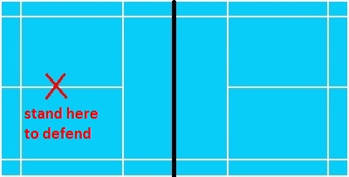Here shows you a step by step tutorial on how to defend a badminton smash.

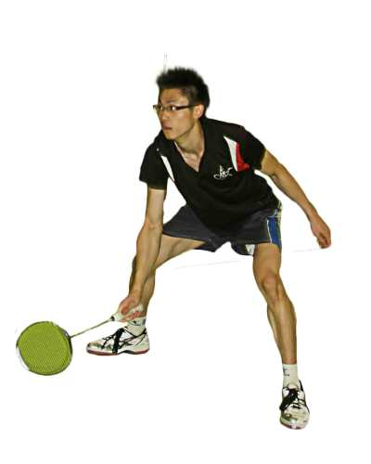First of all, whenever you lift the shuttle to your opponent (badminton clear or net lift), quickly move to point X as seen in the picture. When defending a smash, position yourself slightly behind your footwork base (slightly behind the center of the court). This gives you some time to ‘catch’ the flight direction of the smash, so that you have enough time to react. When you’re at point X in the picture, adopt the defensive stance.

The picture above shows you a defensive stance when you anticipate a strong smash from your opponent.

* Bend down as low as you can. The ideal point: bend down until the point when your eyes are on a level plane level with the highest point of the badminton net.
* Keep your chest wide and rectify your lower back. Twist your knees, abstain from bending your spine.
* Make beyond any doubt your racket arm (the arm holding the racket) is situated before you. This is to guarantee you're prepared to react rapidly (normally with underarm strokes) when your adversary crushes to you.
* It's difficult to advise whether your rival will crush to your forehand or strike territory. Along these lines, don't grasp your racket too firmly. This is to change from a forehand to strike hold effortlessly (and the other way around).
* 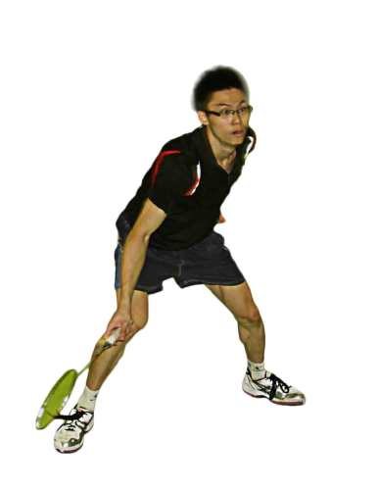Besides, holding your racket too firmly limits your wrist activity.

Keep your non-racket arm in action too. This assistance with badminton body balance.

While receiving a smash from your opponent,

* STAY FOCUS and RELAX
* Stand on a FIRM cautious position
* DO NOT fear the shuttle. The shuttle won’t hurt you

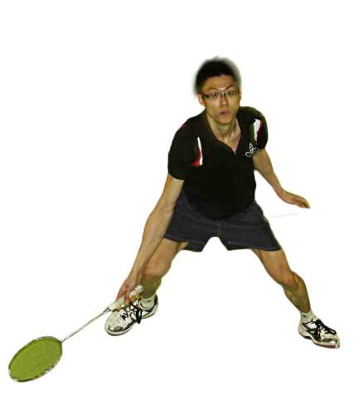

While on the badminton defensive stance, it is easy to move left or right, as long as you are facing the front (your body facing your opponent). This empowers you to retrieve a smash to the left or right. Defending a badminton smash is somewhat like defend yourself from catching an incoming ball when someone throws on you. Except that you use a racket instead of your hands.

***Important Tips***

1. The key to guard a strong smash from your opponent is to receive the cautious position.
2. Stand at a position marginally behind the focal point of the court to give yourself more opportunity to see flight direction of your opponent’s smash.
3. Do not scare of the shuttle. When you are afraid of the shuttle, you will normally face slightly to the side. That means that the side of your body will be facing your opponent. If this is the case, you would not be able to cover wide points.
4. Be fast in moving to this defensive base when you anticipate a strong smash from your opponent. The faster you can move to this point and adopt the badminton defensive stance, you will be more prepared to receive your rival’s smash.

In short, every player should learn this technique to defend themselves from giving a point to your opponent.