# MINI PROJECT - II

## (2021-2022)

**Bookxholic**

# PROJECT REPORT



**Institute of Engineering & Technology**

## SUBMITTED BY:

### Sahil Vishwakarma (191500693)

### Snigdha Dhamija (191500816)

**Under the Supervision of Mr. Neeraj Khanna Technical Trainer**

**Department of Computer Engineering & Applications**

|  |
| --- |
| **Table Of Contents** |
| **Certificate 3**  **Acknowledgement 4**  **Abstract… 5** |
| **1. Introduction 6** |
| 1.1 Overview 6 |
| 1.2 Motivation 6 |
| 1.3 Problem Statement 7 |
| 1.4 Objective… 7 |
| **2. Software Requirement Analysis 8** |
| 2.1 System Analysis 8 |
| 2.2 Role of System Analyst 8 |
| 2.2.1 Main roles of System Analyst 8 |
| 2.3 Users 9 |

* 1. Methodology 9
  2. Dependencies /External Systems 10
  3. Hardware and Software Requirements 11
  4. Technology Used 12
  5. DFD 13
  6. Use-case Diagram 14

1. Implementation details 15
2. Contribution Summary 18
3. Project Work 19
4. Future Scope… 29
5. Conclusion 30
6. Reference 31

## Certificate

This is to certify that the project entitled “Bookxholic”, carried out in Mini Project – II, is a work by Sahil Vishwakarma and Snigdha Dhamija. The project is submitted in partial fulfillment of the

requirements for the award of the degree Bachelor of Technology (Computer Science

& Engineering).

Signature:

**Mr. Neeraj Khanna**

(Mentor)

## Acknowledgement

It gives us a great sense of pleasure to present the synopsis of BTech Full Stack Project **(Bookxholic)** undertaken during B-Tech IIIrd Year. This project in itself is going to be an acknowledgement to the inspiration, drive and technical assistance that has motivated individuals like us.

We owe special debt of gratitude to **Mr. Neeraj Khanna,** Technical Trainer, Department of CEA, for providing us with an encouraging platform to develop this project, which thus helped us in shaping our abilities towards a constructive goal and for his constant support and guidance to our work. His sincerity, thoroughness and perseverance is been a constant source of inspiration for us. We believe that he will shower us with all his extensively experienced ideas and insightful comments at different stages of the project & also guide us about the latest industry-oriented technologies.

We would also like to acknowledge the contribution of all faculty members of the department for their kind guidance and co-operation.

Sahil Vishwakarma (191500693)

Snigdha Dhamija (191500816)

## Abstract

In this cut throat competition, Android Development is one of those fields that is experiencing great demand in the current era. It has gained a lot of scope in the top-notch industries. Therefore, being a Computer Science student, it becomes quite necessary to learn such Android technologies in order to increase one’s career prospects. For this, it is important to have practical knowledge of languages and build projects that can be utilized and worked upon in future and among such projects is “Bookxholic”

The main aim of this project is to connect all the book lovers and avid readers out there, who can see a list of books and other details along with its description. Also, this platform will give readers a new perspective around the books that they have read, helping them understand the aspects that they never considered.The key components of Bookxholic are:(i) Explore Book Titles (ii) Description of various books

(iii) Price and Rating of book (iv) Favourite Section

(v) Room database

* There are following users: Readers
* Readers can read about a list of books by clicking on them, add them to favourite section, check their rating, prices and author name.
* They can enter detail about themselves like- Name, E-mail and Phone number.

## Introduction

* 1. **Overview**
     + Software and Hardware Requirements, corresponding DFD’s and Use Case Diagrams have been organized in this report. Along with these designs, this report also contains the essential data of this project.
     + The complete description of the application followed by the functionalities has been listed initially. Later on, the app layout has been described diagrammatically with the help of different designing tools like Data Flow Diagram, Use Case Diagram.

## Motivation

In this cut throat competition, Android app development is one of those fields that is experiencing great demand in everywhere. It has gained a lot of scope in the top-notch industries. Therefore, being a Computer Science student, it becomes quite necessary to learn such android technologies in order to increase one’s career prospects. For this, it is important to have practical knowledge of languages and build projects that can be utilized and worked upon in future and among such projects is “Bookxholic”.

## Problem Statement

In this digital era where people share their hobbies like dance, music etc, there comes a need to provide an open platform to all those readers who want to explore new book titles every day and share their aspects regarding a book. This idea has led to building book-specific social media application: Bookxholic, where people can connect over poetry, literature, blogs, articles, quotes, scriptures- writings that are worth reading.

## Objective

The main aim of this project is to connect all the book lovers and avid readers out there, who then can read the book they want . Also, this platform will give readers a new perspective around the books that they have read, helping them understand the aspects that they never considered. The key components of Bookxholic are: :(i) Explore Book Titles (ii) Description of various books

(iii) Price and Rating of book (iv) Favourite Section

* + - There are following users: Readers
    - Readers can read about a list of books by clicking on them, add them to favourite section, check their rating, prices and author name.
    - They can enter detail about themselves like- Name, E-mail and Phone Number.

## Software Requirement Analysis

* 1. **System Analysis**

System analysis is a process of collecting and interpreting facts, identifying the problems, and decomposition of the system into its components.

It is a process of studying a system in order to define its goals or purposes and to discover operations and procedures for accomplishing them most efficiently.

## Role of System Analyst

The system analyst is a person who is thoroughly aware of the system and guides the system development project by giving proper directions. He is an expert having technical and interpersonal skills to carry out development tasks required at each phase.

## Main Roles of System Analyst:

* + - * Defining and understanding the requirement of user through various fact finding techniques.
      * Prioritizing the requirements by obtaining user consensus.
      * Maintains analysis and evaluation to arrive at appropriate system which is more user friendly.
      * Draw certain specifications which are easily understood by users and programmer in precise and detailed form.
      * Implement the logical design of system which must be modular.

## Users

The Users of this website would be the Readers who can read books and add them to their list of interested books, which contains other details too. They can also enter detail about themselves like – name, e-mail and phone number.

## Methodology

Our methodology is designed to help you take maximum advantage of the internet technologies. It incorporates all aspects related to our application and allows us to ensure that the final product is of the highest standards. Below are the steps we will take to ensure that all our deliverables are completed in time, within budget also we will try to solve each and every problem efficiently.

### Requirements analysis

The first step for us is to analyze the target market’s requirements who will be visiting our application, what will be the purpose of their visit, what is the primary goal of our application, how can the users benefit from it. Many such questions are analyzed for the need’s analysis stage.

If we are given access to the current application statistics, we would also like to analyze our current layout views, average user time spent on the app, top landing books, existing search engine rankings, existing bounce rates and many such factors. We analyze our online target audience and assess our differentiation strategy to best attract and retain our online visitors.

Our application should also undergo comprehensive search engine analysis twice during the course of the project; once during this stage and once again after the deployment (Starting) of our application.

### Application handover

Once the app is setup on our android studio, upon your approval we make the application to launch. One final set of testing is done on the launched app for the quality assurance purposes. We then hand over the control of the application to you.

## Dependencies/External Systems

### User Interfaces:

Bookxholic application shall permit complete navigation; including all the functionalities described above, starting from seeing the list of books to read and adding them to favourite list to read them whenever they want.

### Hardware Interfaces:

There are two external machines/devices used by the application, each related to a user interface. These are – a machine at the admin end hosting the application databse and device at readers’s end who wants to read about popular book titles as well as share their experience by adding new book title. The devices at the user end behave as terminals. Also capable of taking user input.

## Hardware Requirement (Minimum)

* 2 GB RAM
* Android (Pie)
* Internet Connections

## Software Requirement -

* SYSTEM SOFTWARE
  + Operating System (Android)
* APPLICATION SOFTWARE
  + Tools: Android studio, postman
  + Front End Technologies: XML (Extensible Markup Language)
  + Back End Technologies: Kotlin, Picasso ,Room(RDBMS)

## Technology Used

* **Kotlin**: It is an [open-source](https://en.wikipedia.org/wiki/Open-source), [back end](https://en.wikipedia.org/wiki/Front_end_and_back_end) based on JVM. Google announced it to be fundamental language for development of android app. It is somewhat similar to java.
* **XML**: Stands for extensible markup language. It is extensible markup language, Front end. A metalanguage which allows user to define their own customized markup language. It consists of tags which stores some information, that is used to present data on screen.
* **Picasso**: It is a open source and widely used image download libraries in android. It simplifies the process of loading images from external URL’s and display them on application.
* **Postman**: It is an interactive collaborative application program interface tool which allows the mobile app developer, testers and other project stakeholders to communicate with each other to do a scalable API testing.
* **Room**: It is a part of the Android Architecture components which provides an abstraction layer over SQLite which allows for more robust database access while still providing the full power of SQLite.

# LEVEL 0 DFD

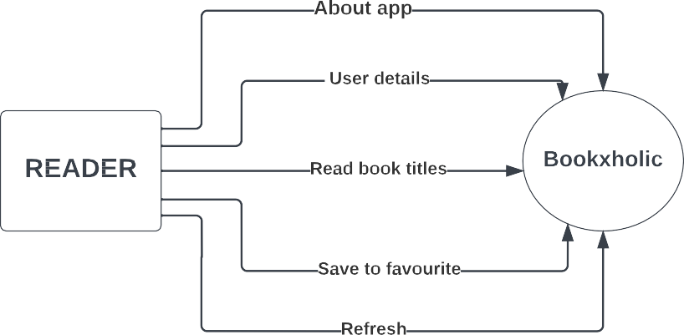

**LEVEL 1 DFD**

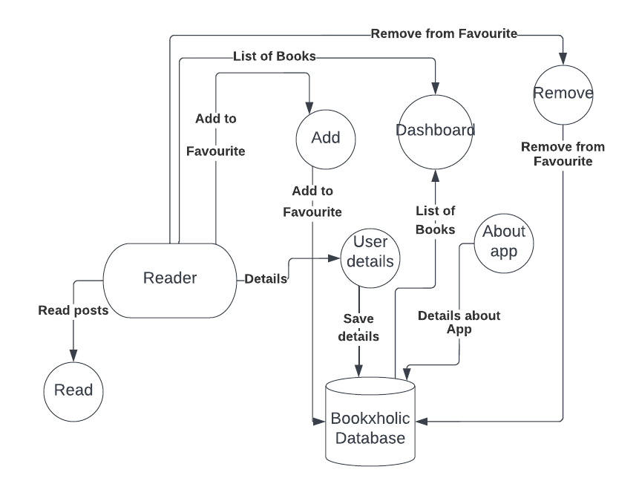

# USE-CASE DIAGRAM

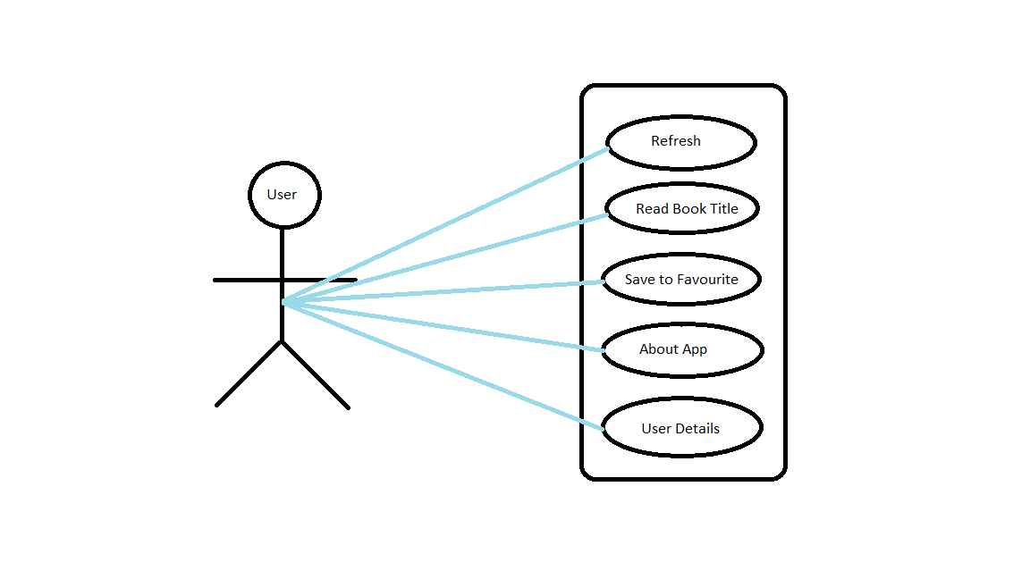

## Implementation Details

This system is intended to develop an open platform for all readers and book lovers where they get to explore new book titles and their aspects and description. This will also help them to share their own aspect for a particular book.

Functionalities are:

* + Using this platform, we can read about various books.
  + This application contains a dashboard containing a list of all books.
  + Users can enter their details like – name, e-mail, and phone number.
  + The user can add the book/books in the favourite section.

## Modules Included

* Profile Fragment – To save details of user.
* Favourite Fragment – To save books of users choice.
* Bookxholic Dashboard – Section where readers have shared their book titles that can be liked by other readers.
* Room Database – To store all the details about saved book.
* About App Fragment – Some basic details about the app.

## Project Work (Dashboard):

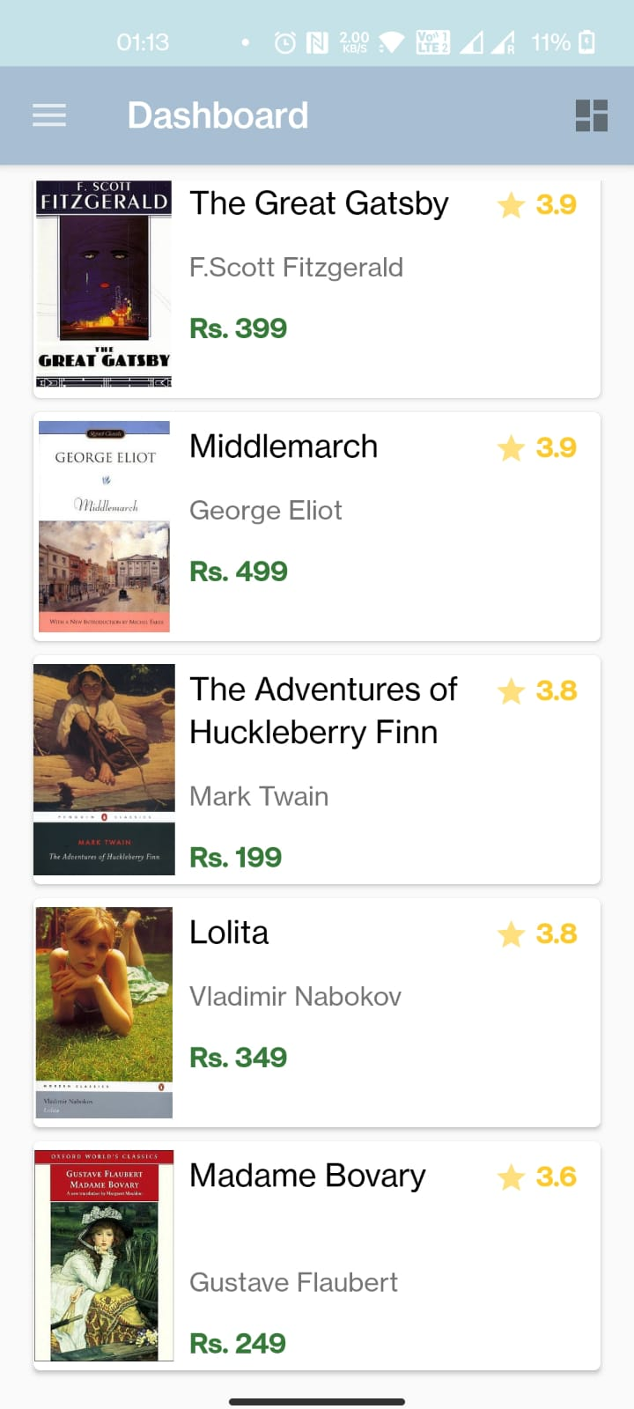

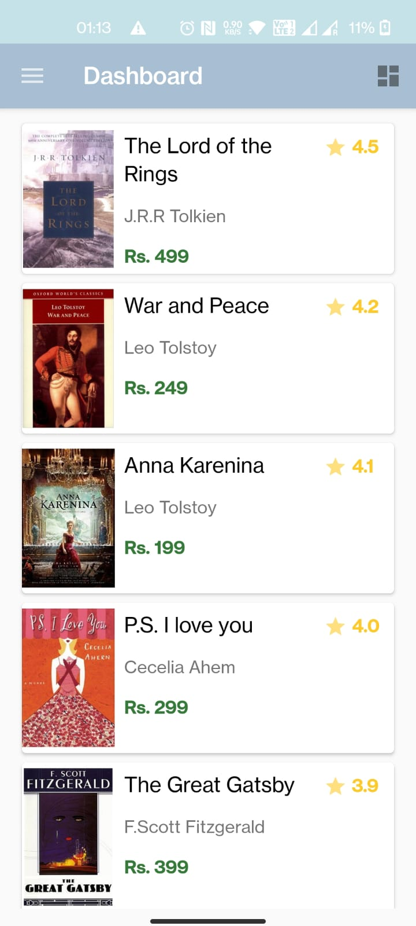

(**Menu Drawer)**

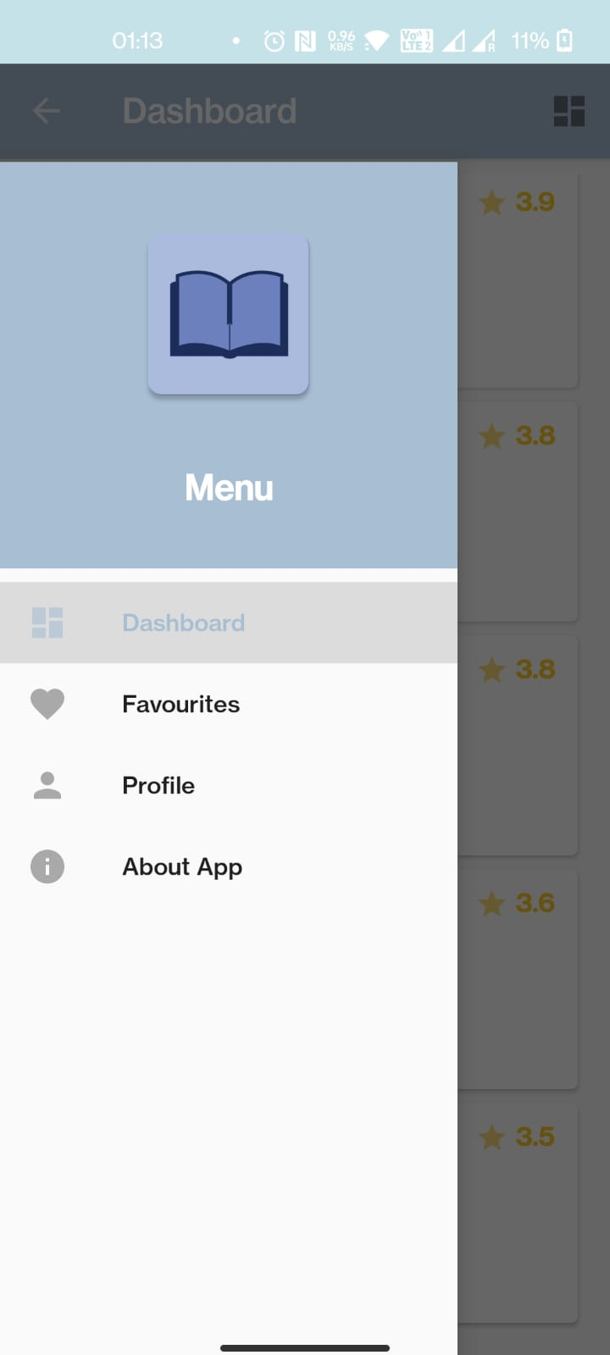

**Favourite(List of books added)**

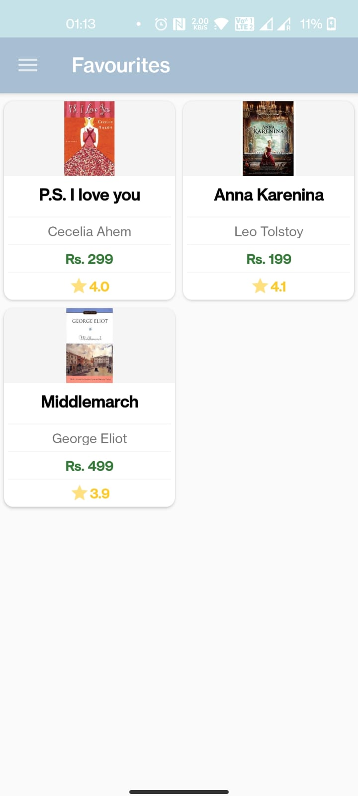

**(Add to Favourite)**



**(Remove From Favourite)**



**(Profile)**

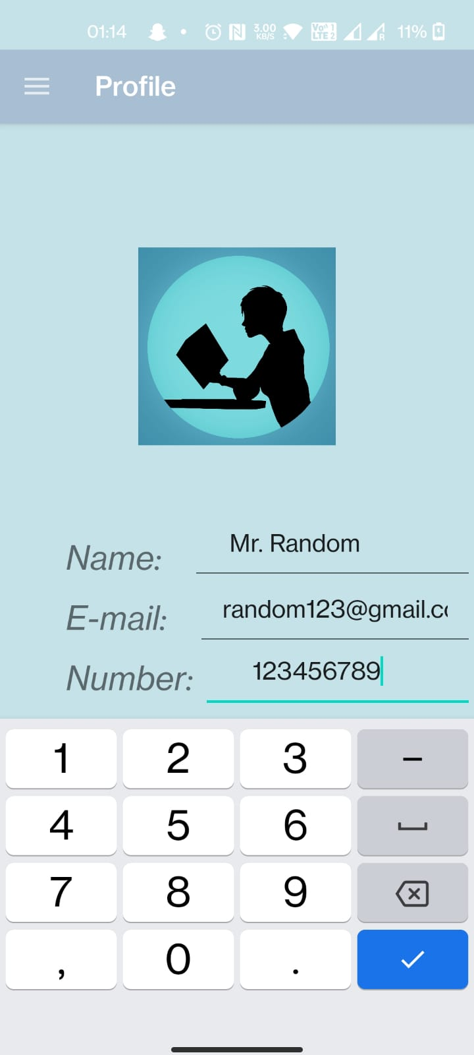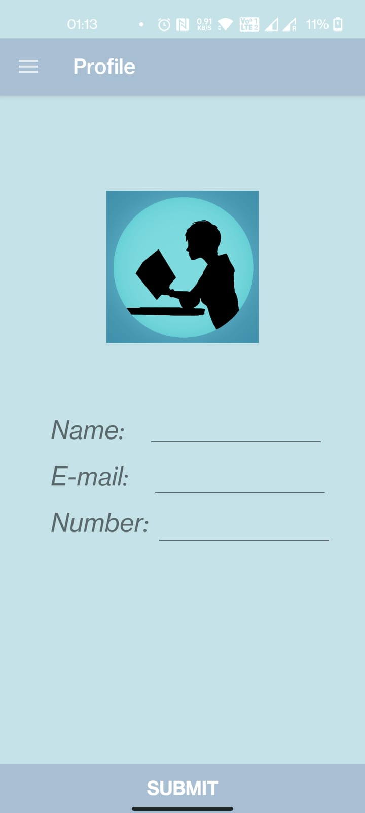

**Profile(After Entry)**

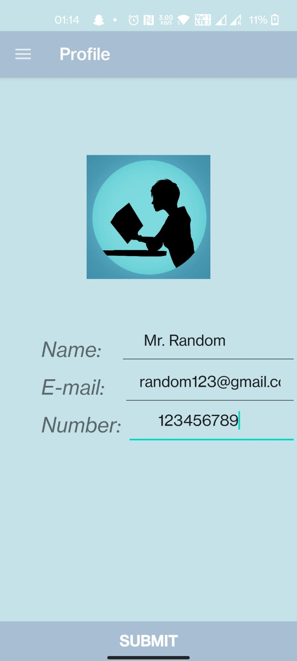

**(About App)**

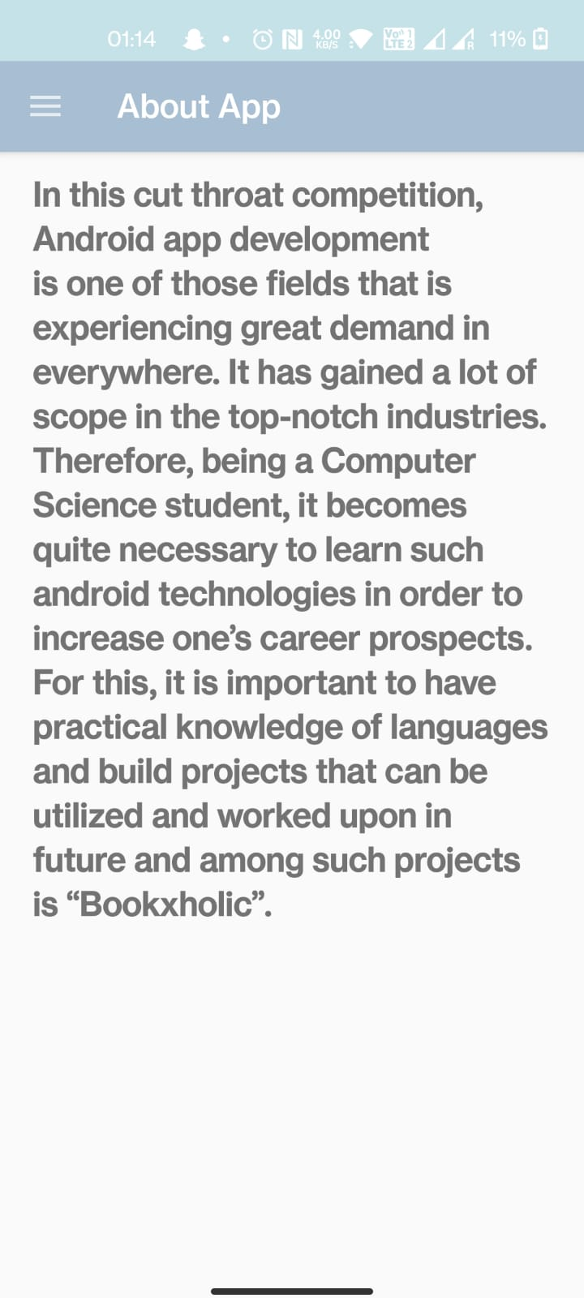

**Room(Database)-A layer of SQLite**

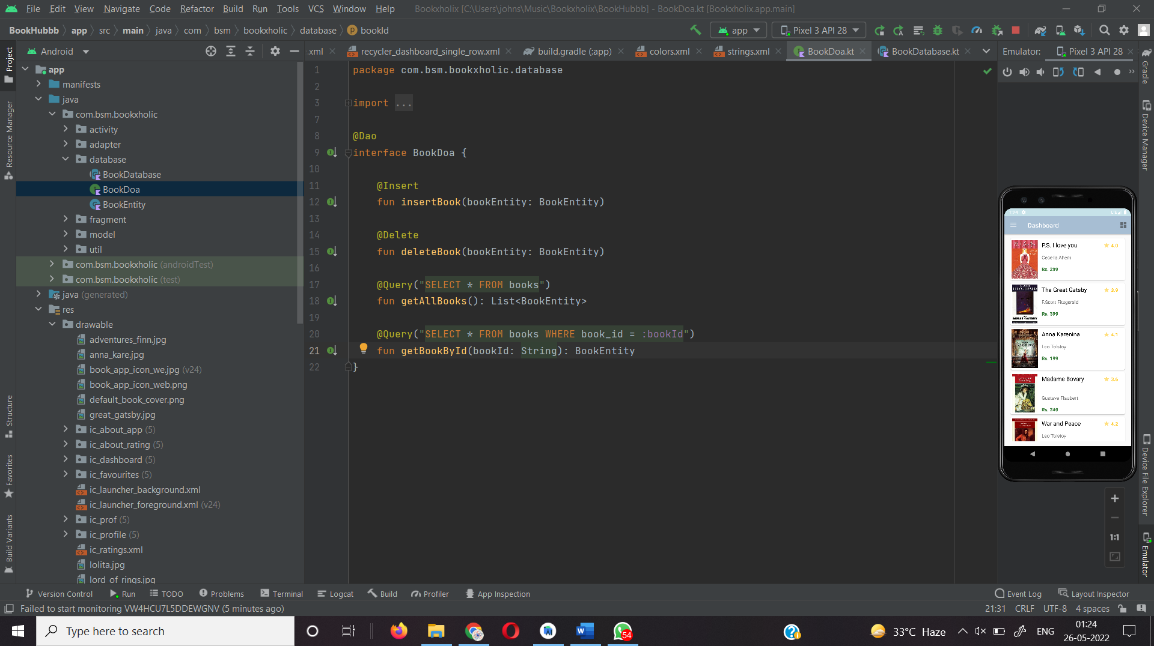

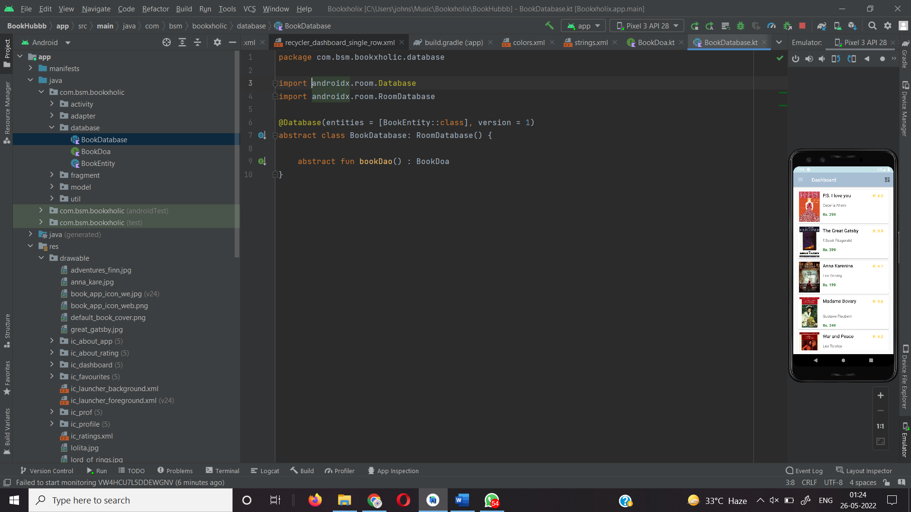

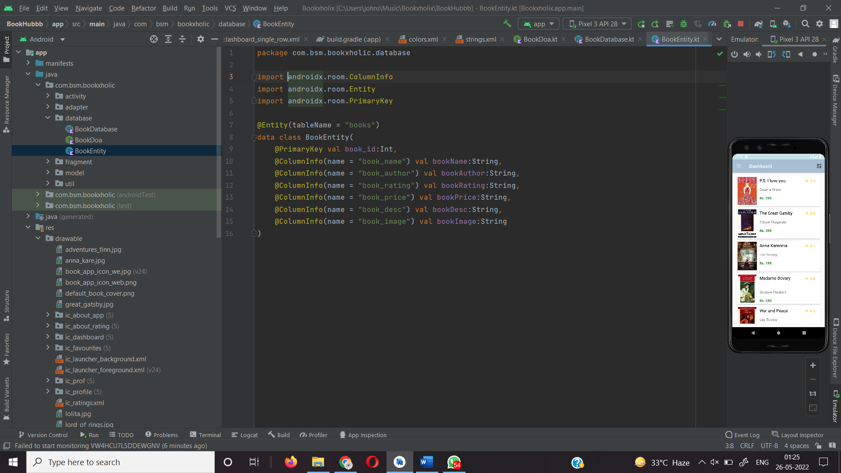

**FUTURE SCOPE**

Bookxholic Project is a real time project which is useful for all the book lovers and readers as this helps in building a social media sort of platform where they get to explore new book titles, get to know what is the current choice of readers and which book has a different plot and aspect. They can also check the cost and rating of the book they are looking for.

## LIMITATIONS OF THE SYSTEM PROPOSED

* It is one user interface website.
* The user can expect more features or want to gather more information.

## CONCLUSION

From proper analysis of positive points and constraints on the platform, it can be safely concluded that “Bookxholic” is efficient UI based platform. This platform can be easily used in many other systems. Also, “Bookxholic” is user friendly. Generally, readers do not get specific application where they can explore different book titles. This all information has to be managed manually. So, there is a need to develop a platform that can solve the mentioned problem. Thus, “Bookxholic” comes with just that solution.

## REFERENCES:

[*www.javatpoint.com*](http://www.javatpoint.com/)[*www.w3school.com*](http://www.w3school.com/)[*www.tutorialspoint.com*](http://www.tutorialspoint.com/)[*www.youtube.com*](http://www.youtube.com/) *https://web.learncodeonline.in/*

*https://www.developers.android.com*

### References-

Internshala Training -Android App Development, GeeksforGeeks.

### Faculty Mentor:

-Mr. Neeraj Khanna