Assignment-1
Snigdha Mohanty
B00487558
smohant1@binghamton.edu

5. I implemented Principle Component Analysis(PCA) of dimensionality reduction. It works with numeric data and when number of dimensions are large. PCA finds the principal components of data.It is often useful to measure data in terms of its principal components rather than on a normal x-y axis. There are 264 rows by 289 columns in sheet 1 which got reduced to 182rows by 41columns There are lots of eigenvalues, but there are which have big values – indicating that these big values contains a lot of information. The data set can then be reduced by ignoring all the eigenvectors that have insignificant eigenvalues. 4 dimensions is much easier to work with than 50! So dimension reduction using PCA helped simplify this data set by finding the dominant dimensions within it. The efficiency rate which I got is around 62.3%.
6. DFT is the oldest (as per my knowledge) and generic transform. However, results in frequency leakage, therefore, not suitable for image and video compression.In DCT is primarily used transform Image and Video transform (in variants). For a good co-related data (natural image and video), DCT comes close to ideal transform KLT, and suitable for compression. It is not the Real{DFT}, but can be considered close to it, and has real number nature.

DCT is better than DFT mainly due to the lack of continuities. Since we usually talk about DCT as a tool for signal representation, compression, etc., we are talking about representing a signal with a minimal number of coefficients. In DFT, since the signal is represented periodically, when truncating representation coefficients, the signal will tend to "lose its form". In DCT, however, due to the continuous periodic structure, the signal can withstand relatively more coefficient truncation but still keep the desired shape.

The Discrete Fourier Transform and Discrete Cosine Transform perform similar functions: they both decompose a finite-length discrete-time vector into a sum of scaled-and-shifted basis functions. The difference between the two is the type of basis function used by each transform; the DFT uses a set of harmonically-related complex exponential functions, while the DCT uses only (real-valued) cosine functions.

The DCT is frequently used in lossy data compression applications, such as the JPEG image format. The property of the DCT that makes it quite suitable for compression is its high degree of "spectral compaction;" at a qualitative level, a signal's DCT representation tends to have more of its energy concentrated in a small number of coefficients when compared to other transforms like the DFT.

- Compression using DCT

Step1. Similarly the DCT compression is also applied on the

original ECG and PPG signal.

Step2. Level of compression is modified to attain better result

of signal modification.

Step3. The signals with primitive values and structures are

retrieved from the compressed data.

Step4. The compressed signals are plotted along with the

original signals to measure the changes.

Step5. Computed the correlation ratio and psnr among the

original and regenerated signals.

Compression using DFT

Step1. Repeated the compression of ECG and PPG signals

using DFT compression, considering the signals as

wavelet.

Step2. The accumulation of the information values contained

in the signal after the compression are measured.

Step3. The ECG and PPG signals are regenerated from the

compressed signals achieved.

Step4. The resultant signals are plotted alongside the original

signals.

Step5. The extent of distortion is measured by calculating the

correlation ratio

DCT Compression
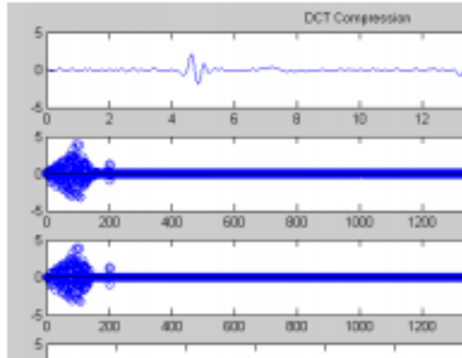
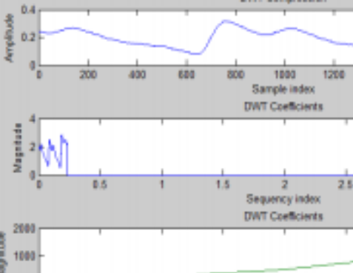
DFT Compression

