Assignment-3

smohant1@binghamton.edu
B00487558

6. Error rate in naïve bayesian is 6.66% and the error rate in case of decision tree classifier is .
One key difference between naïve bayesian classifier and decision trees,with respect to boosting,is the stability of the classifiers-naive bayesian classifier learning is relatively stable with respect to small changes in training data,but decision tree learning is not. Combining these two techniques will result in a learning method that produces more unstable classifiers than naïve bayesian classifiers.So we expect it will improve the performance of boosting for naïve bayesian classification.
- The accuracy rate of 10 fold cross validation is 93.75.
- K Nearest Neighbour

K nearest neighbors is a simple algorithm that stores all available cases and classifies new cases based on a similarity measure (e.g., distance functions). KNN has been used in statistical estimation and pattern recognition.

→ Lazy Learning Algorithm

Defer the decision to generalize beyond the training

examples till a new query is encountered

→ Whenever Whenever we have a new point to classify, classify, we find its K

nearest neighbors from the training data.

→ The distance is calculated using one of the following

measures

Euclidean Distance

Minkowski Distance

Mahalanobis Distance

Simple KNN Algorithm

→ For each training example <x,f(x)>, add the

example to the list of training_examples.

→ Given a query instance xq to be classified,
→ Let x1
,x2….xk denote the k instances from training_examples that are nearest to xq.

→ Return the class that represents the maximum of the k

instances.

In Wine DataSet K=3 ,Learning Rate-NA, # of example= 178 , # of training examples=146 ,
# of testing examples = 32, # of attributes = 13 and number of classes=3
So the total accuracy comes up to 87.5%.

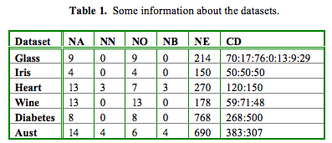

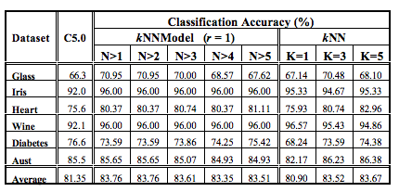

But the kNNModel significantly improves the
efficiency of kNN by keeping only a few representatives for classification. The
experimental results show that the average classification rate is 85.89%.

