Test Case 1 : 1234567891011123

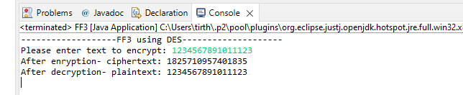

Test Case 2 : 4324887462491234

